TARGETS / TARGEDAU (Skills Audit / Awdit Sgiliau)

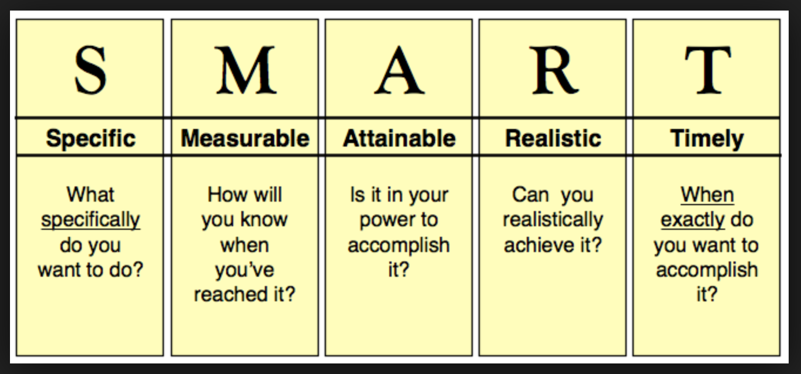

 | TARGET / TARGED | HOW / SUT? | WHEN? PRYD?
Gallu Cynllunio a Threfnu
Able to plan & organise
Gweithio Gyda'r Gymuned
Working with the community
Gweithio mewn Tim
Working in a team
Arwain
Leading
Llythrennedd
Literacy
Rhifedd
Numeracy
Llythrennedd Digidol
Digital Literacy

