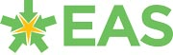
Making the Most of PDG to Close the Gap and Break the Link

Workshop, Summer Term 2015

Activity Options

The workshop will undertake item 1 plus any two of the other four items. Electronic versions of the resources for all activities will be available to delegates.

- The compliance flowchart – making best use of the grant as set out by WG
This element is to be delivered in all of the workshops (20 minutes explanation and questions)

- The balance of purposes – explores the balance between the four key purposes of the funding:
- Intervention
- Investment
- Development
- Transformation
This is an optional element – KP will explain the distinctions between the purposes and delegates work in pairs to identify the best examples of each from their own schools. The group will arrive at a consensus for the best balance of purposes for their own schools. Requires 30-40 minutes

- What makes and breaks the link – the overview diagrams and how we achieve them
This is an optional element – KP will explain the overview diagram and the leadership behaviours springing from it. Delegates will compare their own schools’ development of these approaches and determine two commitments to act. Requires 30-40 minutes

- Comparison of case studies – the 12 case studies from the Observatory report
This is an optional element – KP will issue relevant copies of the case studies as determined by the size and configuration of the group and we will discuss them as a workshop. Requires 30-40 minutes

- Overview of the resource base
This is an optional element and requires 30 minutes – KP will talk through the resource base on which this programme has been developed, specifically:
- The overview diagram
- The Estyn November 2012 report
- What Really Works, Guidance for Using the PDG
- WG PDG Poster
- Estyn Supplementary Guidance, September 2014
- PDG Essential Guidance 2015-17
- PDG Essential Guidance Flowchart

The compliance flowchart – making best use of the grant as set out by WG

See the embedded document:

The balance of purposes – explores the balance between the four key purposes of the funding:
- Intervention
- Investment
- Development
- Transformation

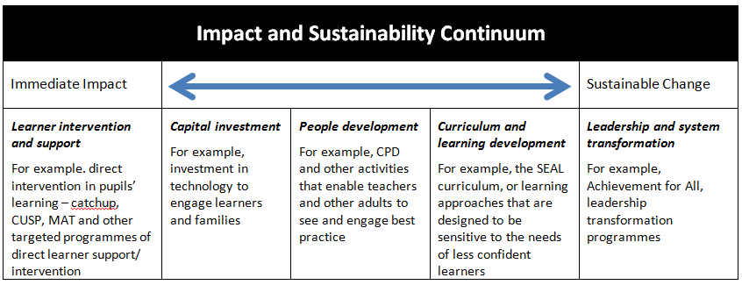

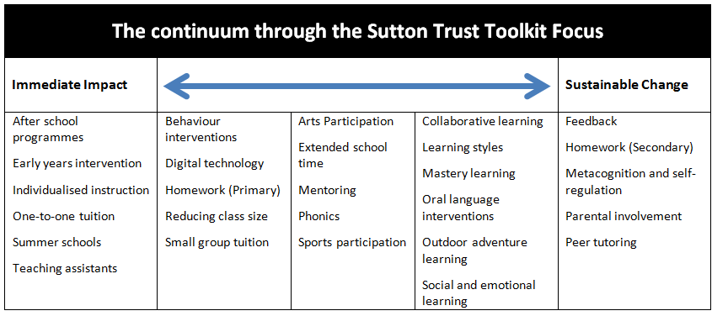

What makes and breaks the link – the overview diagrams and how we achieve them

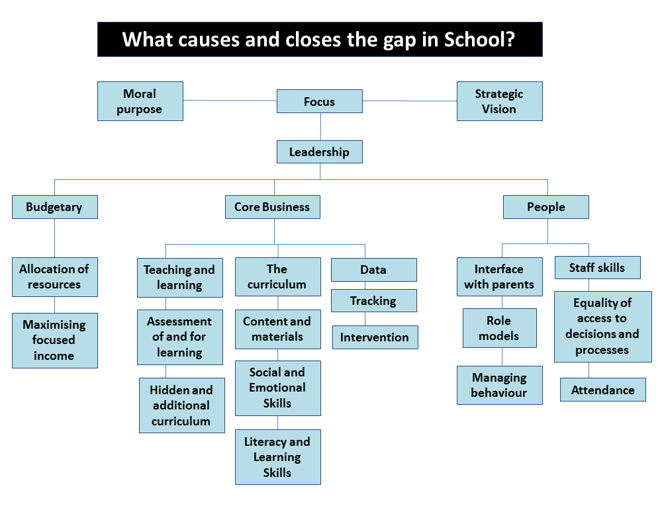

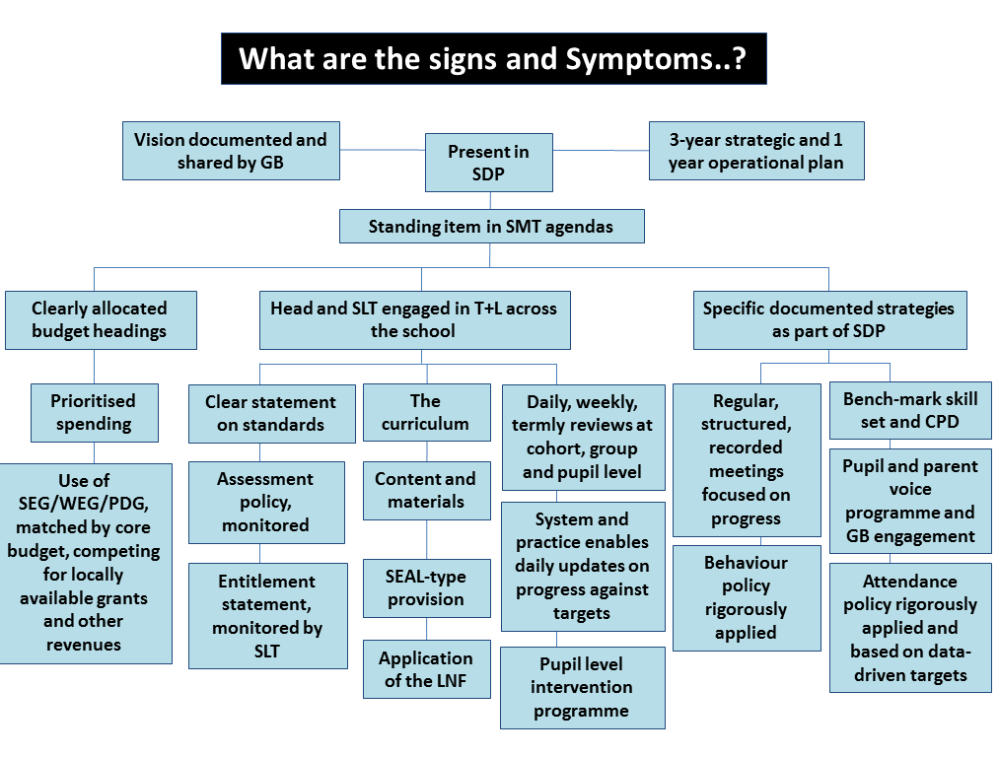

Comparison of case studies – the 12 case studies from the Observatory report

1. Ysgol Glan Gele
Strategic planning to tackle the impact of poverty

2. Ysgol y Dderi
Use of data to identify and support pupils who are falling behind

3. Pencoed Comprehensive School
Use of data to support the aspirations of young people and to identify and support pupils who are falling behind

4. Ysgol Hen Felin
Workforce development through staff training, self-evaluation, and distributed leadership

5. Ysgol Uwchradd Tywyn
Identifying low-achieving pupils and developing a range of strategies to improve their performance

6. Oakdale Comprehensive School
Developing a framework to support high-quality relationships and learners’ wellbeing

7. Bishop Gore School
Supporting low achieving pupils to reach their target grades

8. Ysgol Bassaleg School
Feedback, peer-to-peer learning and learners’ thinking skills

9. Mount Stuart Primary
Engaging parents and families to overcome cultural barriers

10. St. Mark’s Church in Wales V.A. Primary School
Engaging parents to support the well-being of vulnerable children

11. Ely Caerau Federation Schools Community Partnership
Strengthening links with communities, family and parental engagement

12. Flintshire Parenting Strategy and Delivery Plan
Strengthening links with communities, family and parental engagement

