Find and use relevant evidence, information and ideas. |  | 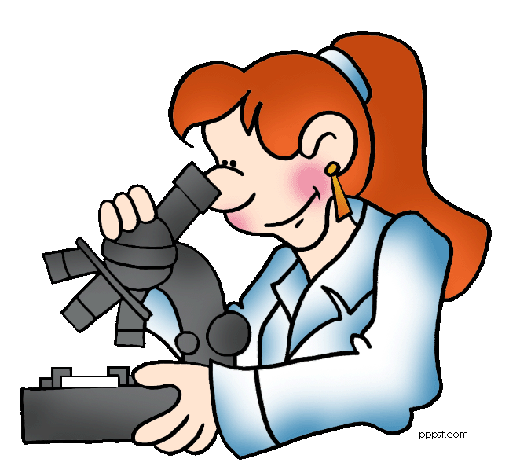  Select measuring instruments that allow them to make a series of accurate measurements |  | Begin to evaluate how far success criteria fully reflect successful outcomes.
Systematically plan their enquiries |  | Regularly check progress and revise the method where necessary |  | Identify the learning/thinking strategy they have used……
Make predictions based on scientific knowledge and understanding, including simple models. |  | Organise and communicate their findings integrating different forms in various presentations and record these systematically, using S.I. units where appropriate. Select the most appropriate type of graph or chart to display data. |  | Link the learning to dissimilar but familiar situations.
Identify key variables and distinguish between independent and dependent variables and those that they will keep the same |  | Use a line graph to describe relationships between two continuous variables. Identify bias and start to consider reliability.
Give some justification for their success criteria. |  | Use scientific knowledge and understanding, including simple models, when explaining their findings……and differences between, or changes to organisms, materials and physical phenomena.
Draw conclusions that are consistent
with the findings and consider others’ views to inform opinion and decisions.

