2.3.2 What are the consequences of urbanisation in two global cities?
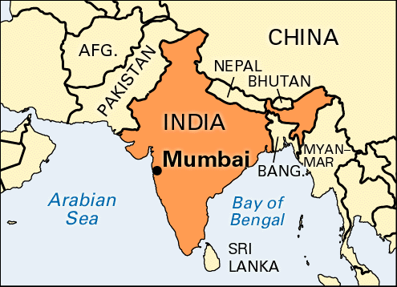
Case study – Mumbai, India – NIC (Newly Industrialised Country)
Mumbai is India’s _________ city with a _____________ of 18.4 million in 2015. Mumbai has __________ over the past 70 years and urbanised rapidly from its origins as a _______ village. The city of Greater Mumbai is built on a low-lying island in the ___________ Sea. As the city has grown it has __________ northwards and eastwards to form a large ____________ region.
- Where is Mumabi?
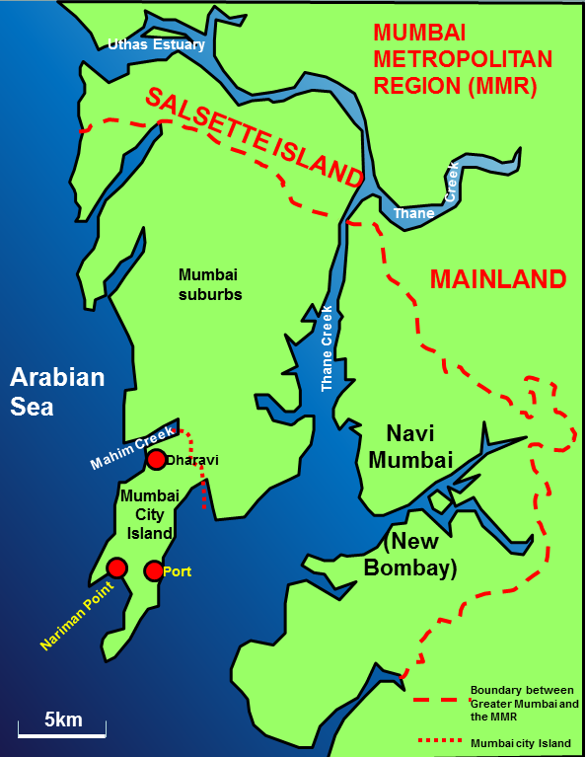

World's super cities to work and live in, Mumbai ranks 13
November 21, 2014 13:02 IST
Mumbai has secured 13th spot in the list of top attractive cities in terms of professional and private life, according to a survey carried out by INSEAD which is one of the largest business schools globally.

largest fishing population urbanised
sprawled Arabian metropolitan

Last Published: Wed, Feb 15 2017.
Mumbai, New Delhi in world’s 100 best cities to be a student: QS rankings
The QS rankings analyzed cities according to performance in six composite indicators: affordability, desirability, student mix, rankings, employer activity and student view.

- Why has Mumbai grown?
Mumbai’s population has grown form 2.86 million in 1950 to 19.42 million in 2010 and will have a projected population of 27.80 million by 2030!!!
- Natural increase in population
Natural increase is the growth of population that occurs when there are more births than deaths. Natural increase has been the main reason for Mumbai’s growth during the twentieth century. One simple way to investigate this is to examine average family size, a statistic known as fertility rate. If women on average have more than two children, then the population will grow.
Year or period | Fertility rate
Average 1974-82 | 4.03
Average 1984-90 | 3.45
Average 1994-2000 | 2.60
2004 | 2.20
2010 | 2.00
2013 | 1.80

By today fertility rates in Mumbai are lower than rural areas. For example, the fertility rate in Maharashtra, a rural province, is 2.2.
This is a common trend – lower fertility rates in urban / metropolitan centres compared to rural communities, but why?

My ideas . . .

- Migration (urbanisation)
Push Factors | Pull Factors
- Way of life in Mumbai
An emerging middle class of young, professional, well-paid men and women is creating urban and economic change in India. Many are young graduates who left rural lives behind when they went to university in a city like Mumbai. They take jobs working for the government, banking and finance sectors, the IT industry, textile (clothing) and manufacturing and jobs relating to industry. These are all formal occupations.
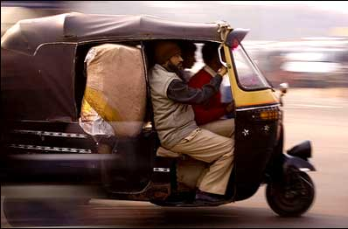
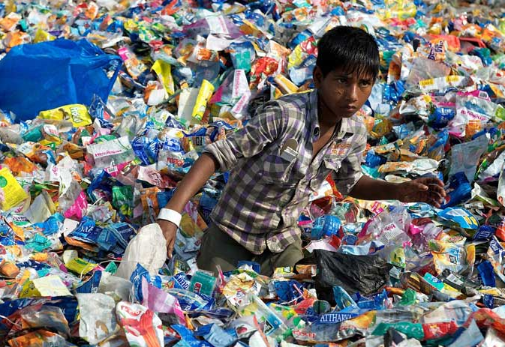
However, Mumbai’s economy also has a very large informal sector. Street vending, rickshaw driving and recycling waste are all examples of informal jobs.

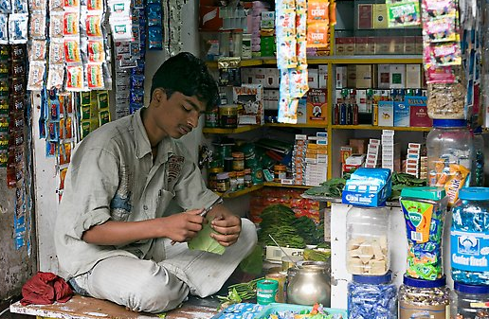

These jobs are not regulated. You don’t necessarily need a qualification to do them and you probably don’t pay tax. However, informal jobs have very little or no rights; holiday pay, pensions or sickness benefits and there are no rules to protect your health and safety at work.
Mumbai is a city of contrast between rich and poor.

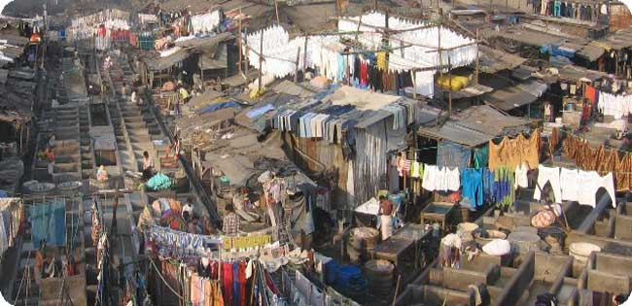
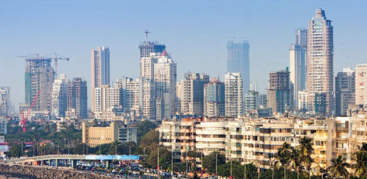

Complete this flow chart about the impacts of the informal sector and the wider economy.
Informal sector wages are low

W
Ch

G

Explain why poverty in the informal sector may prevent India from;
- Developing greater wealth in the economy _________________________________
_______________________________________________________________________________________________________________________________________________________________________________________________________________
- Improving education ________________________________________________
__________________________________________________________________________________________________________________________________________

Read the article; ‘Mumbai is on the verge of imploding.’
Draw a mind map to summarise the problems facing Mumbai.

Challenges in Mumbai
Like all global cities Mumbai is facing challenges or problems when it comes to accommodate a growing population!
- Transport

Solutions?
Cause?
Effects?
What can you see?

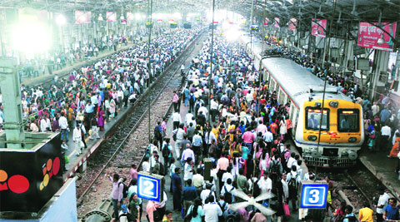

- Housing – Overcrowding, poor sanitation and homes that are in danger of collapse, flooding or fire – these are some of the issues facing the urban poor of Mumbai. There are three types of housing where occupants are at risk because of the poor conditions.
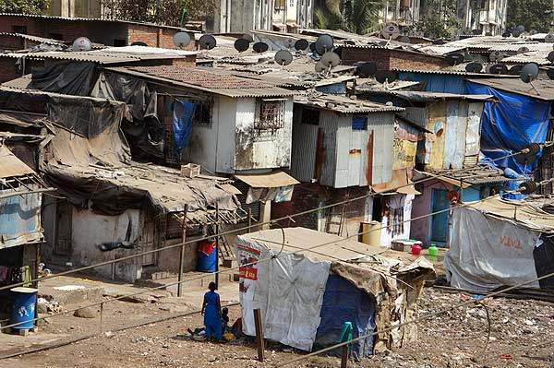
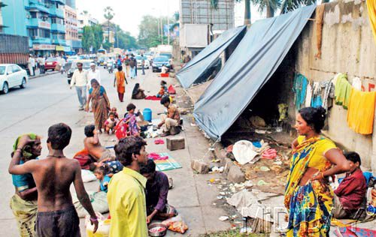
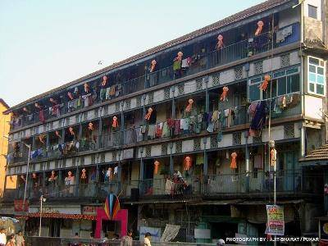
Join each description to the correct photo.
Pavement dwellers many of whom are children live in huts along pavements. Pavement dwellers pay rent to criminals who control the pavements. The structures are illegal and are often demolished by the authorities.
Squatter homes also known as slums in India (or in some places shanti towns / favelas), are simple single or two storey buildings built without planning control. Sanitation is very poor: 73% of residents share communal latrines.
Chawls are a type of four or five-storey tenement building. Families live in single rooms arranged along a corridor. Basic toilet facilities are shared by the tenants on each corridor. Many chawls were built between 1920 and 1956. They are overcrowded and poorly ventilated. But they are affordable.

Study the photograph below taken from a slum in Mumbai, India.
Annotate the photo to outline the dangers of living in a slum. [4]
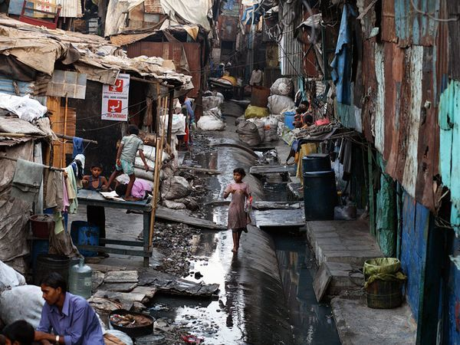

Is wholesale clearance and redevelopment the answer?
Advantages | Disadvantages

In my opinion ___________________________________________________________ ______________________________________________________________________________________________________________________________________________________________________________________________________________________________________________________________________________________________________________________________________________________________________________________________________________________________

