Resources for Advanced Global Citizenship Challenge: Politics
Theme: Population
Is it ever right politically to hold major sporting events in countries which have on-going human rights issues?

- www.bbc.co.uk/iwonder Search Bahrain > Bahrain country profile – Overview 25/11/2014
Bahrain country profile - Overview
- 25 November 2014
- From the section Middle East
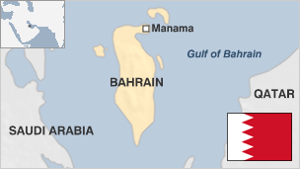
Bahrain - which name means "two seas" - was once viewed by the ancient Sumerians as an island paradise to which the wise and the brave were taken to enjoy eternal life.
It was one of the first states in the Gulf to discover oil and to build a refinery; as such, it benefited from oil wealth before most of its neighbours.
Bahrain never reached the levels of production enjoyed by Kuwait or Saudi Arabia and has been forced to diversify its economy.
The country has been headed since 1783 by the Khalifa family, members of the Bani Utbah tribe, who expelled the Persians. From 1861, when a treaty was signed with Britain, until independence in 1971, Bahrain was virtually a British protectorate. Since independence it has forged close links with the United States, and is home to the US Navy's Fifth Fleet.
At a glance
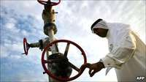
- Politics: The Khalifa family has ruled since 1783; Bahrain is now a constitutional monarchy with an elected legislative assembly; majority Shia Muslims are demanding more power from Sunni-led government. The government launched a crackdown on pro-democracy protests in 2011, but unrest continues to simmer
- Economy: Bahrain is a banking and financial services centre; its small and reasonably prosperous economy is less dependent on oil than most Gulf states
- International: Bahrain is home to the US Navy's Fifth Fleet. Bahraini-Qatari ties have been strained though they settled a territorial dispute in 2001
Country profiles compiled by BBC Monitoring
The king is the supreme authority and members of the Sunni Muslim ruling family hold the main political and military posts. There are long-running tensions between Bahrain's Sunnis and the Shia Muslim majority. On occasion, these have spilled over into civil unrest.
In 2001 Bahrainis strongly backed proposals put by the emir - now the king - to turn the country into a constitutional monarchy with an elected parliament and an independent judiciary.
Elections - the first such poll in nearly 30 years - were duly held in 2002 for a 40-member parliament, the Council of Deputies, which included a dozen Shia MPs.
Over the years the country enjoyed increasing freedom of expression, and monitors said the human rights situation had improved.
However, in early 2011 the government called in the Saudi military to crush protests by demonstrators demanding a greater say in government and an end to what Shias say is systematic discrimination against them in jobs and services.
Thousands of demonstrators gathered for several days in the centre of Manama, inspired by the popular uprisings which toppled the leaders of Tunisia and Egypt. Several people were killed in clashes with security forces.
Despite the crackdown, Shia resentment has continued to simmer, sporadically erupting in anti-government protests. The controversial decision to allow Bahrain to host the Formula 1 Grand Prix in April 2012 further galvanised protests.
Analysts believe that the ruling Khalifa family - which effectively controls the government - is split on how best to respond to opposition calls for a more meaningful dialogue.
It is thought that Prime Minister Sheikh Khalifa bin Salman al-Khalifa is a hardliner who is reluctant to make any concessions on the grounds that they will only encourage opposition leaders to make more demands.
Crown Prince Salman al-Khalifa, on the other hand, is seen as a moderate, and the opposition is keen that he should be involved in any dialogue. The Crown Prince appeared to have been sidelined after the 2011 security crackdown, but in March 2013 he was appointed deputy prime minister by King Hamad, giving rise to speculation that the king might be prepared to meet some of the opposition's demands.
However, the national dialogue launched in February 2013 ended in stalemate, and were suspended in January 2014.
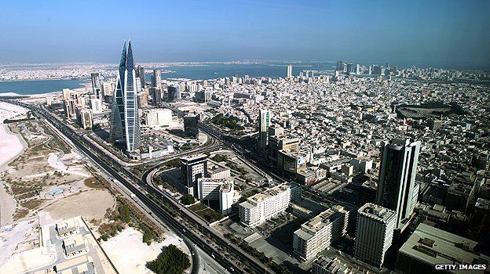
Bahrain is a regional financial and banking centre

- www.bbc.co.uk/news/world-middle-east-22122792
Baharain GP: The BBC explains the background to the protests 16/04/2013
Bahrain GP: The BBC explains the background to the protests
Bill LawGulf analyst
- 16 April 2013
- From the section Middle East
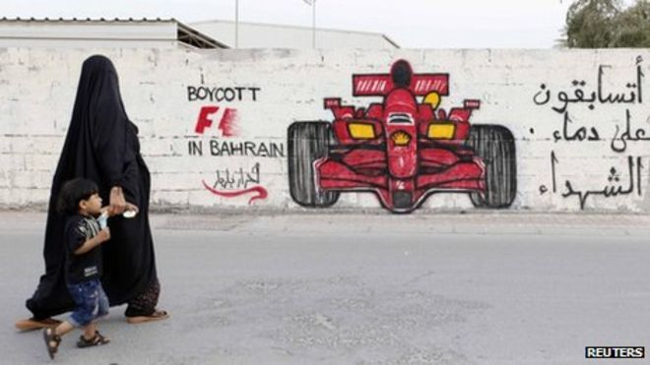
Unrest on the island forced the cancellation of the 2011 Bahrain Grand Prix
Bahrain unrest
As Formula 1 returns to Bahrain this week, protesters in the tiny Gulf state have once again threatened to disrupt the annual Grand Prix. But who is protesting and why?
Dwarfed by its mainland neighbour Saudi Arabia, the Kingdom of Bahrain, made up of 33 islands in the Persian Gulf, has experienced unrest and rioting on an almost daily basis for more than two years.
The problems began when the country was caught up in the Arab Spring, a revolutionary wave of demonstrations and civil wars in the Arab world, at the start of 2011.
Protests broke out in the Bahraini capital of Manama on 14 February 2011, when campaigners occupied an iconic landmark, the Pearl Roundabout. They wanted reform and democracy in a country that has been ruled by the royal al-Khalifa family for more than 200 years.
Many, but not all of the protesters, were Shia Muslims, who make up the majority of the population in Bahrain.
Like Christianity's two main branches of Catholicism and Protestantism, Islam is divided into two main broad interpretations: Shia and Sunni.
There are approximately 600,000 Bahrainis, with Shia making up roughly 60% of that number. A large expatriate community takes the total population to more than a million. The al-Khalifas, like the vast majority of their fellow Arabs in the Middle East, are Sunni Muslim.

Unhappy majority
For decades, Shia Bahrainis have complained of discrimination, high unemployment and inadequate housing in a country that first grew rich on oil discovered in 1931.
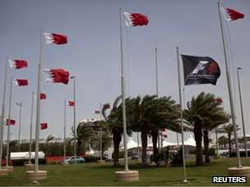
Preparations for the Grand Prix are well under way at the Bahrain International Circuit
In the 1990s, there was a widespread crackdown. Shia religious leaders, opposition political figures and human rights activists faced arbitrary arrest and abuse in detention. Forty people died as dissent was crushed.
The situation in the country improved dramatically when a new king came to power in 1999 with a promise of reform.
King Hamad presided over parliamentary elections, the relaxation of press restrictions and economic reforms that gave human rights activists and the Shia majority new optimism.
It was in that climate of hope that Bahrain secured a coveted place on the Formula 1 calendar. The first race, which took place at the £94m Bahrain International Circuit at Sakhir in 2004, was a huge success.
Embraced by nearly all Bahrainis, the event passed off smoothly for several years.
Prince with a vision
F1 in Bahrain was the brainchild of the King's son, Crown Prince Salman bin Hamad al-Khalifa.
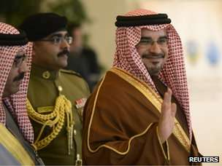
Crown Prince Salman was responsible for bringing F1 to Bahrain
Regarded by many as a moderniser and a reformer, he saw the potential of an international event that would introduce the country to a huge global audience.
Together with its other reforms, Bahrain positioned itself as a progressive Gulf state, open to the West and its influences. F1 proved a brilliant platform to convey that message. The country and the race flourished.
But the smooth ride hit the buffers in 2011, when unrest in the island kingdom forced the postponement and then the cancellation of the Grand Prix.
The occupation of Pearl Roundabout was a peaceful affair that soon turned bloody. The roundabout was forcibly cleared, leaving three dead and hundreds wounded.
The government found itself on the back foot as peaceful demonstrations continued and the roundabout was re-occupied.
Pearl Roundabout was finally cleared when troops from Saudi Arabia and other Gulf Co-operation Council (GCC) states entered the kingdom in March 2011 in what was a moment of humiliation for the Khalifa family.
A cancelled race
Bahrain crisis timeline
- 14 February, 2011: Demonstrators occupy iconic landmark , Pearl Roundabout in the capital
- 14 March: Gulf Cooperation Council force led by Saudi troops enters Bahrain. Police clear Pearl Roundabout
- March-April: Hundreds arrested, thousands sacked from their jobs. Protest continues, 35 killed, F1 cancelled
- 23 November: Protests continue as Cherif Bassiouni releases damning report on human rights abuses. Authorities accept findings
- April 2012, F1 returns despite opposition protests
- Feb 10, 2013: Opposition and pro-government groups open dialogue but unrest continues
In the months that followed the GCC intervention and the race cancellation, more than 50 people died, including five security officers.
Hundreds of people were arrested, scores were tortured in jail and convicted in front of military tribunals, while more than 4,000 people were summarily sacked from their jobs, including 29 employees at the Sakhir track.
The vast majority of those affected, including all of the BIC employees, were Shia.
An international outcry led to King Hamad appointing a panel of human rights experts to investigate the events of February and March 2011.
Headed by an Egyptian, Cherif Bassiouni, theBahrain Independent Commission of Inquiry (BICI) report was a scathing indictment of his government, but King Hamad accepted the findings and promised sweeping reforms.
The government says that, as proof of its commitment to reform, the legal and law enforcement systems have been overhauled, employees who were unfairly dismissed have been reinstated, and a special prosecution unit set up to investigate abuse claims.
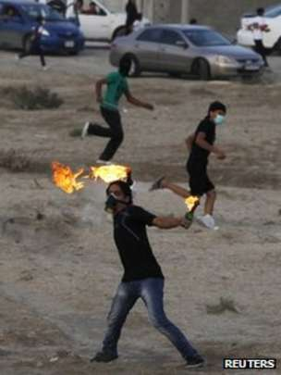
Thousands regularly turn out to protest in Shia villages around the capital
But critics say that, since the report was released, little has changed. They point to the political prisoners still in jail, to ongoing arrests, to what they say are extra-judicial beatings of young protesters, and to the heavy use of tear gas.
Last year's race did go ahead but in an atmosphere of heightened security and ongoing tension far removed from the celebratory mood that F1 and Bahrain had enjoyed before the 2011 uprising.
And four mechanics from the Force India team were caught up briefly in aconfrontation on a main highwaybetween youths hurling Molotov cocktails and police responding with tear gas.
No Force India staff were hurt but two team members subsequently asked to return home.
Car blast rocks capital
The government has sought to reassure F1 fans and the international community that this year's race is safe.
At a media conference, Samira Rajab, Bahrain's Information Affairs minister, described the situation in Bahrain as "very reassuring" and blamed foreign media for "blowing the security (aspect) out of proportion".
"There has been no major escalation of violence on the ground recently as the F1 Bahrain Grand Prix is drawing nearer," the minister said.
However a car blast in the heart of Manama a few hours later was a clear indication that, despite the reassurances, all is not well in Bahrain.
A shadowy protest group that calls itself the February 14 movement took credit for the explosion.
As the unrest drags on with little progress being made, angry youths from Shia villages continue their daily barrage of Molotov cocktails, burning tyre roadblocks and running battles with the police.
The response of the authorities has sometimes been scarcely less violent, with police opening up at close range with birdshot and high levels of tear gas on both peaceful and violent protesters.
Because Bahrain is a tiny place and most of its inhabitants live in an area that is not much larger than London and its suburbs, everyone is affected by the ongoing unrest one way or another.
More than a race
Unlike any of the other F1 venues, Bahrain finds itself stuck in a political quagmire with no easy way out. F1 organisers would no doubt be delighted if the political controversy around the event died down.
But F1 in Bahrain has come to represent much more than a grand prix.
Ironically, it is F1's global stature that has guaranteed that the race, unlike any other sporting events held in Bahrain, has become a strategic symbol for both sides.
For the government and its supporters, holding an F1 race demonstrates that the kingdom is stable and back on track. For the opposition, the race is little more than an attempt to conceal what they say is the ugly truth of daily life in the country.
For ordinary Bahrainis and members of the large expat community, F1 is a way of putting aside, at least for a few days, the roads blocked by burning tyres, the police checkpoints and the whiff of tear gas in the air.
But, with Sunday's explosion, walls being daubed with anti-F1 slogans, and protesters promising further disruption, that may prove hard to do.

- Tear gas used to quell Bahrain Grand Prix protests 17/04/2013
F1: Tear gas used to quell Bahrain Grand Prix protests
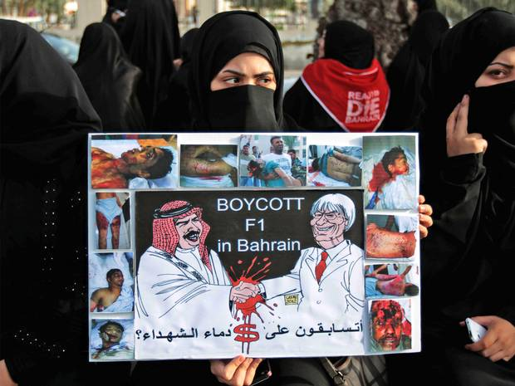
Government accused of rounding up troublemakers ahead of lucrative Grand Prix

LOVEDAY MORRIS
Wednesday 17 April 2013
Security forces fired tear gas to disperse protesters at a secondary school in Bahrain as calls grew for this weekend’s Formula One race to be called off due to escalating violence.
The skirmishes came after the arrest of a student at the boys’ school, amid accusations that the government is arbitrarily arresting potential troublemakers ahead of the Grand Prix. The Interior Ministry said that “thugs” at Al Jabriya School in the capital Manama had been dealt with in line with the law.

Authorities have doubled efforts in recent weeks to quell unrest that has blighted the country for the past two years, since protesters, largely from the country’s Shia majority, took to the streets complaining of widespread discrimination under the country’s Sunni monarchy.

Bernie Ecclestone, the head of Formula One – the coffers of which are boosted by $40m (£26m) in hosting fees from Bahrain – has so far resisted calls to call off the race. He likened the demonstrators to those protesting Baroness Thatcher’s funeral, saying “people use these things when there is an opportunity”. His refusal to reconsider comes despite the fact that often violent demonstrations and scuffles with security forces have ramped up over the past week as protesters demand that the race is cancelled. A series of small explosions rocked the country on Sunday, adding to security concerns.

The blasts, one of which destroyed a car in the city’s financial district, caused no casualties but the Coalition of February 14 Youth claimed responsibility and threatened further action if the race was not called off, in a campaign it has called “volcanic flames”. The hacktivist group Anonymous also issued a threat to wreck Mr Ecclestone’s “little party”, calling on him to “cancel your blood race now”.

Photos and videos of the incident at the school showed young men hurling bottles at security forces before tear gas was fired. On Monday, police arrested a 17-year-old student, Hassan Humidan, at the school.

Human Rights Watch earlier this week accused the government of arresting scores of young men in a series of dawn raids since the beginning of the month. Amnesty International also condemned the decision by the Bahraini government to amend the penal code to enable it to jail for up to five years anyone found guilty of insulting King Hamad bin Isa Al Khalifah or other national symbols. “Increasing the punishment for criticism of Bahrain’s King is a further attempt to muzzle activists ahead of the upcoming Grand Prix,” said Hassiba Hadj Sahraoui, deputy Middle East and North Africa programme director at Amnesty.

A group of 20 British MPs have joined the opposition in calling for the race to be cancelled. “I think most democratic-minded people would be appalled if you allowed the Bahrain leg of the Formula One championship to go ahead amidst the most atrocious human rights violations,” the All-Party Parliamentary Group for Democracy in Bahrain wrote in a letter to the F1 boss.
The Bahraini government is attempting to bridge a growing political divide by engaging in a “national dialogue” with opposition groups. Mr Ecclestone has offered to speak to representatives of Al Wefaq, the main opposition party, as he did last year.

However, the traditional largely Shia opposiwtion political parties have lost support among many of the demonstrators, with much of the youth contending that they have lost touch. Al Wefaq has refrained from calling for the F1 to be cancelled, wary of derailing discussions.

“They don’t reflect the street,” said Sayed Ahmed a Bahraini activist now residing in the UK after being injured at protests during the Formula One last year and imprisoned and tortured in 2011. “The street are clear, they don’t want a race on their blood. The security being used is enormous – it’s simply martial law which has not been announced.”

- www.iaa.bh/Responsedetails.aspx?id=90
Responses to The Independent from the Bahrain Information Affairs Authority – F1 Tear gas used to quell Bahrain Grand Prix protests

17 April 2013
Response to The Independent - F1 Tear gas used to quell Bahrain Grand Prix protests - April 16th 2013
Dear Editor,
We are writing to shed light on an alternative perspective to the one portrayed by Loveday Morris in “F1: Tear gas used to quell Bahrain Grand Prix protests” (April 16th 2013) as the author has not captured the full picture of the current environment.
Firstly, it needs to be made clear that the dispersion of protests is not a result of a proactive initiative to target individuals for their views, but for expressing this discontent by breaching the law violently and severely endangering the rest of the community. The incident at the Jabriya School the author referred to occurred after students threw stones, fire extinguishers and metal rods over school walls onto oncoming cars. These youth have been politicized by other more radical members of society, who have admittedly taken responsibility for a series of terrorists acts including several car bombs across the country. These radical views are not representative of the population, nor even of the opposition front.
The Bahrain Grand Prix does not set back the Government's push towards reform, but in fact reinforces Bahrain’s commitment to improving the lives of citizens who had been severely affected by the global recession, as well as by the regional unrest. An independent study proved that the race had a gross economic impact of $295m in the past, and supported 3000 jobs across retail, business and hospitality sectors. This fact alone supports many of the social grievances being voiced in the country.
Contrary to the same call made by UK Parliamentarians' last year, a survey conducted by Nielson showed that 77% of citizens were in favor of the 2012 race for its economic and social advantages. This poll was reinforced by the 28,000 spectators that attended, making it Bahrain's third most popular race. Formula One Driver Allan McNish stated that after arriving in the country, him along with his colleagues felt the situation in Bahrain "was blown out of all proportions [by the international media] as to what was happening on the ground".
The Bahrain Grand Prix began in 2004, before the uprising or the Arab Spring, and it is unfair for individuals to hijack this event now for political gains. We will always welcome constructive criticism, as long as it takes into consideration the broad consensus.
Regards,
Salman H. AlJalahma
Media Attaché
Information Affairs Authority

- www.bbc.co.uk/sport/0/formula1/17804598 (Video)
Niki Lauda saysF1 should be’ kept apart’ from politics

- Error! Hyperlink reference not valid.
Bernie Ecclestone strikes again with ‘stupid’ remark in Bahrain 20/04/2013

Bernie Ecclestone strikes again with 'stupid' remark in Bahrain
• F1 supremo criticises Bahrain government over staging of race
• Crown Prince laughs it off: 'It's just Bernie being Bernie'
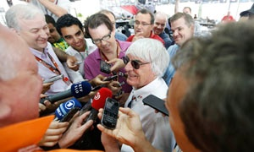
Bernie Ecclestone's remarks ahead of the Bahrain Grand Prix amused the Crown Prince. 'It's just Bernie being being Bernie.' Photograph: Hoch Zwei/Action Images
Paul Weaver at Sakhir
Saturday 20 April 2013 17.57 BSTLast modified on Wednesday 21 May 201420.00 BST
Bernie Ecclestone has a habit for maladroitness that has become more noticeable as each of his 82 years has passed. But he sounded alarm bells here when he seemingly called the Bahrain government "stupid" for staging a grand prix because of the opportunities it presented to pro-democracy protesters.
It was another race and another gaffe for Formula One's supremo, who once said Adolf Hitler got things done and who on Friday had suggested everything was OK in Bahrain but that, no, he wouldn't be staging a race in Syria. The 82-year-old was again due to meet with opposition leaders for talks later.
Sensitivity is acute in these parts following the controversial decision to bring F1 back to the small gulf kingdom so soon after deaths in the 2011 protests. In fact, Ecclestone, who has this week been extremely positive towards a race that continues to attract negative press, was trying to make a tongue-in-cheek remark and apparently it just came out wrong. What he actually said to BBC Sport's Dan Roan, who had asked him if the race had been politicised, was: "We believe the government were in a way really stupid to put this race on [because] it's a platform for people to use for protesting."
Ecclestone added: "It [the race] is good. I don't think it's for us to decide the politics, good or bad. It's a good circuit, a good race, and we think everybody's happy so we're here."
When his comments were later repeated in the paddock the country's crown prince laughed them off: "It's Bernie being Bernie," said Prince Salman bin Hamad Isa al-Khalifa on his visit to the track. "I love Bernie and his quotes. I think it's funny. I have a sense of humour. People will know he's being sarcastic. I think it's funny, and I can't be thankful enough for his support."
Last year's race was a public relations disaster for both F1 and the Bahrain government with the race taking place against a background of protest and repression. This year security at the race and in the capital, Manama, is tighter but even as Ecclestone and the crown prince were speaking there were unconfirmed reports of violence being meted out to protesters. Bernie may have been right after all.

- www.telegraph.co.uk >sport>Motorsport>Formula One F1 boss Bernie Ecclestone says Bahrain government is ‘stupid’ for allowing today’s grand prix in the troubled Gulf kingdom to give voice to human rights protestors. 20/04/2013

F1 boss Bernie Ecclestone says Bahrain government is 'stupid' to race
Bernie Ecclestone has described the Bahrain government as “stupid” for allowing today’s grand prix in the troubled Gulf kingdom to give a voice to human rights protestors.
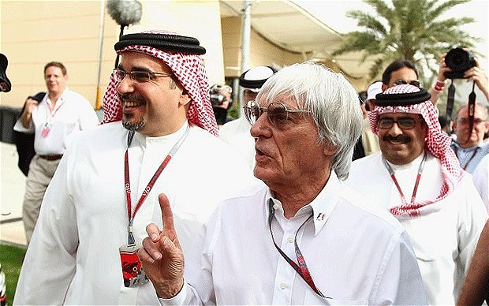
On the attack: Ecclestone and Prince Salman Bin Hamad Al Khalifa, whose country the F1 boss has criticised Photo: GETTY IMAGES
By Oliver Brown, Bahrain
11:00PM BST 20 Apr 2013
In ill-judged remarks, as pro-democracy demonstrations continued in the capital Manama, the Formula One chief said: “We believe the government were in a way really stupid to put this race on, because it is a platform for people to use for protesting.”
With further unrest yesterday in Bahrain’s outlying Shia villages, away from the Sakhir circuit, Ecclestone hardly endeared himself either to the demonstrators or to the ruling regime paying £26 million a year for the privilege of staging Sunday afternoon's race.
The 82 year-old, asked if he should be bringing Formula One to a country with a recent history of human rights abuses, replied that it was not his job to take a moral position.
“We don’t go anywhere to judge how a country is run,” he said. “I keep asking people, what human rights - I don’t know what they are.
"The rights are that people who live in the country abide by the laws of the country, whatever they are. I might be in Africa and can go 200kmph on the highway with no problem. If I come to England and do the same thing, I’m in trouble. So it’s a case of whatever the laws are, people need to respect them.”
The crown prince of Bahrain claimed last night to be unconcerned about Ecclestone’s labelling of the government as “stupid”. “It’s Bernie being Bernie,” said Prince Salman bid Hamad bin Isa Al Khalifa. “People will know he is being sarcastic. I have a sense of humour.”
On the subject of regimes with questionable human rights records, Ecclestone was also pressed on whether, if Syria ever had a circuit in Damascus, he could be persuaded to take a grand prix there. “We’ll have to take a look and see,” he said. Dan Roan, the BBC reporter who asked the question, later tried to insist that Formula One's commercial rights holder had made the remark tongue-in-cheek.
Ecclestone was withering about the All-Party Parliamentary Group for Democracy in Bahrain, the group of MPs led by shadow justice minister Andy Slaughter, who have called for the grand prix to be scrapped.
He said: “MPs are really good. We see them, like, once a year. We never see them otherwise. They suddenly pop up, which is good really, because nobody knows who they are and they get their name in the paper.”
Just hours after Ecclestone’s dismissal of human rights concerns, there were unconfirmed reports last night of significant disturbances in the
Shia community of Sanabis, west of Manama.
Ala’a Shehabi, leader of the group Bahrain Watch and an unofficial spokeswoman for the protestors, described on Twitter “a scene of carnage” at the house she was visiting. She wrote: “It’s chaos. Police have tear-gassed the house and women have been sprayed in the faces.”

- www.dailymail.co.uk >Sport>F1
Bernie Ecclestone gives Azerbaijan green light to host European Grand prix next season despite human rights concerns. 19/04/2015

Bernie Ecclestone gives Azerbaijan green light to host European Grand Prix next season despite human rights concerns
- The European Grand Prix will be staged in Azerbaijan next year
- Former Soviet republic has been criticised for poor human rights record
- Bernie Ecclestone claims F1 has conducted its due diligence
By IAN PARKES
PUBLISHED: 19:02, 19 April 2015 | UPDATED: 07:50, 20 April 2015

Formula One supremo Bernie Ecclestone has given Azerbaijan the all-clear ahead of its debut next season despite serious concerns over the country's human rights record.
Human Rights Watch's 2015 report on the former Soviet republic stated there had been 'a dramatic deterioration in its already poor rights record' particularly in its treatment of opponents of the political regime.
However, Ecclestone maintains F1 has conducted its due diligence on Azerbaijan. The capital, Baku, will host a street race to be known as the European Grand Prix.
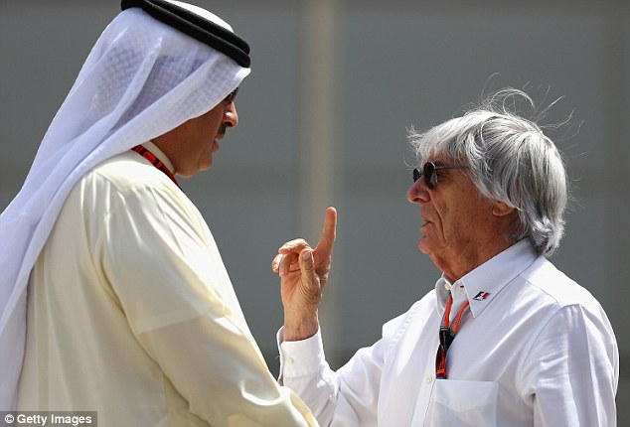
Bernie Ecclestone, speaking in Bahrain, has confirmed Azerbaijan will stage the European Grand Prix
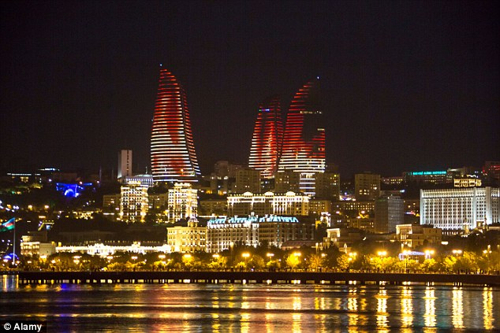
+5The race will be held in the capital of Baku, despite the country's poor human rights record

Asked whether Azerbaijan's human rights record would be checked, the 84-year-old replied: 'We have.
'I think everybody seems to be happy. There doesn't seem to be any big problem there.
'There's no question of it not being on the calendar. It's going to be another good race.'
The sport recently published a 'Statement of Commitment to Respect for Human Rights' that was posted on the formula1.com website.
It said: 'The Formula One Group is committed to respecting internationally recognised human rights in its operations globally.
'Whilst respecting human rights in all of our activities, we focus our efforts in relation to those areas which are within our own direct influence.'
It added that the sport would also 'identify and assess...any actual or potential adverse human rights impacts with which we may be involved either through our own activities or as a result of our business relationships, including, but not limited to, our suppliers and promoters.'

+5
The Human Rights Watch report on Azerbaijan for 2015 was pretty damning.
'The Azerbaijani government escalated repression against its critics, marking a dramatic deterioration in its already poor rights record,' the report states.
'The authorities convicted or imprisoned at least 33 human rights defenders, political and civil activists, journalists, and bloggers on politically motivated charges, prompting others to flee the country or go into hiding.
'Authorities froze the bank accounts of independent civic groups and their leaders, impeded their work by refusing to register foreign grants, and imposed foreign travel bans on some.
'Many of those detained complained of ill-treatment in police custody. Many organisations, including several leading rights groups, were forced to cease activities.'
Concerns remain, however, over the Italian Grand Prix, one of the most historic races in F1.

Ecclestone is currently negotiating with promoters at Monza over a new contract, with the current one due to expire after next year's race.
Officials have made it clear they can no longer afford Ecclestone's terms and are hoping he will reduce his fees.
Ecclestone, though, seems unconcerned at losing F1's heartland of Europe as key races such as those at Imola, France and Germany have disappeared.
'We have to wait and see. They don't have an agreement. Bit like Germany really,' said Ecclestone.
Suggested to Ecclestone it was unthinkable the race could be dropped, he replied: 'I tell you something, I was told that when we didn't have a race in France actually. And Germany now. We've got some good replacements, haven't we?'

- www.the guardian.com>home>world>middle east
Formula One reverses human rights stance in run up to Bahrain Grand Prix
Joe Sandler Clarke 17/04/2015

Formula One reverses human rights stance in runup to Bahrain Grand Prix
Campaigners have persuaded Formula One to create a human rights policy after years of unwillingness to engage with the issue

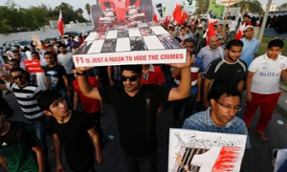
Marchers protest against the Bahrain Formula One race in 2013. Photograph: Hamad I Mohammed/Reuters
Joe Sandler Clarke

@JSandlerClarke

Friday 17 April 2015 14.25 BSTLast modified on Friday 17 April 201514.51 BST
In a victory for campaigners, the organisation behind Formula One racing has done a 180-degree policy reversal in the runup to the contentious Bahrain Grand Prix and agreed to formulate a human rights policy.
F1 supremo Bernie Ecclestone has previously been reluctant to be drawn on human rights issues, saying in 2013: “We don’t go anywhere to judge how a country is run. I keep asking people, ‘What human rights?’ – I don’t know what they are. The rights are that people who live in the country abide by the laws of the country, whatever they are.”
The change of heart comes after the UK government agreed to investigate a complaint from international human rights organisations who argued that between 2012-14 the Bahrain Grand Prix led to increased human rights abuses, and helped to “present an international image of Bahrain at odds with a reality of ongoing human rights abuses”.

From land grabs to anti union behaviour, businesses are increasingly being held accountable
Rolf Nieuwenkamp

Americans for Democracy and Human Rights in Bahrain (ADHRB) submitted acomplaint alleging that F1 had breached the Organisation for Economic Co-operation and Development (OECD) guidelines on responsible business, doing nothing to prevent the Bahraini government launching a bloody crackdown on protesters in the runup to the 2012 and 2013 races, in which protester Salah Abbas died and hundreds were injured.
The UK National Contact Point, which is conducting the investigation into this complaint,agreed in its initial assessment that the Bahrain race has become “politicised, with a new risk that it may be used as a focus for actions by both opponents and agencies of the government”. It said that as a result, F1 needed to look at its human rights procedures. It points out that the information submitted by F1 so far did not show much evidence of having engaged with this issue.
In response, F1 issued a statement this week announcing that it “has committed itself to respecting human rights in Bahrain and other countries in which it conducts business”. On a page of their website, headed “legal notices” there is a brief statement that commits the organisation to “understand and monitor through our due diligence processes the potential human rights impacts of our activities”, and to “engage in meaningful consultation with relevant stakeholders in relation to any issues raised as a result of our due diligence, where appropriate”.
The build-up to the Bahrain Grand Prix this year has once again been marked by political unrest. The situation in the country is said to be deteriorating, with protests throughout the country and arrests taking place in the lead-up to this weekend’s race, according to Human Rights Watch. Video footage seen by the Guardian shows protesters burning a photo of Ecclestone and marching against F1. Human rights defenders on the ground have spoken of a government crackdown on dissent similar to the scenes before the Grand Prix in recent years.
Sayed Ahmed Alwadaei, director of Advocacy at Bahrain Institute for Rights and Democracy, said: “During previous F1 races, we have seen people killed and their corpses thrown on rooftops, villages enclosed in barbed wire, children chased down and detained and homes flooded with tear gas. This crackdown continues after the spotlight leaves the country through reprisals against anyone who voices an opinion. The abuses in the country are noticeably heightened during the race inevitably leading to local calls for a boycott.”
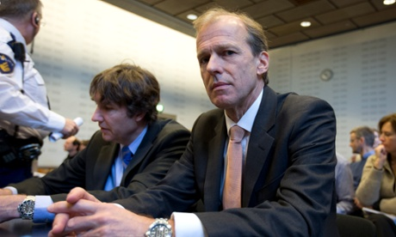

Shedding light on human rights: do businesses stand up to scrutiny?

Read more
Daniel Carey, solicitor at Deighton Pierce Glynn, who supported ADHRB’s case against F1 says campaigners will be keeping a close eye on events in Bahrain this weekend. “Mediation was successful and F1, for the first time has promulgated a human rights policy, which is quite significant given F1’s complete disavowal of any human rights policy in the past,” he says. “We hope to see them carrying out proper human rights due diligence both before they award a race contract to human rights abusing state and also during the term of that contract. ADHRB will be lobbying F1 to keep up their commitment to human rights.”
OECD guidelines provide one of the few means for holding multinational corporations to account. In the UK, complaints can been filed with the department for business, innovation, and skills, which has a team of civil servants dealing with complaints against UK-based companies.
The guidelines have been increasingly used by NGOs looking to hold corporations to account for their activities abroad. In 2013, WWF successfully filed a complaint to prevent British oil company Soco International drilling for oil in Virunga National Park in the Democratic Republic of the Congo (DRC).

- www.adhrb.org ADHRB, (Americans for Democracy & Human Rights in Bahrain) Formula One Reach Agreement on Human Rights Framework for Bahrain. Press Release 10/04/2015
- Press Release
10 April 2015
For Immediate Release
- Following Americans for Democracy & Human Rights in Bahrain’s (ADHRB) successful mediation of a complaint to the United Kingdom National Contact Point for the OECD Guidelines for Multinational Enterprises—concerning Formula One Management’s lack of due diligence considerations regarding possible human rights impact in Bahrain—Formula One has committed itself to respecting human rights in Bahrain and other countries in which it conducts business. ADHRB praises Formula One’s decision to adopt a human rights policy and examine its impact in Bahrain, and thanks the OECD National Contact Point of the United Kingdom of Great Britain and Northern Ireland for their role in the successful mediation process.
- In 2014, ADHRB submitted a complaint to the OECD regarding Formula One’s links to adverse impacts on human rights in Bahrain in relation to its annual race. The UK National Contact Point for the OECD accepted that the complaint merited examination “on issues relating to Formula One World Championship Limited and Formula One Management Limited’s management systems, due diligence, human rights policy and communications with stakeholders and business partners,” and suggested that the parties mediate in order to arrive at a mutually satisfactory solution.
- Following the successful conclusion of those mediation proceedings, Formula One has for the first time in its history publicly committed to respecting internationally recognized human rights in all of its operations. Included in this commitment is a promise to develop and implement a due diligence policy in which Formula One analyzes and takes steps to mitigate any human rights impact that its activities may have on a host country, including on the human rights situation in Bahrain. The new policy represents a significant first step in addressing human rights abuses occurring in Bahrain during the annual Formula One race.
- Playing a key role in the mediation was Nabeel Rajab, member of ADHRB’s advisory board and the President of Bahrain Center for Human Rights. While the mediation process was on going and only two weeks before the 2015 race, authorities in Bahrain detained Mr. Rajab. ADHRB understands that this arrest amounts to a signal that the government will broach no criticism or dissent before or during the race, which has previously attracted significant anti-government protests. ADHRB does not link Formula One Management in any way to the arrest. The US State Department hascalled for his immediate release.
- “Formula One’s development of a human rights policy is a big step forward for the advancement of human rights, both in Bahrain and throughout the world,” said Husain Abdulla, the Executive Director of ADHRB. “We hope that this policy shows the Government of Bahrain that it cannot torture its citizens, that it cannot put down peaceful protests, that it cannot silence dissent without serious and actual repercussions and accountability.”
- ADHRB welcomes the engagement of Formula One during the mediation, and will work to monitor the conduct of Formula One Management in upholding its new human rights policy regarding the human rights impacts in future Bahrain races. ADHRB will continue to scrutinise adverse human rights impacts during events held by Formula One Management in Bahrain, and hold them to account with the standards set in their new human rights policy and internationally recognised human rights law.

- Joint Statement between ADHRB and Formula One Management
- Americans for Democracy & Human Rights in Bahrain (ADHRB) and Formula One entered into mediation in order to discuss the matters raised by ADHRB in its complaint under the OECD Guidelines for Multinational Enterprises (“Guidelines”) to the UK Government’s National Contact Point.
- As a result of that process, Formula One Group has committed to taking a number of further steps to strengthen its processes in relation to human rights in accordance with the standards provided for by the Guidelines. Formula One also takes this opportunity to reaffirm its commitment to respect internationally recognised human rights. Formula One’s written policy commitment to respect human rights is available at http://www.formula1.com/content/fom-website/en/toolbar/legal-notices.html.
- ADHRB has agreed to stop further pursuit of its complaint and stated that it “welcomes this opportunity to engage on human rights issues in Bahrain”.
- Both parties would also like to thank the NCP and mediator for their work on this matter.
- The participants in the mediation on behalf of ADHRB were Husain Abdulla (Executive Director of ADHRB), Nabeel Rajab (ADHRB Advisory Board Member) Ahmed Ali (ADHRB Advisory Board Member) and Sayed Ahmed Alwadaei (ADHRB Board Member).
- Formula 1 & ADHRB – Public Statement re. F1 Bahrain – 10-4-15

