Budgeting using Excel Spreadsheets
You have recently moved into your new flat and you want to be able to manage your income and outgoings easily. This will help you to find out how much money you will have left each month for food and nights out! A simple way of doing this is by using an Excel spreadsheet.

Step 1: Open a new page in Excel and save it as “Home Budgeting spreadsheet”.
Step 2: In cell A3, type in “Income” and press return.
Step 3: In cell C3, type in “Outgoings” and press return.
Step 4: In cell E3, type in “Total” and press return.
Step 5:
Now you need to add in the details of your income, and your outgoing payments. Type in the following information in the following cells:
Income: Outgoings:
A3- Monthly wages C3- Rent
A4- Items sold on Ebay C4- Utilities
A5- Birthday Money C5- Gym
A6- Savings C6- Charity Donation
C7- Phone Bill
C8- Bus Pass
C9- Council Tax
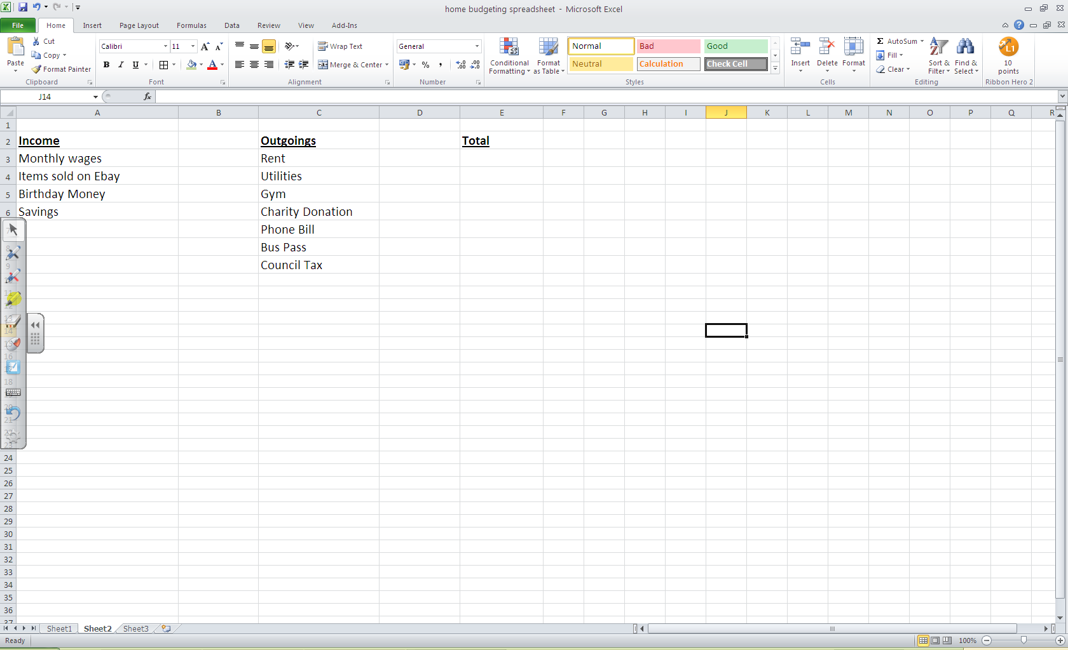
Your spreadsheet should look like this:

Step 6:
Now you need to enter the values of your income and outgoings. First you need to click on the B column at the top of the sheet to highlight the entire column (see below).
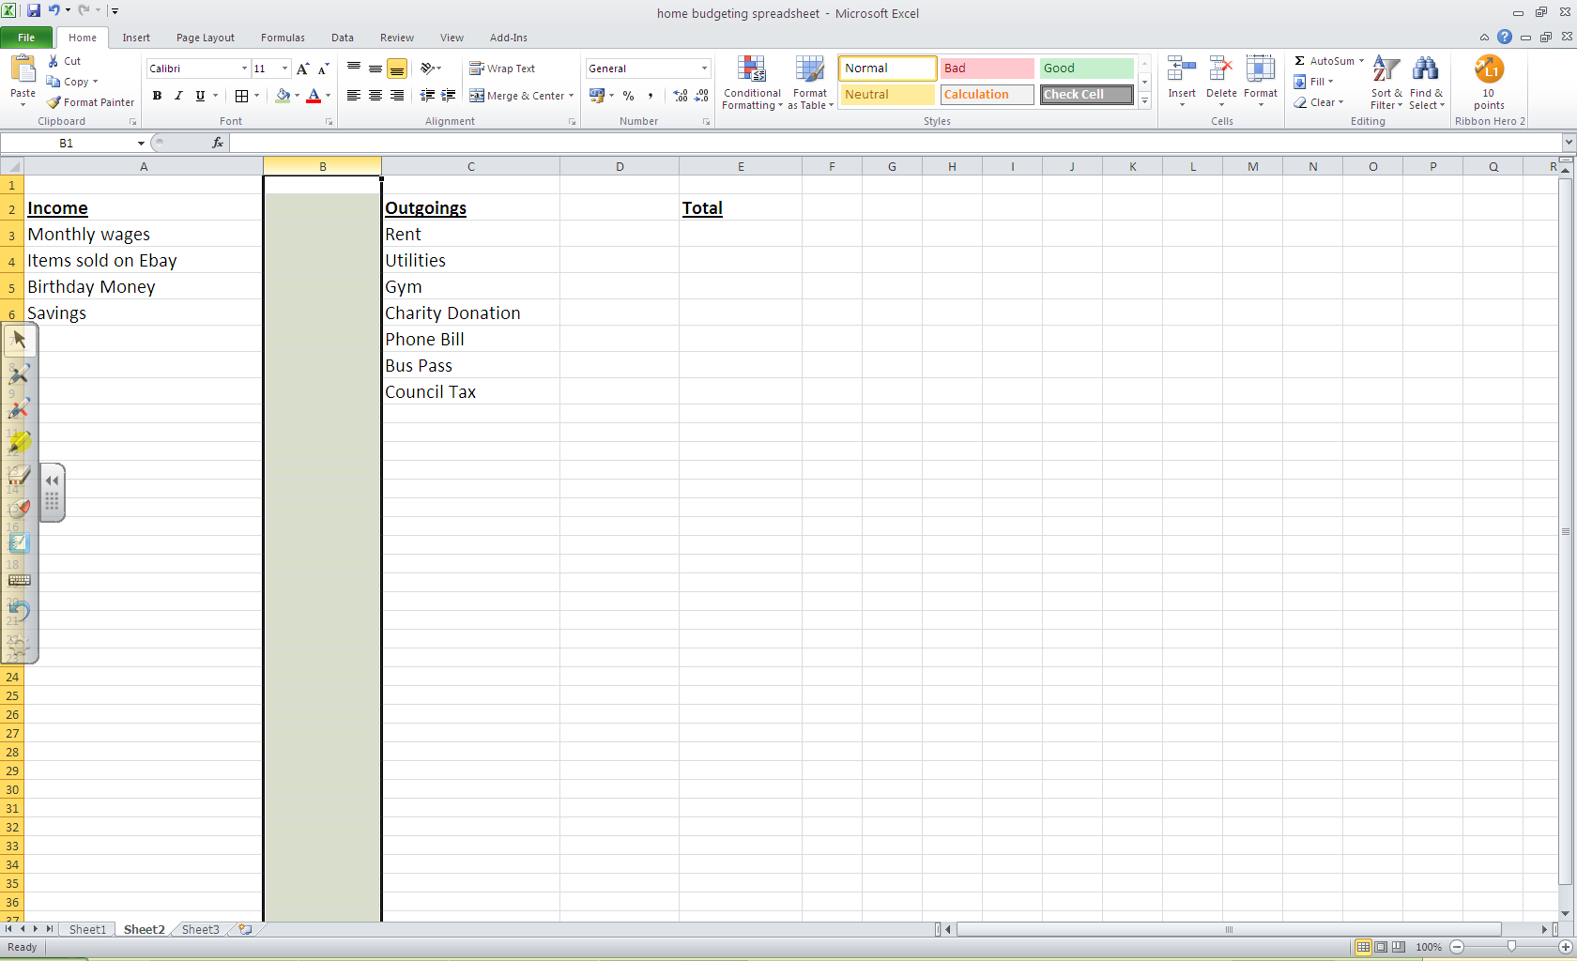

Then you need to change the column to “currency” from Number section on the “Home” bar: 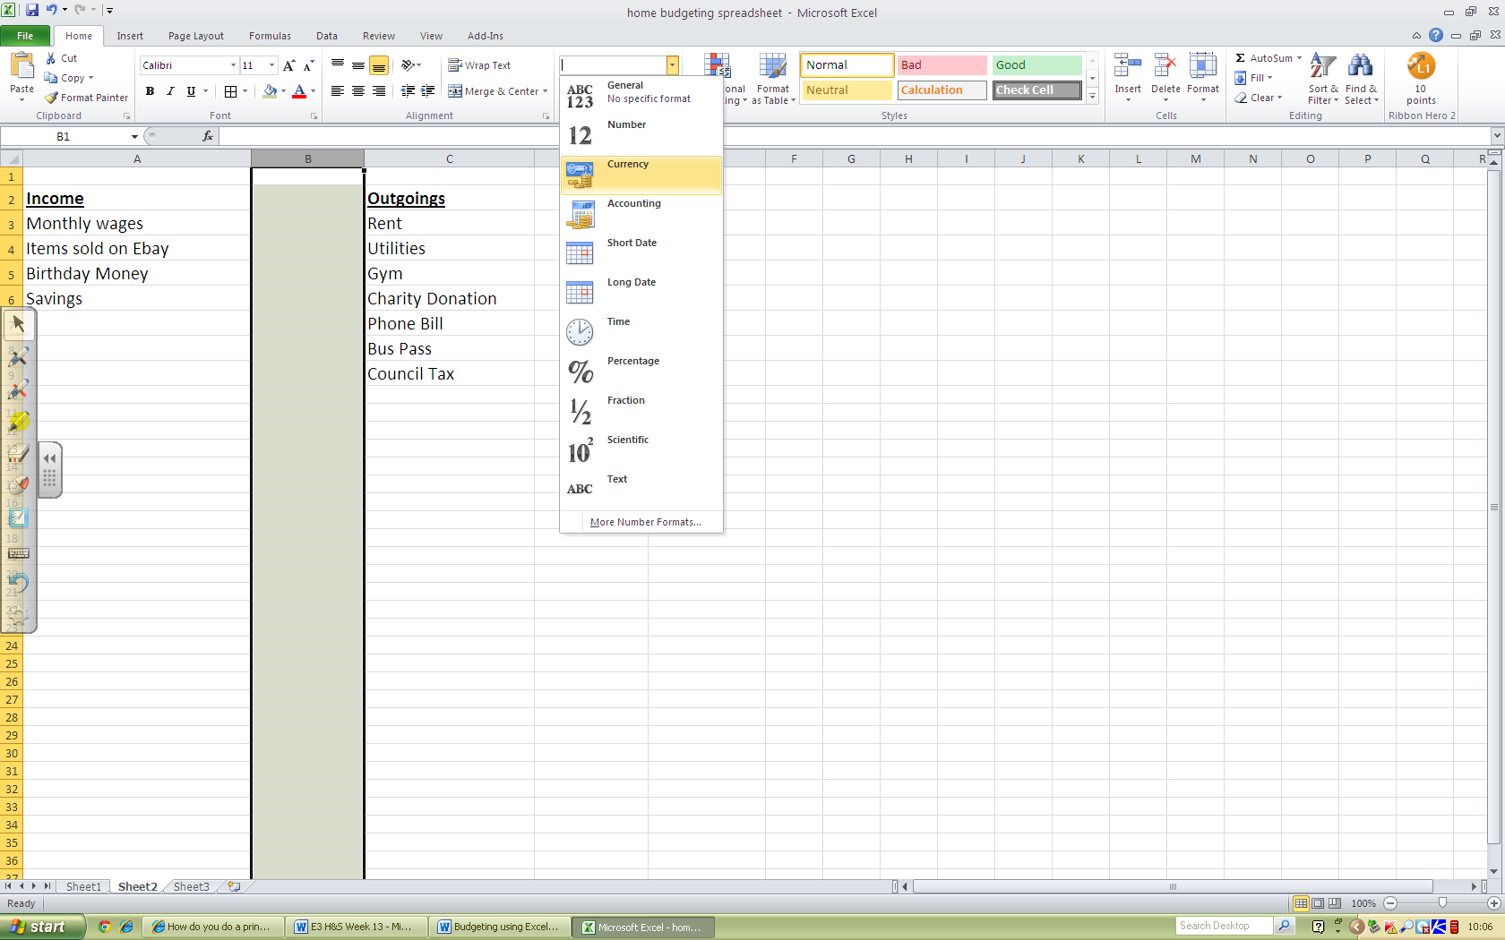
Step 7: Now repeat this step, and set column D and E as currency.
Now that you have done this, Excel will input the £ signs automatically, so you don’t have to!

Step 8: Now input your costings into your spreadsheet. When you press return the pound signs will add automatically.
Income Outgoings
B3- 950 D3- 450
B4- 50 D4- 50
B5- 30 D5- 25
B6- 500 D6- 15
D7- 25
D8- 40
D9- 90

Your spread sheet should now look like this:
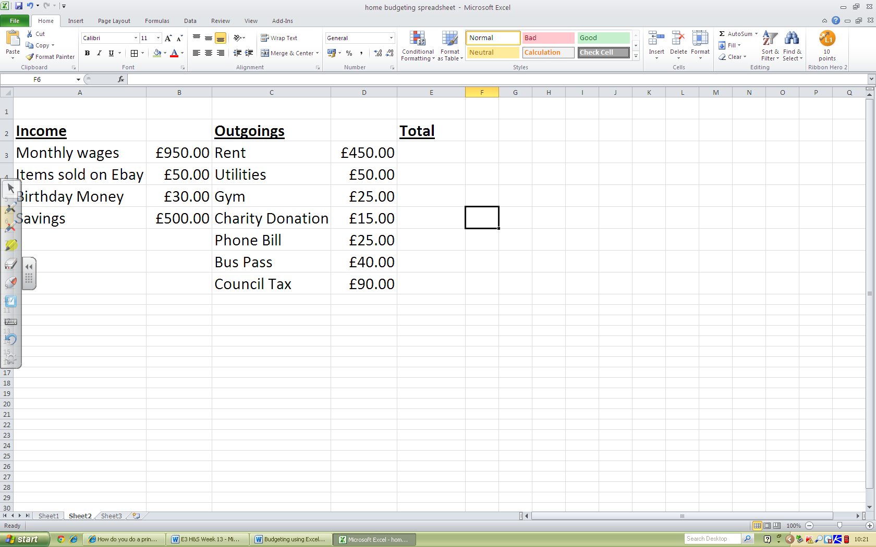
Now you need to add in a formula to calculate your remaining budget.
Step 9: Select cell E4 with your cursor, and then click in formula bar just above your spreadsheet.
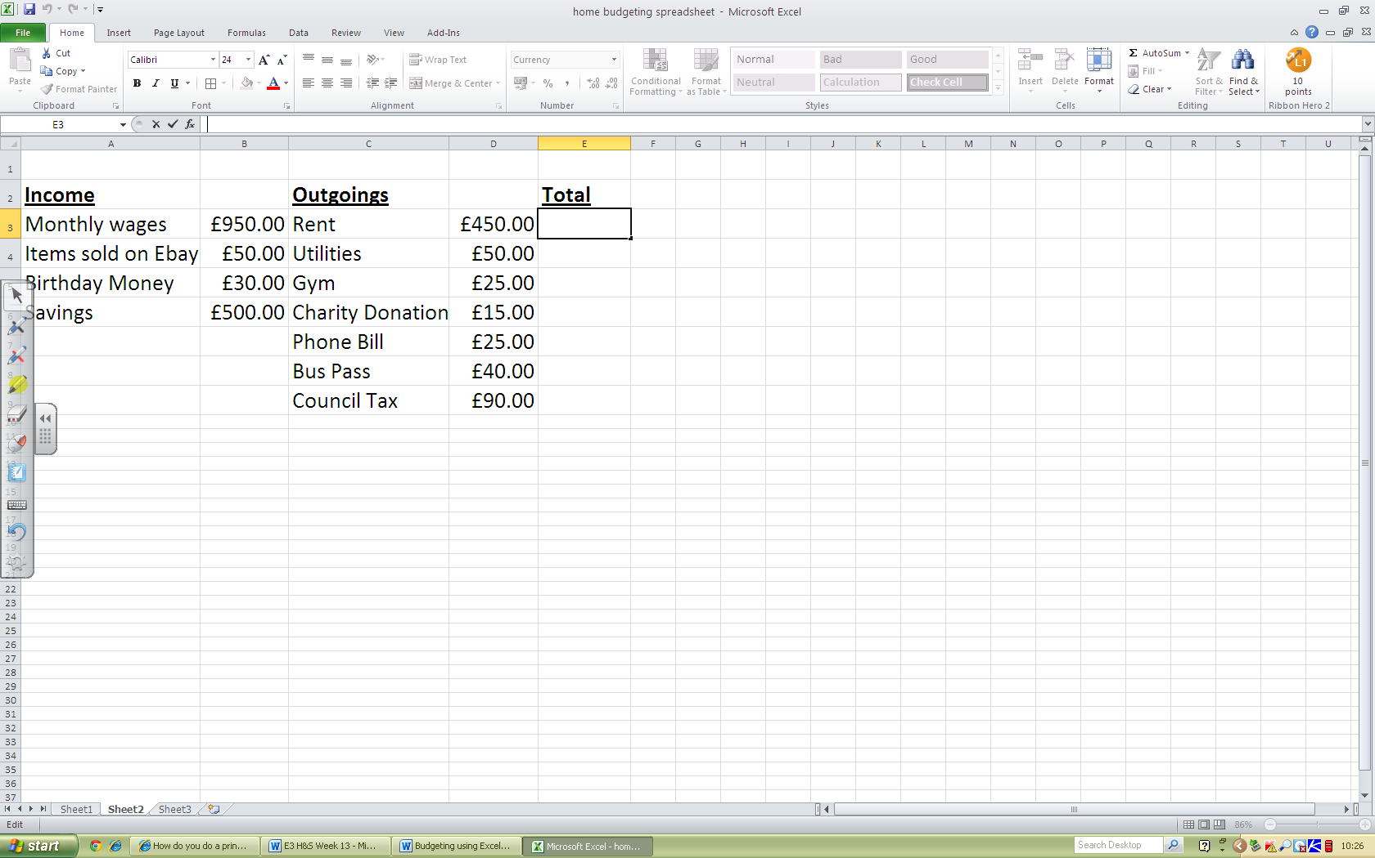
Formula Bar

Step 9A: In the formula bar, you now need to type in the formula that will tell the spreadsheet to add up your income, and subtract your outgoings, which will give you your total amount.
To start your formula, type in = ( and then click on cell B3. The cell should be highlighted and the “B3” should appear in your formula bar.
Now type in a + sign, and then click on cell B4. The cell should also be highlighted and typed into your formula bar.
Keep doing this until you have selected all of income totals, and then put a bracket at the end. Your formula should look like this:
=(B3+B4+B5+B6)
Step 9B: Now you need to tell your spread sheet to subtract your outgoings. Now you need to type in “–“ at the end of your formula, and then repeat the same steps as before, adding up all of your outgoings. Your formula should then look like this.
=(B3+B4+B5+B6)-(D3+D4+D5+D6+D7+D8+D9)

Your spread sheet should look like this:
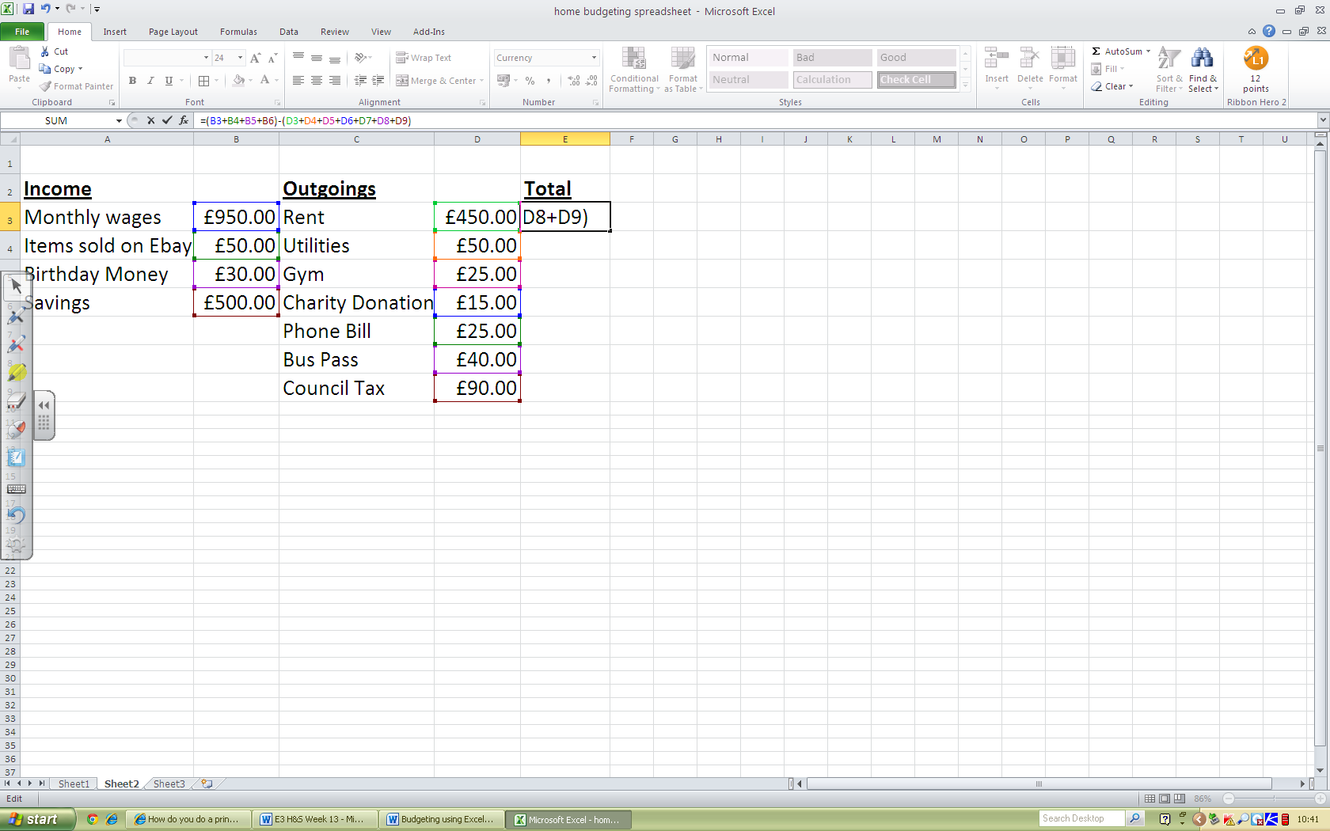

Step 10: Now press return on your keyboard, and your total amount will appear in your “Total” cell. The total should be “£835.00”
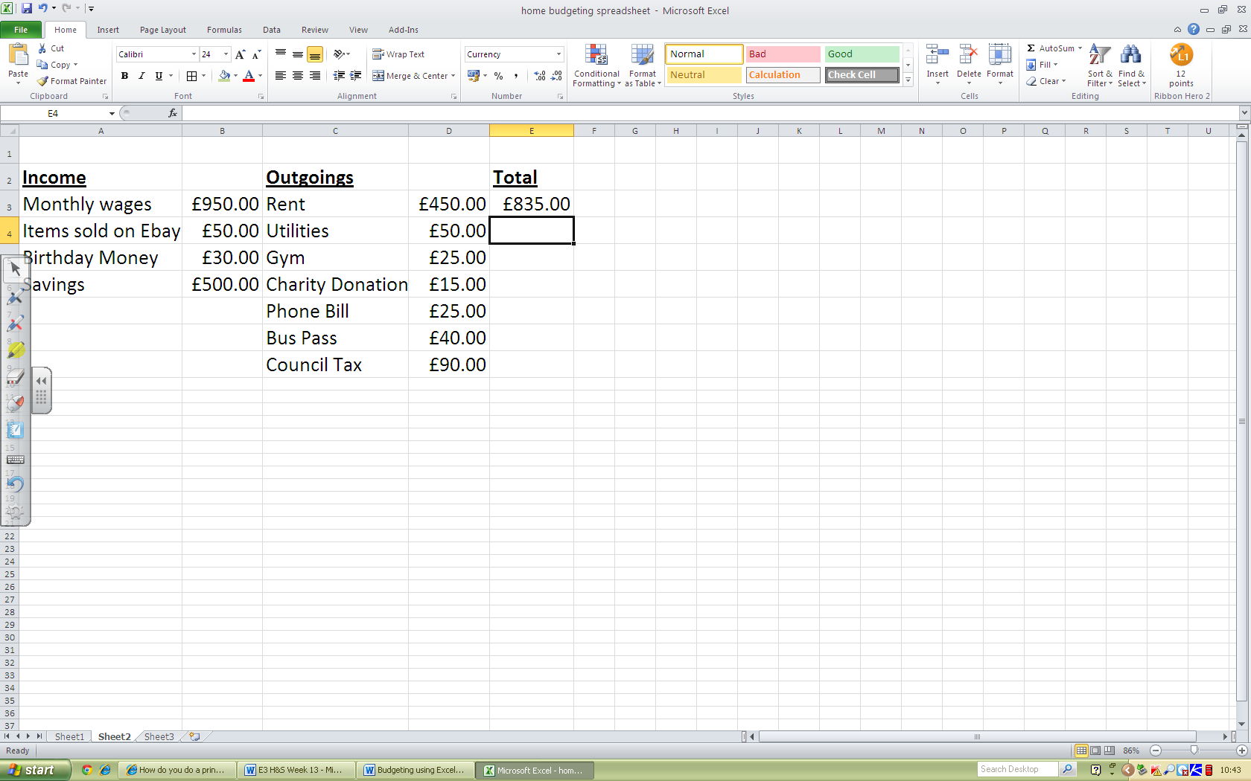

Step 11: Now experiment adding new outgoings or incomes, or you could even add more cells to your formula to make the list longer to add “Food” and “Cinema Trip”.

Step 12: Now add a suitable title bar to your spreadsheet. You could even change the colours etc to make it look nicer. Here is an example:
