Resources for Advanced Global Citizenship
Challenge: Social
Theme: Health
Is society doing enough to care for the social needs of its ageing population?

http://blog.ted.com/what-its-like-to-grow-old-in-different-parts-of-the-world/

What it’s like to grow old, in different parts of the world

Posted by: Liz Jacobs November 25, 2013 at 3:55 pm EDT
At TED2013, Jared Diamond shares some of his research on how different societies treat the elderly. Photo: James Duncan Davidson
The world’s population is getting older. Across the globe, people are living longer thanks to improvements in healthcare, nutrition and technology. This population shift brings with it incredible possibilities, but also a new set of challenges. How do we care for our elderly?
Jared Diamond: How societies can grow old better

In today’s talk, Jared Diamond examines the vast differences in how societies across the globe view and treat their senior citizens. Some groups revere and respect their oldest members, while others see them as senile and incompetent, making them the butt of jokes. In some societies, children care for their parents at home, while in other cultures, children put their parents in homes where others care for them. Some cultures even see their elderly as a burden and resource drain, and opt for more violent approaches to senior care.
The Western system for elder care is far from perfect, notes Diamond, and everyone stands to learn something from how different societies care for their seniors. Watch his talk to hear what he means, and below, read some further insights on how people across the globe treat their old folks.
Who is considered old?
As Diamond mentions in his talk, the perceived value of the elderly is an important factor in determining whether seniors are respected or not. And this may be a function of who is considered old. In the United States a senior citizen is defined as someone who is 65+. But in other parts of the world, like New Guinea, anyone 50 or over is considered lapun, or an old man. As Diamond points out in his book, The World Until Yesterday, this difference has wide implications, as the two age groups tend to have a different set of physical and mental abilities.
The United Nations recently turned its attention to developing policy to support aging populations around the world — and their line for elderly begins at 60. In fact, the UN has started celebrating the International Day of Older Persons in October, which acknowledges the contributions to society made by those over the 60-line.
Where do the elderly live?
The Confucian teaching of filial piety shapes the living arrangements of elderly Chinese, Japanese and Korean people. About ¾ of elderly Japanese parents live with their adult children, a pattern replicated in Korea and China. China’s new Elderly Rights Law mandates that children visit their parents frequently, no matter how far away they live. If children don’t comply, they could face fines or jail time. “We raise our children to take care of us when we get old,” one Chinese senior citizen told the BBC.
But of course, it doesn’t take Confucian ideals to place value on spending time with the elderly. Article 207 of the French Civil Code, which was passed in 2004, requires that adult children “keep in touch” with their elderly parents. The law was passed, according to a recent article in The Week, in response to a study that showed a high rate of elderly suicides in France, and to a heat wave in which 15,000 mostly elderly people died,
In India and Nepal, the tradition has long been: a newlywed couple moves in with the groom’s family, in what’s called a patrilocal living arrangement. But shifting economic forces are reshaping residence patterns, according to the University of Maryland’s India Human Development Survey. As parts of the country urbanize, children are moving hundreds of miles away from their parents. The Indian and Nepalese governments are addressing this by developing state-run elderly care programs.

What words describe the elderly?
A culture’s respect for the elderly is often reflected in its language. Honorific suffixes like –ji in Hindi enable speakers to add an extra level of respect to important people — like Mahatma Gandhi, who is often referred to as Gandhiji. According to Wikipedia, mzee in Kiswahili — spoken in many parts of Africa — is a term used by younger speakers to communicate a high level of respect for elders. And as this report reveals, the Hawaiian wordkūpuna means elders, with the added connotation of knowledge, experience and expertise.
And then there’s the suffix –san in Japanese, which is often used with elders, reveals the nation’s deep veneration for the old. The country regularly holds Respect for the Aged Day, with the media running special features that profile the oldest Japanese citizens. The Japanese also see a person’s 60th birthday as a huge event. Kankrei, as the celebration is called, marks a rite of passage into old age.
What special foods can the elderly eat?
Around the world, a number of traditional societies reserve certain foods for the elderly, Diamond reveals in his book. In Nebraska, only senior members of the Omaha Indians eat bone marrow — they believe that if young men do so, they will sprain an ankle. Similarly, the Iban of Borneo advise that only old men eat venison because, if the young taste it, it could make them timid. In Siberia, the Chukchi believe that reindeer milk will make young men impotent and young women flat-chested, so it’s reserved only for older people.
The group with the strongest food taboos: the Arunta Aboriginies, who live near Ayers Rock in Australia. Eating certain foods can lead to a “series of dire consequences for young people,” as Diamond notes in The World Until Yesterday. The Arunta believe that eating parrots will create a hollow in a young man’s head, and a hole will grow in the chin. If young Arunta men eat wildcat, they will develop painful and smelly sores on their head and neck. According to societal belief, young women who eat kangaroo tails will age prematurely … and go bald. Meanwhile, quail consumption will lead to stunted breast development, and conversely, eating brown hawks will lead the breasts to swell and burst, without even producing milk.
Do the elderly have special powers?
As Diamond mentions in his talk, many elders are respected because of highly specialized skills and knowledge. For example, Hawaiian grandmothers are revered for their unique knowledge and skill at creating ornate leis and feather accessories. Similarly, since an elderly woman in New Guinea was the only person alive who witnessed a devastating typhoon, her people looked to her for guidance on which plants are safe to eat if another disaster were to strike. Even Western societies revere the experience associated with age — the average age for a US President is 54; the average age for a Supreme Court justice is 53.
But certain societies take this a step further and attribute magical powers to the elderly. The Huaorani people of Ecuador believe that elderly shamans, called mengatoi, are endowed with magical powers, according to this Thinkquest article. This society believes that shamans can transform into jaguars. These elderly healers sit with the infirm to channel their animal spirits a cure for disease.
And what does the end of life look like?
End-of-life decisions vary drastically across cultures. Some societies do everything possible to keep their elderly alive. Other groups, however, see old and frail members as a burden, and thus take steps to end their lives. In his talk, Diamond notes that eldercide typically happens in communities that are either nomadic, or that live in harsh climates with limited resources.
According to a study in American Ethnologist, the Chukchi of Siberia practice voluntary death, in which an old person requests to die at the hand of a close relative when they are no longer in good health. And in The World Since Yesterday, Diamond notes that the Crow Indians in the US and Norse tribes in Scandinavia follow similar practices — the elderly put themselves in an impossible situation, like setting out to sea on a solo voyage. Finally, the Ache of Paraguay let their men wander off to die on the “white man’s road,” and — perhaps shockingly to some — they kill elderly women by breaking their necks.
On the flip side, the curious Greek island of Ikaria seems to have life-extending magic in its soil, notes The New York Times. Residents of this small Mediterranean island are four times more likely than their American counterparts to live to 90, and they live on average 8 to 10 years longer after being diagnosed with cancer or cardiovascular disease. Its residents don’t rush through life: they stay up late, eating Kalamata olives, drinking mountain tea and swimming in the crystal-clear water. The answer to this island’s longevity probably lies in its eating patterns and relaxed lifestyle, but nobody can definitively explain the magic behind this island of centenarians.
What are the traditions surrounding old age in your culture?

- http://newsroom.ucla.edu/stories/jared-diamond-on-aging-150571

Honor or abandon: Societies' treatment of elderly intrigues scholar
Judy Lin | January 07, 2010
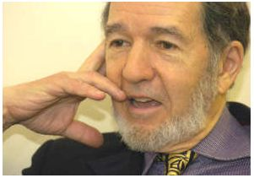
Jared Diamond
When people grow old in traditional villages in Fiji, family and friends care for them at home until their dying days. In America, the elderly are more typically sent to nursing homes — a contrast that may appear unfeeling, even cruel. But the ways in which societies around the world treat their elderly span a vast and varied range, according to Jared Diamond, UCLA professor of geography and physiology.
Why this differs so drastically from culture to culture is an intriguing question that Diamond, 72, a Pulitzer Prize-winning author of “Guns, Germs, and Steel: The Fates of Human Societies” and recipient of a MacArthur Foundation "genius" award, is currently researching. Recently, he shared some of his thoughts on the subject with a standing-room-only audience in the Neuroscience Research Building auditorium in a lecture, "Honor or Abandon: Why Does Treatment of the Elderly Vary so Widely Among Human Societies?”
The idea that it’s human nature for parents to make sacrifices for their children and, in turn, for their grown children to sacrifice for their aging parents — turns out to be a “naïve expectation,” said Diamond. This assumption, he said, ignores undeniable conflicts of interest between generations.

From a common sense perspective, “Parents and children both want a comfortable life — there are limits to the sacrifices that they’ll make for each other.” And from a scientific perspective — natural selection — Diamond noted, “It may under some circumstances be better for children to abandon or kill their parents and for the parents to abandon or kill their children.”

Those circumstances include life’s often heart-wrenching realities — from the threat of starvation among indigenous tribes to the difficult choices posed by modern societies’ life-prolonging medical care, Diamond said.

Traditional nomadic tribes often end up abandoning their elderly during their unrelenting travels. The choice for the healthy and young is to do this or carry the old and infirm on their backs — along with children, weapons and necessities — through perilous territory. Also prone to sacrificing their elderly are societies that suffer periodic famines. Citing a dramatic example, Diamond said Paraguay’s Aché Indians assign certain young men the task of killing old people with an ax or spear, or burying them alive.

“We react with horror at these stories, but upon reflection, what else could they do?” Diamond asked. “The people in these societies are faced with a cruel choice.”

Those of us in modern cultures face cruel choices of our own, he added. “Many of you have already faced or will face a similar ordeal when you are the relative responsible for the medical care of an old person — the one who has to decide whether to halt further medical intervention or whether to administer painkillers and sedatives that will have the side effect of hastening death.”

Yet the fact remains, Diamond said, that many societies treat their elderly better than Americans do. In some cultures, he said, children are so devoted that when their aging parents lose their teeth the children will pre-chew their food. A closer look at how traditional societies value (or don’t value) their old people might teach us what to emulate and what to avoid.

The elderly’s usefulness in a society plays a big part in determining their fate, Diamond said. While old people in traditional societies can no longer spear game or battle enemies, they can still gather food to care for children. They are also often expert at making tools, weapons, baskets and clothes. In many societies they serve as “tribal elders” in medicine, religion and politics.

Perhaps most important, in cultures lacking written records of history, song and other forms of culture, older people are invaluable sources of information.

“The repositories of knowledge are the memories of old people,” Diamond said. “If you don’t have old people to remember what happened 50 years ago, you’ve lost a lot of experience for that society,” from communal history to advice on how to survive a cyclone or other natural disaster.

Societies also vary in how much they respect their old people — or don’t. In East Asian cultures steeped in a Confucian tradition that places a high value on filial piety, obedience and respect, Diamond said, “it is considered utterly despicable not to take care of your elderly parents.” The same goes for Mediterranean cultures, where multigenerational families live together in the same house — in stark contrast to the United States, “where routinely, old people do not live with their children and it’s a big hassle to take care of your parents even if you want to do it.”

While modernization has brought many benefits to the elderly — most notably improved health and longer life spans — it has also led to a breakdown of traditions. For example, multigenerational families are becoming a thing of the past in many modern cities in China, Japan and India, Diamond said, where “today’s young people want privacy, want to go off and have a home of their own.”

In America, Diamond said, a "cult of youth" and emphasis on the virtues of independence, individualism and self-reliance also make life hard on older people as they inevitably lose some of these traits. Then, there's America’s Protestant work ethic, “which holds that if you’re no longer working, you’ve lost the main value that society places on you.” Retirement also means losing social relationships, which, coupled with America’s high mobility, leaves many old people hundreds or even thousands of miles away from longtime friends and family.

Modern literacy and its ties to technology are also putting the elderly at a disadvantage.

“Modern literacy means that we look up things in books or on the Internet — we don’t go ask an old person,” Diamond said. “Formal educational systems, such as UCLA, replace old people with highly trained professors for transmitting specialized knowledge.”

And lightning-speed technological advances “mean that the things that old people do understand got technologically outdated,” Diamond said, adding that his ability to multiply two-digit numbers in his head has now been superseded by pocket calculators. He even admitted to having to consult his teenage sons to use the TV's “remote with 47 buttons on it.”

Still, steps can be taken to improve the lives of our elderly, Diamond said. Understand their changing strengths and weaknesses as they age, he advised, and appreciate their deeper understanding of human relationships and their ability to think across wide-ranging disciplines, to strategize, and share what they’ve learned.

“So if you want to get advice on complicated problems, ask someone who’s 70; don’t ask someone who’s 25,” Diamond concluded. “Old people can have new value … although we often don’t recognize that this is possible.”

His lecture was part of the Molecular Medicine Institute Seminar series

- http://www.huffingtonpost.com/2014/02/25/what-other-cultures-can-teach_n_4834228.html

7 Cultures That Celebrate Aging And Respect Their Elders

Aging isn't just a biological process -- it's also very much a cultural one.
Different cultures have different attitudes and practices around aging and death, and these cultural perspectives can have a huge effect on our experience of getting older.
While many cultures celebrate the aging process and venerate their elders, in Western cultures -- where youth is fetishized and the elderly are commonly removed from the community and relegated to hospitals and nursing homes -- aging can become a shameful experience. Physical signs of human aging tend to be regarded with distaste, and aging is often depicted in a negative light in popular culture, if it is even depicted at all.
"There's so much shame in our culture around aging and death," Koshin Paley Ellison, Buddhist monk and co-founder of the New York Zen Center for Contemplative Care, told the Huffington Post. "People themselves when they're aging feel that there's something wrong with them and they're losing value."
Psychologist Erik Erickson argued that the Western fear of aging keeps us from living full lives. "Lacking a culturally viable ideal of old age, our civilization does not really harbor a concept of the whole of life," he wrote.
Here's what we can learn from other cultures, both past and present, about embracing the aging process.
"Old man" isn't a bad word in Greek.
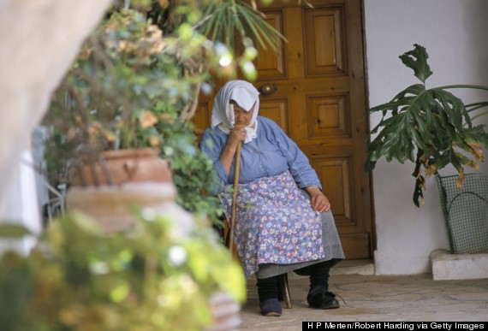
The Western cultural stigma around aging and death doesn't exist in Greece. In Greek and Greek-American culture, old age is honored and celebrated, and respect for elders is central to the family.
Arianna Huffington described an experience of Greek elderly respect in her book, On Becoming Fearless:
"Ten years ago I visited the monastery of Tharri on the island of Rhodes with my children. There, as in all of Greece, abbots are addressed by everyone as 'Geronda,' which means 'old man.' Abbesses are called 'Gerondissa.' Not exactly terms of endearment in my adopted home. The idea of honoring old age, indeed identifying it with wisdom and closeness to God, is in startling contrast to the way we treat aging in America."

Native American elders pass down their knowledge.

Though attitudes towards death in contemporary American culture are largelycharacterized by fear, Native American cultures traditionally accept death as a fact of life.
There are over 500 Native American nations, and each has its own traditions and attitudes toward aging and elderly care. But in many tribal communities, elders are respected for their wisdom and life experiences. Within Native American families, it's common for the elders to be expected to pass down their learnings to younger members of the family, according to the University of Missouri, Kansas City.

In Korea, elders are highly respected.

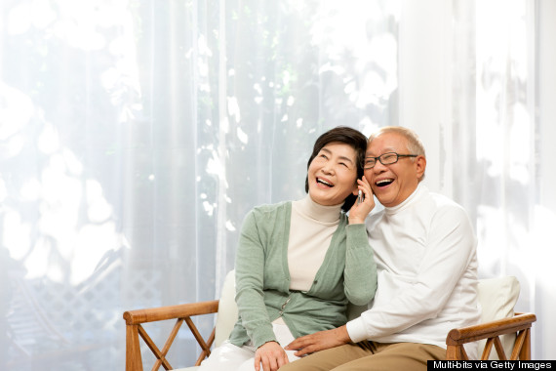
Much of the Korean regard for aging is rooted in the Confucian principle of filial piety, a fundamental value dictating that one must respect one's parents (although Confucius was Chinese, Confucianism has a long history in Korea). Younger members of the family have a duty to care for the aging members of the family. And even outside the family unit, Koreans are socialized to respect and show deference to older individuals as well as authority figures.
"Few of those who are filial sons and respectful brothers will show disrespect to superiors, and there has never been a man who is respectful to superiors and yet creates disorder," Confucius wrote in Analects. "A superior man is devoted to the fundamental. When the root is firmly established, the moral law will grow. Filial piety and brotherly respect are the root of humanity.
It's also customary in Korean to have a big celebration to mark an individual's 60th and 70th birthdays. The hwan-gap, or 60th birthday, is a joyous time when children celebrate their parents' passage into old age. The age is thought to be reason for celebration in part because many of their ancestors would not have survived past the age of 60 without the advances of modern medicine. A similar large family celebration is held for the 70th birthday, known as kohCui ("old and rare").

Chinese children care for their parents in old age.

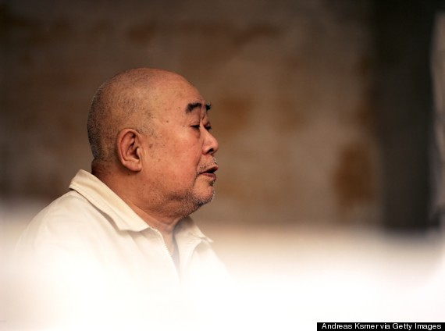
As in Korea, Chinese families traditionally view filial piety and respect for one's elders as the highest virtue, deriving from the Confucian tradition. Although westernizationhas lessened the power of these values in some cities and communities, adult children are still generally expected to care for their parents in their old age.
"Placing your parents in retirement homes will see you labeled as uncaring or a bad son," Beijing resident Zhou Rui told China.org. "To abandon one's family is considered deeply dishonorable."
However, this tradition is beginning to break down in China, due to the country's one-child policy, rising life expectancy and an aging population. Nursing homes are beginning to become a more socially acceptable option for elderly care.

In India, elders are the head of the family.

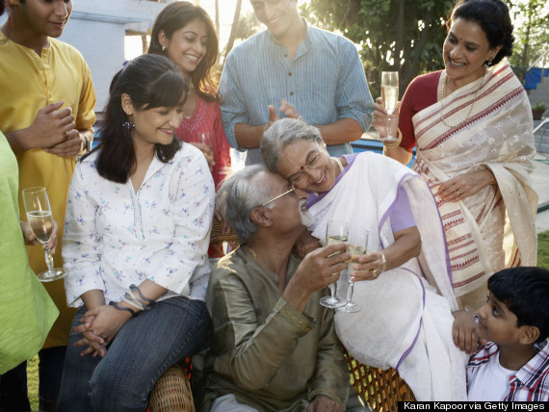
Many Indians live in joint family units, with the elders acting as the head of the household. The elders are supported by the younger members of the family and they in turn play a key role in raising their grandchildren.
"Advice is always sought from them on a range of issues, from investment of family money to nitty-gritties of traditional wedding rituals and intra-family conflicts. And this is not just passive advice; their word is final in settling disputes," Achyut Bihani wrote in Slate. "The elderly are often the most religious and charitable members of the family."
Disrespecting the elders of the family or sending them to an old-age home has a social stigma in India, Bihani adds.

In the African-American community, death is seen as an opportunity to celebrate life.

In African-American culture, death is seen as part of the "natural rhythm of life," which lessens the cultural fear around aging. For this reason, Karen H. Meyers writes in The Truth About Death and Dying, "African-American funerals tend to be life-affirming and to have a celebratory air intermingled with the sorrow."

In ancient Rome, elders were a precious resource.

Though the average life expectancy in ancient Rome was around 25, some individuals did live into their 70s, and they were generally respected for their wisdom.
"The Romans made use of their elderly and had faith in their wisdom and experience,"writes Dr. Karen Cokayne of the University of Reading, quoting Cicero as saying, "For there is assuredly nothing dearer to a man than wisdom, and though age takes away all else, it undoubtedly brings us that."
But Cokayne explains that older individuals had to earn that high status of respect by living a virtuous life.
"Wisdom had to be worked at -- by hard work, study and especially by virtuous living," writes Cokayne. "The old were expected to act with moderation and dignity, at all times. The old had to be an example to the young, as it was thought the young learned by example. This was ingrained in Roman society."

- http://www.debatingeurope.eu/2015/04/07/ready-cope-ageing-europe/#.VUdqbPlViko

Is Europe ready to cope with an ageing population?
- Started 07/04/2015

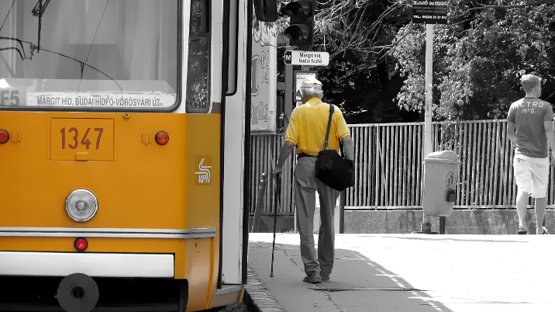
Europe is the only region in the world whose total population is projected to shrink by 2050.The “old continent” is also ageing faster than any other region, with the number of working-age people expected to decline steadily in relation to the elderly population. A recent World Bank reportindicates that this demographic trend is particularly strong in Central Europe and the Baltics, where some countries have already been experiencing a declining population since the 1990s.
According to current trends, some of Europe’s strongest economies – including Germany, Austria, and the Netherlands – could experience severe labour shortages by 2050. The strains on pension and healthcare systems could also increase substantially, as Europeans live longer than ever before.
One of the countries feeling this trend most strongly is Latvia. Due to a combination of low fertility rates and high emigration, Latvia’s population has been shrinking since 1990. Latvia’s former Minister for Health, Ingrida Circene, has argued in an article in Europe’s World that confronting this issue should be one of the top priorities of EU policymakers.
In light of these challenges, our sister think tank, Friends of Europe, convened a Health Working Group in 2013 and 2014 in order to address the much needed changes to Europe’s health systems and policymaking. The final report outlines 21 policy recommendations to improve the health of Europe’s citizens in an evolving Europe.
But what do citizens think? We had a comment sent in by Bastian arguing that, while Europeans are living longer, they won’t necessarily be healthier. Bastian argues that health risks such as obesity are increasing among young people and, in future, Europe’s population could end up older and unhealthier than ever before.
To get a response to Bastian’s concerns, we spoke to Francesca Colombo, Head of the Health Division at the OECD. How would she respond to Bastian?
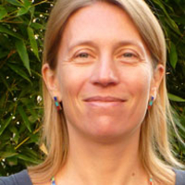
The evidence we have is that, for the moment, people are living longer but in addition they’re also living in better health. So, for example, if we look at the trends for disability among the population, we see that disability among the elderly population is not getting worse, it’s getting better or staying the same.
However, the difficult part is that this applies to the elderly population of today. What happens in the future is pretty much an open question, and Bastian is right – there are some stresses, particularly with growing obesity levels. Obesity is responsible for the growth in certain chronic conditions that tend to kick off more in a middle or old age population. So, there is indeed a question mark over whether we will be able to sustain the gains not just in life expectancy but also in a life free of disabilities because of some of the challenges from the lifestyles of the population.
To get another reaction, we also spoke to Vytenis Andriukaitis, EU Commissioner for Health and Food Safety. Is Bastian’s grim scenario, of Europeans being older and unhealthier than ever before, a realistic assessment of the situation?
Will Europe’s healthcare systems be able to cope with the strain? We had a comment from Nikolai arguing that, given healthcare budgets are being cut in many countries, we may need to reduce expectations about what health systems can deliver:
Ultimately in order to support the aging populations, pensions and medical care et al., which are at the heart of many national systems, there will need to be a young working, tax paying population large enough to support all the elderly living ever longer – unless expectations on the state are reduced.
To get a reaction, we spoke to Kathrin Komp, Assistant Professor at the Population Research Unit of Helsinki University and Chair of the Research Network on Ageing in Europe. How would she respond?
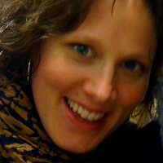
Old people should not automatically be seen as a burden on healthcare systems. Many older people are also healthy and active, so more older people does not necessarily mean more frail people. Also, many old people are also contributing to overall healthcare and social care, because they are looking after their family members, including grandchildren, or looking after their partners who may need help or support. So, many elderly people actually improve the situation in healthcare and social care.
On the other hand, we might also need a different way of looking at healthcare. We might need to put more emphasis on prevention, so we start to support positive living habits in youth or middle age and we don’t bump into those problems when we people are older.
To get another response, we also put Nikolai’s comment to Francesca Colombo, Head of Health Division at the OECD. What would she say?
It’s a very timely question. It’s timely because, obviously there is an economic and financial crisis and all of the countries are facing tough fiscal circumstances, and in some countries they’ve had to cut budgets, including in health. So, obviously, there are more demands on health systems to deliver better value for money, and to deliver better improved outcomes in tough fiscal circumstances.
It’s true that we cannot expect the health budget to continue to grow at the rate it has before the crisis, where health budgets were largely outpacing the growth of the economy. It might be that countries will need to reconsider allocations between health and other parts of the economy. At the same time, spending on health and what health delivers to citizens is something that people value a lot. There is a very strong willingness to pay, and there is a consideration that health is delivering very good results and that investment is worthwhile…
We also put the same question to Vytenis Andriukaitis, EU Commissioner for Health and Food Safety. How would he respond to Nikolai?
Finally, we had a comment sent in by Rita, arguing that more public money should be invested in prevention. At the moment, roughly 3% of total healthcare budgets in Europe are being spent on prevention. Instead of spending more money on hospitals, doctors and pharmaceuticals, should we be investing more in public health campaigns, free exercise structures in parks, more bike lanes, etc? How would Kathrin Komp respond?
I would absolutely agree with her. Because research shows that many of the habits you pick up over your life will influence your situation in old age. Which means that what you do as a child and a young person can already shape your health status in old age.
So, if you want healthier older people then we need to start working towards that goal when people are children or middle aged. We need to encourage people to develop healthy lifestyles and habits, such as doing sports, being outdoors, and maybe also having healthier eating habits. That’s something that needs to start earlier, so I would definitely agree with that.
Are we ready to cope with an ageing Europe? Let us know your thoughts and comments in the form below, and we’ll take them to policymakers and experts for their reactions!

- http://theweek.com/articles/462230/how-elderly-are-treated-around-world
How the elderly are treated around the world
Karina Martinez-Carter

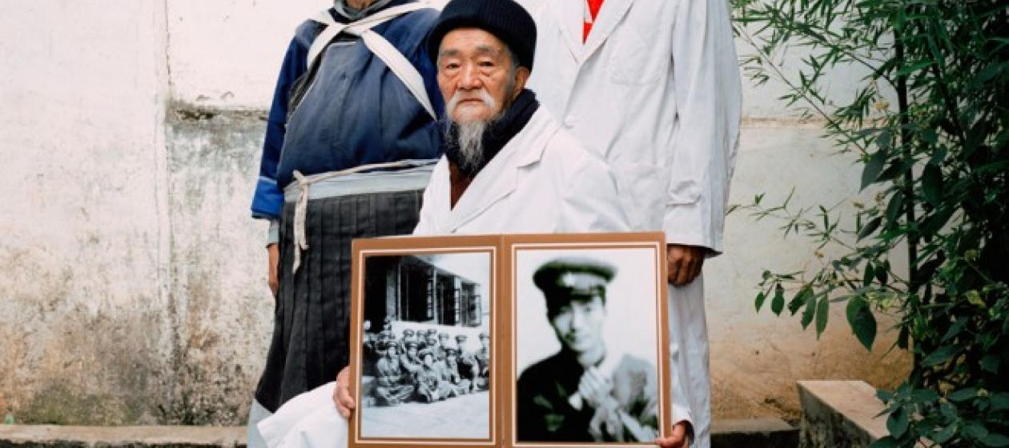
Traditional family bonds in China have been tested by industrialization. Andrew Rowat/Corbis
July 23, 2013
A new "Elderly Rights Law" passed in China wags a finger at adult children, warning them to "never neglect or snub elderly people" and mandating that they visit their elderly parents often, regardless of how far away they live. The law includes enforcement mechanisms, too: Offspring who fail to make such trips to mom and dad face potential punishment ranging from fines to jail time.
If the Elderly Rights Law is any indication, Chinese parent-child relationships have become a bit complicated lately. Eastern cultures like China's adhere to the Confucian tradition of "filial piety," which prioritizes the family unit and values elders with the utmost respect. But China's rapid industrialization has forced people to flock to urban areas for work, causing many adult children to move farther away from their parents, who often remain in rural areas and are unfit to pick up and move.
How cultures view and treat their elderly is closely linked to their most prized values and traits. Here, a sampling of the experience of aging in different cultures around the world:
Korea: Celebrating old age
Not only do Koreans respect the elderly, but they also celebrate them. For Koreans, the 60th and 70th birthdays are prominent life events, which are commemorated with large-scale family parties and feasts. As in Chinese culture, the universal expectation in Korea is that roles reverse once parents age, and that it is an adult child's duty — and an honorable one at that — to care for his or her parents.
Japan: An elderly predicament
Like the Chinese and the Koreans, the Japanese prize filial piety and expect children to dutifully tend to their parents. But Japan also faces the unique problem of tending to an increasingly elderly population. According toSocial Gerontology: A Multidisciplinary Perspective, 7.2 percent of the Japanese population will be 80 or older in 2020 (compared to 4.1 percent in the U.S.), which will likely lead to a host of new problems for the country. Adult diapers are already outselling baby diapers, and the pension system is on course to dry up.
The U.S. and U.K.: Protestantism at play
Western cultures tend to be youth-centric, emphasizing attributes like individualism and independence. This relates back to the Protestant work ethic, which ties an individual's value to his or her ability to work — something that diminishes in old age. Anthropologist Jared Diamond, who has studied the treatment of the elderly across cultures, has said the geriatric in countries like the U.K. and U.S. live "lonely lives separated from their children and lifelong friends." As their health deteriorates, the elderly in these cultures often move to retirement communities, assisted living facilities, and nursing homes.
France: Parents also protected by law
It's difficult to imagine such an Elderly Rights Law being a legislative priority in many Western cultures. France did, however, pass a similar decree in 2004 (Article 207 of the Civil Code) requiring its citizens to keep in touch with their geriatric parents. It was only enacted following two disturbing events, though: One was the publication of statistics revealing France had the highest rate of pensioner suicides in Europe, and the other was the aftermath of a heat wave that killed 15,000 people — most of them elderly, and many of whom had been dead for weeks before they were found.
The Mediterranean and Latin culture: One big, happy family
Mediterranean and Latin cultures place similar priority on the family. In both cultures, it's commonplace for multiple generations to live under one roof, (à la My Big Fat Greek Wedding) sharing a home and all the duties that come with maintaining one. In the contemporary iteration of this living arrangement, the oldest generation often is relied on to assist with caring for the youngest, while the breadwinners labor outside the home. As such, the aged remain thoroughly integrated well into their last days.

- https://sweden.se/society/elderly-care-in-sweden/

ELDERLY CARE IN SWEDEN

Elderly people represent a growing share of the Swedish population. Many are in good health and lead active lives, and most live in their own homes. Sweden invests more of its gross domestic product in its elderly than any other country in the world. As a proportion of GDP, Sweden’s allocation to elderly care is almost five times the EU average.
Photo: Calle Bredberg/Bildarkivet.se

A challenge for our future
Health and social care for the elderly are important parts of Swedish welfare policy. Of Sweden’s 9.7 million inhabitants, 18 per cent have passed the retirement age of 65. This number is projected to rise to 30 per cent by 2030, partly because of the large number of Swedes born in the 1940s.

Largely funded by taxes
Life expectancy in Sweden is among the highest in the world. In 2010, it was 79.1 years for men and 83.2 years for women. Sweden has the second-largest proportion of people aged 80 or over among the EU member states, totaling 5.3 per cent of the population. Since more and more citizens in this age group are in good health, their care requirements have declined since the 1980s. Most elderly care is funded by municipal taxes and government grants. In 2010, the total cost of elderly care in Sweden was SEK 95.9 billion (USD 14.0 billion, EUR 10.7 billion), but only 3 per cent of the cost was financed by patient charges. Health care costs paid by the elderly themselves are subsidised and based on specified rate schedules.

Public or private
More municipalities are choosing to privatise parts of their elderly care, letting private care providers run their operations. In 2011, private care provided services for 18.6 per cent of all elderly people getting home help. All recipients can choose whether they want their home help or special housing to be provided by public or private operators. The municipality always has overall responsibility, however, for areas such as funding and allocating home help or a place in a special housing facility.
The number of private companies in the social-service sector increased fivefold between 1995 and 2005. Recent media investigations have unearthed alarming shortfalls among several private care companies. In subsequent criticism, the companies were accused of letting profit have a negative impact on the standard of care.

LEARN MORE

The right to live together
In 2012, Sweden’s Social Services Act was revised so that elderly people who have lived together for an extended period can continue to do so even when one of them needs to move into supported accommodation.

European year for active aging
The EU proclaimed 2012 as the European Year for Active Ageing and Solidarity between Generations, with the aim of helping establish a culture across Europe of people remaining active into old age. The Swedish Government and agencies launched a range of initiatives on this theme throughout the year. These included strengthening family-member organisations with SEK 2 million in extra funding, distributing SEK 30 million for activities to boost the participation of older people in cultural life, and investing SEK 45 million over three years in a trial program involving health coaches.

How the elderly live
Swedish municipalities planning housing and residential areas are required to ensure that they meet the needs of elderly people and those with disabilities. These accessibility requirements have been given greater prominence in legislation over the years. A growing number of elderly people in Sweden want to live in ‘senior housing’, ordinary homes for people aged 55 and over. In such homes, accessibility is a priority. Some are newly built, while others are regular homes that have been made more accessible as part of conversion or renovation work.
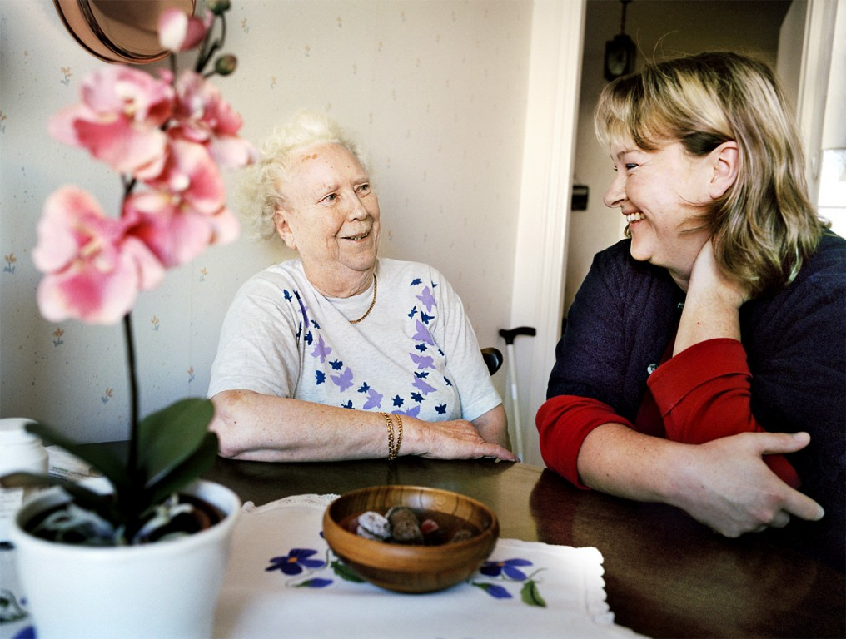
Various forms of support help people continue to live in their own homes.
Photo: Susanne Kronholm/Johnér

Home help makes life easier
One of the aims of elderly care is to help elderly people and those with disabilities live normal, independent lives. This includes living in their own homes as long as possible.
Elderly people who continue to live at home can obtain various kinds of support to make life easier. For example, almost all municipalities in Sweden offer ready-cooked meals that can be home-delivered.
In 2011, home-help staff assisted around 211,000 people aged 65 or over. Almost half of the country’s municipalities also provide communal meals for the elderly at special day centers, while a few organise small groups of elderly people into teams that cook their own meals.

Around the clock
When an elderly person is no longer able to cope with the demands of everyday life, he or she can apply for assistance from municipally funded home-help services. The extent of such care is subject to an assessment of need. Elderly people with disabilities can receive assistance around the clock, which means that many are able to remain at home throughout their lives. The severely ill, too, can be provided with health and social care in their own homes.
Each municipality decides its own rates for elderly care. The cost depends on such factors as the level or type of help provided and the person’s income. A maximum charge for home help, daytime activities and certain other kinds of care has been set since January 1, 2011, at SEK 1,760 per month.
Municipalities offer daytime activities for elderly and disabled people in need of stimulation and rehabilitation. These activities primarily target those with dementia or mental disabilities. Daytime activities help many to continue to live in their homes.

Transportation services
The elderly and disabled also qualify for transportation services in taxis or specially adapted vehicles. This option is available to those who are unable to travel by regular public transport. In 2010, there were 11 million such journeys completed across the country, a national average of 34 per eligible person.

LEARN MORE

SEK 1 billion invested in skills
Elderly care today is more advanced and complicated than in the past. Much of the care and treatment once provided in hospitals is now provided in the home, which makes it essential to have efficient, multi-professional teams capable of working with elderly people and their families. To ensure high standards, the Government is investing a total of SEK 1 billion in additional training programs in 2011-2014 for staff working in elderly care.

Pensioners moving abroad
In 2010, around 223,000 pensioners in more than 194 countries received payments from the Swedish pension system, an increase of more than 25 per cent on 2005. The majority move to other Nordic countries or to Germany, while many are also attracted to the warmer climes of France, Greece and Italy.

Looking after the interests of pensioners
There are several associations that promote the interests of pensioners, of which the National Pensioners’ Organisation (PRO) is the largest. PRO’s mission is to look after the interests of pensioners in respect of various social issues. Other organizations include the Swedish Pensioners’ Association (SPF) and the Swedish Municipal Pensioners’ Association (SKPF).

Red Cross helping the elderly
The Swedish Red Cross’s most extensive operations involve visits to the elderly. Red Cross volunteers visit elderly people living at home or in different kinds of housing. The visits may include a chat, a walk or accompanying someone on a visit to the doctor or hospital. Each year, Red Cross volunteers make around 30,000 visits to the elderly.
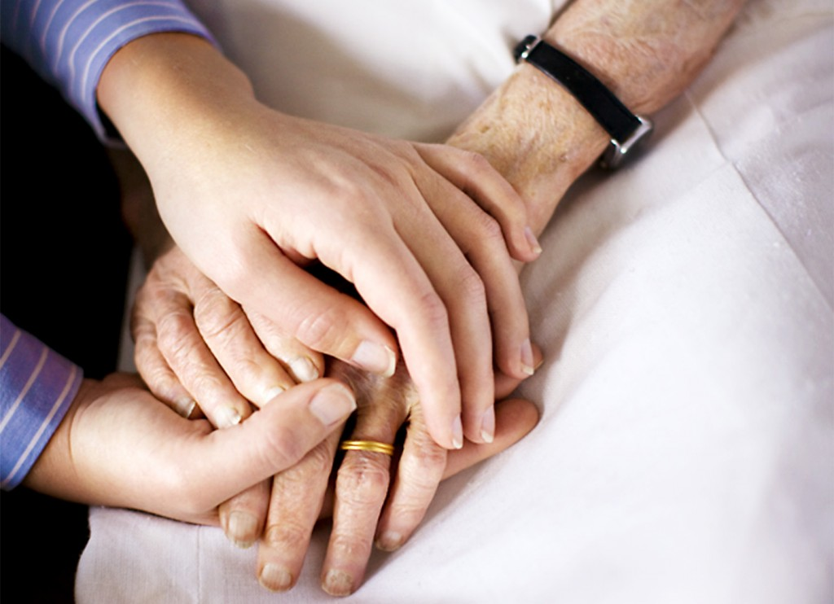
Sweden is preparing itself to take care of an increasing number of elderly people.
Photo: Hans Bjurling/Johnér

The Swedish pension system

All Swedish citizens are entitled to a pension after they retire. People can choose to start receiving their pension between the ages of 61 and 67.
From 2005 to 2011, the number of working Swedes aged 65–74 increased by 49 per cent. The average retirement age today is 64. In Sweden, the average age up to which people feel they will be capable of working in their current job is 64.4 years, the highest in the EU.
There are several different sources that make up a Swedish pension. People who have worked and lived in Sweden will get a national retirement pension based on the income on which they have paid tax. The national retirement pension consists of income pension, premium pension and guarantee pension.
The average national retirement pension in 2012 was SEK 11,428 per month. In addition to the national retirement pension, most people employed in Sweden also get an occupational pension, based on contributions made by their employers.
Altogether, 65 per cent of pensioners’ total income derives from the public pension system. For added security, many choose to supplement their retirement benefits with private pension savings.

National preparations for an ageing population
Like many other countries, Sweden has a growing proportion of elderly people. Elderly care has therefore become increasingly important, and the Government has taken steps to meet future challenges in this area.
In 20 years’ time, one Swede in four will be over 65, and most of the people in this age group will be active and healthy. Several initiatives aimed at meeting future needs are now being put in place around the country.
- The Government has appointed a Commission on the Futurewhose task is to present the latest strategies for dealing with four specified social challenges facing Sweden in the years ahead. One of these is the country’s ageing population.
- To meet the coming demographic challenge without jeopardising welfare levels, people will have to work longer. An inquiry has begun analysing pension-related age limits and the potential obstacles to a longer working life, with a final report due in April 2013.
- The Government is investing SEK 4.3 billion up to 2014 in measures to improve health and social care for the most infirm members of the 65+ age group. The aim is to improve coordination of home health care, elderly care, hospital care and health-center care provided to elderly people.
Many elderly people continue to lead active lives.
Photo: Niklas Bernstone/Johnér

Preventive care keeps older people healthier
Several new forms of effective preventive health care for the elderly have been introduced in recent years, and are attracting increasing levels of interest.
One example is physical activity on prescription, both for preventive purposes and as a form of treatment. Older people are prescribed not just exercise in general but a certain type of physical activity, sometimes in combination with medication, with doctors monitoring the results.
Personal injury is one of the main health problems among older people, so considerable efforts are made to reduce injuries from falls. Information is made available to the elderly, and special municipal ‘fixers’ help with things like curtain-hanging and changing light bulbs in the home.
Stimulation through music, films, reading, painting and other cultural activities also plays a role in well-being. This is increasingly recognised in elderly care homes where many people engage in at least one such activity every day.

- http://www.theguardian.com/world/2012/dec/26/german-elderly-foreign-care-homes

Germany 'exporting' old and sick to foreign care homes
Pensioners are being sent to care homes in eastern Europe and Asia in an austerity move dismissed as 'inhumane deportation'
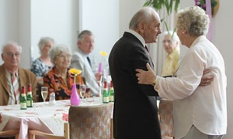
German pensioners in Berlin. Many elderly Germans are increasingly being sent to cheaper retirement and long-term care accommodation in eastern Europe and Asia, as the care industry finds itself financially unable to meet the needs of Europe's ageing populations. Photograph: Sean Gallup/Getty Images
Kate Connolly in Berlin
Wednesday 26 December 201216.37 GMTLast modified on Wednesday 4 June 201405.51 BST
Growing numbers of elderly and sick Germans are being sent overseas for long-term care in retirement and rehabilitation centres because of rising costs and falling standards in Germany.
The move, which has seen thousands of retired Germans rehoused in homes in eastern Europe and Asia, has been severely criticised by social welfare organisations who have called it "inhumane deportation".
But with increasing numbers of Germans unable to afford the growing costs of retirement homes, and an ageing and shrinking population, the number expected to be sent abroad in the next few years is only likely to rise. Experts describe it as a "time bomb".
Germany's chronic care crisis – the care industry suffers from lack of workers and soaring costs – has for years been mitigated by eastern Europeans migrating to Germany in growing numbers to care for the country's elderly.
But the transfer of old people to eastern Europe is being seen as a new and desperate departure, indicating that even with imported, cheaper workers, the system is unworkable.
Germany has one of the fastest-ageing populations in the world, and the movement here has implications for other western countries, including Britain, particularly amid fears that austerity measures and rising care costs are potentially undermining standards of residential care.
The Sozialverband Deutschland (VdK), a German socio-political advisory group, said the fact that growing numbers of Germans were unable to afford the costs of a retirement home in their own country sent a huge "alarm signal". It has called for political intervention.
"We simply cannot let those people who built Germany up to be what it is, who put their backbones into it all their lives, be deported," said VdK's president, Ulrike Mascher. "It is inhumane."
Researchers found an estimated 7,146 German pensioners living in retirement homes in Hungary in 2011. More than 3,000 had been sent to homes in the Czech Republic, and there were more than 600 in Slovakia. There are also unknown numbers in Spain, Greece and Ukraine. Thailand and the Philippines are also attracting increasing numbers.
The Guardian spoke to retired Germans and people needing long-term care living in homes in Hungary, Thailand and Greece, some of whom said that they were there out of choice, because the costs were lower – on average between a third and two-thirds of the price in Germany – and because of what they perceived as better standards of care.
But others were evidently there reluctantly.
The Guardian also found a variety of healthcare providers were in the process of building or just about to open homes overseas dedicated to the care of elderly Germans in what is clearly perceived in the industry to be a growing and highly profitable market.
According to Germany's federal bureau of statistics, more than 400,000 senior citizens are currently unable to afford a German retirement home, a figure that is growing by around 5% a year.
The reasons are rising care home costs – which average between €2,900 and €3,400 (£2,700) a month, stagnating pensions, and the fact that people are more likely to need care as they get older.
As a result, the Krankenkassen or statutory insurers that make up Germany's state insurance system are openly discussing how to make care in foreign retirement homes into a long-term workable financial model.
In Asia, and eastern and southern Europe, care workers' pay and other expenses such as laundry, maintenance and not least land and building costs, are often much lower.
Today, European Union law prevents state insurers from signing contracts directly with overseas homes, but that is likely to change as legislators are forced to find ways to respond to Europe's ageing population.
The lack of legislation has not stopped retired people or their families from opting for foreign homes if their pensions could cover the costs.
But critics of the move have voiced particular worries about patients with dementia, amid concern that they are being sent abroad on the basis that they will not know the difference.
Sabine Jansen, head of Germany's Alzheimer Society, said that surroundings and language were often of paramount importance to those with dementia looking to cling to their identity.
"In particular, people with dementia can find it difficult to orientate themselves in a wholly other culture with a completely different language, because they're very much living in an old world consisting of their earlier memories," she said.
With Germany's population expected to shrink from almost 82 million to about 69 million by 2050, one in every 15 – about 4.7 million people – are expected to be in need of care, meaning the problem of provision is only likely to worsen.
Willi Zylajew, an MP with the conservative Christian Democrats and a care service specialist, said it would be increasingly necessary to consider foreign care.
"Considering the imminent crisis, it would be judicious to at least start thinking about alternative forms of care for the elderly," he said.
Christel Bienstein, a nursing scientist from the University of Witten/Herdecke, said many German care homes had reached breaking point due to lack of staff, and that care standards had dropped as a result.
"On average each patient is given only around 53 minutes of individual care every day, including feeding them," she said. "Often there are 40 to 60 residents being looked after by just one carer."
Artur Frank, the owner of Senior Palace, which finds care homes for Germans in Slovakia, said that was why it was wrong to suggest senior citizens were being "deported" abroad, as the VdK described it.
"They are not being deported or expelled," he said. "Many are here of their own free will, and these are the results of sensible decisions by their families who know they will be better off."
He said he had seen "plenty of examples of bad care" in German homes among the 50 pensioners for whom he had already found homes in Slovakia.
"There was one woman who had hardly been given anything to eat or drink, and in Slovakia they had to teach her how to swallow again," he said.
German politicians have shied away from dealing with the subject, largely due to fears of a voter backlash if Germany's state insurers are seen to be financing care workers abroad to the detriment of the domestic care industry.

- http://blogs.redcross.org.uk/health/2015/01/people-scared-growing-older/

WHY PEOPLE ARE SCARED OF GROWING OLDER
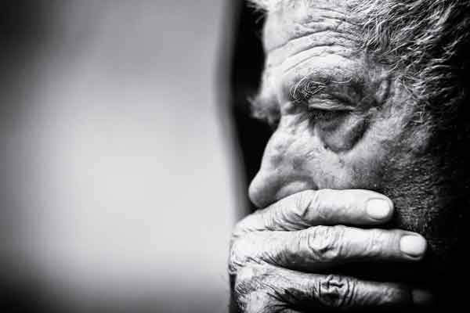Our elderly population is on the rise, and increasingly depends on the charity sector for support – so the government needs to stop taking us for granted.
So much for peace of mind and tranquillity in one’s twilight years.
A major new study, commissioned by 75 organisations (including the British Red Cross), shows that one person in four is worried about receiving proper care in their old age.
It doesn’t take a genius to work out why. News bulletins show elder abuse in care homes, bed-blocking, MRSA, over-stretched A&E departments – all against a backdrop of government cuts.
Big demands
But bad as things are in the NHS, it’s the social care system that’s really starting to buckle under the weight of ever-increasing expectations.
A combination of budget cuts and a rapidly growing elderly population has effectively wiped out a quarter – yes, a quarter – of local authorities’ care budgets throughout England in just four years.
The specific figures are disturbing. Since 2010, social care spending has fallen by 12 per cent. Meanwhile, the number of those needing support has increased by 14 per cent. Whichever way you do the math, that’s not sustainable.
But this is the reality that the British Red Cross has to tackle every day. As one of the UK’s leading voluntary social care providers, we’ve seen a huge ramp-up in demand for our services in recent years.
Black holes
Across the UK, the Red Cross currently holds contracts with numerous local authorities and clinical bodies. Our speciality is offering low-level support that helps people at home following a hospital stay (or ideally, precludes the need for one in the first place).
Now, you might be surprised to learn that a charity is involved with this kind of work, but there’s a very good reason.
You see, we work right in the midst of two of the country’s biggest bureaucracies – the NHS and the social care system – where there’s a major problem. Namely, vulnerable people keep falling into administrative black holes at the transition point between the two.
This is where the Red Cross proves so invaluable. By acting as a kind of ‘glue’ between the two systems, we keep the links intact. We ensure that, for example, the 84-year-old pensioner discharged from hospital late on Friday afternoon won’t be left alone without care until Monday morning.
Every day, our staff and volunteers make scores of such small-scale interventions. And for people with no-one else to count on, they make a big difference.
‘Bespoke’ care
Our services also bring many specific benefits – a really good standard of personalised care, for one. To take a common example: when someone’s recovering from an illness, a statutory provider will generally go out and get their food shopping.
By contrast, a Red Cross volunteer will do the person’s shopping the first time, but then encourage them to take the lead on future trips. Why? Because that will help them grow stronger and regain their confidence. Sure, it takes longer, but we think it’s worth the effort.
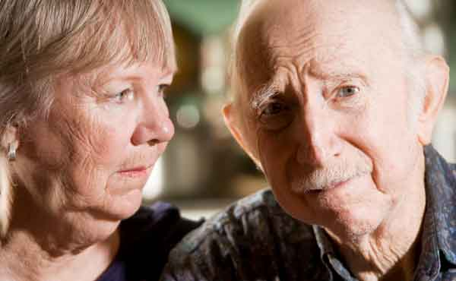
This ‘bespoke’ care has yet another knock-on effect – it puts pressure on statutory providers to do more. Much as a homeowner might ruefully look at his neighbour’s pristine front garden and get out the lawn mower, the Red Cross’ positive example encourages others to raise their own game.
Also, it goes without saying, we work on a not-for-profit basis. In a nutshell, this is why the Red Cross is involved in social care contracts – to ensure vulnerable people get proper care that takes their dignity and personal needs into account.
Government cuts
But there’s a problem. Year on year, as swingeing cuts start to bite, we’re being asked to help more and more people for less and less money until our capacity is stretched to breaking point. (“To deliver a Harrods service for an Aldi price”, as one charity wag put it.)
Of course, local authorities want to provide the best possible service for vulnerable people, but cuts mean their expectations of what can be delivered – and for how much – have become increasingly unrealistic.
And when our volunteers start struggling to meet demand, then that high standard of care focussed on each individual’s needs – the reason we’re doing this in the first place – inevitably suffers.
This is a dilemma that the Red Cross, and many other volunteer organisations, currently face. On the one hand, we’re determined not to stand by while someone in crisis suffers. Helping such people is hardwired into our DNA: it’s why we exist.
But there’s a nagging question that’s causing many a furrowed brow throughout the voluntary sector just now: at which point does helping statutory providers reach vulnerable people end, and papering over the cracks of government cuts begin?
Think about it. If the Red Cross keeps on striving to meet excessive – and sometimes impossible – demands, there’s only one logical end-point. We’ll eventually become little more than an unpaid government subsidiary plugging gaps caused by under-funding.
This isn’t nearly as far-fetched as it might sound. You might not know this, but the NHS already depends on the Red Cross to manage short-term wheelchair loans on a national basis.
And now it seems we’re gradually being pushed into accepting a bigger slice of the social care pie as well.
‘Sticking plaster’
Following the latest cuts to health and social care budgets, local authorities are desperate for help from the voluntary sector – and who can blame them?
Faced with huge holes in their bank balances, they’ll take whatever is on offer. But voluntary organisations need to tread very carefully here.
The Red Cross, in particular, has far too many other priorities both in the UK and overseas to get bogged down in this particular quagmire.
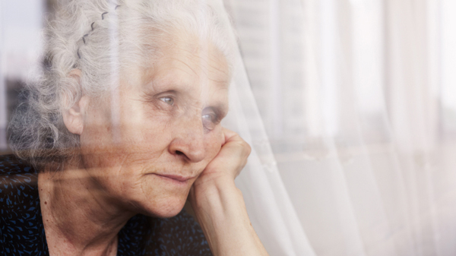
Indeed, we’re only doing so much work in this area now because we see the whole system failing – badly, in places – and won’t just stand idly by and watch. But news reports last week promised even more cuts on the way. Eventually, something will have to give.
At the moment, the Red Cross and other voluntary organisations act like a sticking plaster, helping to hold the whole crumbling edifice together.(Although we mustn’t forget the huge role played by unpaid carers, who collectively give millions of hours every week to look after loved ones.)
According to the Kings Fund, there are currently around three million health and social care volunteers across England. Imagine if all of them spontaneously decided to find another interest tomorrow? It’s a scary prospect.
Action needed
Which brings us back to our starting point: just why are thousands of people across the UK scared of growing older? They’re not paranoid, just realistic. They see a creaking social care system struggling to accommodate a growing elderly population and wonder what might be waiting for them further down the line.
Currently, it feels like we’re all stuck in a leaky lifeboat with a bucket that just isn’t quite big enough to scoop out the water as it comes in.
Slowly, almost imperceptibly, we’re taking on water and sinking. And now the government has told us we’ll have to use a smaller bucket. People are right to be worried.
Ultimately, the only way to truly tackle this social care crisis is through a decently funded government response. As one newspaper commentator recently said: “Charities may be dealing with the consequences, but this is a problem only politics can solve.”
Make no mistake: the Red Cross is ready to help – but our role should be to complement the statutory sector’s work, not subsidise it.
The government needs us. So it needs to stop taking us for granted.

- http://www.ageuk.org.uk/documents/en-gb/for-professionals/evidence_review_loneliness_and_isolation.pdf?dtrk=true
- https://www.gov.uk/government/policies/improving-opportunities-for-older-people
- http://www.theguardian.com/society/2014/aug/06/ageing-well-whose-responsibility
- http://www.cbsnews.com/news/china-law-brings-attention-to-pros-cons-of-caring-for-aging-parent/
- http://www.theguardian.com/commentisfree/2013/jul/15/china-grey-tide-elderly-people

China's unfeasible plan for the 'grey tide': force people to visit their parents
Lijia Zhang
The growing number of elderly Chinese people is a demographic timebomb that won't be defused by a new law passed this month
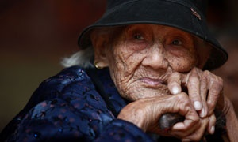
Liu Yuhua, a 104-year-old, rests at the Huangzhu village of Jinjiang township Photograph: China Photos/Getty Images
Monday 15 July 2013 14.08 BSTLast modified on Thursday 22 May 201401.40 BST
My grandma endured war, famine and other hardships in her 83 years of life. Yet by the time she died, some 15 years ago, she regarded herself a lucky and happy woman, because she had been living with three generations of her family – what the elderly regard as the greatest fortune. She raised me and my siblings and was well taken care of in her old age.
In today's China, I don't know how many of the 185 million old people – referring to those aged over 60 – can share my grandma's fortune. The rapid economic development, the urbanisation, the much smaller family sizes and a more mobile society have loosened family ties and broken the traditional system of old-age care.
The findings of the China health and retirement longitudinal study of Peking University, released in May, indicate that only 38% of the old people in China share the same roof with their offspring. Millions of farmers have left their poverty-stricken villages in search of a better life in the city; the educated urban dwellers also move away in droves to wherever jobs or opportunities take them. Young people prefer to set up their own homes, even if they live in the same city as their parents.
In response to the ever louder complaints by ageing parents of being abandoned, China this month introduced a new law, "the protection of the rights and interests of elderly people", which demands that adult children visit their parents often as well as offering emotional support. As a centrally powered government, China readily takes up the legal weapon to cope with its issues. But I am not sure this law can work effectively.
Filial piety, once a cherished virtue, is now taking a back seat in China's increasingly individualist society. And the faster pace of life and the higher work pressure make it harder for the children to spare some time for their parents. Yet it is a moral and a private issue. It is debatable if the authorities can just interfere by introducing a law.
In some cases, it is simply a question of feasibility. Many migrants can only afford the time and money to visit home once a year, usually during the lunar new year, the occasion for family reunion.
In the face of the vastness of China's ageing population problem – more severe than any other country in the world – the enacting of the law feels to me like trying to put out a fire with a glass of water. A massive grey tidal wave will soon hit China. The number of old people will leap from 185 to 478 million by 2053, according to the China national committee on ageing. It means that 35% of the total population will enter the so-called "grey tide", compared with the 20% of the world average. The startling percentage stems from the combination of the dramatic demographic change, caused by the family planning policy which was introduced in 1979, and a considerable increase in life span – from 41 to 73 over the past five decades.
Xiao Jinming, a law professor at Shandong University, who took part in the drafting of the law, was quoted as saying that it is primarily aimed at raising awareness of the old people's jing shen xu qiu – translated as "mental need" or "spiritual need".
When I called my mother and asked for her take on this mental need of elderly people, she said: "Old people often feel lonely and empty in their empty nests and sometimes feel abandoned if they hear nothing from their children." She added that if her children can visit her when they can, call a couple of times every month and send her postcards when they travel – anything that makes her feel that they care – then her emotional needs are fulfilled.
My parents live alone in my hometown Nanjing. I myself have long migrated to the capital. Every year, I make the 1000km journey home (actually only four hours by the speed train) about half a dozen times, dutifully and slightly grudgingly (given half a chance, mother would nag me to find a husband and a proper job). Luckily, my sister and brother live nearby and pop over frequently.
In the next 10 to 15 years, people reaching old age will have fewer children as the family planning policy bears its fruit. The demographic trends will cause increasing constraints to the family-centreed old age support system. The government will have to invest vigorously to improve its poor social provisions for the elderly, building affordable retirement homes, expanding the rural pension programme and offering subsidised, if not free, medical care for the old. To combat China's grave task of caring for the grey population, a joint effort by the government, society, family and individuals is needed. Otherwise, millions of old people will face a bleak future of poverty and loneliness.

- http://www.bbc.co.uk/news/world-asia-china-23124345
- http://www.npr.org/blogs/parallels/2013/10/01/227876034/ethical-tradition-meets-economics-in-an-aging-china

