Resources for Advanced Global Citizenship
Challenge: Technology
Theme: Natural Environment
How can technology help reduce the impact of natural disasters?

- http://www.nationmultimedia.com/technology/How-technology-can-help-reduce-the-impact-of-natur-30235813.html
How technology can help reduce the impact of natural disasters
Gianluca Lange
June 10, 2014 1:00 am
Short-sighted design is at the root of much of the destruction caused by environmental crises, whether it is flooding, earthquakes, tsunamis or other natural disasters. Buildings and critical infrastructure have started failing because they were not designed to withstand the rising intensity of Mother Nature.
Even though Thailand has a good geographical location and does not face terrible disasters like its neighbours, it was recently hit by one of the worst earthquakes in the North, which left many buildings, roads and significant sites badly damaged.
The 6.3-magnitude quake and its 700 or so aftershocks killed two people in Chiang Rai's Mae Lao district and injured 20. The earthquake was so strong that it could be felt in certain high rises in Bangkok. The Bangkok Fire and Rescue Department said more than 100 buildings in the capital faced the risk of catching fire because they had not been designed to withstand earthquakes.
However, technology can provide governments, planners and engineers with essential information, offering a better way to predict behaviour of buildings during a natural crisis. In effect, advanced technology provides a proactive method to more effectively create disaster-resistant communities.
Needless to say, it is necessary for the authorities to find new ways to prevent and reduce earthquake damage. This includes the development of infrastructure and long-term maintenance and preparedness in the event of a disaster.
Technology available today can converge architectural, engineering design and geo-spatial data. Cities have the capability to use precise geo-spatial data and apply it across the entire infrastructure, including operations and maintenance. This integration has enabled significant changes to be put in place to address town planning and management needs.
The creation of virtual city-wide 3D models can help owners, builders, architects, engineers and even the public understand how and where to prioritise restoration efforts in the wake of a disaster, so repairs can be made as quickly as possible. This is particularly relevant for damaged utility networks, whose "up-and-running" status is essential for life and business to return to normal. Furthermore, this model can be used to more effectively plan the city's future buildings.
In this case, if officialdom used digital model on the entire city, it will include both above and underground infrastructure. It will be accessible to city planners, surveyors, engineers, public works and others who may need it and helps indicate where the best areas are for future development.
Using 3D models for construction and for urban planning to help prepare for any future disasters might be a good start for Thailand.
Gianluca Lange is senior industry manager of Autodesk Asean.

- http://theinstitute.ieee.org/technology-focus/technology-topic/minimizing-the-damage-from-natural-disasters

Minimizing the Damage From Natural Disasters
Researchers use satellites to monitor Earth’s conditions
By KATHY PRETZ 9 September 2013
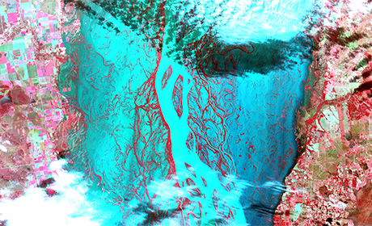
Flooding in Argentina: This image taken by the Advanced Spaceborne Thermal Emission and Reflection Radiometer (ASTER) in early July shows major flooding along the Parana River, in Argentina, due to heavy rainfall in June. ASTER is one of five Earth-observing instruments launched in December 1999 aboard NASA’s Terra satellite.
Image: NASA/GSFC/METI/ERSDAC/JAROS/U.S.-Japan ASTER Science Team
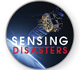
Whether they’re floods, earthquakes, or sinkholes, natural disasters wreak havoc. Since 2010, more than 700 have been registered worldwide, affecting more than 450 million people, according to a study released last year by the International Monetary Fund. The IMF reports that since the 1990s, annual damages have risen from an average of US $20 billion to about $100 billion. And that upward trend is expected to continue.
Natural disasters can’t be prevented, but much can be done with technology to lessen their financial impact and reduce the loss of life. In this special issue, The Instituteexamines three such projects: the global-mapping ASTER instrument on board a NASA satellite that shares with relief organizations the images it gathers from catastrophes; a method of applying a satellite system to monitor temperature changes on the ground that might lead to forecasting earthquakes; and software for detecting sinkholes.
You might think technologies that warn of impending natural disasters have been developed only recently, but inventions that were meant to do so existed more than 170 years ago, as an article from the IEEE History Center describes.
Also featured in this issue is the work of IEEE Fellow James A. Smith, who helped pioneer the remote sensing of Earth’s biosphere.
FROM HIGH ABOVE
The Advanced Spaceborne Thermal Emission and Reflection Radiometer (ASTER) on board NASA’s Terra spacecraft is a multi-spectral instrument launched in 1999. ASTER is part of the agency’s Earth Observing System, a series of satellites that monitor Earth to better understand its nature.
The instrument provides high-resolution images of Earth in 14 different bands of the electromagnetic spectrum. The images in turn are used to identify changes in the land, atmosphere, climate, and oceans. For example, ASTER monitors glaciers and volcanic activity, heat in urban areas, and changes in land use. It can also track floods [see image below], hurricanes, and earthquakes. Since its launch, ASTER has taken more than 2 million images of Earth’s surface, adding about 500 to its archives daily.
ASTER is a joint project of Japan’s Ministry of Economy, Trade, and Industry (METI) and NASA. METI monitors the instrument, notifies NASA staff when the position of the instrument’s antenna or the satellite’s orbit needs adjustment, and handles the preliminary data processing of the images. ASTER has three instrument subsystems divided by wavelength: visible and near-infrared, shortwave infrared, and thermal infrared. Each subsystem has a different ground resolution, with several bands spanning each range of wavelengths.
“This agreement with Japan is quite typical of the kind of bilateral arrangements NASA has with other space-enabled countries such as Canada, France, and Germany,” says Michael Abrams, leader of the U.S. ASTER science team at NASA’s Jet Propulsion Laboratory, in Pasadena, Calif.
Abrams is coauthor of the paper “ASTER Satellite Observations for International Disaster Management,” along with Kenneth A. Duda, a senior scientist with the Earth Observing System, which is part of the Earth Resources Observation and Science Center, in Sioux Falls, S.D. The two are part of the team at NASA that executes the commands and controls the Terra satellite on which ASTER sits.
Their paper appeared in Proceedings of the IEEE in October 2012, a special issue dedicated to the remote sensing of natural disasters. It is available in the IEEE Xplore Digital Library.
GLOBAL COOPERATION
ASTER’s most prominent mission is to acquire and deliver emergency observations about natural disasters, one of the things it was specifically designed to do more than 14 years ago. NASA participates in the effort through the International Charter on Space and Major Disasters, which is composed of private, national, and international space agencies. The 20 signatories to the charter, which went into effect in 2000, agree to share data from their satellites with relief organizations. The satellite images can help officials prepare for troubling events, provide warnings, reveal the extent of damage, and assist with recovery efforts.
The charter provides a way for authorized groups that urgently need imagery of a disaster to make a request for multiple images through a single call, according to Duda. “Annual charter activations have been generally trending upward since inception as the value of the service has repeatedly been demonstrated,” he says.
According to Abrams, the cooperation ensures that only data from the most appropriate sensors are used, which minimizes the redundancy of data collection by the agencies and makes information available faster.
“The agreements, based on friendship and cooperation, are meant to share knowledge and experience,” he says. “ASTER is one of many such instruments operated by different countries that cooperate to provide data whenever satellite imagery for any kind of big disaster is needed.”
PREDICTION HURDLES
While they do a fairly good job of warning of impending events such as floods because of the information they gather about rainfall and snow packs, ASTER and other such instruments can’t make exact predictions because of the random nature of disasters, Abrams explains.
“At least with warnings, you can evacuate people and prevent loss of life,” he says.
The Terra mission and ASTER project will continue to be funded by NASA through September 2014.
- http://www.worldbank.org/en/news/feature/2014/01/29/reducing-the-impact-of-natural-disasters-in-malawi-empowering-citizens-and-taking-charge

Reducing the Impact of Natural Disasters in Malawi: Empowering Citizens and Taking Charge
January 29, 2014

STORY HIGHLIGHTS
- Malawi’s disaster risk management project, supported by the World Bank, helps the government reduce the impact of natural disasters on its citizens
- Disaster forecasting and risk modeling provide the government with tools to better able predict and prepare for catastrophic events
- Training in flood and drought forecasting models not only leads to better preparedness, but also climate-smart practices
RELATED
WORLD BANK
- Website: Disaster Risk Management in Africa
LILONGWE, January 29, 2014 – Aiming to avert large-scale flood and drought damage in Malawi, the government is implementing disaster forecasting and risk modeling measures that are reducing risks and creating safer environments for communities.
These measures have led to advanced disaster preparedness by the country’s citizens, who are better able to predict catastrophic events and, therefore, more effectively prepare for them. Such preparedness has been achieved through the Malawi Disaster Risk Management project led by the World Bank’s Africa Disaster Risk Management Group, with financing from the Global Facility for Disaster Reduction and Recovery.
"Following the 2009 Karonga earthquake disaster and the awareness it raised, integration of disaster risk management in Malawi's overall development strategies has remained a key element in the country's improving capacity to deal with sudden onset as well as long-term disasters," said Kundhavi Kadiresan, World Bank Malawi country director.
The livelihood of a typical rural Malawi household can be negatively impacted by the sudden onset of extreme weather and climatological events during which, the poorest and most vulnerable communities often suffer the most. As most households are heavily dependent on the steady income amassed from rain-fed agriculture, just one disaster can cause an entire loss of a crop and subsequently, their income.
This is most evident from the continuous flooding in the Shire River Basin in the southern part of Malawi which impacts thousands of households each year and keeps poorer families in a constant state of disaster recovery. The government decided to take action in order to better protect residents in the Valley.
A Malawi Economic Vulnerability and Disaster Risk Assessment was conducted to better understand the socio-economic effects of disasters. The analytical study indicated that annual flood damage in the Shire River Basin resulted in an average loss of 0.7% of GDP ($9 million) per year. Elsewhere in the country, drought caused an average economic loss of 1% annually ($13 million).
The results of study inspired a government-led Shire River Basin Management Program which began to implement more comprehensive flood prevention measures such as the mapping of flood zones, an early warning system and flood forecasting. The research was then combined with technology-focused efforts, such as a flood risk modeling framework using geospatial information and new software services to better take advantage of the latest flood prevention tools.
Using this new empirical analysis on flooding in the lower Shire Valley, the government profiled the disasters and supplied mitigation measures to the local population through a series of training sessions.
“Disasters are everybody’s responsibility because it was evident during the training that all sectors of the economies are greatly impacted by them,” said Dyce Nkhoma, Chief Relief and Rehabilitation Officer from the Department of Disaster Management Affairs (DODMA).
Once awareness was raised, the groundwork for comprehensive action was put in place along with the new measures and a notable shift occurred from a reactive emergency response structure to disaster management capacity building. This resulted in the implementation of key risk reduction activities such as data preparedness for known disasters using the open data for resilience initiative (DRI), which has led to the development of Malawi Spatial Data Platform (MASDAP) a platform for sharing all spatial data in the country[1]. Other activities include community mapping to enhance baseline information and contingency planning, the improvement of weather, climate and hydrological services and general disaster risk management awareness.
These activities are now being implemented to better inform the population of potential disaster risks and empower citizens to take preventative action. Additionally, in order to curb the negative effects of changing weather patterns on some of the country’s major crops, such as maize and cotton, climate-smart agriculture initiatives have also been proposed. This has led to additional training sessions which have been implemented on climate-smart agriculture and conservation agriculture, highlighting how disaster risk management is intrinsically linked to the effects of climate change.
“The capacity building supported by The World Bank in climate-smart agriculture and conservation agriculture has greatly impacted the momentum of the country to take these initiatives seriously and this has shown a strong linkage of Disaster Risk Management and Climate Change Adaptation,” said Dr. Patson Cleopus Nalivata, a Lecturer in soil science at Bunda College, Lilongwe University of Agriculture and Natural Resources (LUANAR).
Malawi’s disaster risk management efforts align with the country’s development strategy of creating a safer environment for all of its citizens. These combined efforts also help reduce the strain on the country’s gross domestic product (GDP) by reducing the economic impact and loss of livelihoods which occur following a disaster. Furthermore, key sector initiatives within social protection and water resources have already been defined, allowing government officials to use the results of the combined disaster risk analysis and use of new disaster risk management measures to continue to make further improvements to forecasting and risk modeling. This will include improved safety nets for the most vulnerable populations, increased irrigation within the agricultural sector and improvements in early warning for floods and drought.
“The Malawi DRM program is a good example how we try to systematically engage with African countries to strengthen long term disaster and climate resilience. It first provided the analytical basis to better understand and quantify the risks, and then integrates risk reduction with climate-smart approaches which are used to build the needed framework that, in the end, truly improves the safety of all citizens,” notes Christoph Pusch, Africa Disaster Risk Management Practice Group Leader.

- http://www.theguardian.com/global-development/2014/feb/14/game-thai-gaming-app-children-floods-child-play

Game on: Thai mobile phone app makes flood safety child's play
Mobile gaming app teaches children what to do when floods strike, as they follow cartoon hero battling his way to safety

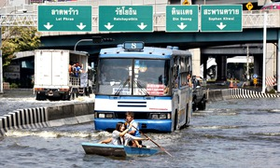
Residents row a boat in front of a bus along a street in Bangkok during the 2011 floods. Photograph: Chaiwat Subprasom/Reuters

Guardian Global development is supported by:
About this content
Claudine Spera
Friday 14 February 2014 01.02 GMTLast modified on Thursday 5 February 201510.36 GMT
From grappling with runaway crocodiles to avoiding electrocution, a new mobile phone app aims to teach children across the Asia-Pacific region how to stay safe when floods strike.
Following the deluge in Thailand in 2011, which killed more than 800 people, the UN agency Unesco's Bangkok office has teamed up with software developers OpenDream to create Sai Fah: The Flood Fighter. Players can follow the cartoon hero Sai Fah as he battles a flood on his way to meet his mother, with each level of the game offering a lesson in flood safety.
Gaming is hugely popular among Thai youth. A recent study found that 72% of youngsters own a mobile phone and 49% use their device for gaming. "In Thailand, people love mobiles, particularly iPhones and Android, so this was the target audience," explains Ichiro Miyazawa, the Unesco Bangkok programme specialist for literacy and lifelong learning. "We wanted to make characters in the game cute so people feel an attachment to them."
Sai Fah: The Flood Fighter was launched in Thai language last month; this week the game was released in English on iOS and Android platforms.
OpenDream's project manager, Nathalie Sajda, says the biggest challenge while designing the game was balancing entertainment with education: "To integrate learning lessons in a fun interactive way with the player – this is what makes the game interesting."
Unesco hopes Sai Fah will be rolled out in Thai schools The Flood Fighter
The game has 22 lessons, many of which are based on real-life scenarios. "There's a moment in the game where Sai Fah receives information that the city is safe as it is surrounded by a dam. But he later sees that something hits the dam and breaks it – this is based on a real-life story," Sajda explains. "It is important to have real-life understanding of what kind of situations a child or adult can encounter during a flood."
Advertisement
Players are also briefed on how to limit indoor hazards, such as preventing toilets and pipes from bringing dirty floodwater into homes.
There are several apps designed to alert phone users of impending natural disasters, but Miyazawa believes Sai Fah: The Flood Fighter is the first of its kind to educate young people through "gamification" – applying typical elements of game playing such as scoring points and earning rewards to make the experience fun and engaging.
Other organisations involved in disaster relief have also got in on the act. Save the Children has an app that allows users to step into the shoes of aid workers – but it is aimed at educating children about the relief effort, not crisis management. Games such as Disaster Island, launched this week by the British Red Cross, teaches users how to cope during a natural disaster, but it's an interactive video rather than a mobile app.
The Thai language version of Sai Fah: Flood Fighter has been downloaded more than 11,000 times, and there are plans to promote the English version in flood-prone areas across the Asia-Pacific region.
Sai Fah has been downloaded more than 11,000 times The Flood Fighter
Youngsters who sampled the game at an event held by the Thai education ministry last month gave the app the thumbs-up. "It's a very fun game and the lessons I learned can be applied to daily life," said nine-year-old Thamphitak Rakwiratham. The first player to complete all levels, Natchalita Nilkeaw, 10, said: "This is so much fun! I learned flood survival skills by doing the challenges. It's different from other internet games because this game teaches kids practical lessons. Will recommend to my friends."
Miyazawa hopes Sai Fah will be rolled out in schools nationwide, once the government's policy to provide Thailand's 9 million pupils with a tablet computer is implemented. "That's something we want to push [and have discussed with] the ministry of education," he says.
"We understand the tablet computer has not been used effectively at school, and we wonder if we can install this type of app in tablets – [which will provide] a good opportunity for kids to play, have discussions and acquire more knowledge [on flood management]. It can create a good opportunity to think and talk about [flood dangers]. If children can use it that way in the classroom, that would be wonderful."
- http://www.bbc.co.uk/news/world-24559932

Access to technology 'aids survival in natural disaster'
- 17 October 2013
- From the section World
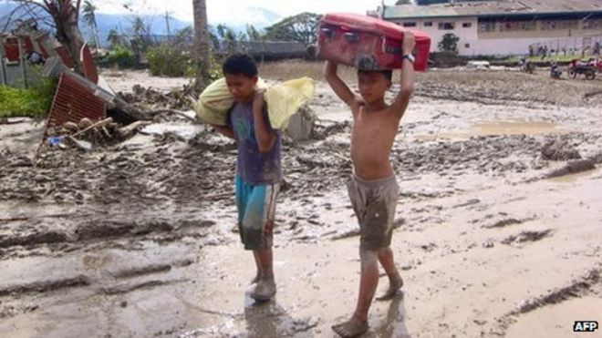
Widespread access to mobile phones in the Philippines is credited with saving many lives during Typhoon Bopha
Some of the countries most prone to natural disasters also have least access to life-saving communications and technology, a major study says.
Such access has a major impact on people's ability to prepare for, survive and recover from disasters.
In the Philippines, for example, 99% of people can access a mobile phone.
Text messaging and Twitter saved many lives in a 2012 typhoon, the International Federation of the Red Cross and Red Crescent says.
Other examples of technology helping save lives or aid recovery include the use of text messages to deliver hurricane warnings in Haiti and a computerised barcode system to monitor the distribution of humanitarian supplies in Syria.
Increase resilience
The author of the IFRC's annual World Disasters report notes that while "the overall number of people affected by disasters decreased in 2012, the number of people affected in the poorest countries increased, with over 31.7 million people affected".
"They are also often the ones with the least access to technology," said Patrick Vinck.
IFRC Secretary General Bekele Geleta expressed hope that "governments and affected people in disaster-prone countries can take advantage of innovations such as weather prediction software, satellite imagery and mass alert systems, increasing their resilience to disasters and their ability to recover quickly when they do happen".
"Typhoon Bopha affected 6.3 million people in the Philippines, and thousands of lives were saved because 99% of the population have access to a mobile phone and could receive early warnings and information on staying safe." he said.
However the report also warns that humanitarian agencies should not make the mistake of listening only to those who are connected and excluding those who are not.
It urges the private sector, humanitarian organisations, governments and local communities to work together to ensure access to technology for such populations.
More on this story
- Extreme weather can be the 'most important cause of poverty'
16 October 2013
- Lives shattered by Typhoon Bopha
10 December 2012
- In pictures: Typhoon Bopha hits Philippines
5 December 2012
- Pakistan's efforts to rebuild thwarted by natural disasters
29 November 2010
Related Internet links
- International Federation of Red Cross and Red Crescent
- World Disasters Report 2013

- http://www.theguardian.com/global-development/2013/oct/17/local-people-access-technology-survive-disasters

Local people 'need access to technology to survive disasters'
Technology can greatly enhance the ability of disaster-affected communities to help themselves, says world disasters report
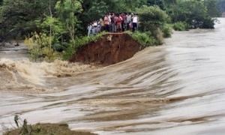
Indian villagers stand on the breached embankment of a swollen river. The widespread use of technology played a huge role in preventing a large loss of life when cyclone Phailin hit the country. Photograph: AP

Guardian Global development is supported by:
About this content
Mark Tran

@marktran

Thursday 17 October 2013 09.49 BSTLast modified on Thursday 22 May 201407.21 BST
Lack of access to information and technology has a major bearing on people's ability to prepare for, survive and recover from disasters, according to the 2013 world disasters report.
While new technologies greatly enhance the ability of disaster-affected communities to help themselves, the report, published by the International Federation of Red Cross and Red Crescent Societies (IFRC) in Geneva on Thursday, says access to technology is deeply unequal. This digital divide is prominent in the most disaster-prone countries around the world.
The report emphasises that during the first critical hours after an emergency, most lives saved are actually by local people. Yet many of these first responders do not have access to basic life-saving information and tools, such as early warning systems and basic connectivity and network infrastructure.
The report also warns that as humanitarian agencies increasingly turn to new technologies as a source of information about disaster-affected communities' needs, they run the risk of only listening to those who are connected, and excluding those who are not. The report urges the private sector, humanitarian organisations, governments and local communities to work together to ensure access to technology for these poorest communities.
"There are great examples of what can happen when technology experts and humanitarians put their heads together," said Ed Happ, the IFRC's global chief information officer. "The IFRC and the telecommunications company Trilogy developed the Tera SMS system, which has allowed 3 million people in Haiti to receive hurricane warnings and disease prevention advice. We recently set it up in Sierra Leone, and our ambition is to launch Tera in 40 countries. But we can't do it alone, we need the private and public sectors to work with us."
This year's report focuses on the role of technology – its potential and its limitations. The widespread use of technology, particularly mobile phone texting, played a huge role in preventing a large loss of life when cyclone Phailin hit the state of Odisha in India last week. The 1999 cyclone in this region killed 10,000 people. This time, 27 people have died so far.
"Technology played a key role in keeping people informed before and during the cyclone," said Simon Eccleshall, IFRC head of disaster and crisis management. "People were prepared. Technology made things quicker this time. Before, people were informed by loudhailer house to house. Now it's text message – people sharing information."
In another example of how organisations are using technology, the American Red Cross has set up a digital operations centre (DigiDoc), which allows social media posts from the disaster affected area to be tracked and integrated into response decision-making.
"This gives the American Red Cross the ability to monitor positive or negative sentiment, displayed in real time," said Eccleshall. "It shows where there is a problem, and allows headquarters to call a branch and ask what is going on to create a blip."
Last year saw the lowest number of deaths and people affected by disasters in the last 10 years, but in terms of costs 2012 was still the fifth most expensive year of the last decade. According to the IFRC, deaths from disasters in 2012 were 90% below the average for the decade. The number of disaster events is also among the decade's lowest.
In all, there were 552 disasters costing just under $158bn last year. The most expensive event was hurricane Sandy in the US, which cost $50bn; the deadliest was typhoon Bopha in the Philippines, which killed 1,901 people. Floods accounted for 53% of the 139 million affected by disasters in 2012, with the most severe taking place in China in April and June.
"We got lucky last year, but we are by no means complacent," said Eccleshall. "It's simply a matter of time before a large-scale disaster will impact a large number of people. The interesting trend is that big disasters have tended to be in high-income countries, whereas donors have looked at responding in low-income countries."
In a separate report published on Wednesday, the Overseas Development Institute(ODI) said governments should forget plans to end extreme poverty if they fail to come to terms with the increased risk of natural disasters in some of the poorest parts of the world.
The ODI estimated that around a third of a billion extremely poor people will be living in countries highly exposed to natural hazards by 2030 – more than the current population of the US. In sub-Saharan Africa, 118 million extremely poor people will face extreme weather hazards – with more than 20 million people at risk in countries such as Nigeria and Ethiopia.
Without addressing the current paltry levels of funding available for efforts to reduce the risk posed by natural disasters – just $0.40 in every $100 of aid – recent progress made in reducing global poverty efforts could be set back by "a lifetime overnight" in countries where drought, hurricanes and flash floods are a threat, warned the ODI.
According to the report, the 11 countries most at risk of disaster-induced poverty are Bangladesh, the Democratic Republic of the Congo, Ethiopia, Kenya, Madagascar, Nepal, Nigeria, Pakistan, South Sudan, Sudan and Uganda.
"We know that disasters entrench poverty – they don't just end lives, they destroy shops, roads, crops, houses and hospitals in places where there are no safety nets such as insurance or social security," said Tom Mitchell, the ODI's head of climate change and one of the report's authors. "Without meaningful change, talk of the end of extreme poverty is pie in the sky."

- http://www.bbc.co.uk/news/technology-29149221

How technology is changing disaster relief
By Edwin Lane Technology reporter, BBC News
- 24 September 2014
- From the section Technology
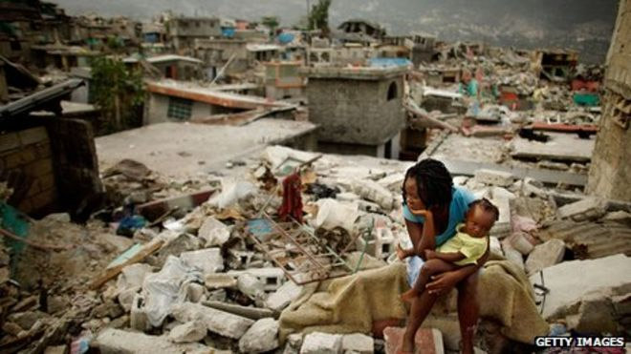
Disasters like the 2010 Haiti earthquake have spurred on technology development in disaster relief
When the British government delivered emergency aid to people fleeing Islamic militants in northern Iraq last month, one of its primary concerns was how the refugees might charge their mobile phones.
Alongside tents and drinking water, RAF planes dropped more than 1,000 solar-powered lanterns attached to chargers for all types of mobile handsets to the stranded members of the Yazidi religious community below.
It is the first time the lanterns have been airdropped in such a relief effort, but humanitarian workers say it is part of growing efforts to develop technology designed to make a difference in disaster zones.
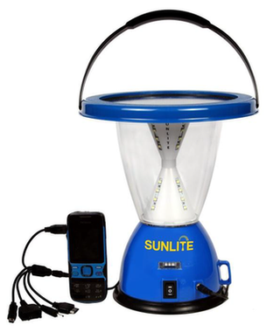
More than 1,000 Sunlite solar powered lanterns and phone chargers were airdropped in northern Iraq
In 2010, Dr Paul Gardner-Stephen, a computer systems researcher at Flinders University in Australia, was driving to work in his car when he first heard radio reports of the devastation of the Haiti earthquake, more than 10,000 miles away.
With roads blocked, infrastructure reduced to rubble and mobile networks down, he realised something needed to be done, and quickly.
"You typically have about three days to restore the communications before the bad people realise the good people aren't in control any more," he says.
His solution was to develop the technology that allows mobile phones to communicate directly with each other even where there is no network coverage, or when mobile masts have been knocked out of action - a system known as "mesh networking".
His Serval Project work means users can send text messages, make calls and send files to other users nearby, creating a mobile network through a web of users.
It is just one example of the dozens of technologies developed in the wake of Haiti to help relief efforts in disaster zones.
"There's plenty of technology for rich white men," Dr Gardner-Stephen says. "It's the rest of the world that we need to help."
Haiti impact
Another project born out of the Haiti disaster was the Trilogy Emergency Relief Application (Tera), a mass text messaging programme now being rolled out by the Red Cross in 40 countries around the world.
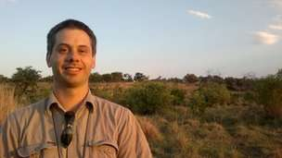
Dr Paul Gardner-Stephen is part of a growing band of researchers working on technological solutions for disaster relief efforts
It allows aid workers to navigate a disaster-hit country from a computer screen, identify all the mobile phones being used in a given area, and blast them all with urgent 140-character updates with a click of a button.
It was first developed in Haiti with the help of local mobile network operators, allowing messages with advice on water sanitation and medical aid to be distributed to millions of people across the Caribbean country.
"I don't know of any other means of communication where you could reach that many people, that quickly and that directly," says Sharon Reader, a communications adviser for the International Red Cross currently working on setting up the Tera system in east Africa.
"It's not like the radio when someone has to be switched on and listening. It's a buzz in their pocket and they're going to be able to see that information immediately."
She says the sheer volume of mobile phones now sold in developing countries makes text messaging the ideal way to communicate.
Global mobile subscriptions are expected to reach seven billion this yearaccording to the UN, with developing countries in Africa and Asia seeing the fastest growth.
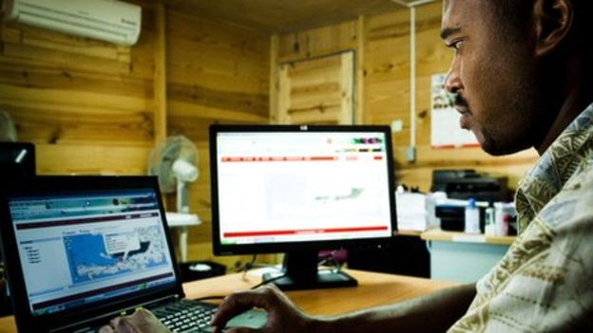
The Tera system allows aid workers to text millions of mobile users with a click of a button
Crowd sourcing challenge
The Tera project also allows disaster victims to send messages back to aid agencies, telling them where they are and what they most urgently need.
That makes it similar to other recently developed applications designed to harvest the huge volumes of information generated in the immediate aftermath of a sudden-onset disaster, like a war or earthquake.
The Ushahidi project was used in Haiti to crowd source information from the Haitain population, using social media sources like Twitter and Facebook alongside text messages, with information visualised on an online map for humanitarian agencies to use.
Similar platforms became popular following the 2011 earthquake and tsunami in Japan.
The Japanese are the third biggest users of Twitter in the world, and the network became a crucial communication method and information source, typically faster and more effective than mainstream media.
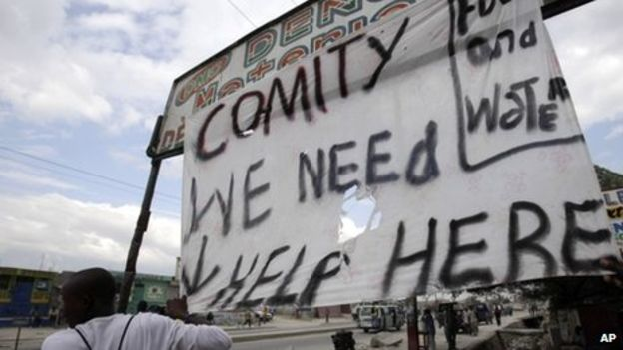
Crowd sourcing is being used to harvest information from those worst-hit by disasters
Several similar projects are being developed, including those through the Digital Humanitarian Network and the Standby Taskforce - organisations that mobilise volunteers with expertise in monitoring social media, translating messages to and from local dialects, and creating crisis maps around disasters.
Kim Scriven is the manager of the Humanitarian Innovation Fund, a government-backed agency set up in 2011 that supports innovative research in humanitarian aid.
[Disaster relief] is no longer about just dropping items on people and leaving them to itSharon Reader, International Red Cross
He says the trying to harvest and filter the vast amounts of data generated by a disaster or conflict is "the big nut that people are trying to crack", with the real challenge being to turn all of that data into information that humanitarian agencies can actually act on.
Technology sea-change
"There are lots of people working on it, but in my view that hasn't happened yet," he says.
Alongside the smaller start-ups typically supported by Mr Scriven's fund, the bigger technology players are beginning to show more interest in humanitarian applications for their technology.
Google recently unveiled its drone programme, which it suggests could be used to airdrop aid into disaster zones.
Last year, the search giant unveiled Project Loon - a plan to deliver internet connections to hard-to-reach places through a network of high-altitude balloons.
Both are in the early stages of development. But aid workers say we are seeing a sea-change in the role of technology in humanitarian relief, and how it can empower those affected by the disaster they find themselves in.
"[Disaster relief] is no longer about just dropping items on people and leaving them to it," says the Red Cross's Sharon Reader.
"There has been a huge shift in the aid world in seeing people who are affected by a crisis not as victims but as people who have the capacity to look after themselves."
More on this story
- How does Haiti communicate?
- 20 January 2010

- Google tests drone deliveries in Project Wing trials
- 28 August 2014

- Iraq aid drops to 'step up', says No 10
10 August 2014

- Mesh networks chat apps to the rescue
1 May 2014

- Mobiles 'to outnumber people next year', says UN agency
9 May 2013

Website links to charities and organisations for further resources:

- http://practicalaction.org/disaster-risk-reduction?utm_source=S000&utm_medium=PPC&utm_campaign=C10105&gclid=CKfZrr-7k8UCFc3MtAodxVsAVQ

- http://worldconcern.org/myconcern/disaster-risk-reduction/?gclid=CMqz6_u7k8UCFSXHtAodVV0Akw

- http://www.trust.org/spotlight/Disaster-risk/?source=jtSpotlights&gclid=COf_l4G_k8UCFVTKtAodhXwADA

