Maxed Out on Everest

How to fix the mess at the top of the world
By Mark Jenkins
Photograph by Subin Thakuri, Utmost Adventure Trekkin

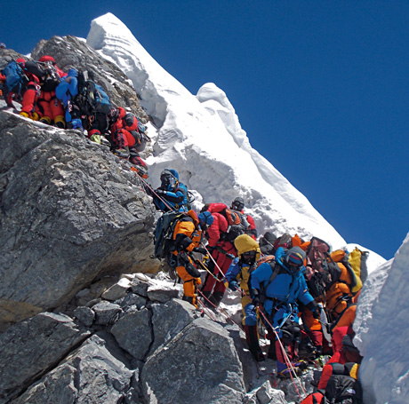
An hour above high camp on the Southeast Ridge of Everest, Panuru Sherpa and I passed the first body. The dead climber was on his side, as if napping in the snow, his head half covered by the hood of his parka, goose down blowing from holes torn in his insulated pants. Ten minutes later we stepped around another body, her torso shrouded in a Canadian flag, an abandoned oxygen bottle holding down the flapping fabric.
Trudging nose to butt up the ropes that had been fixed to the steep slope, Panuru and I were wedged between strangers above us and below us. The day before, at Camp III, our team had been part of a small group. But when we woke up this morning, we were stunned to see an endless line of climbers passing near our tents.
Now, bumper to bumper at 27,000 feet, we were forced to move at exactly the same speed as everyone else, regardless of strength or ability. In the swirling darkness before midnight, I gazed up at the string of lights, climbers’ headlamps, rising into the black sky. Above me were more than a hundred slow-moving climbers. In one rocky section at least 20 people were attached to a single ratty rope anchored by a single badly bent picket pounded into the ice. If the picket popped, the rope or carabiner would instantly snap from the weight of two dozen falling climbers, and they would all cartwheel down the face to their death.
Panuru, the lead Sherpa of our team, and I unclipped from the lines, swerved out into open ice, and began soloing—for experienced mountaineers, a safer option. Twenty minutes later, another corpse. Still attached to the line of ropes, he was sitting in the snow, frozen solid as stone, his face black, his eyes wide open.

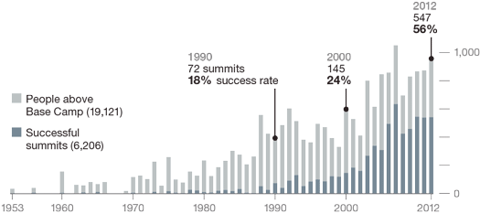

MARTIN GAMACHE AND MATT TWOMBLY, NGM STAFF
SOURCES: GERMAN AEROSPACE AGENCY; RICHARD SALISBURY, HIMALAYAN DATABASE

Several hours later, before the Hillary Step, a 40-foot wall of rock and the last obstacle before the summit, we passed yet another corpse. His stubbly face was gray, his mouth open as if moaning from the pain of death.
Later I would learn the names of these four climbers: Chinese Ha Wenyi, who was 55; Nepali-Canadian Shriya Shah-Klorfine, 33; South Korean Song Won-bin, 44; and German Eberhard Schaaf, 61. As I cramponed past their icy corpses on my own descent from the summit, I thought of the shattering sorrow their families and friends would experience when they heard the news. I too had lost friends to the mountains. Exactly why these individuals died still wasn’t clear. However, many recent deaths on Everest have been attributed to a dangerous lack of experience. Without enough training at high altitude, some climbers are unable to judge their own stamina and don’t know when to turn around and call it quits. “Only half the people here have the experience to climb this mountain,” Panuru told me. “The half without experience are the most likely to die.” Too often, it’s not the mountain’s harshness that kills climbers but their own hubris

Six ways to repair Everest
Fewer permits To limit the total number of climbers and Sherpas on the mountain
Smaller teams To reduce dangerous traffic jams on the standard Southeast Ridge route
Certify outfitters To make sure that they meet acceptable standards of safety and mountain knowledge
Require experience To ensure that climbers and Sherpas are prepared for high-altitude challenges
Leave no trace To remove human waste and garbage from the mountain, with penalties for noncompliance
Remove bodies To show respect not only for the dead but also for the living, who encounter corpses on main routes

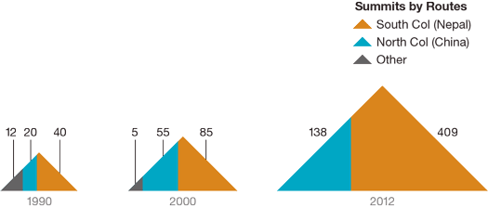
How different it was 50 years ago when, on May 1, 1963, James Whittaker, accompanied only by Sherpa Nawang Gombu, became the first American to reach the summit of the world. “Big Jim” did it by climbing the Southeast Ridge, the same route pioneered in 1953 by the peerless New Zealander Edmund Hillary and Sherpa Tenzing Norgay. Whittaker had climbed Mount McKinley a few years before, and it was Gombu’s third trip to Everest. Three weeks after Whittaker and Gombu’s ascent, in an unprecedented act of boldness, teammates Tom Hornbein and Willi Unsoeld clawed their way up a completely new route, the West Ridge. (The two men had been teammates on the 1960 American Pakistan Karakoram Expedition.) On that same day Barry Bishop and Lute Jerstad made the second American ascent of the Southeast Ridge. The two teams managed to meet below the summit, but by then it was dark, and they were forced to bivouac at 28,000 feet—a risky, last-ditch option never before attempted. Without tents, sleeping bags, stoves, Sherpas, oxygen, water, or food, they weren’t expected to survive.

“God, they were lucky,” says Whittaker. “If there had been any wind, they would have all perished. It would have been horrible.” All four men lived—although Unsoeld and Bishop lost 19 toes between them. And despite the death two months earlier of Wyoming climber John “Jake” Breitenbach in an accident in the Khumbu Icefall, the 1963 American expedition became a tale of heroic success, the moon shot of mountaineering.
Our team was on Everest to mark the anniversary of that expedition. Yet as we witnessed, the mountain has become an icon for everything that is wrong with climbing. Unlike in 1963, when only six people reached the top, in the spring of 2012 more than 500 mobbed the summit. When I arrived at the apex on May 25, it was so crowded I couldn’t find a place to stand. Meanwhile, down below at the Hillary Step the lines were so long that some people going up waited more than two hours, shivering, growing weak—this even though the weather was excellent. If these throngs of climbers had been caught in a storm, as others were in 1996, the death toll could have been staggering.
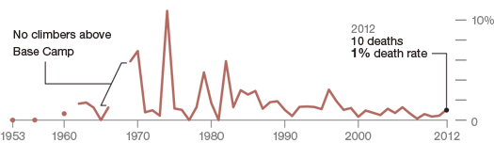
MARTIN GAMACHE AND MATT TWOMBLY, NGM STAFF
SOURCES: GERMAN AEROSPACE AGENCY; RICHARD SALISBURY, HIMALAYAN DATABASE

Everest has always been a trophy, but now that almost 4,000 people have reached its summit, some more than once, the feat means less than it did a half century ago. Today roughly 90 percent of the climbers on Everest are guided clients, many without basic climbing skills. Having paid $30,000 to $120,000 to be on the mountain, too many callowly expect to reach the summit. A significant number do, but under appalling conditions. The two standard routes, the Northeast Ridge and the Southeast Ridge, are not only dangerously crowded but also disgustingly polluted, with garbage leaking out of the glaciers and pyramids of human excrement befouling the high camps. And then there are the deaths. Besides the four climbers who perished on the Southeast Ridge, six others lost their lives in 2012, including three Sherpas.
Clearly the world’s highest peak is broken. But if you talk to the people who know it best, they’ll tell you it’s not beyond repair.
Russell Brice, 60, runs Himalayan Experience, the largest and most sophisticated guiding operation on Everest. Himex, as it’s known, has led 17 expeditions to Everest, on both the Nepal side and the China side. Brice, a Kiwi transplanted to Chamonix, France, is famous for running a tight ship. Every climber and Sherpa on a Himex team is issued a radio and is required to check in every day. Each is also required to wear an avalanche transceiver, a helmet, a harness, and crampons and to attach themselves to safety lines. (During the spring 2012 season a Sherpa from another team failed to clip the safety lines and fell to his death in a crevasse.) To avoid getting into trouble, clients must keep pace or turn around.
Despite the relatively large size of Brice’s teams—as many as 30 clients matched with 30 Sherpas—they leave a small footprint on the mountain, removing all of their excrement and rubbish, a practice not followed by most teams. Cleanup efforts by the Sagarmatha Pollution Control Committee, a sort of Everest city council, have improved conditions at Base Camp (human waste goes into barrels that are later removed), but they haven’t had much impact higher on the mountain. Camp II, at 21,240 feet, is particularly disgusting. Camp IV is little better, the tattered skeletons of abandoned tents snapping in the wind.
“We can manage the numbers if all the operators talk to each other,” Brice insists. “It’s all about good communication.”
If only it were that simple. There are other factors at work. One, ironically, is improved weather forecasting. Lack of information once led expeditions to attempt the summit whenever their team members were ready. Today, with hyper-accurate satellite forecasts, all teams know exactly when a weather window will open up, and they often go for the top on the same days.
Another factor: Low-budget outfitters don’t always have the staff, knowledge, or proper equipment to keep their clients safe if something goes wrong. The cheaper operators often employ fewer Sherpas, and those they do hire sometimes lack experience. “All of the clients who died on Everest this past year went with low-budget, less experienced operators,” says Willie Benegas, 44, an Argentine-American high-altitude guide and co-owner, with his brother Damian, of Benegas Brothers Expeditions, which has led 11 trips to Everest. Besides holding Nepalese outfitters to the same standards as international ones, the brothers say, Nepal’s Ministry of Culture, Tourism and Civil Aviation, which regulates climbing on Everest, should promote better education for Sherpas so they can perform their duties as well as international guides.
To prevent crowding on the mountain, some have proposed limiting not only the total number of permits per season but also the size of each team—to no more than ten clients per team. Others are skeptical.
“That will not happen,” says New Zealander Guy Cotter, 50, owner of Adventure Consultants, which has led 19 expeditions to Everest. “Everest is big business for Nepal, and they will never turn down the money.” In Nepal, a country of nearly 30 million, one in four citizens lives in poverty. The country itself is in limbo. A ten-year civil war between Maoists and government loyalists ended in 2006. The monarchy was later dissolved and a coalition government created, but the past seven years have been deeply troubled, with belligerent political parties operating under an interim constitution. The political system is “so corrupt and so feckless,” Kunda Dixit, editor of the Nepali Times, has said, “that not having a government is actually beneficial, because there is no one to make all those mistakes.”
Expeditions on the mountain spent almost $12 million in Nepal in the spring of 2012, according to Ang Tshering Sherpa, owner of Asian Trekking. The ministry took in more than $3 million in permit fees from climbers on 30 foreign expeditions. “You have to remember, Nepal is almost a failed state,” Cotter says. “More government intervention would only encourage more corruption.” Dave Hahn, a high-altitude guide whose 14 Everest summits are an American record, agrees. Expecting the Nepalese government to institute solutions isn’t realistic, he says. “Everest operators must come together to self-regulate the situation.”
A decade ago Anker, with his wife, Jenni, founded the Khumbu Climbing Center (KCC) in the village of Phortse to improve the mountaineering skills of Sherpas and thereby increase the safety margin for everyone on Everest. Many of the center’s 700-plus graduates are now working for outfitters on the mountain. The Sherpas, after all, are the ones who perform most of the rescues. Danuru Sherpa, a KCC graduate who has summited Everest 14 times, told me he has dragged at least five people off the mountain to save their lives.
“One of the obvious problems is that clients don’t respect the knowledge and experience of Sherpas,” Anker says. The Sherpas are, in a way, partly to blame. Most of them are Tibetan Buddhists whose culture and religious principles discourage confrontation. “Clients sometimes disregard their advice and die,” Anker says. “Last year was a case in point. We’re trying to help the Sherpas become more assertive.”
Modern technology, which is already ubiquitous on Everest—everyone at Base Camp has access to a cell phone or the Internet—could also make the mountain safer. In a meeting with the ministry last summer Anker proposed something new: identification cards issued with every climbing permit.
“The Everest ID would contain data that could save the life of a climber or Sherpa,” Anker explains. It would have the climber’s photo, of course, but more important, a QR code—a type of bar code. “Scanned with a smartphone by an Everest climbing ranger, the QR code would reveal all pertinent information—age, experience, health history, allergies, insurance, family, emergency phone numbers, everything.”
Anker said the Kathmandu bureaucrats sat there looking at him with blank faces. “I even got out my phone and showed them how it would work,” he says. “It’s 2012. This isn’t difficult. It’s just like a ski pass.”
Despite all the problems on the mountain, Everest still stands alone. There will always be people who want to climb the world’s tallest peak, because there’s more to being on Everest than getting hemmed in by crowds or confronted by heaps of trash. The mountain is so high and so indifferent it calls upon every climber, at one time or another, to rise to his or her better self.
There is also beauty on Everest. I’ll never forget the breathtaking view from our perch at Camp III, clouds roiling up the Western Cwm like a slow-motion reverse avalanche. Or the visceral relief of a cup of scalding soup at Camp IV. Or the crunch of my crampons in the crystalline labyrinth of the Khumbu Icefall just above Base Camp. I’ll treasure the memory of climbing with friends on the mountain. I committed my life to them, and they committed their lives to me.
Such moments are the reasons climbers keep coming back to Everest. It’s not simply about reaching the summit but about showing respect for the mountain and enjoying the journey. Now it’s up to us to restore a sense of sanity to the top of the world.

