Mount Everest litter targeted by Nepalese authorities
Climbers will have to bring down 8kg of extra waste or face legal action as government tackles rubbish mountain in Himalayas

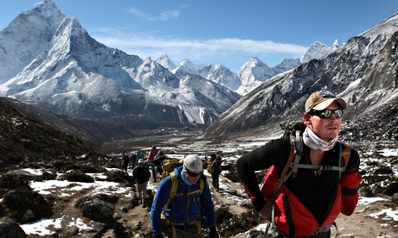
Mount Everest (above) is strewn with rubbish from past expeditions, including oxygen cylinders, human waste and even bodies. Photograph: David Cheskin/PA

Climbers scaling Mount Everest will have to bring back 8kg (17.6lb) of rubbish under rules designed to clean up the world's highest peak.
The rule, one of several new measures for mountaineering in Nepal, will apply to climbers ascending beyond Everest's base camp from April, said tourism ministry official Madhusudan Burlakoti.
"The government has decided, in order to clean up Mount Everest, each member of an expedition must bring back at least 8kg of garbage, apart from their own trash," he said.
Authorities would take legal action against climbers who failed to comply, Burlakoti said, although it was unclear whether this would involve a fine or other penalty.
Decades of mountaineering have taken a toll on the peak, which is strewn with rubbish from past expeditions, including oxygen cylinders, human waste and even climbers' bodies, which do not decompose in the extreme cold.
Expeditions will have to submit their refuse to an office to be set up next month at base camp. It will also offer medical aid and mediation services, after a brawl between European climbers and local guides last year.
Although expeditions have to pay a $4,000 (£2,390) deposit, which is refunded once they show they have brought back everything they took up the mountain, enforcement has been a problem.
"Our earlier efforts have not been very effective. This time, if climbers don't bring back garbage, we will take legal action and penalise them," Burlakoti said.
Last month, Nepal cut its fees for individual climbers to Everest and other Himalayan peaks to attract more mountaineers, sparking concerns of increased traffic and more rubbish being left on the mountains.
In an overhaul of security, the new office at Everest base camp will be staffed by soldiers and police so climbers can approach officers with any problems, officials said last month.
Environmental and climbing groups have long sought to focus attention on the waste problem, with clean-up projects having also been organised.
Discarded oxygen and cooking gas cylinders, ropes, tents, glasses, beer cans, plastic and even the remains of a helicopter made up 75 artworks commissioned for a Kathmandu exhibition in 2012, highlighting the environmental impact of alpine tourism.
Everest is a key revenue earner for the impoverished country, with hundreds scaling the mountain every year during the peak climbing season in April and May.

