Sherpas: The Invisible Men of Everest

They carry the heaviest loads and pay the highest prices on the world's tallest mountain.
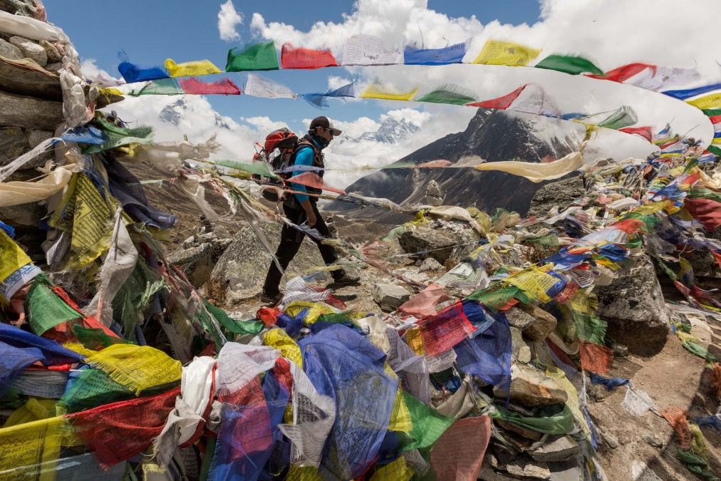
On the trek to Mount Everest, Mingma Ongel Sherpa passes by prayer flags at a memorial for Sherpas who died on the peak. Since the first expeditions in the 1920s, 99 Sherpas and other Nepalis have been killed on Everest—about 40 percent of all climbing deaths there.

Chip Brown
Photographs by Aaron Huey
PUBLISHED APRIL 26, 2014
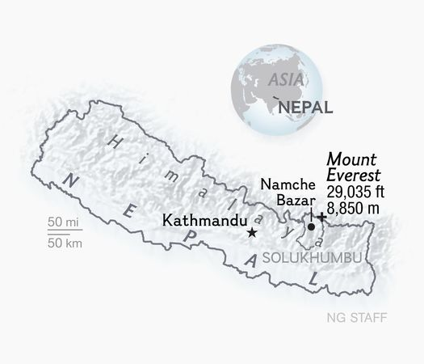
Sherpas working on Everest normally don't die en masse. Apart from their darkest seasons—1922, 1970, and now, 2014, the darkest of all—they tend to perish one by one, casualties of crevasse falls, avalanches, and altitude sickness. Some have simply disappeared on the mountain, never to be seen again.

If mentioned at all, their individual deaths are briefly noted in the Western media. Last year, when the attention of the world was focused on a fight between Sherpas and some Western mountaineers, you would hardly have known four Sherpas died on Everest in separate incidents. Likewise, the year before: three more Sherpa fatalities.
The sad fact is that over the years Sherpas and Nepali mountain workers have died so routinely—40 percent of all Everest deaths over the last century—that it's easy for Western tourists and guiding agencies, Nepali officials, and even some Sherpas themselves to gloss over the loss of any one particular life. Sincere condolences are offered. Inadequate insurance payments are made. Chortens are built, plaques affixed, pictures posted on blogs. And then all parties turn back to the mighty Everest cash machine and the booming business of catering to thousands of foreigners paying small fortunes to stand on the top of the world.
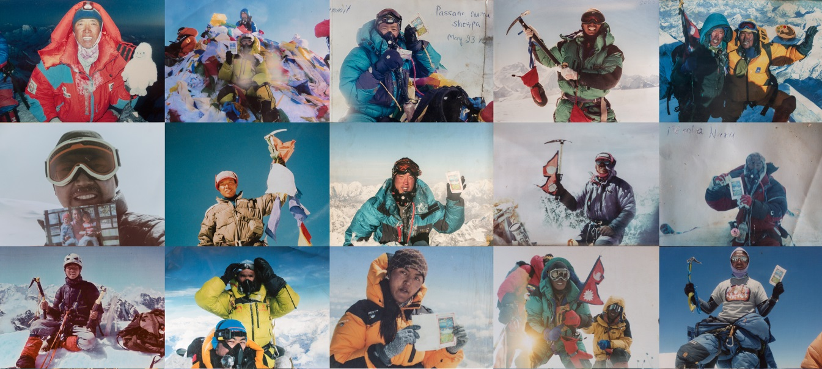
Taking pride in their moments of glory, Sherpa guides pose for snapshots on the summits of Himalayan giants such as Mount Everest (29,035 feet/8,850 meters), Cho Oyu (26,906 feet/8,201 meters), Ama Dablam (22,493 feet/6,812 meters), and Island Peak (20,210 feet/6,160 meters). Clockwise from left: Tenzing Dorjee Sherpa, Sonam Tashi Sherpa, Passang Nuru Sherpa, Phu Tashi Sherpa, Pemba Sherpa and Pensa G Sherpa, Phunuru Sherpa, Tenzing Dorjee Sherpa, Danuru Sherpa, Panuru Sherpa, Pemba Nuru, Sonam Tashi Sherpa, Tenzin Gyaltzen Sherpa, Pasang Lhamu Sherpa, Phu Tashi Sherpa, Panuru Sherpa. PHOTOGRAPHS COURTESY THE SHERPAS

To most outsiders the death of any one Sherpa serving in this system is a kind of meaningless abstraction. And then one afternoon you find yourself sitting in a teahouse in Upper Pangboche, where the human cost of Everest peak fever becomes inescapably clear.
Pangboche is the storied village where Lama Sanga Dorje founded a temple in 1615, about a hundred years after the Sherpa people came into the Khumbu valleys from Tibet. I was there for the first time in late May 2013, when the Everest climbing season was winding down. The trail from Everest Base Camp was full of outbound Sherpa guides heading home laden with seven or eight times the annual per capita income in Nepal and ready to help their wives weed the potato fields, tend the yaks, and watch the kids. Sherpas had helped get more than 200 clients to the summit of Everest in May, but the 2013 season would be remembered in the public mind as the year of the Brawl.
Ama Dablam and the other giant peaks above the Imja Khola River were hidden in monsoon mists as our guide Mingma Ongel Sherpa led photographer Aaron Huey and me through the curtained door of a teahouse next to the Pangboche monastery. We had come to visit DaSona Sherpa, a 47-year-old guide who had ten Everest summits to his credit.
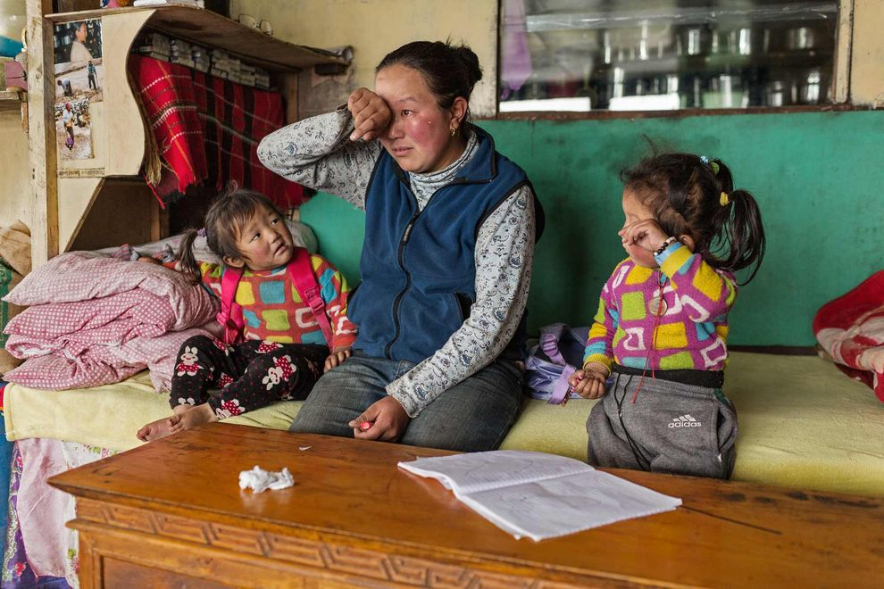
DaSona's wife poured sweetened milk tea into glass mugs, and DaSona politely answered our questions about his experiences on Everest. But there was a heaviness in the air. As he talked, he absently moved four grains of rice around on the table in front of him and looked out the window where his two granddaughters, three-year-old Kelsang and two-year-old Nawang, were playing on the patch of ground between the teahouse and the monastery. The girls were wearing blue fleece jackets to ward off the chill in the mist. DaSona said he had planned to guide five more seasons on Everest, but now he thought he would call it quits after two. Why? He paused. He rolled the rice grains under his finger.
"I lost my son-in-law last month at Camp 3," he said.

Memories are still tender for Nimadoma Sherpa, from the village of Pangboche, who lost her husband, DaRita Sherpa, on Mount Everest in May 2013. The 37-year-old guide died of altitude-related causes at Camp 3 while he was working for a commercial expedition. He left behind two daughters.

Hole in the Heart
His son-in-law, DaRita Sherpa from the village of Phortse, was 37. DaRita had been a monk before he'd married DaSona's daughter, Nimadoma. The 2013 season was his third with International Mountain Guides. He'd returned to work on Everest only because he was building a lodge in Phortse and had already taken out a loan.
On May 5, he got up, dressed, had breakfast, and was about to head down to Camp 2 when he lay back down, feeling dizzy. He stopped breathing. His teammates performed CPR but were unable to revive him. Doctors at Base Camp thought he might have had a heart attack or succumbed to an altitude-related illness. DaSona rode in the helicopter with the body when it was flown home to Phortse and cremated, leaving his father-in-law to wonder how he would pay for his granddaughters' schooling and support his widowed daughter.
As we sat there, under the weight of DaSona's stoical grief, Nimadoma came in. When she saw Mingma, she ran to him and began sobbing. DaSona said that since DaRita's death, Nimadoma had burst into tears at the sight of every Sherpa guide walking down the trail from Base Camp.
Kelsang and Nawang were too young to understand the hole in the heart of their home, but when Kelsang wandered into the house and saw her mother's distress, she said, "Don't cry, Mommy," and daubed her mother's eyes with the sleeve of her fleece.
Both girls eventually sat down outside on the ground with some blue and yellow cups and plastic toy food—a chicken, a corncob, some green vegetables. Nimadoma leaned against Mingma. We sipped our tea in silence, listening to the crows in the hemlocks and watching DaRita's daughters pretend to eat the dirt they were scooping up in their cups.
A monk in a long maroon robe appeared out of the mist like an apparition. He bent down and said something to the girls. And then he walked away along the monastery wall, spinning a row of prayer wheels with his outstretched arm, and leaving in his wake an eerie hush as, one by one, the whirling wheels grew still.
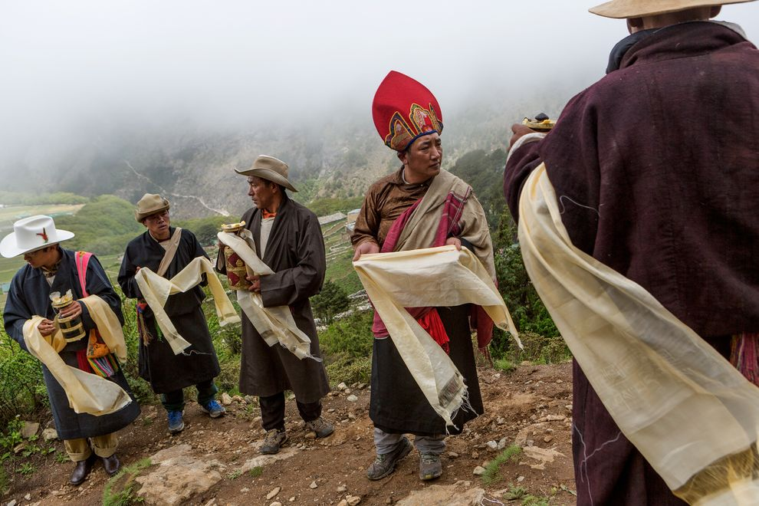
Residents of the Sherpa village of Phortse prepare to welcome a senior lama from the Tengboche Monastery to lead the annual Dumji celebration, a Tibetan Buddhist dance ceremony. Several of the men in Phortse who make their living as guides on nearby Mount Everest were educated at such monasteries.

Culture of Mountaineering
These are times of crucial change for Sherpa culture, and in particular for the subculture of the Sherpa climbing community. Since Sherpas first were hired away from their potato farms to carry loads for an expedition in 1907, Sherpa culture has arguably been more influenced by the Western passion for mountaineering than by any other single force.
In less than a century, they have come from wondering about the sanity of the mikaru, their term for foreign climbers, to being among the best mountaineers in the world themselves. Sherpas hold speed records on Everest. They work as guides on Denali and Mount Rainier. In 2012, Mingma and Chhang Dawa Sherpa of Seven Summit Treks became the first two brothers to climb all 14 of the world's 8,000-meter (26,000-foot) peaks.
It's hard to imagine that the Sherpa porters on the British expeditions to the Tibet side of Everest in the 1920s did not even have a word for "summit." Instead, they were convinced, as Wade Davis notes in his book Into the Silence: The Great War, Mallory, and the Conquest of Everest, that the foreigners were treasure hunters searching for a statue of a golden cow or yak to melt down for coins.
In 1950, American mountaineer Charles Houston was a member of the first team of Westerners to explore Everest from the south. He photographed Namche Bazaar, the so-called Sherpa capital, which at the time was a small, profoundly isolated village of slate-roofed stone houses. No hydropower, no four-story hotels, no dental clinic, no gear shops stuffed with counterfeit North Face fleece, no coffeehouses with Internet access.
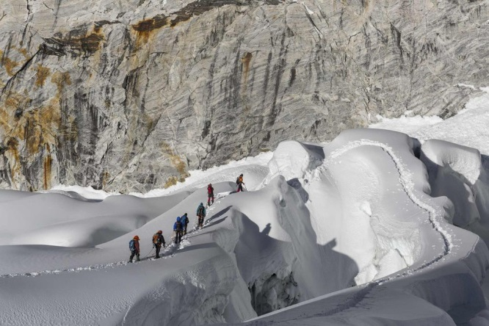
Most Sherpas spoke only their own language and had little contact with the world beyond the mountains. The transformation began when the Sherpa–New Zealander duo of Tenzing Norgay and Edmund Hillary scaled Everest in 1953. Much of the credit for how life in Khumbu has improved is owed to Hillary, esteemed until his death in 2008 as "the Sherpa King" for his efforts to build schools and health clinics and raise living standards.

Sonam Dendu, a guide with Thamserku Trekking, an adventure company founded by Sherpas, leads a group of Spanish and French climbers on Imja Tse, also known as Island Peak.

Steadily Professionalized
While interest in climbing Everest grew gradually over the decades after the first ascent, it wasn't until the 1990s that the economic motives of commercial guiding on Everest began to eclipse the amateur impetus of traditional mountaineering. Climbers who once looked after each other for the love of adventure and "the brotherhood of the rope" now were tending to mountain businesses or taking jobs as guides to look after clients for a salary. Commercial guiding agencies promised any reasonably fit person a shot at Everest. As the American guide Scott Fischer famously said before he died on Everest in 1996 when eight Western climbers died in a blizzard, "We've built a yellow brick road to the summit."
In some ways, Sherpas have benefited from the commercialization of Everest more than any group, earning income from thousands of climbers and trekkers drawn to the mountain. Along the way, the job of "sherpa" has been steadily professionalized. Aaron and I talked one night last January to Ang Dawa, a 76-year-old former mountaineer who now spends a lot of time corralling yaks with a slingshot.
"My first expedition was to Makalu [the world's fifth highest mountain] with Sir Edmund Hillary," Ang Dawa recalled. "We were not allowed to go to the top. We wore leather boots that got really heavy when wet, and we only got a little salary, but we danced the Sherpa dance, and we were able to buy firewood and make campfires, and we spent a lot of the time dancing and singing and drinking. Today Sherpas get good pay and good equipment, but they don't have good entertainment. My one regret is that I never got to the top of Everest. I got to the South Summit, but I never got a chance to go for the top."
Many outsiders use the word "sherpa" as slang for "porter," but in Nepal it more often signifies "shrewd businessman." Former climbing Sherpas now hire other ethnic groups to do much of the unskilled portering. They own hotels, trekking companies, airlines; Khumbu Sherpas today are among the wealthiest of Nepal's dozens of ethnic groups.
Paradoxically, much of their success has come from playing up the aura of Shangri-La and their peaceful life in a timeless mountain kingdom far from modern anxieties and travail. It's this mythology, projected onto the Sherpas by the West, that largely explains why so many Westerners were taken aback by the Brawl last year at Camp 2.

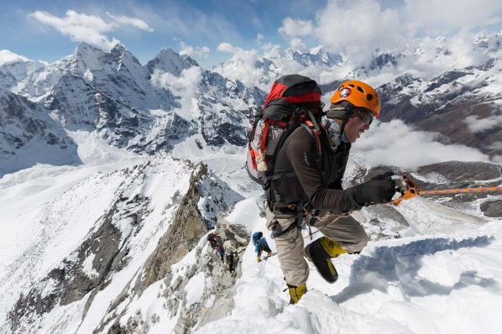
Danuru Sherpa, a veteran guide, pulls his way up a fixed line between Camp 1 and Camp 2 on Ama Dablam. To help climbers reach the top of the beautiful, steep peak, Sherpa attach ropes to the snow and ice for clients hold on to during ascent.

A New Assertiveness
Enough has already been written about the incident last April in which three European climbing superstars got into a fight with a group of Sherpas fixing ropes on the Lhotse Face. The superstars were climbing on a day traditionally reserved for Sherpas to fix ropes, and they may have knocked some ice onto the Sherpas. Or maybe it didn't happen that way. The accounts can't be reconciled. The upshot was that curses were exchanged and a tense standoff ensued in which a group of Sherpas surrounded the Westerners, then punched and kicked and threw rocks before permitting them to flee, fearing for their lives.
The so-called Brawl may have signified nothing more than an outbreak of tensions in a dangerous place where people's brains are chronically starved for oxygen. But it also seemed to reflect a new assertiveness on the part of Sherpa mountaineers, many of them younger and growing up with better educations and, thanks to cell phones and Facebook, conversant with a wider world.
In the past, Sherpas have been yelled at, kicked, and punched in the face by climbers employing them. In old Everest documentaries, you often hear Sherpas being ordered to go up and perform some heroic feat the mikaru just can't manage. Nine-time Everest summiter Tenjing Dorji told me about one ascent when a client from South Korea announced he wanted to go to the top first and by himself—and began swinging his ice ax at the Sherpa.
"What are you doing?" Tenjing cried out.
"I'm trying to kill you!" the climber said.
Tenjing ran for his life only to discover, of course, that he was still roped to the possibly altitude-addled climber. They hit steep ice, began sliding toward a precipice, and were saved only because the line snagged.
Tenjing knew better than to think he was in line for a big post-climb tip, but what was worse was when he made it back to Base Camp, no one believed his story. Other Sherpas have described similar tales of abuse in the course of a job that can encompass not just the duties of a guide and porter, but also those of a butler, a motivational coach, and a lifeguard.
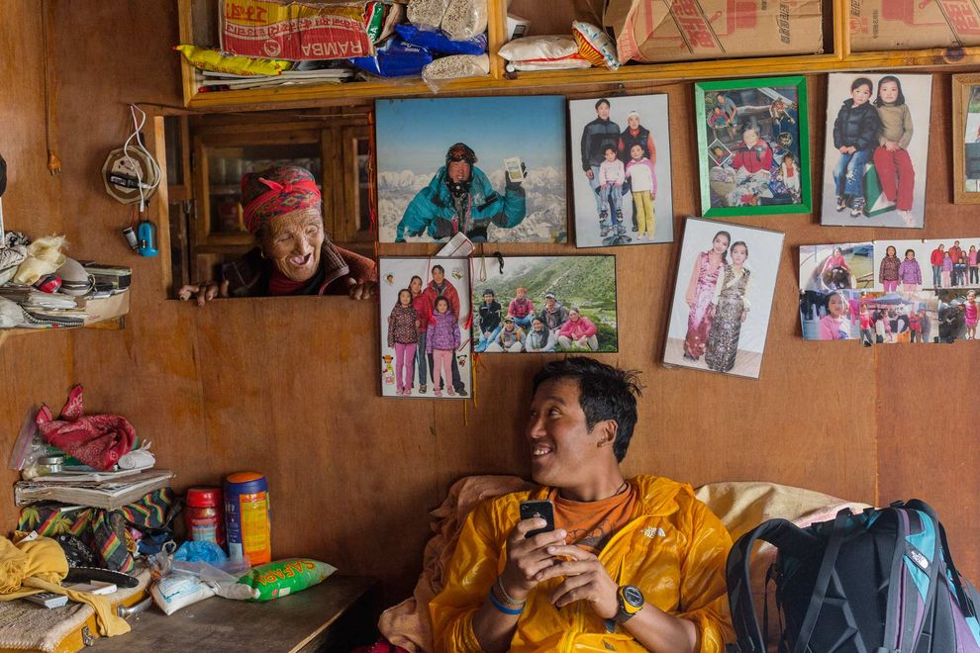
When Mingma, Aaron, and I were visiting villages last May, most Sherpas were embarrassed by the Brawl; even when we returned to the village of Phortse eight months later to spend a week at the Khumbu Climbing Center—where Sherpas and other ethnic Nepali mountaineers learn skills that will lessen their chance of dying in the mountains—the Brawl was still a sensitive topic.

Danuru Sherpa shares a laugh with his mother, Daki Sherpa, at her home in the village of Phortse in the Mount Everest region. Danuru, who has summited Everest 16 times, lives part of the time with his mother and part in Kathmandu with his wife and children, whose photos decorate the wall behind him. Eight of Daki's sons have worked as mountain guides.

A New Era
After last week's catastrophic avalanche that killed 16 Nepali mountaineers, 13 of them Sherpas, the passing militancy of the encounter at Camp 2 in April 2013 looks like the opening of a new era, hopefully not one that encourages violence but addresses what may have lain underneath it: years of inequality, disrespect, and lack of recognition.
"I do feel like some of the pushback is a new face of the Sherpas," University of California, San Francisco anthropologist and Sherpa scholar Vincanne Adams said last week. "It's about time. A lot of Westerners have an idealized view of the Sherpas. They see them as virtuous, strong, sturdy, undaunted, brave, loyal Buddhists. The Sherpas themselves have striven to live up to the ideals Westerners projected onto them—augmenting the qualities they often did possess but also wanting to be the kind of people they were imagined to be. The Brawl on Everest showed a side of the Sherpas that people in the West are scared of. We don't want them to be assertive or to put their interests ahead of [those of] foreigners."
The mass casualties of last week's avalanche brought home the risks in a way that could not be glossed over the way they previously were when Sherpas died one at a time. The enormity of the death toll mobilized a vocal contingent of the Sherpas who took steps to shut down climbing for the season on Everest and put forward 13 demands calling for, among other things, more insurance for mountain workers, bigger payments for families that lost relatives and for workers who were disabled, and a portion of permit fees to be set aside for a relief fund.
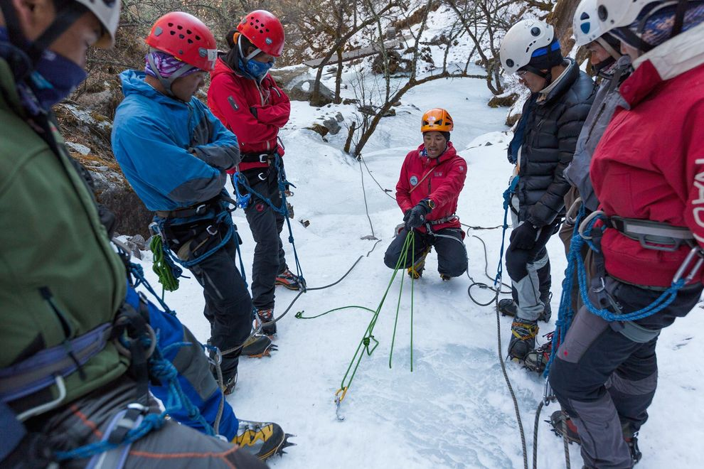
Jangbu Sherpa, a certified mountain guide, shows students how to set an ice anchor at the Khumbu Climbing Center in Phortse. The center was founded in 2003 by American mountaineer Conrad Anker and Jennifer Lowe-Anker to teach Sherpas and other Nepalis how to climb and work safely at high altitudes.

Managing the Risk
As Alan Arnette reported on his widely followed Everest blog, after a large ceremony in Everest Base Camp to commemorate the dead, there was an undercurrent of anger amid the Sherpa grief, similar in its way to the tensions behind the Brawl, when "many in the Sherpa community seemed to come together feeling they were not being shown proper respect." This time, however, the anger was not directed at Western climbers but at the government of Nepal.
"What the Sherpas are doing now needs to look less like a strike and more like a referendum on the risk they accept for their own benefit, but also for Nepal as well," said Pete Athans, a veteran of seven Everest climbs and one of the co-founders of the Khumbu Climbing Center in Phortse.
"I think if Sherpas truly want to change their industry, they need to … demonstrate their mastery of their working environment and the requisite skills. Some Sherpas are extremely adept, but to be fair, many have not really arrived technically," he said. "Of the ones with mastery, I still think they would have to prepare for the [official] alpine guide exams rigorously. They also need to address communication skills, interpersonal skills, and the ability to manage their own businesses. The essential issue is how to manage the risk."
The KCC training program was started in 2003 by Jennifer Lowe-Anker and Conrad Anker with the purpose of teaching Sherpas the skills that would make their work in the mountains safer and lower the number of casualties. The faculty, initially all Western mountain guides, now includes 17 Nepali instructors, most of them Sherpas.

"A KCC certificate has become the union card of an Everest Sherpa," KCC volunteer director Steve Mock told me last January in Phortse. When I visited the school, there were 82 students enrolled in the two-week program, mostly Sherpas but also mountaineers and would-be guides from other Nepali ethnicities. Many were young, but some had already been to the top of Everest. Mock, a climber and chemistry professor at the University of Montana Western in Dillon, said it was very strange to find himself "teaching rappelling to a man who'd already summited Everest two times."
Still, no amount of training can eliminate the hazards of Everest, particularly the Khumbu Icefall. It is, Conrad Anker noted last week, "the most dangerous location humans climb at on a regular basis." He was prompted to write on Facebook in the wake of the historic Sherpa tragedy on Everest, because his friend Ang Kaji Sherpa—36 years old, a father of three sons and three daughters, and an instructor in years past at the KCC—was one of the dead.

Thoughts of the Future
Last May, a few days after our heartbreaking afternoon in DaSona's teahouse in Upper Pangboche, Mingma Ongel Sherpa, Aaron Huey, and I were wandering around the village of Phortse, Mingma's home. We had walked down to the edge where the stone corrals and terraced fields of the village end and the ground shears away above a gorge.
There among the groves of rhododendrons and the pale rosy boles of Himalayan birch, we ran into Nimadoma, DaRita's widow. She had just come from the lodge she and her husband had been building. She seemed more composed, as if she had turned her thoughts to the future and the little girls left for her to raise alone.
In the basket she carried on her back were the ashes of her husband. She was taking them up the long slope of the village to the Phortse monastery, high above the fields where the monks would mix them with clay and mold figurines of the Buddha to tuck away in special spots and sacred places under the shadow of Everest.
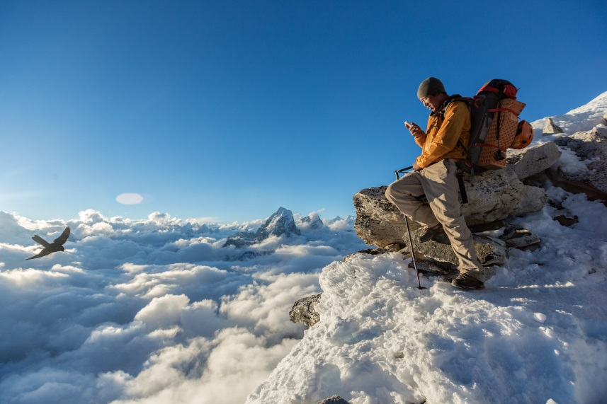
Finding just the right spot above the clouds at Camp 1 on Ama Dablam, Danuru Sherpa uses his iPhone to catch up with friends and family. Even at 18,500 feet (5,654 meters), climbers here can check their email and other dispatches from the world below

