Peace
Tasks – ‘We want Peace’ Song by Lenny Kravitz
1. Discuss the words of the song
2. Write the meaning of peace in your own opinion (in no more than 20 words)
3. What creates conflict?
4. Think and write a list of ways to have peace

Peace
- Read the below list of ways to have peace

- Go to a peace rally
- Make an effort to get to know your neighbours
- Be friends with people of different race, ethnicity, age, ability or other sexual orientation
- Listen to other people
- Support other people
- Be patient
- Speak with people that you’ve never spoken to before in your class
- Write a peace song
- Turn your back on arguments

- Decide where you would put the above recommendations on the below line

NOT VALUABLE
VALUABLE
- Which of the below words or terms helps to create a good relationship between people?
Put a circle around them.

Religious opinion Different interests Honesty

Trust Tolerance

Definitions of Peace
It is not just a goal to aim for in the distance but the way we achieve that goal.
(Martin Luther King Jr, USA)
There isn’t a way towards peace, peace is the way. (Mahatma Gandhi, India)
Without justice, peace is only pleasant word to the ear. (Dom Helder, Camara, Brazil)

Peace comes from within. Don’t try to find it from the outside. (Siddhartha Gautama, The Buddha
If you want peace with your enemy, you will need to work with your enemy. They will then become your partner. (Nelson Mandela, South Africa)
Peace is not only the absence of war. As a cathedral, we must build peace patiently with a strong faith. (The Pope – John Paul II)

Peace is not a product of being frightened. Peace is not the silence of cemeteries. Peace is not the silence after fierce repression. Peace is the silence, giving contribution to everyone for the welfare of everyone. Peace is dynamic. Generosity is peace. It is the right and the duty. (Oscar Romero, priest, South America)
3 thousand years is peace and it must be taken step by step. (Lyndon B. Johnson, Past President of the USA)

Tasks
- Chose any two quotations and explain them
- Design your own logo to show your idea of peace

Christianity – What does the religion teach about peace?
Christians do not believe in retaliation when someone does something bad to you or doesn’t help you.
Why?

We need to pray for those who are against you.
How does praying help by discussing peace?

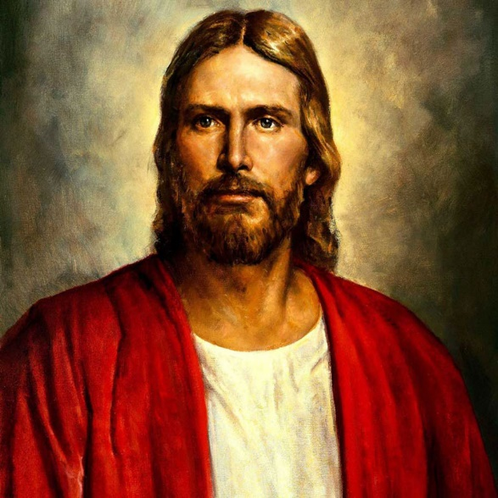
Christians follows Jesus’ example and shows love, sympathy and kindness towards others.
Jesus called on people to be peacemakers – Mathew 5:9
‘Blessed are the peacemakers,
for they will be called children of God.’

Some Christians confess before the communion if they are angry with someone.

What is Pacifism?
Believes that any sort of violence or war is incorrect.

Conscientious Objectors
Conscientious objectors are people who has claimed the right to refuse to join the military service to fight on the basis of freedom of thought, conscience or religion.
Throughout history many understood that Jesus had been a pacifist, which is suggested in his Sermon on the Mountain. Jesus stated in the sermon: 'But I'm telling you: Do not try to payback. If someone hits you on the right cheek, offer him the other cheek. And if someone wants to sue you and take your shirt, give him your coat also. (41) If a Roman soldier forces you to carry his pack for one mile, go with two.
Also in his sermon, Jesus said:
"You have heard this, it was said:'Love your neighbor' (and ‘hate thine enemy'). (44) But I tell you: Love your enemies and pray for those who persecute you! (45) Then you will show that you are the children of your Father in heaven, because that is the kind of thing he does - he makes sun shine on the evil and the good, and gives rain to those who do what is right and those who do not.'

Pacifists – Society of Friends in Wales
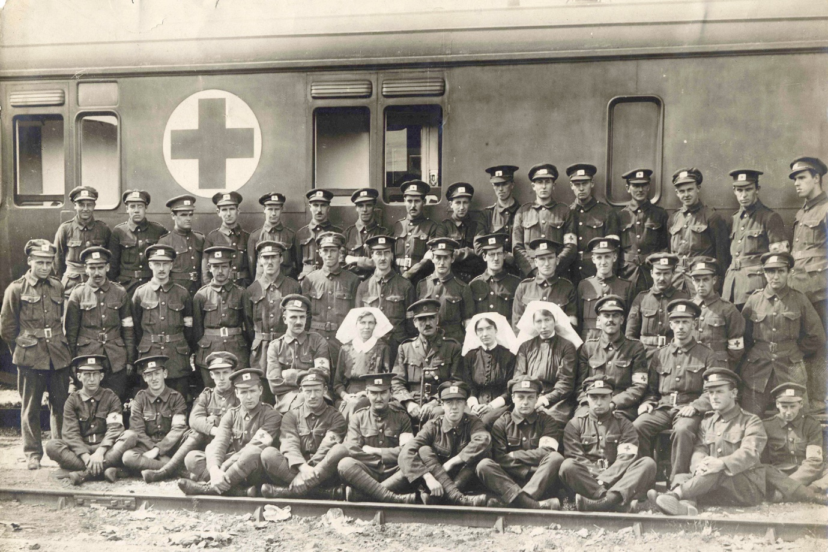
The Quakers, or the Religious Society of Friends, is a Christian denomination founded in the 17th century in England. The Quakers are pacifists. They believe that peace should be kept at all times and they would not engage in war or conflict.
Why do you think?

Some Christians, such as the Religious Society of Friends (Quakers), opposes fighting completely and during warfare they oppose publically and conscientiously. They are ready to go into battle by being responsible for driving an ambulance or doing other duties but they will not fight in a war.
Of course, other Christians are more than ready to fight in the armed forces and many Quakers are always a part of military units.

How can you get peace?
One way is to get religions to collaborate. The key concept here is the dialogue – inter-faith, defined as researching common ground between different faith groups.

TASK
Follow the ‘Pacifism Powerpoint’
- Create an information sheet about Corrymeela
Use notes from the Powerpoint or the below websites:
- http://www.corrymeela.org/
- https://www.youtube.com/watch?v=f5iw62O9_18

What comes to your mind when you look at this picture?
Forgiveness
Some believe that the only way to have peace after conflict is by forgiving. Every religion has a clear teaching about the importance of forgiving.

Believers can consider it is possible to forgive anyone with the help of God

It must come from the heart

The acts of religious leaders show this for example the Pope of John Paul II

Reconcile activities for example Corrymeela shows that this is possible
There are some things you cannot forgive

Sometimes, forgiveness can take a lot of time; it comes in the end but no one ever forgets

In Judaism you cannot forgive on behalf of others.

Believers can consider what God has forgiven them for and then teach how to forgive others

Is forgiveness
possible?
Improvement services for forgiveness are held to make it possible

If we do not learn to forgive, society will become hard and even more selfish
Even though it’s hard, forgiveness must come, or people will not be able to carry on with their lives
Forgiveness is an important part of the Lord’s Prayer and Prayers from other holy subjects

Without forgiveness, there is no hope; only bitterness

Forgiveness is the path to reconcile, so it’s very important for us to do it and receive it, ask for it and offer it

Christian teaching about forgiveness
Christians have certain teachings about forgiveness. Jesus’ teaching, for example, the Beatitudes (‘Blessed are the merciful, for they will receive mercy ‘), and his words on the cross – ‘Father, forgive them because they do not know what they are doing.’
Jesus’ actions for example, Zacchaeus. Jesus visited him even though he was a cheat and was selfish, and gave him a new sense of life and purpose for him.
You also need to remember examples of Christians that forgave e.g. Martin Luther King Jr.
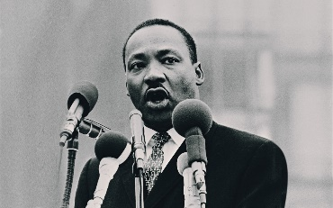
‘Forgiveness does not mean ignoring what has been done or putting a false label on an evil act. It means, rather, that the evil act no longer remains as a barrier to the relationship. Forgiveness is a catalyst creating the atmosphere necessary for a fresh start and a new beginning. It is the lifting of a burden or the cancelling of a debt. The words "I will forgive you, but I'll never forget what you've done" never explain the real nature of forgiveness. Certainly, one can never forget, if that means erasing it totally from his mind. But when we forgive, we forget in the sense that the evil deed is no longer a mental block impeding a new relationship. Likewise, we can never say, "I will forgive you, but I won't have anything further to do with you." Forgiveness means reconciliation, a coming together again’
Task – Summarize Martin Luther King’s vocabulary to 25 words.
The Lord’s Prayer includes the words ‘Forgive us our debts as we forgive our debtors.’ Here’s Jesus’ important prayer that he would narrate and say to his disciples.

Matthew 18:21-22
²¹ Then Peter came to Jesus and asked, “Lord, how many times shall I forgive my brother or sister who sins against me? Up to seven times?”
²² Jesus answered, “I tell you, not seven times, but at least seventy-seven times!

The Parable of the Unforgiving Servant
Watch the clips on the website and make some notes on the two clips -http://request.org.uk/jesus/parables/the-unforgiving-servant-2/
What is the Parable’s message?

Mathew 6:14-15
¹⁴ For if you forgive other people when they sin against you, your heavenly Father will also forgive you. ¹⁵ But if you do not forgive others their sins, your Father will not forgive your sins.
In pairs – note what this quotation says about forgiveness. Do you believe in what is being said?

TASK
Watch the clip - http://request.org.uk/issues/ultimate-questions/big-questions-why-should-i-forgive/
Write a ‘Tweet’ to note what the clip says about forgiveness.

Forgiveness – Personal Beliefs
Gee Walker – the mother of the young boy from Liverpool that was murdered
I forgive them. I can’t hate. Hate is what killed Anthony.

Anthony Walker was 18 years old and a member of the Grace Family Church in Liverpool. He was also a youth leader. He was murdered as he was walking with his girlfriend in the direction of the bus station. Two young boys attacked him because he was black and he later died.
Gee Walker, Anthony’s mum, explained that it’s important for her to forgive as she is a Christian and follows Jesus’ example when he showed forgiveness. Not forgiving would insult her son Anthony that shared the same Christian faith as her. It was also important to respond to racism and hate with tolerance and love – the only way of overcoming racism.
In response to someone asking her if she forgives the murderers of her son for the sake of them; she said that she does so for the sake of herself and her son Anthony. She said:
Not forgiving is a heavy weight. It is a heavy burden to carry. I have seen what this does to people. They turn bitter and angry. I do not want to be that way. I do not want to be a sufferer in two ways. In my heart I have the love and pain that I feel over Anthony and there is no space for anything else.

Here are Gee Walker and her family’s quotations in an interview. In the interview they say they forgive murderers. Choose 2 quotations that you think are the most special and discuss.
___________________________________________________________________________________________________________________________________________________________________________________________________________________________________________________________________________________________________________________________________________________________________________________________________________________________________________________________________________________________________________________________________________________________________________________________________________
Task – watch the below clips:
- Gee Walker’s history:
http://www.bbc.co.uk/education/clips/zkxr87h
- Julie Nicholson’s history:
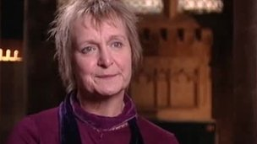
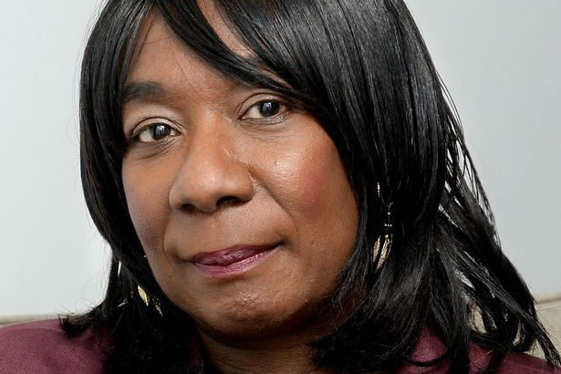
http://www.bbc.co.uk/education/clips/zdt4wmn

Fill in the venn diagrams about the two stories

