**Unit 2**

Issues of Good and evil

Crime and Punishment

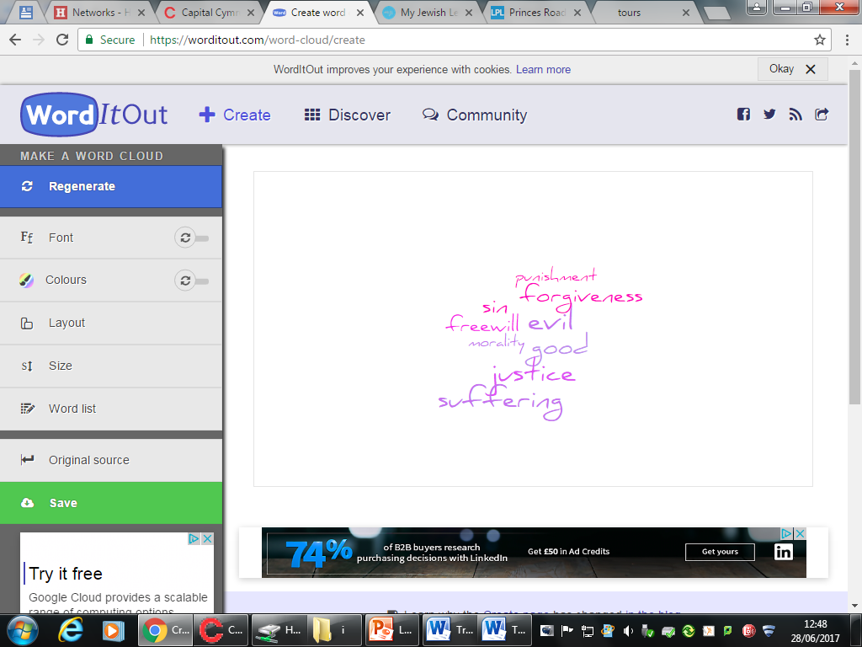

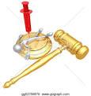

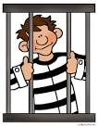

Name: _____________________________________

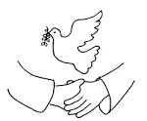







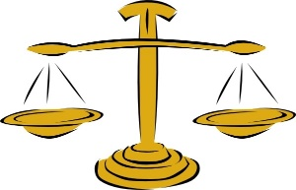

**Morality**

Principles and standards determining which actions are right or wrong.



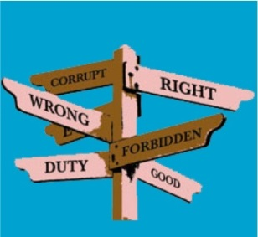

**Making moral decisions**

People use a variety of sources to make decisions:

* scriptures
* religious leaders
* consience
* Reasoning.

**How do we make moral decisions?**

Our past experiences allow us to learn the rightness and wrongness of our actions, partially though the responses of others to our behaviour and choices. The human brain has evolved to learn from previous experiences and use these reflections to help us to make decisions in the future.

The law offers us strict guidance for our behaviour. Laws are made by our elected representatives in government and exist to help maintain order, peace and harmony. Breaking these laws is met with punishments such as fines, community services and prison.

Many people consult religious leaders for advice and guidance before making difficult moral decisions. It is widely accepted that these individuals have the wisdom, experience and knowledge to help. They have usually received special training to understand and interpret Holy Scriptures and teachings; these are God’s representatives on earth.

**How do people make decisions?**

Principles and standards determining which actions are right or wrong.

* What influences my decisions? Smart art two circle diagram showing decisions, influences is this a bad or positive things

**How do people make moral decisions?**

Principles and standards determining which actions are right or wrong.

Making moral decisions is not a straightforward process.

We all have a conscience- an inner voice which keeps a person on the right track, a sense of right and wrong, an insticnct (which religious believers think is given by God”

**Relative and Absolute Morality**

Morality: Principles of standards determing which actions are right of wrong.

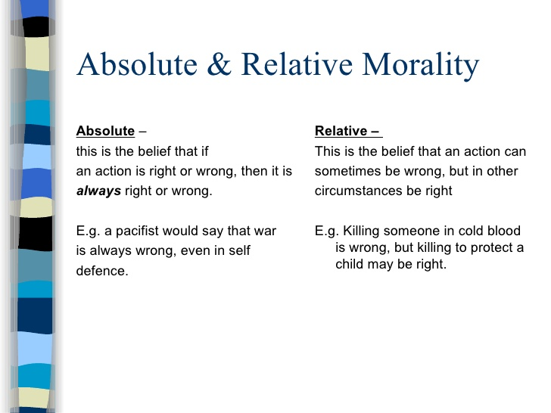

**Crime**

Crime can be defined as any offence that is punishable by law. The government makes laws which govern our behaviour, the police control this with the justice system,

Principles and standards determining which actions are right or wrong.

Crime versus sin

Sin- is a deliberate immoral action, breaking a religious or moral law. Although there are many sins that can be punished by law, a number of sins are not considered crimes in modern society. For example, while it goes against the Ten Commandments to commit adultery and to work on a Sunday neither are crime according to the law,

The consequences of committing a sin are critically different. For Christians sinful behaviour can lead to personal suffering, offending God- excommunication (being cut off from the church) or even exclusion from heaven.

Jews believe that , while to sin is part of human life, those who sin will suffer for their punishment.

**Causes of crime**

Principles and standards determining which actions are right or wrong.

The cause of crime can be complex because they can be anything, Create a mind map look at the main causes of crime in society today:

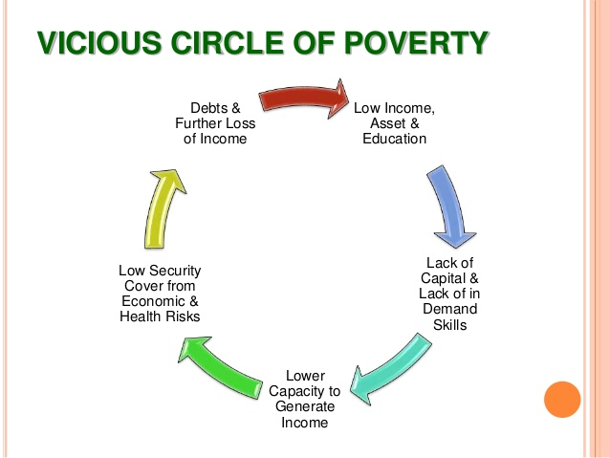

Numeracy- Research the main causes of crime and create a pie chart what are the main causes.

**-**

**Aims of punishment**

Punishment- A penalty given to someone for a crime or wrong they have done

When detected and prosecuted, criminal behaviour results in punishment. There are a number of different punishment options available to judges. Often a judge will consider several different punishments for a person who has committed a crime.

**Protection**- punishment often aims to protect more people from becoming victims of crime. As a prison sentence removes a criminal from society innocent people are prevented from suffering from wrongdoing as the criminal has no option to commit further crime, Terrorists, murderers rapists and drug dealers are given prison sentences as they pose a danger to the rest of society.

**Retribution**- In simple terms, this means revenge. Getting even with a person who has committed a crime means that the criminal suffers just as they have made others suffer. For some victims of crime, this is the only way that they feel that justice has been done.

**Deterrence -**For many people, one of the main aims of punishment is to deter or put people off committing crime altogether. Historically in England this was the main purpose of the death penalty, and is still seen to be the aim in some states in the USA where executions take place for murder. For a deterrent to work, the criminals who are caught need to be made an example of in order to warn others in society not to commit crime.

**Reformation**- Punishment can only go so far if it does not address the causes of crime and the reasons why some people become criminals. Because of this, one of the main aims of modern punishment is to reform or rehabilitate offenders so that they can understand why they committed offence and attempt to fix these problems. Reform can take the shape of therapy, counselling, education or training.

**Vindication-** Through effective punishment the government and the law can prove that it deserves respect and should be followed. Punishment exists to prove the authority of the law, and it reminds people that without law and order there is chaos. This aim of punishment allows people to have confidence in the law and respect for the role it plays in creating order.

**Reparation-** simply means repairing the damage done through crime. Restorative justice programmes, such as community service clean up schemes for vandals allow offenders to attempt to make up for the crime they have committed.

|  |  |  |  |
| --- | --- | --- | --- |
| Punishment/ key ideas  Cosb/ Prif syniadau | Example of when it may be used  Enghraifft o phryd mae’n cael ei ddefnyddio. | Positives of this punishment  Agweddau positif o’r gosb | Image result for thinking bubble question markNegatives of this punishment  Agweddau negatif o’r gosb. |
|  |  |  |  |
|  |  |  |  |
|  |  |  |  |
|  |  |  |  |
|  |  |  |  |
|  |  |  |  |

**Justice**

Fairness where everyone has equal provisions and opportunity.

Justice is fairness, when talking about crime and punishment most people takes justice to mean that a criminal is caught, fairly tried in court and given a punishment which both fits the crime and allows the victim to overcome their resentment.

**Justice and punishment**

Justice can’t be maintained to some extent without some form of punishment. For justice to be truly achieved punishment must address the cause of the crime and reflect the severity. Should we give a murderer community service? Or a drug dealer a life sentence in a high security prison? Where’s the line?

21st century Britain

Prisons are schools for crime.

Prisons in Britain are at breaking point. Numbers in prison have never been so high, and yet neither have rates of reoffending on release,

Benefits of prisons are to protect the society from violent and dangerous criminals and remove those who have done wrong from their families.

Many prisoners however re-offend when they are released whit the rate higher for those who have received short sentences of less than a year.

Prison has a poor recorded for reducing reoffending 46% of adults are reconvicted within in one year of release.

It is hard to get a job with a criminal record- this can add to bitterness and resentment.



**Christian attitudes to punishment and justice**

Christianity is a religion of forgiveness and as such Christians do not support the idea of retribution as a purpose of punishment. Christians do believe in justice which means that forgiveness and punishment should go together. Christians should try to follow the example of Jesus who forgave those who betrayed him. Many support punishment practices which lead to forgiveness, for example restorative justice programmes in prison.

Jesus taught compassion not revenge and because of this many Christians have been involved in prison reform to ensure that people are treated as humanely possible.

They also believe it is important to recognise and address the causes of criminal behaviour, such as poverty, unemployment and poor social conditions as a means of restoring social justice and preventing crime.

Punishment should allow someone to reform to change their ways.

Restorative justice- a system of justice that enables criminals to make amends for their behaviour by meeting with their victim and apologising.



**Jewish attitudes to punishment and justice**

In Judaism free will is important therefore people should take responsibilities over their actions. Jews believe that punishment should deter, protect society , provide retribution and promote justice. God created a just world and they must practise justice themselves. Judges must be appointed and they should be fair.

Torah gives instructions on how crime should be punished.

There are different views on punishment within Judaism. Reform Jewish community are often active in protesting for the fair treatment of prisoners while in jail. Jews teach that they should be forgiven; however only the victim is able to forgive as no one can be forgiving on behalf of others.

Offenders should repeat and ask God’s forgiveness by avoiding repeat offending, giving money to charity and fasting- especially on the day of attoment.

**Research Task: What** is the Day of Atonement and **why** is it important to Jews?



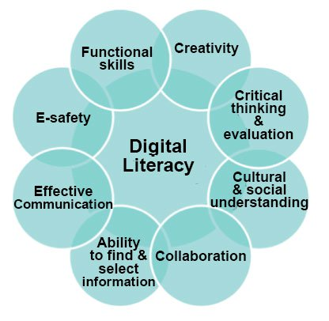**Task:** Create an information sheet using your digital literacy skills.

* Cultural and social understanding: by researching the above questions on what is the day of atonement.
* Use your creativity: Set your work in a readable and revisable format.
* Show your ability to find and select information.
* Functional skills: SPAG must be checked before printing.

**Challenge yourself:**

Is it relevant in the West?

Do Jews celebrate it in Wales?

How would this effect Jewish viewpoint on punishment?



**Prison Reformers**

**Prison reform** is the attempt to improve conditions inside **prisons**, establish a more effective justice system, or implement alternatives as a punishment.

**John Howard**

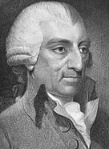Committed Calvinist (Protestant Christian) and inspected prisons in the late 18century. He found them to be diseased, dirty and corrupt, and gave evidence to Parliament with recommendations that conditions and practices be improved.

He called for basic but essential provisions such as clean running water, separate cells from men and women, access it doctors and greater number of prison officers to support and ensure the safety of inmates. This was at a time when the majority of prisons were privately run for profit.

**Elizabeth Fry**

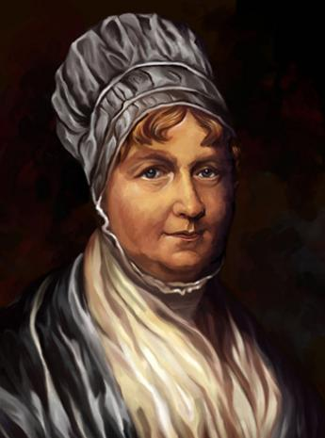19century Quaker prison reformer who dedicated her life to improving the state of British prisons after vising Newgate Prison in London in 1813.

She was a passionate advocate of education in prisons and looked towards reforming prisoners as opposed to simply isolating them from society. She is most famous for teaching female prisoners to read and write and holding Bible readings for inmates.

By 1870’s ideas about prisons had changed dramatically. Purpose build institutions like Pentonville prison in London were to be found accord the country and a lively debate about how to treat prisoners once in jail had been born.

Do you recognise this woman?

Religious opinion:

………………………………………………………………………………………………………………………………………………………………………………………………………………………………………………………………………………………………..

Do you think she deserved to be on the back? Why?

Why do you think Elizabeth Fry was chosen to be on the back of an old £5 note?

Some would disagree:

………………………………………………………………………………………………………………………………………………………………………………………………………………………………………………………………………………………………..

Some would agree:

………………………………………………………………………………………………………………………………………………………………………………………………………………………………………………………………………………………………..

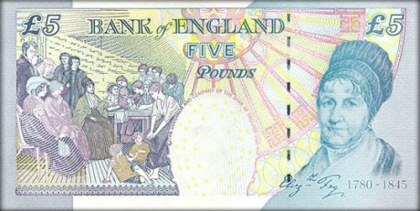 “Every famous person should be on the back of money”

My opinion:

………………………………………………………………………………………………………………………………………………………………………………………………………………………………………………………………………………………………..

If you designed the new £5 who would you put on the back? Why?

Who is on the back of the new £5? Good decision?

**Prisons in Wales**

The prison population in England and Wales I 85,641 compared to 44,246 in 1993. Reoffending rates are high. According to the National Audit Office, reoffending costs us the equivalent of staging another Olympic games every year,

Government statistics: 53% of the prison population have qualifications, compared to 85% of the working population.



**What is your opinion on this?**

Disadvantages

Advantages

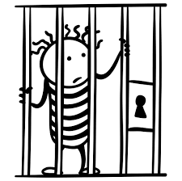

**HMP Berwyn, Wrexham**

HMP Berwyn, which has opened in Wrexham, can hold more than 2,100 prisoners, dwarfing HMP Oakwood, near Wolverhampton, which has a 1,600 capacity. The new prison's governor, Russ Trent, believes offenders will have a great opportunity to rehabilitate themselves.

The prison was built at a cost of £212 million. There are three wings. The first - Bala - is open for inmates. The second ward, Alwen, is set to open in May and Ceiriog in July, each housing 702 men.

In total there will be about 2,100 inmates when fully operational, the largest in the UK. The prison features colourful environments with wall art and showers and a college style facility to learn new skills including joinery, carpentry and brick-laying. Each wing will be further split into eight communities of 88 prisoners

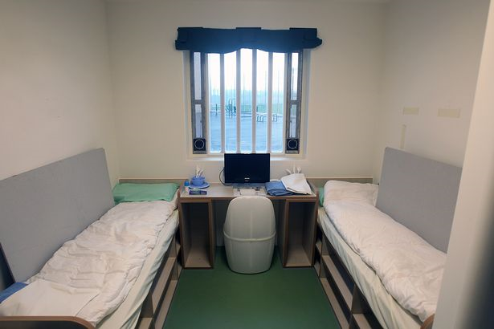Each two-man room - they’re not called cells - will have a laptop as well as a phone, shower and toilet. The laptops will not have access to the internet but will be used to arrange visits, order meals for the week and do their weekly shopping, as well as complete any work related to their studies.

The phones in the prisoners’ rooms can only be used under strict conditions and when earned as a privilege.The prison also has new gyms, five-a-side pitches, a library and a visiting room with play area for children.

On the walls were also messages of inspiration “Look to the future with ambition and hope” and “Big journeys begin with little steps”. The majority of inmates at HMP Berwyn will be Category C, classed as prisoners who cannot be trusted in open conditions but who are unlikely to try to escape.

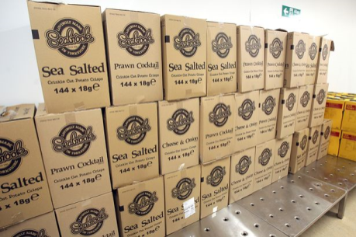It may take some Category B prisoners classed as, if they escape would pose a large risk to members of the community.

Prison governor Russ Trent said:

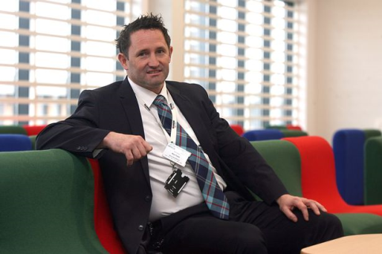"I think Berwyn can be a truly rehabilitative prison where the men will be kept in decent conditions and given every opportunity to live law-abiding lives when they return to their community. People are being taken away from their families and their homes – that is the punishment. While they’re here, it’s our job to give them every chance to better themselves and become better educated, with better work opportunities and being someone that the community can be proud of."

2016 was a bad 12 months for UK jails with a record number of inmates taking their own lives - 119 - and riots seen at prisons including HMP Birmingham and HMP Swaleside on the Isle of Sheppey in Kent.

Mr Trent believes the ethos of rehabilitation, which permeates all aspects of the prison and was a criteria for selecting staff, will deter inmates from wanting to take their lives or behave badly.

“We should open more prisons in Wales, there’s plenty of room here”

|  |  |
| --- | --- |
| Agree  ………………………………………………..……………  ………………………………………………..……………  ………………………………………………..……………  ………………………………………………..……………  ………………………………………………..……………  ………………………………………………..……………  ………………………………………………..……………  ………………………………………………..……………  ………………………………………………..……………  ………………………………………………..……………  ………………………………………………..…………… | Disagree  ………………………………………………..……………  ………………………………………………..……………  ………………………………………………..……………  ………………………………………………..……………  ………………………………………………..……………  ………………………………………………..……………  ………………………………………………..……………  ………………………………………………..……………  ………………………………………………..……………  ………………………………………………..……………  ………………………………………………..…………… |
| Religious Opinion  ………………………………………………..…………………………………………………………………………………..………………………………………………..…………………………………………………………………………………..  ………………………………………………..…………………………………………………………………………………..  ………………………………………………..…………………………………………………………………………………..  ………………………………………………..…………………………………………………………………………………..  ………………………………………………..…………………………………………………………………………………..  ………………………………………………..………………………………………………………………………………….. | |
| My opinion  ………………………………………………..…………………………………………………………………………………..………………………………………………..…………………………………………………………………………………..  ………………………………………………..…………………………………………………………………………………..  ………………………………………………..…………………………………………………………………………………..  ………………………………………………..…………………………………………………………………………………..  ………………………………………………..…………………………………………………………………………………..  ………………………………………………..…………………………………………………………………………………..  ………………………………………………..………………………………………………………………………………….. | |

**Care for prisoners- prison chaplains.**

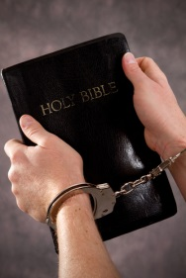**What is a chaplain?**

Traditionally a chaplain is a minister, such as a priest, or rabbi. They are attached to non- religious institutions such as hospitals, prisons, schools or universities. Their job is to provide ‘pastoral’ care for patients, pupils or prisoners.

**What is their role?**

Prison chaplains have a demanding and essential job, providing counselling to inmates, supporting them through their rehabilitation and seeing to their spiritual and religious needs. Prisoners have to deal with a complex mixture of emotions and needs during their sentence and they often need someone who is not a prison officer or warden to offer support. Fear, loneliness, guilt, concerns about family or children on the outside; all of these become the concern of the prison chaplain.

Chaplains also offer help for prisoners to re-enter the community, working with parole officers (a person that supports a prisoned on their release from prison and the return to the community). Families of inmates also have access to prison chaplains. Family members can be the victim of the inmate’s crimes and require the care of the chaplain just as much as the inmate.

Chaplains do not have to be religious, and it is documented that 32% of the prison population have no religious faith. Since 2011 the British Humanist society has been running a project with Humanist Pastoral support at Winchester prison.

This includes meeting inmates with nil religion on admission, holding discussion groups and proving counselling, such as bereavement support, for inmates. This is especially important as often prisoner are unable to attend funerals of loved ones or benefit from the type of community support offered to those who have suffered the loss of family or friends.

**Why do you think people become chaplains?**

………………………………………………..…………………………………………………………………………………..………………………………………………..……………………………………………………………………………………………………………………………………………..…………………………………………………………………………………..………………………………………………..……………………………………………………………………………………………………………………………………………..…………………………………………………………………………………..………………………………………………..……………………………………………………………………………………………………………………………………………..…………………………………………………………………………………..………………………………………………..……………………………………………………………………………………………………………………………………………..…………………………………………………………………………………..………………………………………………..……………………………………………………………………………………………

**Why do people become chaplains?**

“As a Quaker I believe that there is something of God in everyone, no matter how they gave behaved or what crimes they have committed I feel it is my duty to save them.”

“Through my work as a chaplain I am following Jesus commands- I am showing compassion, love and kindness.”

“There are so many problems in prison that cannot be solved by therapy, doctors or rehab. These problems are outside of religion, they are matters of the spirit.”

**Helen Prejean**

“People are more than the worst thing they have ever done in their lives”

Helen Prejean is a Roman Catholic Nun, and leading advocate for the abolition of the death penalty. She began her prison ministry in 1981, when she began writing to a death row inmate.

“Prision chaplains are non-judgemental; we are not there to judge their actions. Loss of freedom is the punishment for the crime and this becomes particularly apparent when they are unable to attend events, whether joyous or sad/ Thar’s when reality hits home and makes them award of the consequences of their actions/ We are there to empathise and give them hope for the future.” Michael Binstock.

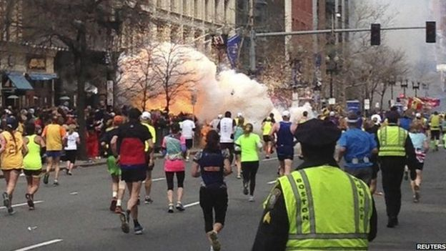**Boston Bombings 2013**

On April 15, 2013, two bombs went off near the finish line of the Boston Marathon, killing three spectators and wounding more than 260 other people. Four days later, after an intense manhunt that shut down the Boston area, police captured one of the bombing suspects, 19-year-old Dzhokhar Tsarnaev, whose older brother and fellow suspect, 26-year-old Tamerlan Tsarnaev, died following a shootout with law enforcement earlier that same day. Investigators later concluded that the Tsarnaevs, who spent part of their childhoods in the former Soviet republic of Kyrgyzstan but lived in the United States for about a decade prior to the bombings, planned and carried out the attack on their own and were not connected to any terrorist organizations. Dzhokhar Tsarnaev was scheduled to stand trial in November 2014; federal prosecutors have announced they will seek the death penalty.

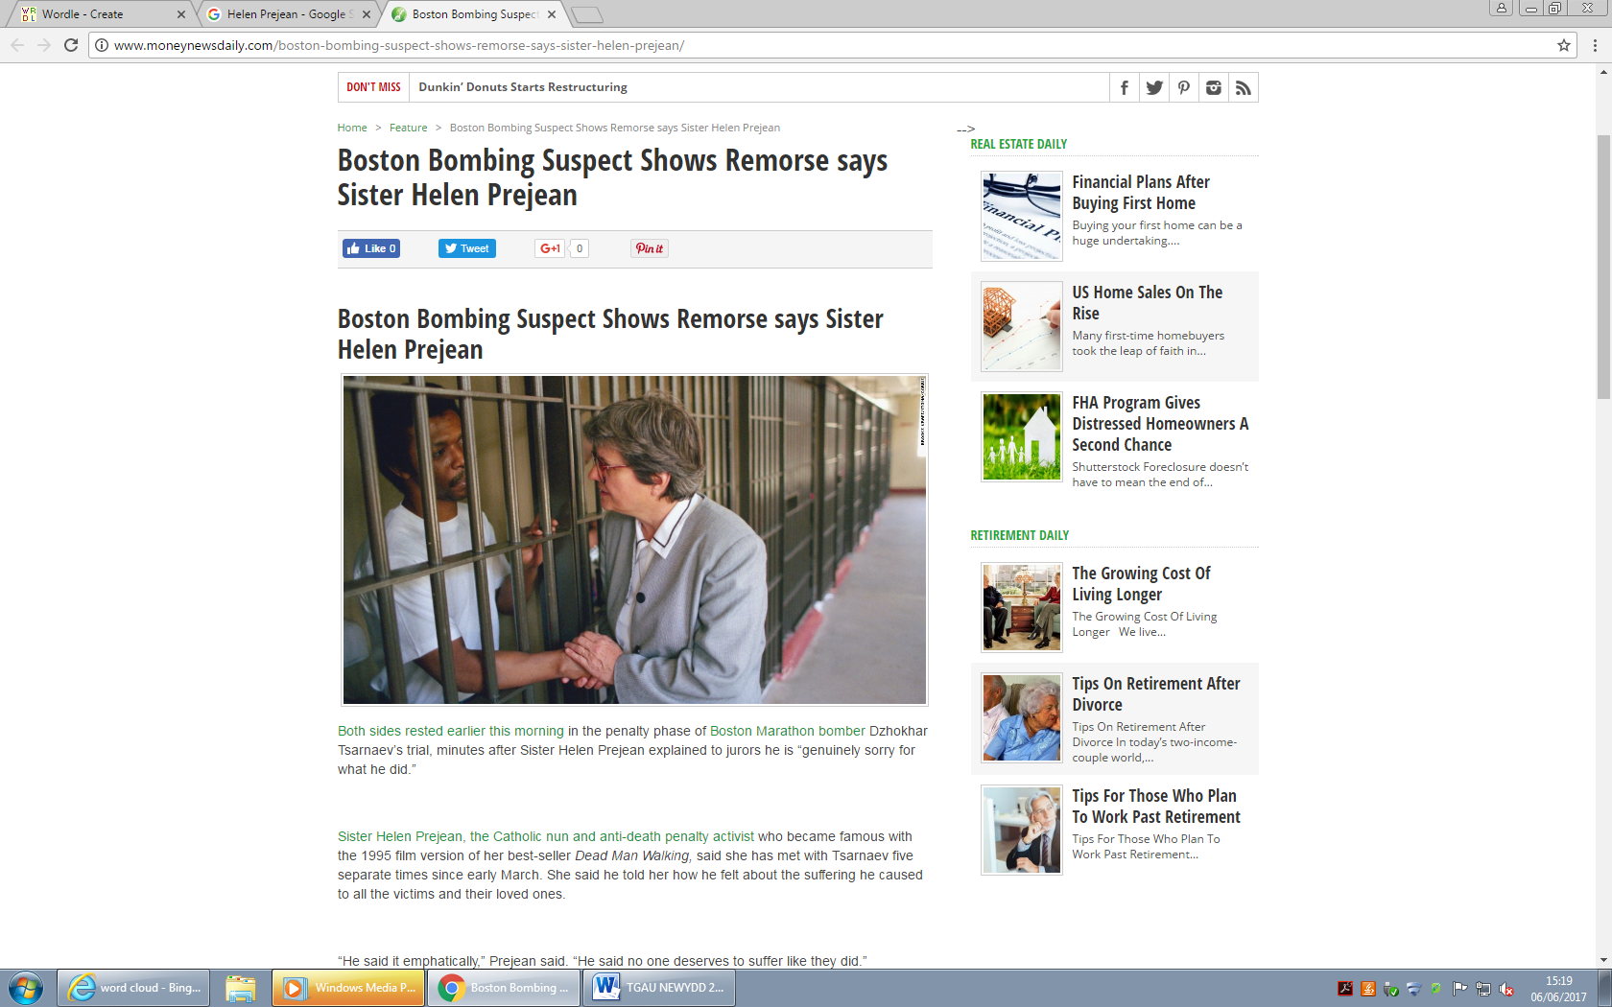

**Read the article from the NY Times**

<https://www.nytimes.com/2015/05/12/us/sister-helen-prejean-says-tsarnaev-shows-remorse-for-boston-bombing.html?_r=0>

**What is Helen Prejean’s opinion on the Boston Bombing suspect?**

………………………………………………..…………………………………………………………………………………..………………………………………………..……………………………………………………………………………………………………………………………………………..…………………………………………………………………………………..………………………………………………..……………………………………………………………………………………………………………………………………………..…………………………………………………………………………………..………………………………………………..……………………………………………………………………………………………………………………………………………..…………………………………………………………………………………..………………………………………………..……………………………………………………………………………………………………………………………………………..…………………………………………………………………………………..………………………………………………..……………………………………………………………………………………………

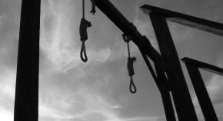**The Death Penalty**

The death penalty has been a feature of punishment practices for thousands of years. It has been used by societies across the world to deter crim e and to punish the very worst criminal behaviours. Also referred to as capital punishment or execution, the death penalty is still legal in over 80 different countries (although 50 of these countries have not used execution.

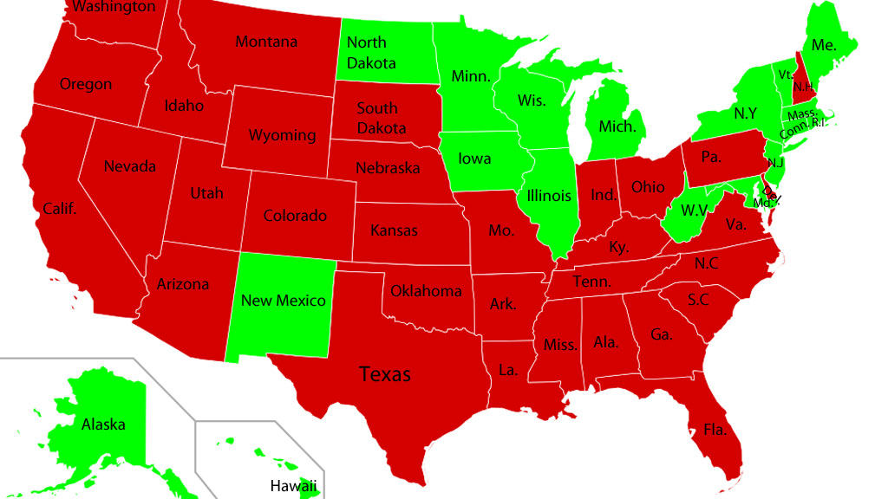

Of the 50 States of America, 31 allow execution. Death row is the name given to the area was death penalty convicts reside in prison for the crimes of murder and treason.

**What is your opinion on this?**



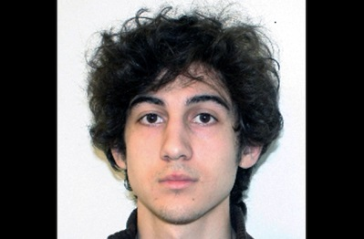*Dzhokhar Tsarnaev The Boston attacker- was on trail for the death sentence in 2014.You are part of the jury. Reasons to sentence him to the death penalty.*

|  |  |
| --- | --- |
| Agree  ………………………………………………..……………  ………………………………………………..……………  ………………………………………………..……………  ………………………………………………..……………  ………………………………………………..……………  ………………………………………………..……………  ………………………………………………..……………  ………………………………………………..……………  ………………………………………………..……………  ………………………………………………..……………  ………………………………………………..…………… | Disagree  ………………………………………………..……………  ………………………………………………..……………  ………………………………………………..……………  ………………………………………………..……………  ………………………………………………..……………  ………………………………………………..……………  ………………………………………………..……………  ………………………………………………..……………  ………………………………………………..……………  ………………………………………………..……………  ………………………………………………..…………… |
| Helen Perjan’s Opinion  ………………………………………………..…………………………………………………………………………………..………………………………………………..…………………………………………………………………………………..  ………………………………………………..…………………………………………………………………………………..  ………………………………………………..…………………………………………………………………………………..  ………………………………………………..…………………………………………………………………………………..  ………………………………………………..…………………………………………………………………………………..  ………………………………………………..………………………………………………………………………………….. | |
| My opinion  ………………………………………………..…………………………………………………………………………………..………………………………………………..…………………………………………………………………………………..  ………………………………………………..…………………………………………………………………………………..  ………………………………………………..…………………………………………………………………………………..  ………………………………………………..…………………………………………………………………………………..  ………………………………………………..…………………………………………………………………………………..  ………………………………………………..…………………………………………………………………………………..  ………………………………………………..………………………………………………………………………………….. | |

**The Death Penalty should be trailed for every murderer?**

………………………………………………..…………………………………………………………………………………..………………………………………………..……………………………………………………………………………………………………………………………………………..…………………………………………………………………………………..………………………………………………..……………………………………………………………………………………………………………………………………………..…………………………………………………………………………………..………………………………………………..……………………………………………………………………………………………………………………………………………..…………………………………………………………………………………..………………………………………………..……………………………………………………………………………………………………………………………………………..…………………………………………………………………………………..………………………………………………..……………………………………………………………………………………………

**How are people treated in prison?**

American Prison British Prison

Your Opinion Should all prisoners be treated the same?

**Research: Methods of execution that have changed over the years.**

|  |  |  |  |  |
| --- | --- | --- | --- | --- |
| Method | Description | Examples | Effective? | Risks? |
| Lethal injection |  |  |  |  |
| Electric chair |  |  |  |  |
| Gas chamber |  |  |  |  |
| Firing squad |  |  |  |  |
| Hanging |  |  |  |  |
| Decapitation (North Korea + Saudi Arabia) |  |  |  |  |
| Shooting under anaesthetic (Taiwan) |  |  |  |  |
| Stoning (Sudan) |  |  |  |  |
|  |  |  |  |  |
|  |  |  |  |  |
|  |  |  |  |  |

**Challenge:** Which countries still permit the death penalty today?

Is this an effective punishment?

**The United Kingdom**

The UK abolished the death penalty in 1969. Although public opinion has been in favour of reinstating execution- all attempts to bring I back has failed. In 2015 the number of people in favour of execution was 48%.UK is among the 82% global nations that do not use the death penalty.

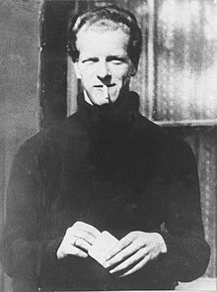Derek Bentley- was the last person to be executed. Research his story.

………………………………………………..…………………………………………………………………………………..………………………………………………..……………………………………………………………………………………………………………………………………………..…………………………………………………………………………………..………………………………………………..……………………………………………………………………………………………………………………………………………..…………………………………………………………………………………..………………………………………………..……………………………………………………………………………………………………………………………………………..…………………………………………………………………………………..………………………………………………..……………………………………………………………………………………………………………………………………………..…………………………………………………………………………………..………………………………………………..……………………………………………………………………………………………

**“Bring Back the Death Penalty to the UK”**

|  |  |
| --- | --- |
| Agree | Disagree |
|  |  |

**Christian attitudes to the death penalty.**

This varies due to different interpretations of the Bible and the extent of the teachings about the sanctity of life and Jesus examples of compassion and forgiveness.

**Liberal Christians**

Execution goes against the sanctity of life, as all life is precious and only God should end it. God only has the right to take life. Christians believe that God commanded “Thou shall not kill”

*Teachings of Jesus:*To be compassionate and forgiving. “Father forgives them for they know what they do. Reform is important- “turn the other cheek” and “love our enemies”Execution makes all of these impossible; The Golden rule is to do to others what you want to do to you.

**Quakers**

Campaigned against the death penalty since 181. All human life should be respected as every person is a reflection of God.Punishments should be used to reform. First prison reformers were Quakers, who worked to maintain the dignity of prisoners,

**Conservative Christians**

Some Christians advocate the death penalty. In the Old Testament it say “eye for an eye”It also says “Whoever sheds the blood of man, by man shall his blood be shed”

The Old Testament specifies 36 capital offences including crimes such as magic and blasphemy, as well as murder.Some would therefore argue that the death penalty should be approved as it was created by God.

Some Christians also argue that capital punishment upholds the commandment “thou shalt not kill” by showing the seriousness of the crime of murder.

**Catholic**

Catholics are also divided. Traditionally the Catholic Church has allowed but not encouraged capital punishment.

In 1997 the Vatican issued a statement saying that execution was acceptable where the identity of the criminal was absolutely confirmed and where execution was the only means to protect society from the aggressor.

**Jewish Attitudes for the death Penalty**

Mixed views also seen here on the death penalty.

“One who takes a human life must be put to death. If one kills an animal, he must pay for it, a life for a life. If one maims his neighbour he must be penalised accordingly. Thus full compensation must be paid for fracture or the loss of an eye or a tooth. If one infliclits injury on another person, he must pau as if the same injury were inflicted on him.” Leviticus 24:17-20

According to the Mishnah (Oral Torah) the death penalty could be inflicted after trail by a Sanhedrin (a cold of men appointed in every city in Israel) which has 23 judges, and there are 4 types of death penalty, stoning, burning, slaying (sword) and strangling.Heavy restrictions and conditions are placed on the use of executing, for example the requirement for two witnesses to the crime itself and for both of those witnesses to have issued warning prior to the crime been committed.

**Orthodox Judaism**

Believe that it should be allowed in certain crimes. However many rabbis view this guidance with suspicion as it means that in practise it is virtually impossible to issue a death sentence. This show that the death penalty is permitted but should only is used with caution.

Israel allows the death penalty for acts of genocide, treason or murder; although in practice it is rarely used.

The last person to be executed in Israel was Nazi war criminal Adolf Eichmann in 1962. Now death penalty exists as a deterrent not retribution.

**Reform Judaism**

1959- Union for Reform Judaism has opposed the death penalty. They said that both in concept and in practice, Jewish tradition found capital punishment repugnant and there is no persuasive evidence the capital punishment serves as a deterrent to crime. The death penalty also goes against the commandment not to kill.

***Humanist attitudes***

*Capital punishment is generally opposed by humanists because they think killing is wrong, even when carried out by the state. You cannot revers the death penalty. Humanist believes treating criminals fairly also helps to ensure that innocent suspects are treated fairly.*

**Discussion on the death penalty**

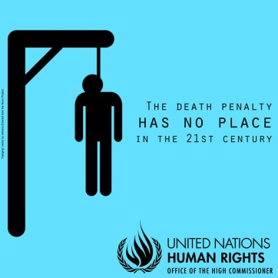

* The death penalty is state sanctioned murder.
* There is evidence that innocent people that have been executed.
* The death penalty does not deter murderers
* Only God has the right to end life.
* Two wrongs do not make a right,
* The state should be a moral force for good.
* Forgiveness is important.
* The death penalty affects members of racial ethnic and religious minorities, as well as living in poverty.
* Life terms in prison are very expensive- £40,000 a year.
* Some people, such as the criminally insane cannot be reformed,
* It is only way that victims can experience closure.
* There has to be an ultimate punishment for the very worst crimes.
* In Britain, life sentences amount to 15 years.
* Execution is the only way to truly protect society from very dangerous murderers and terrorists.

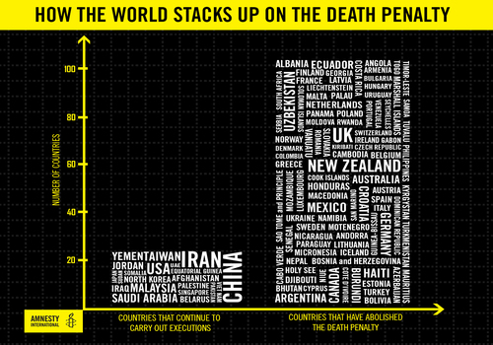

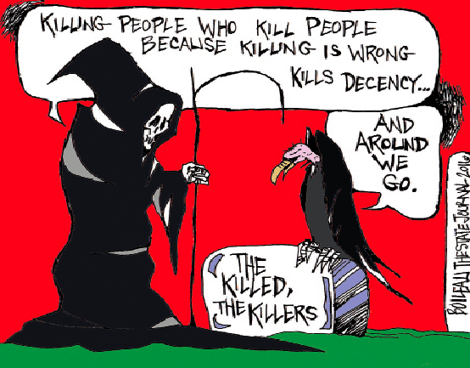

**Arguing for the death penalty**

.

Justice for use of death penalty.

Greater good for society

As an act for a deterrent.

“While the evidence tells me that the death penalty does little to deter crime, I believe there are some crimes- mass murder, the rape and murder of a child so heinous, so beyond the pale, that the community is justified in expressing the full measure of its outrage by the ultimate punishment.” Obama 2006

I believe that people who go out prepared to take the lives of other people forfeit their own right to live. I believe that the death penalty should be used only very rarely, but I believe that no-one should go out certain that no matter how cruel, how vicious, how hideous their murder, they themselves will not suffer the death penalty. Thatcher 1984.

“You have to kill me. I am evil. If you don’t I’ll just kill again” Aileen Wuronos convicted serial killer, Florida- executed 2002.

**Examples of dangerous criminals who have been let back into society.**

Jonathan Vass 2010: Murdered his ex-girlfriend Jane Clough when he was 30, after he had been released on bail for raping her. He was jailed for 0 years.

Myles Williams: 19 from East London, was convicted for the murder of his girlfriend Kirsty Treloar who was 20. He was previously arrested for violently dragging her along the street, but was released on bail.

Nathan McLeod 16, Murdered Temidayo Ogyuenne, 15 got a mobile phone in 2011. Earlier that day he had been granted bail after attacking a gas man with a bread knife.

**Can you find further examples of people that have been let into society and broken the law?**

………………………………………………..…………………………………………………………………………………..………………………………………………..……………………………………………………………………………………………………………………………………………..…………………………………………………………………………………..………………………………………………..……………………………………………………………………………………………………………………………………………..…………………………………………………………………………………..………………………………………………..……………………………………………………………………………………………………………………………………………..…………………………………………………………………………………..………………..…………………………………………………………………………………..………………………………………………..……………………………………………………………………………………………………………………………………………..…………………………………………………………………………………..………………………………………………..……………………………………………………………………………………………………………………………………………..…………………………………………………………………………………..………………………………………………..……………………………………………………………………………………………………………………………………………..…………………………………………………………………………………..……………………………………………..……………………………………………………………………………………………………………………………………………..…………………………………………………………………………………..………………………………………………..………………………………………………………………………………………………………..…………………………………………………………………………………..………………………………………………..……………………………………………………………………………………………………………………………………………..…………………………………………………………………………………..………………………………………………..……………………………………………………………………………………………………………………………………………..…………………………………………………………………………………..………………………………………………..……………………………………………………………………………………………………………………………………………..…………………………………………………………………………………..……………..…………………………………………………………………………………..………………………………………………..……………………………………………………………………………………………………………………………………………..…………………………………………………………………………………..………………………………………………..……………………………………………………………………………………………………………………………………………..…………………………………………………………………………………..………………………………………………..……………………………………………………………………………………………………………………………………………..…………………………………………………………………………………..…

**Against the death penalty**

Morally wrong.

Little evidence that the death penalty works as a deterrent.

Life is sacred and shouldn’t be ended by human beings.

**Amnesty international**

Amnesty opposes the death penalty- for all crimes without expectation.The death penalty violates basic human rights in every case.Evidence shows that it does not deter crime. It is often used within skewed or unfair and corrupt justice systems.

It discriminates. Statistics show that the death penalty is used against poor, minorities and members of racial ethnic and religious communities. It also decimates based on the race of the victim.

USA you are several times more likely to receive the death penalty if the victims was white than if the victim was African American.

It can be used as a political too. In UDS many have fast tracked executions during re-election time to prove that they are tough on crime.

What if something goes wrong?

Oklahoma inmate takes 43 minutes to die after botched lethal injection.

“My objection to the death penalty is based on the idea that this is a democracy, and in a democracy the government is me, and if the government kills somebody then I’m killing somebody.” Steve Earle musician,

“I do not think that God approves the death penalty for any crime, rape and murder included. Capital punishment is against the better judgement of modern criminology, and, above all, against the highest expression of love in the nature of God. Martin Luther King.

Numeracy task:

Average cost of a prisoner being sentenced to the death penalty $3 million.

Average cost of a prisoner being sentenced to life imprisonment: $1.1 million.

Average cost of keeping a person in jail for a year is. $58,351.

Average cost for a lethal injection $1,300

Convert dollars into pounds to see how much that would cost.

1 dollar = 0.77 pence

## Example:

Ann is going to Spain on holiday and changes £200 to euros. How many euros does she get?

One pound is €1.58

So £200 = 200 x 1.58 = 316

Ann gets €316

