QUESTION 1
Examiner only
This question is about Race and Religion.
Study the source below and then answer the question which follows.
Source A
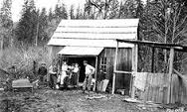

[An Indian logger and his family outside their home in Washington State, 1916]

Use Source A and your own knowledge to describe the lifestyle of the Native Americans.
[6]
--------------------------------------------------------------------------------------------------------------------------------------------------------------------------------------------------------------------------------------------------------------------------------------------------------------------------------------------------------------------------------------------------------------------------------------------------------------------------------------------------------------------------------------------------------------------------------------------------------------------------------------------------------------------------------------------------------------------------------------------------------------------------------------------------------------------------------------------------------------------------------------------------------------------------------------------------------------------------------------------------------------------------------------------------------------------------------------------------------------
Turn over.
--------------------------------------------------------------------------------------------------------------------------------------------------------------------------------------------------------------------------------------------------------------------------------------------------------------------------------------------------------------------------------------------------------------------------------------------------------------------------------------------------------------------------------------------------------------------------------------------------------------------------------------------------------------------------------------------------------------------------------------------------------------------------------------------------------------------------------------------------------------------------------------------------------------------------------------------------------------------------------------------------------------------------------------------------------------------------------------------------------------------------------------------------------------------------------------------------------------------------------------------------------------------------------------------------------------------------------------------------------------------------------------------
Examiner only

QUESTION 2
Examiner only
This question is about the economic boom.
Describe the economic impact of the First World War [8]
----------------------------------------------------------------------------------------------------------------------------------------------------------------------------------------------------------------------------------------------------------------------------------------------------------------------------------------------------------------------------------------------------------------------------------------------------------------------------------------------------------------------------------------------------------------------------------------------------------------------------------------------------------------------------------------------------------------------------------------------------------------------------------------------------------------------------------------------------------------------------------------------------------------------------------------------------------------------------------------------------------------------------------------------------------------------------------------------------------------------------------------------------------------------------------------------------------------------------------------------------------------------------------------------------------------------------------------------------------------------------------------------------------------------------------------------------------------------------------------------------------------------------------------------------------------------------------------------------------------------------------------------------------------------------------------------------------------------------------------------------------------------------------------------------------------------------------------------------------------------------------------------------------------------------------------------------------------------------------------------------------------------------------------------------------------------------------------------------------------------------------------------------------------------------------------------------------------------------------------------------------------------------------------------------------------------------------------------------------------------------------------------------------------------------------------------------------------------------------------------------------------------------------------------------------------------------------------------------------------------------------------------------------------------------------------------------------------------------------------------------------------------------------------

QUESTION 3
This question is about Crime and Corruption.
Study the source below and then answer the question which follows.
Source B
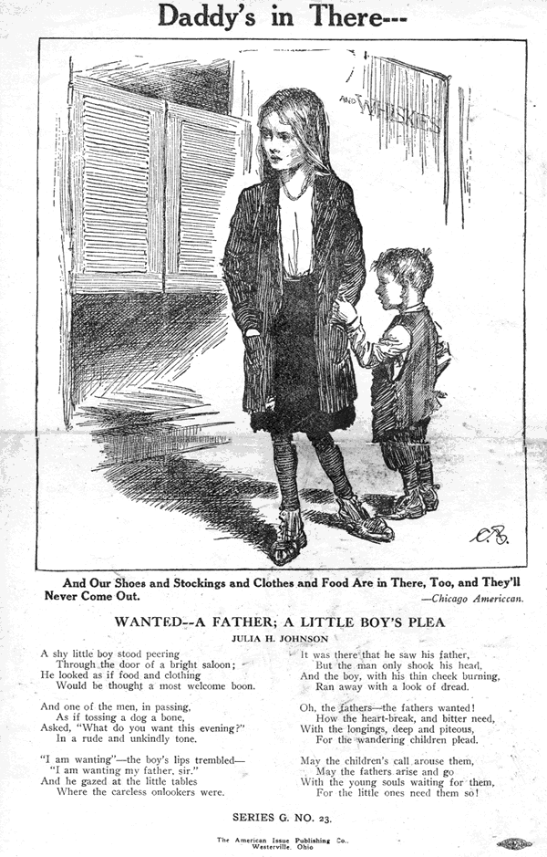

[A poster issued by the Anti-Saloon League in 1917]

What was the purpose of Source B? [8]

[Use details from Source B and your own knowledge and understanding of the historical context to answer the question.]

------------------------------------------------------------------------------------------------------------------------------------------------------------------------------------------------------------------------------------------------------------------------------------------------------------------------------------------------------------------------------------------------------------------------------------------------------------------------------------------------------------------------------------------------------------------------------------------------------------------------------------------------------------------------------------------------------------------------------------------------------------------------------------------------------------------------------------------------------------------------------------------------------------------------------------------------------------------------------------------------------------------------------------------------------------------------------------------------------------------------------------------------------------------------------------------------------------------------------------------------------------------------------------------------------------------------------------------------------------------------------------------------------------------------------------------------------------------------------------------------------------------------------------------------------------------------------------------------------------------------------------------------------------------------------------------------------------------------------------------------------------------------------------------------------------------------------------------------------------------------------------------------------------------------------------------------------------------------------------------------------------------------------------------------------------------------------------------------------------------------------------------------------------------------------------------------------------------------------------------------------------------------------------------------------------------------------------------------------------------------------------------------------------------------------------------------------------------------------------------------------------------------------------------------------------------------------------------------------------------------------------------------------------------------------------------------------------------------------------------------------------------------------------------------------------------------------------------------------------------------------------------------------------------------------------------------------------------------------------------------------------------------------------------------------------------------------------------------------------------------------------------------------------------------------------------------------------------------------------------------------------------------------------------------------------------------------------------------

QUESTION 4
This question is about the end of prosperity.
Study the sources below and then answer the question that follows.
Source C
Stock prices virtually collapsed yesterday, swept downwards with gigantic losses in the most disastrous trading day in the stock market’s history. Billions of dollars in market value were wiped out. The market on the rampage is no respecter of persons. It wasted fortune after fortune yesterday and financially crippled thousands of individuals in all parts of the world.

[The New York Times, 30 October 1929]
Source D
It was Thursday 24 October, the day the dam burst on the American economy. It was a frantic day. There were two very big news stories to worry about. An anarchist had tried to kill an Italian prince in Brussels. And the price of shares had collapsed on Wall Street. Thousands of people seemed to be ruined. The Exchange had had a few slumps in the past and a few serious hiccups but had always recovered. Some of the country’s most important bankers and political leaders told the people that they should not panic, and invited them not to sell America short, to trust in the country’s future.

[Luigi Barzini, an Italian immigrant, writing in a newspaper article shortly after the crash]

Which of the sources is more useful to an historian studying the Wall Street Crash?
[12]
[You should refer to both sources in your answer and use your knowledge and understanding of the historical context.]

------------------------------------------------------------------------------------------------------------------------------------------------------------------------------------------------------------------------------------------------------------------------------------------------------------------------------------------------------------------------------------------------------------------------------------------------------------------------------------------------------------------------------------------------------------------------------------------------------------------------------------------------------------------------------------------------------------------------------------------------------------------------------------------------------------------------------------------------------------------------------------------------------------------------------------------------------------------------------------------------------------------------------------------------------------------------------------------------------------------------------------------------------------------------------------------------------------------------------------------------------------------------------------------------------------------------------------------------------------------------------------------------------------------------------------------------------------------------------------------------------------------------------------------------------------------------------------------------------------------------------------------------------------------------------------------------------------------------------------------------------------------------------------------------------------------------------------------------------------------------------------------------------------------------------------------------------------------------------------------------------------------------------------------------------------------------------------------------------------------------------------------------------------------------------------------------------------------------------------------------------------------------------------------------------------------------------------------------------------------------------------------------------------------------------------------------------------------------------------------------------------------------------------------------------------------------------------------------------------------------------------------------------------------------------------------------------------------------------------------------------------------------------------------------------------------------------------------------------------------------------------------------------------------------------------------------------------------------------------------------------------------------------------------------------------------------------------------------------------------------------------------------------------------------------------------------------------------------------------------------------------------------------------------------------------------------------------------------

--------------------------------------------------------------------------------------------------------------------------------------------------------------------------------------------------------------------------------------------------------------------------------------------------------------------------------------------------------------------------------------------------------------------------------------------------------------------------------------------------------------------------------------------------------------------------------------------------------------------------------------------------------------------------------------------------------------------------------------------------------------------------------------------------------------------------------------------------------------------------------------------------------------------------------------------------------------------------------------------------------------------------------------------------------------------------------------------------------------------------------------------------------------------------------------------------------------------------------------------------------------------------------------------------------------------------------------------------------------------------------------------

QUESTION 5
This question is about Popular Entertainment.
Was ‘going to the movies’ the main development in American culture and society
during this period? [16]

Use your own knowledge and understanding of the issue to support your answer. Marks for spelling, punctuation and the accurate use of grammar and specialist language are allocated to this question. [3]
------------------------------------------------------------------------------------------------------------------------------------------------------------------------------------------------------------------------------------------------------------------------------------------------------------------------------------------------------------------------------------------------------------------------------------------------------------------------------------------------------------------------------------------------------------------------------------------------------------------------------------------------------------------------------------------------------------------------------------------------------------------------------------------------------------------------------------------------------------------------------------------------------------------------------------------------------------------------------------------------------------------------------------------------------------------------------------------------------------------------------------------------------------------------------------------------------------------------------------------------------------------------------------------------------------------------------------------------------------------------------------------------------------------------------------------------------------------------------------------------------------------------------------------------------------------------------------------------------------------------------------------------------------------------------------------------------------------------------------------------------------------------------------------------------------------------------------------------------------------------------------------------------------------------------------------------------------------------------------------------------------------------------------------------------------------------------------------------------------------------------------------------------------------------------------------------------------------------------------------------------------------------------------------------------------------------------------------------------------------------------------------------------------------------------------------------------------------------------------------------------------------------------------------------------------------------------------------------------------------------------------------------------------------------------------------------------------------------------------------------------------------------------------------------------------------------------------------------------------------------------------------------------------------------------------------------------------------------------------------------------------------------------------------------------------------------------------------------------------------------------------------------------------------------------------------------------------------------------------------------------------------------------------------------------------------------------------------------------------------------------------------------------------------------------------------------------------------------------------------------------------------------------------------------------------------------------------------------------------------------------------------------------------------------------------------------------------------------------------------------------------------------------------------------------------------------------------------------------------------------------------------------------------------------------------------------------------------------------------------------------------------------------------------------------------------------------------------------------------------------------------------------------------------------------------------------------------------------------------------------------------------------------------------------------------------------------------------------------------------------------------------------------------------------------------------------------------------------------------------------------------------------------------------------------------------------------------------------------------------------------------------------------------------------------------------------------------------------------------------------------------------------------------------------------------------------------------------------------------------------------------------------------------------------------------------------------------------------------------------------------------------------------------------------------------------------------------------------------------------------------------------------------------------------------------------------------------------------------------------------------------------------------------------------------------------------------------------------------------------------------------------------------------------------------------------------------------------------------------------------------------------------------------------------------------------------------------------------------------------------------------------------------------------------------------------------------------------------------------------------------------------------------------------------------------------------------------------------------------------------------------------------------------------------------------------------------------------------------------------------------------------------------------------------------------------------------------------------------------------------------------------------------------------------------------------------------------------------------------------------------------------------------

