Peace
Tasks – ‘We want Peace’ Song by Lenny Kravitz
1. Discuss the words of the song
2. Write the meaning of peace in your own words (no more than 20 words)
3. What creates conflict?
4. Think and write a list of ways to have peace

Peace
- Read the following methods to create peace:

- Go to a peace rally
- Try to get to know your neighbours
- Be friends with people of different race, ethnicity, age, ability, or other sexual orientation
- Listen to other people
- Support other people
- Be patient
- Speak with people that you’ve never spoken to before in your class
- Write a peace song
- Turn your back on arguments

- Decide where you would put the above methods on the below line

NOT VALUABLE
VALUABLE
- Which of the following words or terms helps to create a good relationship between people?
Put a circle around them.

Religious opinion Different interests Honesty

Trust Tolerance

Definitions of Peace
It is not just a goal to aim for in the distance but the way we achieve that goal.
(Martin Luther King Jr, USA)
There isn’t a way towards peace, peace is the way. (Mahatma Gandhi, India)
Without justice, peace is only pleasant word to the ear. (Dom Helder, Camara, Brazil)

Peace comes from within. Don’t try to find it from the outside. (Siddhartha Gautama, The Buddha
If you want peace with your enemy, you will need to work with your enemy. They will then become your partner. (Nelson Mandela, South Africa)
Peace is not only the absence of war. As a cathedral, we must build peace patiently with a strong faith. (The Pope – John Paul II)

Peace is not a product of being frightened. Peace is not the silence of cemeteries. Peace is not the silence after fierce repression. Peace is the silence, giving contribution to everyone for the welfare of everyone. Peace is dynamic. Generosity is peace. It is the right and the duty. (Oscar Romero, priest, South America)
3 thousand years is peace and it must be taken step by step. (Lyndon B. Johnson, Past President of the USA)

Tasks
- Chose any two quotations and explain them.
- Design your own logo to show your idea of peace.
What does Christianity teach about peace?
Christians do not believe in retaliation when someone does something bad to you or doesn’t help you.
Why?

We need to pray for those who are against you.
How does praying help by discussing peace?

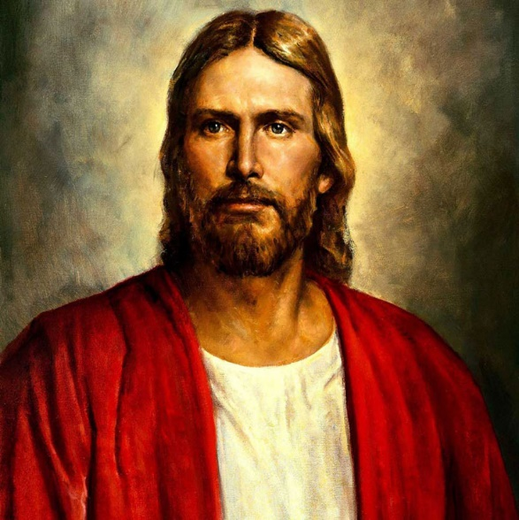
Christians follows Jesus’ example and shows love, sympathy and kindness towards others.

Jesus called on people to be peacemakers:

‘Blessed are the peacemakers,
for they will be called children of God.’
Mathew 5:9
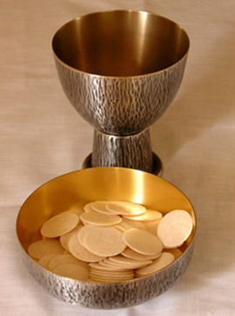
Some Christians confess before communion if they are angry with someone.

What is Pacifism?
Belief that any sort of violence or war is incorrect.

Conscientious Objectors
Conscientious objectors are people who has claimed the right to refuse to join the military service to fight based on freedom of thought, conscience, or religion. Throughout history many understood that Jesus had been a pacifist, which is suggested in his Sermon on the Mountain. Jesus stated in the sermon: 'But I'm telling you: Do not try to payback. If someone hits you on the right cheek, offer him the other cheek. And if someone wants to sue you and take your shirt, give him your coat also. If a Roman soldier forces you to carry his pack for one mile, go with two. Also in his sermon, Jesus said:
"You have heard this, it was said: ‘Love your neighbour' (and ‘hate thine enemy'). But I tell you: Love your enemies and pray for those who persecute you! Then you will show that you are the children of your Father in heaven, because that is the kind of thing he does - he makes sun shine on the evil and the good, and gives rain to those who do what is right and those who do not.'
Pacifists – Society of Friends in Wales
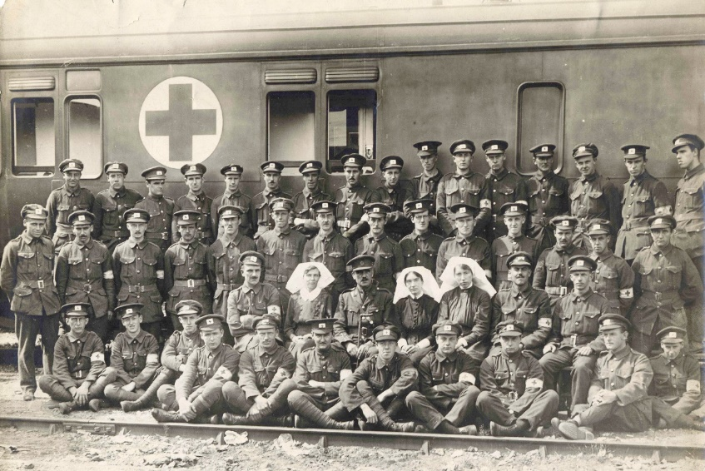
Quakers, or the Religious Society of Friends, is a Christian denomination founded in the 17th century in England. The Quakers are pacifists. They believe that peace should be kept always and they would not engage in war or conflict.

Why, in your opinion?

Some Christians, such as the Religious Society of Friends (Quakers), opposes fighting completely and during warfare they oppose publicly and conscientiously. They are ready to go into battle by being responsible for driving an ambulance or doing other duties but they will not fight in a war. Of course, other Christians are more than ready to fight in the armed forces and many Quakers are always a part of military units.
How can you get peace?
One way is to get religions to collaborate. The key concept here is inter-faith dialogue, defined as researching common ground between different faith groups.

TASK
Follow the ‘Pacifism Powerpoint’
- Create an information sheet about Corrymeela
Use notes from the Powerpoint or the below websites:
- http://www.corrymeela.org/
- https://www.youtube.com/watch?v=f5iw62O9_18

What comes to your mind when you look at this picture?
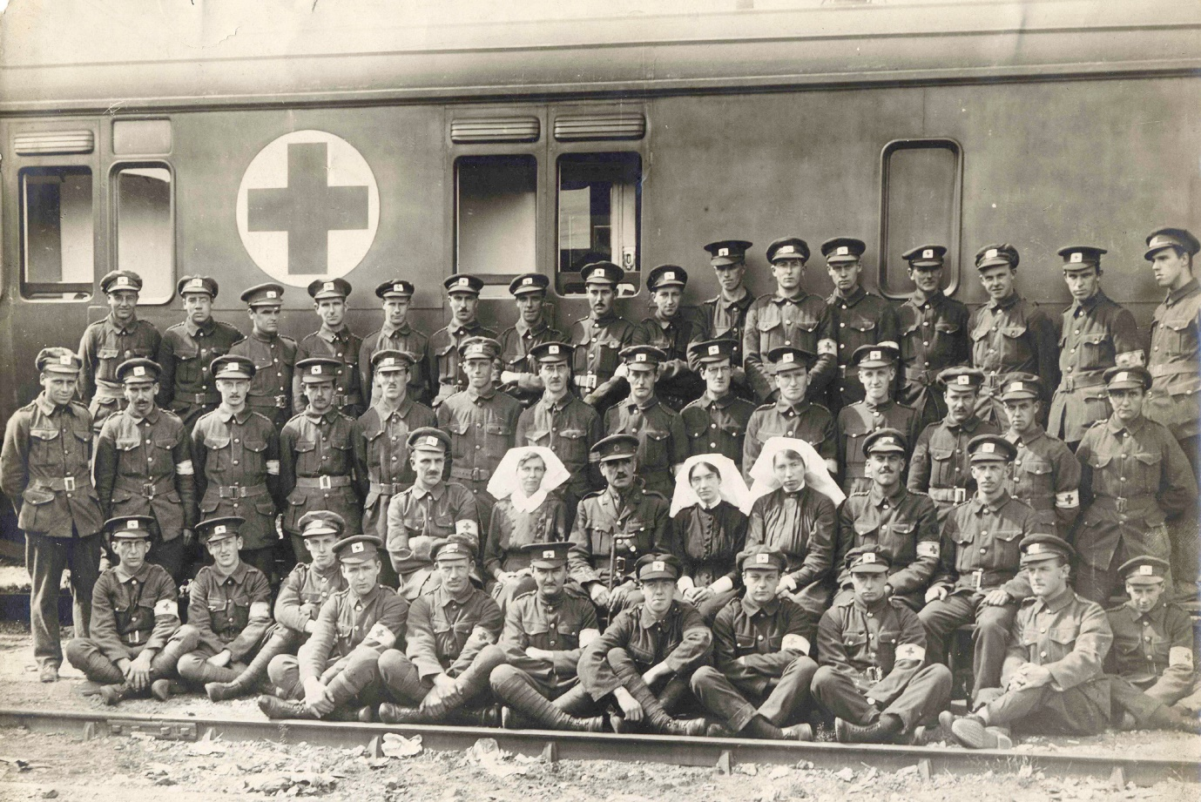
Forgiveness
Some believe that the only way to have peace after conflict is by forgiving. Every religion has a clear teaching about the importance of forgiving.

Believers can consider it is possible to forgive anyone with the help of God

It must come from the heart

The acts of religious leaders show this for example the Pope of John Paul II

Reconcile activities for example Corrymeela shows that this is possible
There are some things you cannot forgive

Sometimes, forgiveness can take a lot of time; it comes in the end but no one ever forgets

In Judaism you cannot forgive on behalf of others.

Believers can consider what God has forgiven them for and then teach how to forgive others

Is forgiveness
possible?
Improvement services for forgiveness are held to make it possible

If we do not learn to forgive, society will become hard and even more selfish
Even though it’s hard, forgiveness must come, or people will not be able to carry on with their lives
Forgiveness is an important part of the Lord’s Prayer and Prayers from other holy subjects

Without forgiveness, there is no hope; only bitterness

Forgiveness is the path to reconcile, so it’s very important for us to do it and receive it, ask for it and offer it

Christian teaching about forgiveness
Christians have certain teachings about forgiveness. Jesus’ teaching, for example the Beatitudes (‘Blessed are the merciful, for they will receive mercy‘), and his words on the cross – ‘Father, forgive them because they do not know what they are doing.’ Jesus’ actions for example, Zacchaeus. Jesus visited him even though he was a cheat and was selfish, and gave him a new sense of life and purpose for him.
You also need to remember examples of Christians that forgave e.g. Martin Luther King Jr.
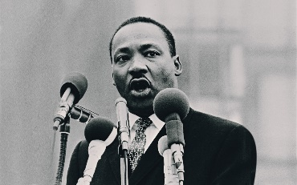
‘Forgiveness does not mean ignoring what has been done or putting a false label on an evil act. It means, rather, that the evil act no longer remains as a barrier to the relationship. Forgiveness is a catalyst creating the atmosphere necessary for a fresh start and a new beginning. It is the lifting of a burden or the cancelling of a debt. The words "I will forgive you, but I'll never forget what you've done" never explain the real nature of forgiveness. Certainly, one can never forget, if that means erasing it totally from his mind. But when we forgive, we forget in the sense that the evil deed is no longer a mental block impeding a new relationship. Likewise, we can never say, "I will forgive you, but I won't have anything further to do with you." Forgiveness means reconciliation, a coming together again’
Task – Summarize Martin Luther King’s vocabulary to 25 words.
The Lord’s Prayer includes the words ‘Forgive us our debts as we forgive our debtors.’ Here’s Jesus’ important prayer that he would narrate and say to his disciples.

Matthew 18:21-22
Then Peter came to Jesus and asked, “Lord, how many times shall I forgive my brother or sister who sins against me? Up to seven times?” Jesus answered, “I tell you, not seven times, but at least seventy-seven times!

The Parable of the Unforgiving Servant
Watch the clips on the website and make some notes on the two clips -http://request.org.uk/jesus/parables/the-unforgiving-servant-2/
What is the message of the parable?

Matthew 6:14-15
For if you forgive other people when they sin against you, your heavenly Father will also forgive you. But if you do not forgive others their sins, your Father will not forgive your sins.
In pairs – note what this quotation says about forgiveness. Do you believe in what is being said?

TASK
Watch the clip - http://request.org.uk/issues/ultimate-questions/big-questions-why-should-i-forgive/
Write a ‘Tweet’ to note what the clip says about forgiveness.

Forgiveness – Personal Beliefs
Gee Walker – the mother of the young boy from Liverpool that was murdered
I forgive them. I can’t hate. Hate is what killed Anthony.

Anthony Walker was 18 years old and a member of the Grace Family Church in Liverpool. He was also a youth leader. He was murdered as he was walking with his girlfriend in the direction of the bus station. Two young boys attacked him because he was black and he later died.
Gee Walker, Anthony’s mum, explained that it’s important for her to forgive as she is a Christian and follows Jesus’ example when he showed forgiveness. Not forgiving would insult her son Anthony that shared the same Christian faith as her. It was also important to respond to racism and hate with tolerance and love – the only way of overcoming racism.
In response to someone asking her if she forgives the murderers of her son for the sake of them; she said that she does so for the sake of herself and her son Anthony. She said:
Not forgiving is a heavy weight. It is a heavy burden to carry. I have seen what this does to people. They turn bitter and angry. I do not want to be that way. I do not want to be a sufferer in two ways. In my heart I have the love and pain that I feel over Anthony and there is no space for anything else.

Here are Gee Walker and her family’s quotations in an interview. In the interview, they say they forgive the murderers. Choose 2 quotations that you think are the most important and discuss why.
______________________________________________________________________________________________________________________________________________________________________________________________________________________________________________________________________________________________________________________________________________________________________________________________________________________________________________________________________________________________________________________________________________________________________________________________________________
Task – watch the following clips:
- Gee Walker’s history: http://www.bbc.co.uk/education/clips/zkxr87h
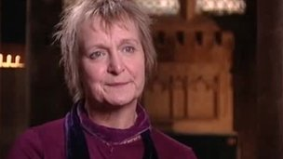
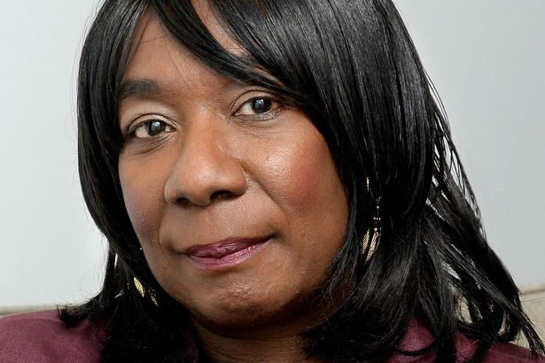
- Julie Nicholson’s history: http://www.bbc.co.uk/education/clips/zdt4wmn
Complete the Venn diagram about the two stories
Judaism – What does the religion teach about peace?
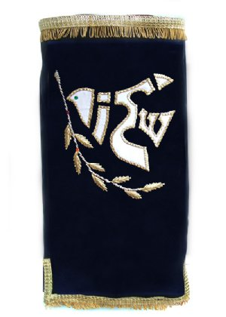
The greeting ‘Shalom’ means ‘peace’, which is desirable in the world.
PEACE
- The right to be in a safe haven
- Envy – forget it by embracing someone
- Abolish the desire to fight
- The end to turning a nation against a nation
- Face an enemy and turn it into love
- Light a candle to reflect hope
Is …SHALOM
A dove of peace that’s been embroidered on a Sefer Torah cover, the scrolls that includes the Jewish laws. The pigeon has been formed from the word ‘Shalom’ (peace) on a Hebrew epigraph.

Facts
- Jews look forward to the time of peace as it’s the condition of the Messianic Era arrival. The Jewish word for peace, shalom, is a general greeting.
- Jews uses it every week by wishing Shabbat Shalom to each other. Not only it’s the absence of war but also the state of living under favourable conditions that is necessary for prosperity. As it says in the Talmud: ‘So excellent is peace, because peace to Earth is like leaven to bread.’
- Even though Jews took part in a lot of wars, seeking peace and taking an active role in working towards reconciliation was never an obstruction. The most significant development was signing the peace agreement by the Prime Minister Israel Yitzhak Rabin and President Yasser Arafat in Washington. The assassination of the Prime Minster put an end on his work in favour of the peace process.
- The Talmud notes three things to keep the world safe: peace, truth and opinion.
- Jews also see peace as the ideal state, and something Jews have to hope for and work towards; the best way to get the benefit and growth in society.
- Jews see peace and harmony among people – without any violence as a foundation – that is the goal.
- Peace and reconciliation should be offered before using any force or war. However, it is fine defending justice and life - even if they have to use force.
- Jews do not consider that violence and war are always being used incorrectly if there’s justice. They accept that some types of wars can be justified morally and ethically, and sometimes acceptable to kill people.
- Before declaring war or begin a battle there must be a genuine attempt to make peace and avoid conflict.
- Jewish law only allows soldiers to be killed deliberately in war. Innocent citizens must have every opportunity to leave the field of battle before the battle begins.
- In the Torah it states that God gives his clear approval to war. He is known as a warrior, and the Jews were shown leads to conflict, bringing victory to them and protecting them from the enemy. But the Torah also refers to peace often. At the same time, the Torah is full of Jewish yearning for peace.
- And he shall judge between the nations and reprove many peoples, and they shall beat their swords into ploughshares and their spears into pruning hooks; nation shall not lift the sword against nation, neither shall they learn war anymore. Isaiah 2: 4
Complete the Spider Chart to summarise Jewish beliefs about peace.

Jewish response to peace and conflict

What is pacifism?
Beliefs that any violence or war is unacceptable. Refuses to use any power or violence e.g. by not joining the army.
Children of Abraham Project
This project was started by a Jewess and a Muslim man. They could see that communities didn’t know a lot about each other, and that it would be good for both sides to know more to try and promote peace.
The name Children of Abraham comes from the fact that Abraham is related to Jews and Muslim faiths as each other. The projects tries to create an understanding between Muslims and Jews throughout the world by using the internet.
Every week, pictures from Muslim and Jewish lives are explained in order to help people on both sides to understand their different beliefs and practices. Through chat rooms, young people can discover that they have more things in common than different. An open discussion is encouraged about difficult things such as suicide and military action on the West Side and Gaza.
Nadia Sheikh, a member of the Children of Abraham project has said: ‘It’s something that you feel that you have to do. Not only you diffuse peace and information, but you also have a better understanding. Your mind is much more open then.’

How to support peace?
Neve Shalom/Wahat al-Salam
An area in Israel is Neve Shalom/Wahat al-Salam (oasis of peace) where Jewish and Arabic families cohabit in peace. A lot of activities are held where Jewish and Arabic children play and learn together.
Research into the area by using -
http://wasns.org/
and watching the clip https://www.youtube.com/watch?v=snBOBIKCxI0

Conscientious Objectors
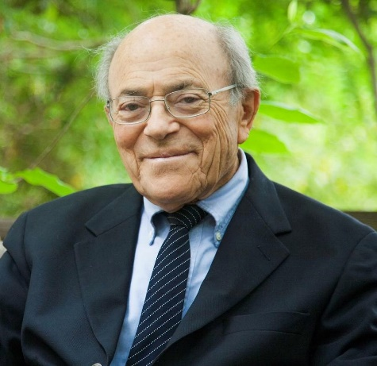
Leonard I. Beerman (April 9, 1921 – December 24, 2014) was an American Reform rabbi. He served for 37 years at Leo Baeck Temple in Los Angeles as founding rabbi. He was known for his liberal political activism, his support of interfaith dialogue, and his advocacy of peace and a two-state solution in the Middle East.
Beerman was born in Altoona, Pennsylvania to Paul and Tillie Beerman. His father was a traveling salesman of women's lingerie, and his mother was a homemaker. He spent some of his later childhood in Owosso, Michigan, then returned to Altoona and studied at Penn State, from which he graduated in 1942. He served but did not see combat in the United States Marines during World War II, studied for the rabbinate at Hebrew Union College in Cincinnati, and briefly joined the Haganah in 1947 while studying for his rabbinical degree in Israel. In a later interview Beerman said that his pacifist convictions arose during his five months experience with the Haganah.
TASK
Research the website - https://www.beermanfoundation.org/ for more information.

Jewish Teachings about forgiveness
Here’s a quote from Micah 7:18 where God is praised for his love. It also discusses forgiveness:
Who is a God like you,
who pardons sin and forgives the transgression
of the remnant of his inheritance?
You do not stay angry forever
but delights to show mercy.

Jews have teachings from the Tenakh, for example it talks about how to treat enemies. Jews sees the importance of repentance.
Jews celebrate Rosh Hashanah. Rosh Hashanah’s role and the ten days of return, the central theme of Yom Kippur and Rosh Hashanah is forgiveness.
According to Jews, only victims can forgive because they suffered the wickedness.
TASK
Read the notes about Rosh Hashanah and Yom Kippur. Then, use the three colours – red, yellow and green.
Use ‘post it’ if you have any questions.
Traffic Light System
Parts that are confusing in red

Parts that you are not sure of in orange

Colour the easy parts you understand in green

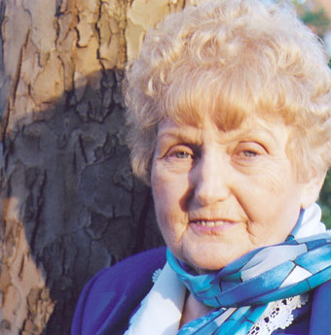
Example of forgiveness that derives from personal beliefs – Eva Kor
At the age of ten, twins Eva and Miriam Mozes, were taken to Auschwitz where Dr Josef Mengele used them for medical experiments. Both survived, but Miriam died in 1993 when she developed cancer of the bladder as a consequence of the experiments done to her as a child. Eva Kor has since spoken explicitly about her experiences at Auschwitz and founded The CANDLES Holocaust Museum in Indiana where she now lives. In 2003 the museum was destroyed in an arson attack, believed to be by white supremacists.

Miriam and I were part of a group of children who were alive for one reason only – to be used as human guinea pigs. During our time in Auschwitz we talked very little. Starved for food and human kindness, it took every ounce of strength just to stay alive. Because we were twins, we were used in a variety of experiments. Three times a week we’d be placed naked in a room, for 6–8 hours, to be measured and studied. It was unbelievably demeaning.
In another type of experiment, they took blood from one arm and gave us injections in the other. After one such injection I became very ill and was taken to the hospital. Dr Mengele came in the next day, looked at my fever chart and declared that I had only two weeks to live. For two weeks, I was between life and death but I refused to die. If I had died, Mengele would have given Miriam a lethal injection to do a double autopsy. When I didn’t die, he carried on experimenting with us and as a result Miriam’s kidneys stopped growing. They remained the size of a child’s all her life.
On 27 January 1945, four days before my 11th birthday, Auschwitz was liberated by the Soviet army. After nine months in refugee camps I returned to my village in Romania to find that no one from my family had survived.
Echoes from Auschwitz were a part of my life but I did not speak publicly about my experiences until 1978 after the television series The Holocaust was aired. People would ask me about the experiments but I couldn’t remember very much so I wanted to find other twins who were liberated with me. I wrote to newspapers asking them to publish an appeal for other survivors of Mengele to contact me. By 1980 I was sending out 500 letters a year – but still no response. In desperation, one day I decided to start an organization in which I would make myself President. People are always impressed if they get a letter from a president, and it worked. Finally, I was able to find other twin survivors and exchange memories. It was an immensely healing experience.
In 1993, I was invited to lecture to some doctors in Boston and was asked if I could bring a Nazi doctor with me. I thought it was a mad request until I remembered that I’d once been in a documentary which had also featured a Dr Hans Munch from Auschwitz. I contacted him in Germany and he said he would meet with me for a videotaped interview to take to the conference. In July 1993, I was on my way to meet this Nazi doctor. I was so scared but when I arrived at his home he treated me with the utmost respect. I asked him if he’d seen the gas chambers. He said this was a nightmare he dealt with every day of his life. I was surprised that Nazis had nightmares too and asked him if he would come with me to Auschwitz to sign a document at the ruins of the gas chambers. He said that he would love to do it.
In my desperate effort to find a meaningful ‘thank you’ gift for Dr Munch, I searched the stores, and my heart, for many months. Then the idea of a Forgiveness letter came to my mind. I knew it would be a meaningful gift, but it became a gift to myself as well, because I realized I was not a hopeless, powerless victim. When I asked a friend to check my spelling, she challenged me to forgive Dr Mengele too. At first, I was adamant that I could never forgive Dr Mengele but then I realized I had the power now…the power to forgive. It was my right to use it. No one could take it away.
On 27 January 1995, at the 50th anniversary of the liberation of Auschwitz, I stood by the ruins of the gas chambers with my children – Dr Alex Kor and Rina Kor – and with Dr Munch and his children and grandchild. Dr Munch signed his document about the operation of the gas chambers while I read my document of forgiveness and signed it. As I did that, I felt a burden of pain was lifted from me. I was no longer in the grip of hate; I was finally free.
The day I forgave the Nazis, privately I forgave my parents whom I hated all my life for not having saved me from Auschwitz. Children expect their parents to protect them; mine couldn’t. And then I forgave myself for hating my parents.
Forgiveness is really nothing more than an act of self-healing and self-empowerment. I call it a miracle medicine. It is free, it works and has no side effects.
I believe with every fibre of my being that every human being has the right to live without the pain of the past. For most people, there is a big obstacle to forgiveness because society expects revenge. It seems we need to honour our victims but I always wonder if my dead loved ones would want me to live with pain and anger until the end of my life. Some survivors do not want to let go of the pain. They call me a traitor and accuse me of talking in their name. I have never done this. Forgiveness is as personal as chemotherapy – I do it for myself.

TASK
What came to your mind after reading Eva’s history and what did you learn about how she forgave? Note your response below.

