**GCSE**

**RELIGIOUS STUDIES**

**UNIT 1 – YEAR 10**

[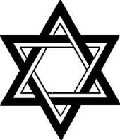](http://www.google.co.uk/url?sa=i&rct=j&q=&esrc=s&source=images&cd=&cad=rja&uact=8&ved=0ahUKEwierMvX6ZLVAhXDcRQKHa5QCEUQjRwIBw&url=http://nacejamie.weebly.com/symbols.html&psig=AFQjCNH9a0HAHygkGjBpQ11TFUdXaC68vQ&ust=1500467099133218)

**BOOKLET 2-JUDAISM**

[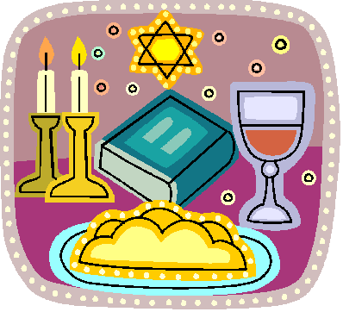](https://www.google.co.uk/url?sa=i&rct=j&q=&esrc=s&source=images&cd=&cad=rja&uact=8&ved=0ahUKEwjRt9yM6pLVAhUKbRQKHR49CcoQjRwIBw&url=https://www.pinterest.com/pin/777574691883893546/&psig=AFQjCNEjtdMzCphsK3Z6CgUD_KkE_dM2fQ&ust=1500467191321370)[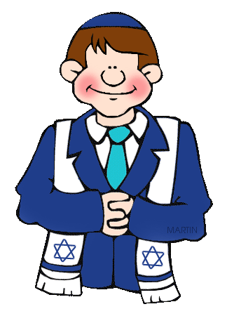](http://www.google.co.uk/url?sa=i&rct=j&q=&esrc=s&source=images&cd=&cad=rja&uact=8&ved=0ahUKEwi-oJz26ZLVAhXGtRQKHerKAE8QjRwIBw&url=http://hddfhm.com/clip-art/jewish-clipart.html&psig=AFQjCNH9a0HAHygkGjBpQ11TFUdXaC68vQ&ust=1500467099133218)[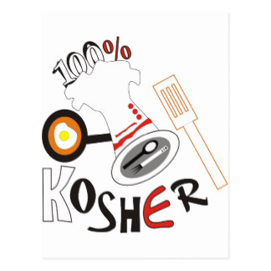](https://www.google.co.uk/url?sa=i&rct=j&q=&esrc=s&source=images&cd=&cad=rja&uact=8&ved=0ahUKEwjCrrC26pLVAhWJuxQKHR5jB5cQjRwIBw&url=https://www.zazzle.com/kashrut+vertical+postcards&psig=AFQjCNHV-wAmqyRLe2EOD5yFIkw-00guJg&ust=1500467278066167)

**Name:**

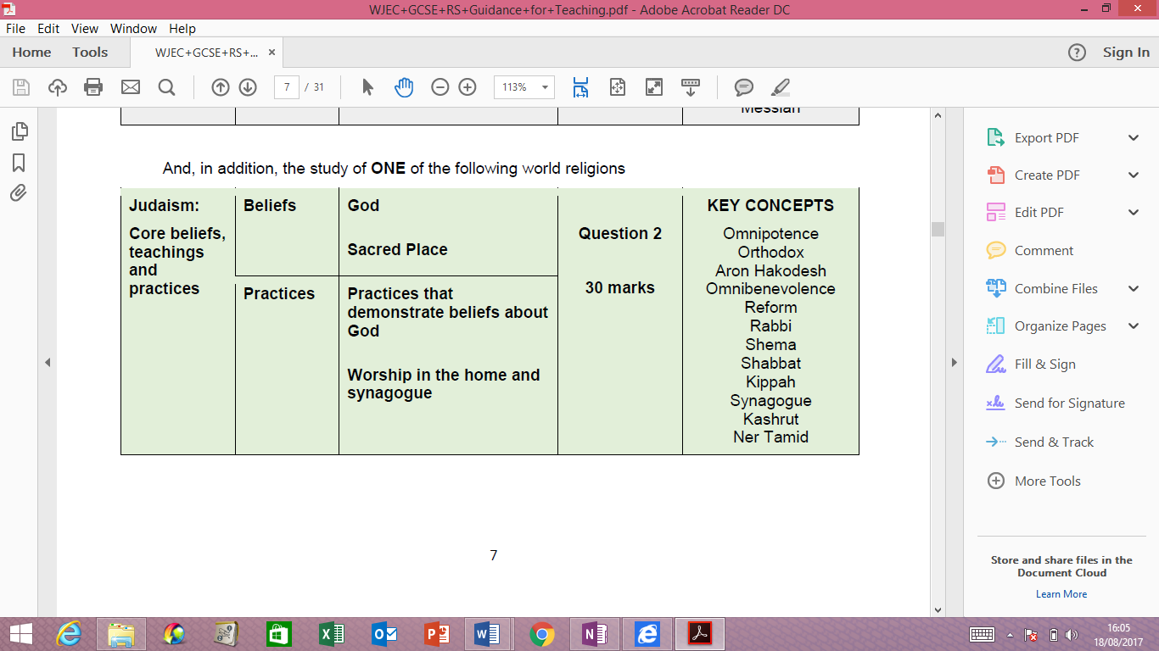

**KEY CONCEPTS – Within this Unit you must learn 12 key terms. You must learn the meaning of each word. This will be the A question in the exam. You should use some of these words in every answer.**

|  |  |
| --- | --- |
| **Key Concept** | **Meaning/example?** |
| Omnipotence |  |
| Orthodox |  |
| Aron Hakodesh |  |
| Omnibenevolence |  |
| Reform |  |
| Rabbi |  |
| Shema |  |
| Shabbat |  |
| Kippah |  |
| Synagogue |  |
| Kashrut |  |
| Ner Tamid |  |

**Beliefs**

**The concept of God**

* Jewish belief in one, creative, omnipotent, omnipresent, omnibenevolent God (Genesis 1:3-5, Exodus 20:1-17)
* Belief in the teachings of the Shema, such as the concept of one God
* God as transcendent above and beyond all earthly things (Isaiah 55:8-9)
* God as eternal, merciful and a judge (punishes, rewards and forgives)

**Practices that demonstrate beliefs about God**

* Reciting the Shema in the morning and evening
* Reasons why God must not be depicted in art and sometimes his full name is not used (G-d)
* Reasons why kippah is worn
* Reasons why Jewish men (some Liberal Jewish women) wear tallith

**WHAT DO THE JEWS BELIEVE ABOUT GOD?**

A central belief in Judaism is that there is only **One God**. They also believe that this One God is **Omnipotent, Omnibenevolent,** and **Omnipresent.**

|  |  |
| --- | --- |
| **Omnipotent** |  |
| **Omnibenevolent** |  |
| **Omnipresent** |  |

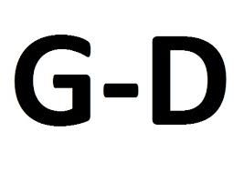**ONE GOD**

Jews show so much respect to God by:-

* some strict Jews use the word **Hashem** or write the word G**-d** instead of ‘God’.
* Maimonides said that there is no language to describe how unique God is.
* In the Torah, God commands that no Jew shall make an image of God:

***“You shall not make for yourself an image in the form of anything in heaven above or on the earth beneath or in the waters below. You shall not bow down to them or worship them…”*** (Exodus 20:4-5)

* To this day, there are no images of God in Synagogues, and the only permanent decoration to be seen are letters of the Hebrew alphabet.
* Judaism is a religion which believes in **One God**. The first sentence of the **Shema** says that Jews should worship One God.

**‘*Hear, Oh Israel: the Lord our God, the Lord is One.’* (*Deut* 6:4).**

**BELIEFS ABOUT GOD**

Although the belief in One God is a central belief in Judaism, Jews believe that God has different natures to his character:

**GOD AS CREATOR**

The Torah tells us that God created the world:

**'In the beginning God created the heaven and earth’**

**(*Genesis* 1)**

It goes on to describe how God created day and night, the world, flowers and all the animals.

**‘And God said, “Let there be light!” and there was light. God saw that the light was good and he separated the light from the darkness. God called the light ‛day‛ and the darkness he called ‛night‛, and there was evening and there was morning, the first day.’ (Genesis 1:3-5)**

He continues to create different things each day, until on the sixth day he creates human beings and gives them special responsibilities, namely to look after his creation (be good stewards):

**“So God created mankind in his own image…** **God blessed them and said to them, “Be fruitful and increase in number...” (Genesis 1)**

To them, what is important is that God is responsible for creating everything on earth. For many Jews, the world is too complex and beautiful to have been created by accident, so it must have had a creator.

**AS LAWGIVER**

* Jews believe that God gave laws and rules for all Jews to keep in order to have a fair society.
* Jews have **613 Mitzvot** which they must keep.
* The Mitzvot deal with worship, observing festivals and issues such as divorce and food. By keeping the Mitzvot, Jews are worshipping God.

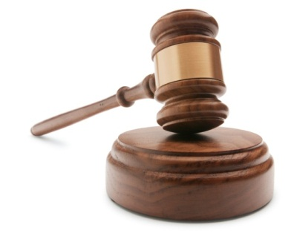

**AS JUDGE**

* God who will judge every person.
* God will always be fair.
* God does not enjoy judging people wrongly so every judgement is made justly.

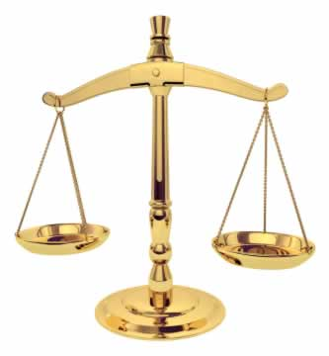

* The festival of Rosh Hashanah celebrates the creation of the world and God will judge everyone during this festival.
* They believe God comes with scales to weigh the Mizvot in every person. He will put their good deeds on one side and their bad deeds on the other.
* As God is a just God, Jews have 10 days between Rosh Hashanah and another festival called Yom Kippur (Day of Atonement) where they have a chance to apologise for the bad things which they have done and ask for forgiveness.

**What does the following passage say about God?**

“For my thoughts are not your thoughts,  neither are your ways my ways,” declares the Lord.“As the heavens are higher than the earth, so are my ways higher than your ways and my thoughts than your thoughts.” Isaiah 55:8-9

**THE SHEMA**

In Judaism, a very special prayer is recited at least every morning and every evening. This prayer declares the belief in one God and confirms their belief in him too. In the synagogue Jews will recite the prayer carefully making sure that every word is pronounced clearly and they cover their eyes with their right hand.

**KEY:**

Relationship with God Commandments which are in the Shema

**Read the following verses carefully to find out what the Shema says about the relationship between the Jews and God. Highlight the parts which refer to their relationship with God.**

4 “Here Israel! The LORD our God, the Lord is one. 5 You are to love the LORD your God with all your heart, and with all your soul and all your power.”

**Read the following verses carefully to find out which commandments are found in the Shema. Highlight the important parts in another colour.**

The LORD said to Moses: 38 “Speak to the Israelites and say to them: ‘Throughout the generations to come you are to make tassels on the corners of your garments, with a blue cord on each tassel. 39 You will have these tassels to look at and so you will remember all the commands of the LORD, that you may obey them and not prostitute yourself by chasing after the lusts of your own hearts and eyes. 40 Then you will remember to obey all my commands and will be consecrated to your God. 41 I am the LORD your God, who brought you out of Egypt to be your God. I am the LORD your God.”

18 “Fix these words of mine in your hearts and minds. Tie them as symbols on your hands and bind them on your foreheads. 19 Teach them to your children, talking about them when you sit at home and when you walk along the road, when you lie down and when you get up. 20 Write them on the doorframes of your houses and on your gates, 21 so that your days, and the days of your children may be many in the land the LORD swore to give your ancestors, as many are the days that the heavens are above the earth.

In the first section of the prayer God addresses Israel and insists that his people obey him with all their heart. It is a group prayer where the Jewish community declare their belief in God which is central to their religion as well as the duties which they must perform, and Jews should recite the prayer whilst standing and facing Jerusalem. The Shema is a morning and evening prayer, which can be recited in the home or in the Synagogue and the prayer is recited as the Torah scroll is taken out of the ark (in the Synagogue) on the Sabbath and other important festivals. It is every Jew’s desire to recite the Shema on his death-bed, but if it is not possible, anyone else who is present can recite the prayer and help the dying Jew to declare their faith in God.



BBC – THE SHEMA

Watch the clip to see how the Shema is recited and followed daily.

**WHAT THE JEWS WEAR WHEN THEY WORSHIP?**

Many Jews believe that they have a duty to wear certain items for worship.

**KIPPAH**

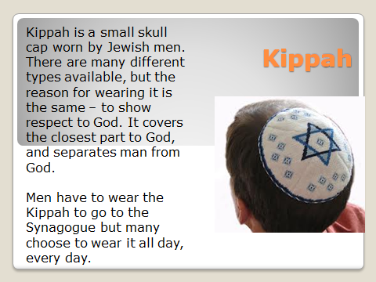

**TALLIT**

**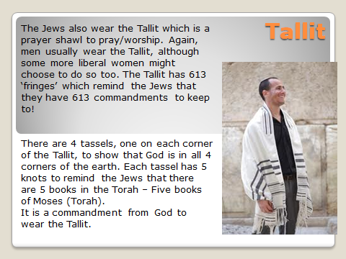**

**Task:** Practice the examination technique for question ‘c’ in the exam paper.

***‘Explain why the Shema is important to Jews’*** (8 Marks)

You should,

Follow the **PEE** formula when answering this question (**P**oint, **E**vidence and

**E**xplanation)



Explain **What? How? Why?**



Need to give **3 reasons** which have been explained **in detail**



Several and correct use of subject terms e.g. God, Mitzvot, Tallit,

Orthodox.



Use sources e.g. quotations; key concepts.

**\_\_\_\_\_\_\_\_\_\_\_\_\_\_\_\_\_\_\_\_\_\_\_\_\_\_\_\_\_\_\_\_\_\_\_\_\_\_\_\_\_\_\_\_\_\_\_\_\_\_\_\_\_\_\_\_\_\_\_\_\_\_\_\_\_\_\_\_\_\_\_\_\_\_\_\_\_\_\_\_\_\_\_\_\_\_\_\_\_\_\_\_\_\_\_\_\_\_\_\_\_\_\_\_\_\_\_\_\_\_\_\_\_\_\_\_\_\_\_\_\_\_\_\_\_\_\_\_\_\_\_\_\_\_\_\_\_\_\_\_\_\_\_\_\_\_\_\_\_\_\_\_\_\_\_\_\_\_\_\_\_\_\_\_\_\_\_\_\_\_\_\_\_\_\_\_\_\_\_\_\_\_\_\_\_\_\_\_\_\_\_\_\_\_\_\_\_\_\_\_\_\_\_\_\_\_\_\_\_\_\_\_\_\_\_\_\_\_\_\_\_\_\_\_\_\_\_\_\_\_\_\_\_\_\_\_\_\_\_\_\_\_\_\_\_\_\_\_\_\_\_\_\_\_\_\_\_\_\_\_\_\_\_\_\_\_\_\_\_\_\_\_\_\_\_\_\_\_\_\_\_\_\_\_\_\_\_\_\_\_\_\_\_\_\_\_\_\_\_\_\_\_\_\_\_\_\_\_\_\_\_\_\_\_\_\_\_\_\_\_\_\_\_\_\_\_\_\_\_\_\_\_\_\_\_\_\_\_\_\_\_\_\_\_\_\_\_\_\_\_\_\_\_\_\_\_\_\_\_\_\_\_\_\_\_\_\_\_\_\_\_\_\_\_\_\_\_\_\_\_\_\_\_\_\_\_\_\_\_\_\_\_\_\_\_\_\_\_\_\_\_\_\_\_\_\_\_\_\_\_\_\_\_\_\_\_\_\_\_\_\_\_\_\_\_\_\_\_\_\_\_\_\_\_\_\_\_\_\_\_\_\_\_\_\_\_\_\_\_\_\_\_\_\_\_\_\_\_\_\_\_\_\_\_\_\_\_\_\_\_\_\_\_\_\_\_\_\_\_\_\_\_\_\_\_\_\_\_\_\_\_\_\_\_\_\_\_\_\_\_\_\_\_\_\_\_\_\_\_\_\_\_\_\_\_\_\_\_\_\_\_\_\_\_\_\_\_\_\_\_\_\_\_\_\_\_\_\_\_\_\_\_\_\_\_\_\_\_\_\_\_\_\_\_\_\_\_\_\_\_\_\_\_\_\_\_\_\_\_\_\_\_\_\_\_\_\_\_\_\_\_\_\_\_\_\_\_\_\_\_\_\_\_\_\_\_\_\_\_\_\_\_\_\_\_\_\_\_\_\_\_\_\_\_\_\_\_\_\_\_\_\_\_\_\_\_\_\_\_\_\_\_\_\_\_\_\_\_\_\_\_\_\_\_\_\_\_\_\_\_\_\_\_\_\_\_\_\_\_\_\_\_\_\_\_\_\_\_\_\_\_\_\_\_\_\_\_\_\_\_\_\_\_\_\_\_\_\_\_\_\_\_\_\_\_\_\_\_\_\_\_\_\_\_\_\_\_\_\_\_\_\_\_\_\_\_\_\_\_\_\_\_\_\_\_\_\_\_\_\_\_\_\_\_\_\_\_\_\_\_\_\_\_\_\_\_\_\_\_\_\_\_\_\_\_\_\_\_\_\_\_\_\_\_\_\_\_\_\_\_\_\_\_\_\_\_\_\_\_\_\_\_\_\_\_\_\_\_\_\_\_\_\_\_\_\_\_\_\_\_\_\_\_\_\_\_\_\_\_\_\_\_\_\_\_\_\_\_\_\_\_\_\_\_\_\_\_\_\_\_\_\_\_\_\_\_\_\_\_\_\_\_\_\_\_\_\_\_\_\_\_\_\_\_\_\_\_\_\_\_\_\_\_\_\_\_\_\_\_\_\_\_\_\_\_\_\_\_\_\_\_\_\_\_\_\_\_\_\_\_\_\_\_\_\_\_\_\_\_\_\_\_\_\_\_\_\_\_\_\_\_\_\_\_\_\_\_\_\_\_\_\_\_\_\_\_\_\_\_\_\_\_\_\_\_\_\_\_\_\_\_\_\_\_\_\_\_\_\_\_\_\_\_\_\_\_\_\_\_\_\_\_\_\_\_\_\_\_\_\_\_\_\_\_\_\_\_\_\_\_\_\_\_\_\_\_\_\_\_\_\_\_\_\_\_\_\_\_\_\_\_\_\_\_\_\_\_\_\_\_\_\_\_\_\_\_\_\_\_\_\_\_\_\_\_\_\_\_\_\_\_\_\_\_\_\_\_\_\_\_\_\_\_\_\_\_\_\_\_\_\_\_\_\_\_\_\_\_\_\_\_\_\_\_\_\_\_\_\_\_\_\_\_\_\_\_\_\_\_\_\_\_\_\_\_\_\_\_\_\_\_\_\_\_\_\_\_\_\_\_\_\_\_\_\_\_\_\_\_\_\_\_\_\_\_\_\_\_\_\_\_**

**\_\_\_\_\_\_\_\_\_\_\_\_\_\_\_\_\_\_\_\_\_\_\_\_\_\_\_\_\_\_\_\_\_\_\_\_\_\_\_\_\_\_\_\_\_\_\_\_\_\_\_\_\_\_\_\_\_\_\_\_\_\_\_\_\_\_\_\_\_\_\_\_\_\_\_\_\_\_\_\_\_\_\_\_\_\_\_\_\_\_\_\_\_\_\_\_\_\_\_\_\_\_\_\_\_\_\_\_\_\_\_\_\_\_\_\_\_\_\_\_\_\_\_\_\_\_\_\_\_\_\_\_\_\_\_\_\_\_\_\_\_\_\_\_\_\_\_\_\_\_\_\_\_\_\_\_\_\_\_\_\_\_\_\_\_\_\_\_\_\_\_\_\_\_\_\_\_\_\_\_\_\_\_\_\_\_\_\_\_\_\_\_\_\_\_\_\_\_\_\_\_\_\_\_\_\_\_\_\_\_\_\_\_\_\_\_\_\_\_\_\_\_\_\_\_\_\_\_\_\_\_\_\_\_\_\_\_\_\_\_\_\_\_\_\_\_\_\_\_\_\_\_\_\_\_\_\_\_\_\_\_\_\_\_\_\_\_\_\_\_\_\_\_\_\_\_\_\_\_\_\_\_\_\_\_\_\_\_\_\_\_\_\_\_\_\_\_\_\_\_\_\_\_\_\_\_\_\_\_\_\_\_\_\_\_\_\_\_\_\_\_\_\_\_\_\_\_\_\_\_\_\_\_\_\_\_\_\_\_\_\_\_\_\_\_\_\_\_\_\_\_\_\_\_\_\_\_**

**PEER ASSESSMENT**

You have followed the **PEE** formula when answering this question (**P**oint, **E**vidence and **E**xplanation)



You have explained **What? How? Why?**



You have included **3 reasons and** have explained them in **detail**



You have made several and correct use of the subject terms.



The work includes use of sources

**Wish:(Peer)**

**\_\_\_\_\_\_\_\_\_\_\_\_\_\_\_\_\_\_\_\_\_\_\_\_\_\_\_\_\_\_\_\_\_\_\_\_\_\_\_\_\_\_\_\_\_\_\_\_\_\_\_\_\_\_\_\_\_\_\_\_\_\_\_\_\_\_\_\_\_\_\_\_\_\_\_\_\_\_\_\_\_\_\_\_\_\_\_\_\_\_\_\_\_\_\_\_\_\_\_\_\_\_\_\_\_\_\_\_\_\_\_\_\_\_\_\_\_\_\_\_\_\_\_\_\_\_\_\_\_\_\_\_\_\_\_\_\_\_\_\_\_\_\_\_\_\_\_\_\_\_\_\_\_**

**Teacher response**

**\_\_\_\_\_\_\_\_\_\_\_\_\_\_\_\_\_\_\_\_\_\_\_\_\_\_\_\_\_\_\_\_\_\_\_\_\_\_\_\_\_\_\_\_\_\_\_\_\_\_\_\_\_\_\_\_\_\_\_\_\_\_\_\_\_\_\_\_\_\_\_\_\_\_\_\_\_\_\_\_\_\_\_\_\_\_\_\_\_\_\_\_\_\_\_\_\_\_\_\_\_\_**

**Your response to the above?**

**Worship in the Synagogue**

**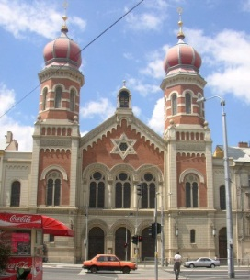**

**Sacred place and Worship in the synagogue**

* The synagogue: a place for prayer, study, celebration, and assembly
* Differences in tradition: Orthodox, Reform, Liberal
* The importance of the synagogue: internal features- aron hakodesh (ark), ner tamid, bimah, Torah, Ten Commandments, seating
* Reading of the Torah during synagogue worship
* Diverse practices within Orthodox and Reform synagogues – worship and the role and gender of the Rabbi

**KEY CONCEPTS**

* **Synagogue** – a Jewish house of worship, often having facilities for religious instruction; an assembly or congregation of Jews for the purpose of religious worship.
* **Aron** **Hakodesh** - a cabinet containing the scrolls of the Torah (the five books of Moses). The ark is the holiest place in the synagogue, both because it contains the sacred writings of Judaism and because it represents the original ark of the Jewish people.
* **Ner** **Tamid** –Everlasting light which burns above / in front of the Ark. Symbolises God’s everlasting presence.
* **Rabbi –** A spiritual leader within the Jewish community and a chief religious official of a Synagogue who delivers a sermon. A Jewish teacher or scholar; qualified to rule on questions of Jewish law**.**
* **Orthodox** - a Jew who adheres faithfully to the principles and practices of traditional Judaism as evidenced chiefly by a devotion to and study of the Torah, daily synagogue attendance if possible, and strict observance of the Sabbath, religious festivals, holy days, and the dietary laws.
* **Reform** - a Jew who adheres to a system of religious worship adapted from Orthodox Judaism to meet the demands of contemporary life, frequently simplifying or rejecting traditional religious law and custom.

 \*\*You will need to know these for the (a) question in the exam

worth 2 marks. Here is an example of this type of question!\*\*

(a) What is meant by ‘Rabbi? [2]

…………………………………………………………………………………………..…………………………………………………………………………………………..…………………………………………………………………………………………...……………………………………………………………………………………………………………………………..

**What is a Synagogue?**

The Synagogue is a ***Jewish place of worship***, and means **’to come together’** or ‘**assembly’**. Originally, Jews worshipped in the Temple in Israel; but after it was destroyed in 70 A.D. Jews had to find another way to worship. They used their homes to ‘come together’ to study the Torah and worship, and later special buildings were built in areas where Jews lived that became known as Synagogues.

**Quick facts – **

* Synagogues usually offer 3 services a day
* Special services will be held during festivals e.g. Shabbat
* Within **Orthodox**, 10 men must be present to conduct a service known as the **MINYAN.**
* Many Jews will attend regularly, whilst others only on certain times of the year e.g. Yom Kippur

Notes-

However, the role of the Synagogue is more than just a place of worship! It is also a:

|  |  |
| --- | --- |
| **Bet Midrash /Shul** | School C:\Users\ald\AppData\Local\Microsoft\Windows\Temporary Internet Files\Content.IE5\MEAAHDAQ\school[1].png |
| **Bet Tefillah** | House of Prayer C:\Users\ald\AppData\Local\Microsoft\Windows\Temporary Internet Files\Content.IE5\JXMXNOEL\pray[1].jpg |
| **Bet Din** | House of Law C:\Users\ald\AppData\Local\Microsoft\Windows\Temporary Internet Files\Content.IE5\JXMXNOEL\familylaw[1].jpg |
| **Bet Knesset** | A meeting place C:\Users\ald\AppData\Local\Microsoft\Windows\Temporary Internet Files\Content.IE5\UIQ3SA2W\peopletalking[1].gif |



 (b) Describe how the Synagogue is used within a Jewish community. [5]

What is the success criteria for answering a B question?

....................................................................................................................................................................................................................................................................................................................................................

....................................................................................................................................................................................................................................................................................................................................................

....................................................................................................................................................................................................................................................................................................................................................

....................................................................................................................................................................................................................................................................................................................................................

....................................................................................................................................................................................................................................................................................................................................................

...................................................................................................................................................................................................................................................................................................................................................................................................................................................................................

..........................................................................................................................................................................

...................................................................................................................................................................................................................................................................................................................................................................................................................................................................................

|  |  |  |  |
| --- | --- | --- | --- |
| **Marked by** | **Mark/Level** | **(+)** | **(-)** |
| **Peer** |  |  |  |
| **Teacher** |  |  |  |

**Your response to the above?**

The Synagogue is normally built facing Jerusalem. This is where the Temple was, and the Western wall of the Temple still remains!!

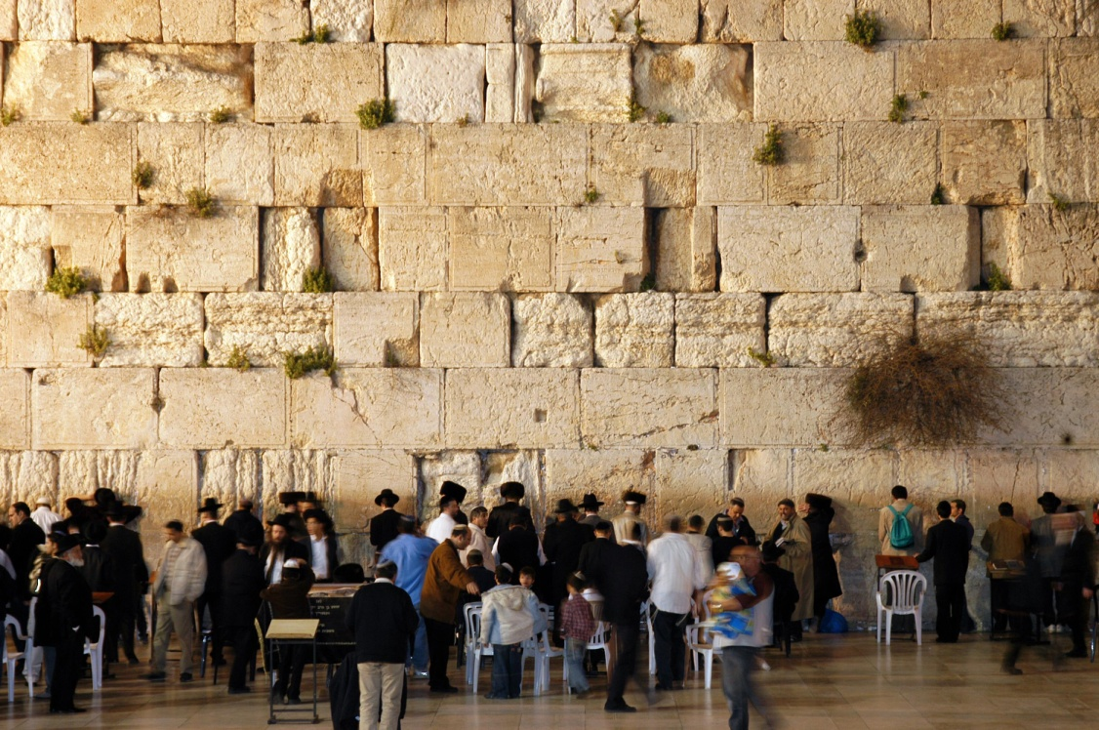

**Features inside a Synagogue**

|  |  |  |
| --- | --- | --- |
| **Feature** |  | **Purpose** |
| **Ark /**  **Aron Hakodesh** | **C:\Users\Lynne\AppData\Local\Microsoft\Windows\INetCache\IE\TZPL9EEZ\220px-Aron_haqodesh_in_New_Tallinn_Synagogue[1].jpg** | It’s a **cupboard** which keep the Torah scrolls safely. Some will close with a decorated curtain and others with doors. During certain prayers, the doors and curtain of the ark may be opened or closed e.g. open during Yom Kippur. It is **the most important** feature within the Synagogue. |
| **Bimah** | **C:\Users\Lynne\AppData\Local\Microsoft\Windows\INetCache\IE\TZPL9EEZ\250px-Jeszywas_Synagoga_08[1].jpg** | A raised platform / **reading desk**  It is in the centre of the Synagogue (Orthodox) so that everyone can see and hear as this is where the Torah is read, by members of the congregation or the Rabbi. The Torah scroll will be brought from the ark to the Bimah during services. |
| **Ner Tamid** | **C:\Users\Lynne\AppData\Local\Microsoft\Windows\INetCache\IE\2YDXW1CG\180px-06-0643-1[1].jpg** | **Everlasting light**  In front and slightly above the aron hakodesh, it represents Gods everlasting presence; God is with them at all times. This is kept burning/lit. It also reminds the Jews of the Menorah that was used to light the Temple. |
| **Torah** | **C:\Users\Lynne\AppData\Local\Microsoft\Windows\INetCache\IE\OBCQHJR2\160127[1].jpg**https://s-media-cache-ak0.pinimg.com/originals/8b/40/b9/8b40b9175de64153819eee1970e5e888.jpg | The Torah scrolls are the most sacred part of any synagogue. They are made from kosher animal skin and are hand written by a scribe. It contains the Five Books of Moses and are read during services. Very often synagogues will have anything up to 7 or 8 scrolls as different ones are used for different services e.g. one for Shabbat service (sidra). It is so holy that one must not touch the scroll, therefore Jews will use a **yad (pointer)** to read from the Torah. |
| **Ten Commandments** | http://thetorah.com/wp-content/uploads/2014/02/Ten-Commandments.jpg | Jews believe that God revealed to Moses the duties that are expected of all Jews. These are recorded in the Torah. The Ten Commandments are a framework of how a just society should behave. They should be kept by every Jew, regardless of age, wealth, gender. They are central to Jewish beliefs and practice. The 10 Commandments are part of the 613 Mitzvot that should be obeyed.  First 4 = people’s duties to God. E.g. “**Remember the Sabbath, and keep it holy.**”  The other 6 = deal with how people should treat one another e.g. “**Do not steal**” “**Do not kill**”. |
| **Seating** | https://www.ou.org/jewish_action/files/113.jpg | Women will sit apart from the men in an **orthodox** synagogue; usually in a women’s gallery on the first floor, or a separate section if only one level. This is to make sure that the men are not distracted during services, worship and prayer. Women only have to keep the negative mitzvoth, therefore are not obliged to take part in services of worship). The men will sit on the ground floor to take part in the services. By sitting away from the women and children they can concentrate on the worship/ service. \*\*Reform synagogue however will often have the men and women sat together\*\* |

 (c) Explain the different features within a synagogue. [8]

What is the success criteria for a C question?

................................................................................................................................................................................................................................................................................................................................................

................................................................................................................................................................................................................................................................................................................................................

................................................................................................................................................................................................................................................................................................................................................

................................................................................................................................................................................................................................................................................................................................................

................................................................................................................................................................................................................................................................................................................................................

................................................................................................................................................................................................................................................................................................................................................

................................................................................................................................................................................................................................................................................................................................................

................................................................................................................................................................................................................................................................................................................................................

................................................................................................................................................................................................................................................................................................................................................

................................................................................................................................................................................................................................................................................................................................................

................................................................................................................................................................................................................................................................................................................................................

|  |  |  |  |
| --- | --- | --- | --- |
| **Marked by** | **Mark/Level** | **(+)** | **(-)** |
| **Peer** |  |  |  |
| **Teacher** |  |  |  |

**Your response to the above?**

**Reading of the Torah during Synagogue worship**

***What is the Torah?***

[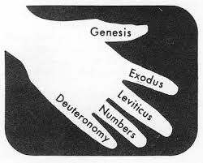](https://www.google.co.uk/url?sa=i&rct=j&q=&esrc=s&source=images&cd=&cad=rja&uact=8&ved=0ahUKEwjml7jxqqnUAhXIZ1AKHflmDZ8QjRwIBw&url=https://www.pinterest.com/pin/382172718353116465/&psig=AFQjCNGAb_8Y7QoWcwzIymNXYASK7H74Gw&ust=1496842466884381)

The Torah is the first part of the Jewish Bible. It is the central and most important document of Judaism and has been used by Jews through the ages. Torah refers to the five books of Moses which are Genesis; Exodus; Leviticus; Numbers and Deuteronomy.

Jews believe that God dictated the Torah to Moses on Mount Sinai. They believe that the Torah shows how God wants Jews to live. It contains 613 commandments. The Torah is written in Hebrew, the oldest of Jewish languages.

The word Torah has various meanings in English. These include: teaching, instruction, and law. For Jews, the Torah means all of these.

[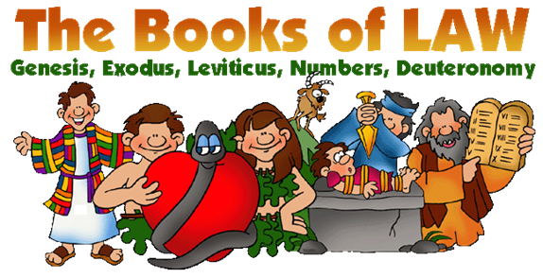](https://www.google.co.uk/url?sa=i&rct=j&q=&esrc=s&source=images&cd=&cad=rja&uact=8&ved=0ahUKEwjG9IqLq6nUAhWSZFAKHYdsACkQjRwIBw&url=https://www.pinterest.com/pin/304204149802079488/&psig=AFQjCNGAb_8Y7QoWcwzIymNXYASK7H74Gw&ust=1496842466884381)

**Use of the Torah during services**

1. The Torah reading service begins when a member of the congregation is given the honour of opening the Ark and taking out the Torah, with much respect. The Torah scrolls are taken out from the Ark (Aron hakodesh) and portions read in the synagogue three times each week. On Mondays and Thursdays small sections are read. The main reading is on the morning of Shabbat (Sabbath).

[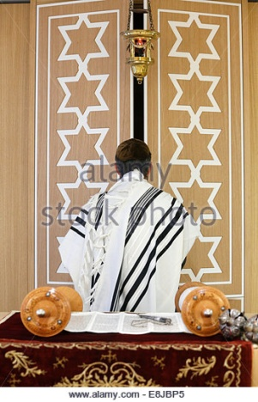](https://www.google.co.uk/url?sa=i&rct=j&q=&esrc=s&source=images&cd=&cad=rja&uact=8&ved=0ahUKEwj6kL6UrKnUAhUCa1AKHeKOAKEQjRwIBw&url=http://www.alamy.com/stock-photo/aron.html&psig=AFQjCNF2635dhrpI3BlQweZaYVlyV3Lp2g&ust=1496842706710369) 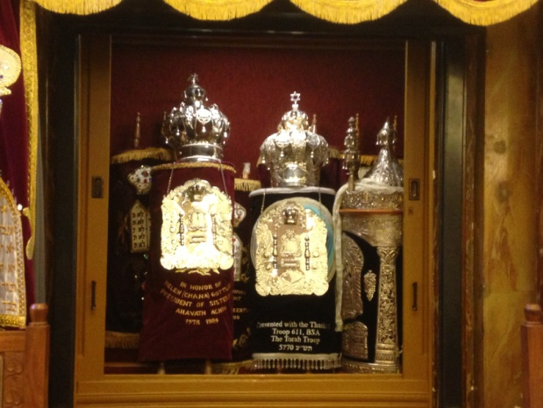 [](https://www.google.co.uk/url?sa=i&rct=j&q=&esrc=s&source=images&cd=&cad=rja&uact=8&ved=0ahUKEwik6uqYranUAhVBPFAKHbx6DuMQjRwIBw&url=https://www.youtube.com/watch?v=0v38e6GSJxw&psig=AFQjCNEtbUVFzHle2RWCrHuAZncHYikS8A&ust=1496843048951170)

1. The Torah is then taken to the Bimah, which is situated in the centre of the synagogue. On the occasion when it is necessary to read two or three different portions, two or three scrolls may be taken from the Ark. One or two additional members of the congregation are then honoured with carrying the additional Torah Scrolls to the Bimah.

As the Torah Scroll passes by, members of the congregation kiss it or try to touch it with their Tallit as a sign of love and respect.

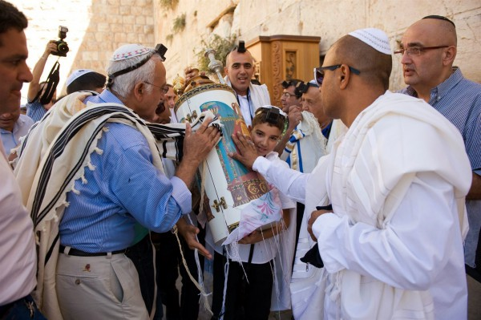 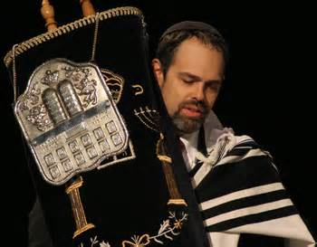 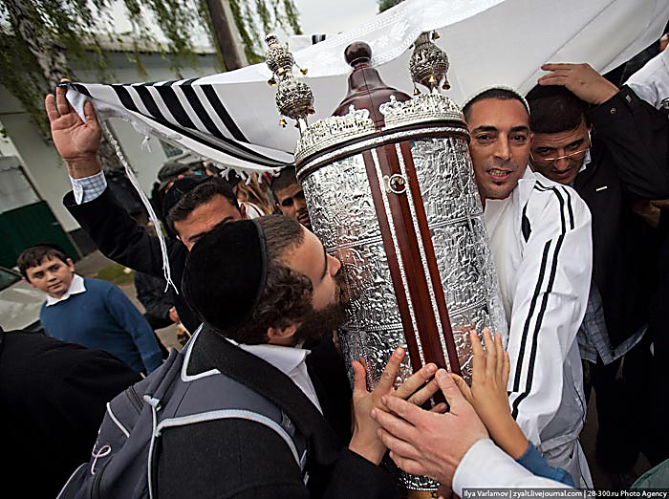

3.The scrolls are not directly touched once placed on the Bimah. A pointer or Yad (hand) is used instead. This is in the shape of a hand with an outstretched finger. The reading or chanting is performed by a person who has been trained in this task. However, it may be carried out by the rabbi. It is a very great honour for a member of the congregation to read during a synagogue service. This is called Aliyah which is Hebrew for going up.

[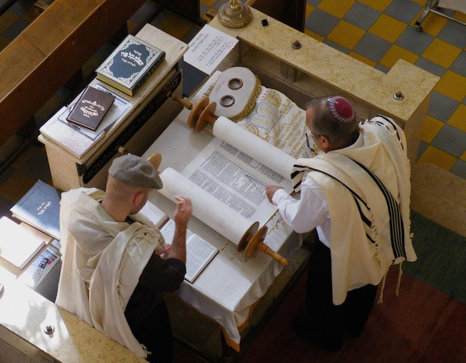](https://www.google.co.uk/url?sa=i&rct=j&q=&esrc=s&source=images&cd=&cad=rja&uact=8&ved=0ahUKEwi5zJmMsKnUAhXBKFAKHVj7AasQjRwIBw&url=http://www.myjewishlearning.com/article/aliyah/&psig=AFQjCNFIGqvLk4_0QV9O5iaS8Q7lXyw6Wg&ust=1496843870620566) **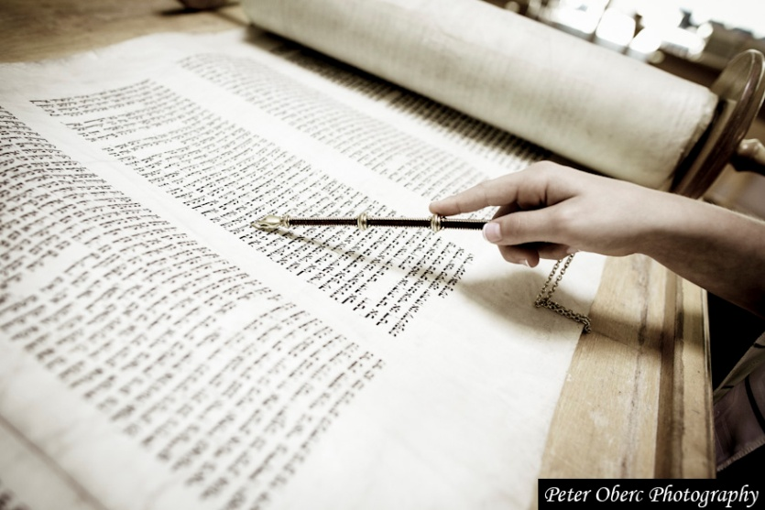**

The reader must be very skilled to read from the scroll because the letters are written without corresponding vowels. They must know the portion very well to avoid making mistakes. The reading is conducted using an ancient tune and is sung rather than spoken.

**The Torah will be read during: -**

|  |  |  |
| --- | --- | --- |
| **1** | **Daily services** | Usually 3 times a day |
| **2** | **Festivals** | Shabbat; Rosh Hashanah; Yom Kippur; Pesach;  Yom Hashoah (these are the festivals in our  course). The readings will be relevant to the occasion e.g. on Shabbat they will read parts of the Torah remembering God creating the world in 6 days and resting on the 7th day. |
| **3** | **Rites of passage** | Brit Milah; Bar/Bat Mitzvah (these are the ones listed in our course). E.g. the boy will read a passage from the Torah during his Bar Mitzvah as he is now Son of the Commandment. |

Diverse practices within Orthodox and Reform synagogue

Judaism is a diverse religion. Practices and traditions vary from one Jew to another. There are even big differences between the same group –i.e. maybe 2 ‘orthodox’ Jews might do things very differently! Here is a simple table outlining the differences between orthodox and reform worship.

[](https://www.google.co.uk/url?sa=i&rct=j&q=&esrc=s&source=images&cd=&cad=rja&uact=8&ved=0ahUKEwiR_M3evKnUAhUFPFAKHRvbCjcQjRwIBw&url=https://diversemag.co.uk/&psig=AFQjCNFZg5gzoNO55nrVFge5mNZdw9svyQ&ust=1496847255618424)

|  |  |
| --- | --- |
| **Orthodox** | **Reform** |
| **Seating**  Men & women sit apart | **Seating**  Men & women can sit together |
| **Language**  Mostly in Hebrew | **Language**  Mostly in the local language, and perhaps some in Hebrew. |
| **Dress**  Formal; women dress modestly; men wear kippah/tallit/teffilin. | **Dress**  Casual; optional to wear prayer shawl/teffilin. |
| **Rabbi**  Men only! | **Rabbi**  Men or women! |
| **Music**  No music! | **Music**  Music allowed – used often; sometimes cantor will use instrumental whilst chanting prayers. |
| **Length of services**  Tend to be quite long e.g. Shabbat service on a Saturday morning can be up to 4 hours long! | **Length of services**  Shorter services. |
| **Services**  Will generally have daily services & services during festivals e.g Shabbat | **Services**  Many do not hold daily services, just for Shabbat and major festivals e.g Yom Kippur. |
| **Shabbat service**  Will hold a service Friday evening – start time vary due to time of sunset. Will also have a lengthy Saturday morning service. | **Shabbat service**  Will hold a service Friday evening. Generally, no Saturday morning service. |

 (d) ‘Synagogues are very important within Judaism’. Discuss this statement showing that you have considered more than one point of view. (You must refer to religion and belief in your answer.) [15]

What is the success criteria for a D question?

....................................................................................................................................................................................................................................................................................................................................................

....................................................................................................................................................................................................................................................................................................................................................

....................................................................................................................................................................................................................................................................................................................................................

....................................................................................................................................................................................................................................................................................................................................................

....................................................................................................................................................................................................................................................................................................................................................

............................................................................................................................................................

....................................................................................................................................................................................................................................................................................................................................................

....................................................................................................................................................................................................................................................................................................................................................

....................................................................................................................................................................................................................................................................................................................................................

....................................................................................................................................................................................................................................................................................................................................................

....................................................................................................................................................................................................................................................................................................................................................

............................................................................................................................................................................................................................................................................................................................................................................................................................................................................................................................................................................................................................................................................................................................................................................................................

....................................................................................................................................................................................................................................................................................................................................................

...................................................................................................................................................................................................................................................................................................................................................

....................................................................................................................................................................................................................................................................................................................................................

....................................................................................................................................................................................................................................................................................................................................................

........................................................................................................................................................................................................................................................................................................................

|  |  |  |  |
| --- | --- | --- | --- |
| **Marked by** | **Mark/Level** | **(+)** | **(-)** |
| **Peer/Self** |  |  |  |
| **Teacher** |  |  |  |

**My response to the above?**

**Sacred place and Worship in the home**

* The synagogue: a place for prayer, study, celebration and assembly
* The importance of the home for worship in Judaism: challenges and benefits of observing Shabbat (Exodus 20:8-10)
* Observing kashrut (kosher, treifa, parev, shechitah)
* Separation of milk and meat in a kosher kitchen (Leviticus 11:1-24, Exodus 23:19)

[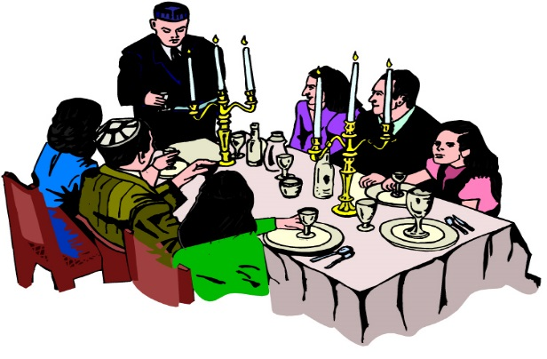](http://www.google.co.uk/url?sa=i&rct=j&q=&esrc=s&source=images&cd=&cad=rja&uact=8&ved=0ahUKEwjOnfC34KbUAhUF7xQKHeinBE8QjRwIBw&url=http://chinuchathome.info/yom-tov-chol-hamoed.html&psig=AFQjCNHy5KZDC0jE36zWYzl3DXJbCD8eVQ&ust=1496753761366485)**The importance of the home for worship in Judaism: challenges and advantages of observing Shabbat (Exodus) 20:8-10)**

*"It is the woman who usually determines the spiritual character of the home. It is the mother who is most often called upon to answer her children's daily questions. It is the extent of the mother's faith, the strength of her values and beliefs that plays the dominant role in shaping the spiritual character of the next generation".* (H.H. Donin: To Raise A Jewish Child)

* Following the destruction of the Temple in 70 A.D, worship moved from the Temple to the home and the synagogue.
* The home was regarded as a 'small sanctuary' or 'small temple.'
* The Pharisees made the home part of religious activities when introducing ceremonies like **Shabbat**.
* Everything which takes place in the home reminds the Jews of God.
* The main events of the rites which form the milestones of Jewish life are prepared or held in the home e.g circumcision and mourning practices.
* Jewish children are educated in the home.
* Children can learn in several ways, such as copying or repeating what their parents do - kedusha.
* In the home also, it is a chance for parents to teach their children the history of the religion e.g. the Holocaust.

**Observing Shabbat: Exodus 20:8-10**

***‘Remember the Sabbath day, by keeping it holy. Six days you shall labour and do all your work, but the seventh day is a Sabbath to the Lord your God. On it you shall do no work, neither you, nor your son or daughter, nor your male or female servant, nor your animals, nor any foreigners residing in your towns; for in six days the Lord made the heavens and the earth, the sea, and all that is in them, but he rested on the seventh day. Therefore, the Lord blessed the Sabbath day and made it holy.’***

[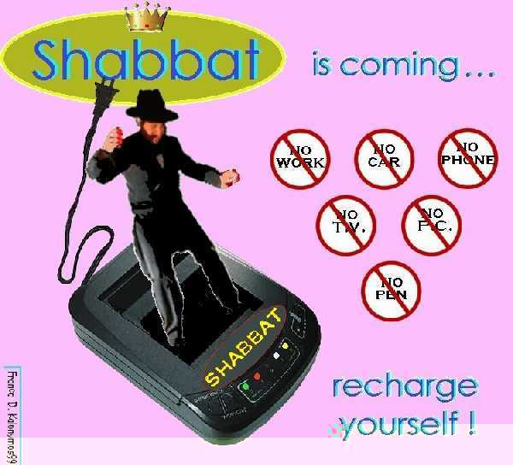](http://www.google.co.uk/url?sa=i&rct=j&q=&esrc=s&source=images&cd=&cad=rja&uact=8&ved=0ahUKEwjp1eqB66vUAhWGXRQKHelMBJsQjRwIBw&url=http://www.vosizneias.com/64121/2010/09/14/israel-minister-shuts-down-online-payments-on-shabbat-holidays/&psig=AFQjCNEk1pS5434h2GRvm32THJiiF8BCpg&ust=1496928334151414)**What is Shabbat?**

* Every week Jews observe a holy day called Shabbat.
* Shabbat is the most holy day of the year, apart from Yom Kippur.
* Shabbat is a day of complete rest, and it is also called Saboth or Shabbos.
* It is a day which is given to studying the Torah, praying, and spending valuable time with the family.
* In the Talmud, God told Moses, *“I have an important gift in my treasury, its name is ‘Saboth’. Go and tell the Israelites that I wish to give it to them”.*
* As Rabbi Saadia Gaon said in the tenth century, it is a chance *“…to rest from the burden of work in order to gain some information and pray some more, and to enable people to meet and discuss …” – this is the Shabbat.*

**When is Shabbat celebrated?**

Shabbat begins at sunset on **Friday evening** …



… and continues until three stars appear in the sky on **Saturday night**.



**Preparing for Shabbat**

Shabbat is a special day, and Jews try to ensure that the atmosphere of the home is different from the rest of the week. All preparations must be made in advance, as no work can be done on Shabbat itself.

**Preparations for Shabbat:**

* All the preparations must be made in advance as no Jews can undertake any work during Shabbat itself e.g shopping or cooking.
* [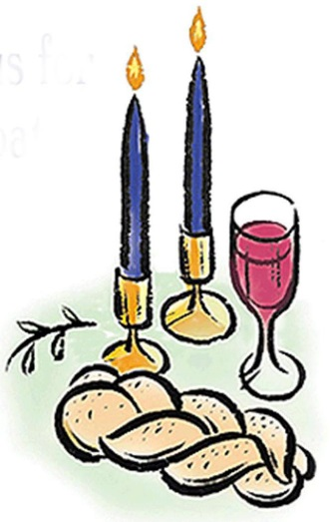](http://www.google.co.uk/url?sa=i&rct=j&q=&esrc=s&source=images&cd=&ved=0ahUKEwjw2bXO7KbUAhUCshQKHYBhCyYQjRwIBw&url=http://www.ncjwbcs.org/category/membership-archives/&psig=AFQjCNHejURyx0gPIRUXPQ8Z_o565wCU_Q&ust=1496757018060656)The best crockery and dishes will be taken out ready for Shabbat.
* The table will be laid, remembering the candlesticks, the challot and the wine.
* The house must be cleaned and tidied before Shabbat begins.
* Television and other electrical items will be covered as the use of electricity is not permitted during Shabbat.
* Jews will wash as an act of purity and change into their best clothes in order to be ready to welcome Shabbat.

[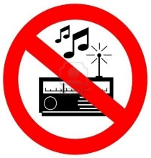](http://www.google.co.uk/url?sa=i&rct=j&q=&esrc=s&source=images&cd=&cad=rja&uact=8&ved=0ahUKEwiTk6PT-6bUAhVK7xQKHeaNALkQjRwIBw&url=http://www.bestjewishstudies.com/shabbat-english&psig=AFQjCNHVNOcx1dXpLrqIBKuz2AGJ510Htw&ust=1496761070094831)**The 39 Melachot**

[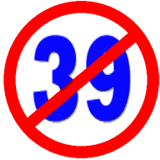](http://www.google.co.uk/url?sa=i&rct=j&q=&esrc=s&source=images&cd=&cad=rja&uact=8&ved=0ahUKEwjOs9WO_KbUAhUK8RQKHZcHB28QjRwIBw&url=http://www.akhlah.com/jewish-holidays/shabbat/39-melachot/&psig=AFQjCNGVQ5BmPjq5xN_Deil0nvv9hzgHmA&ust=1496761197036847)During Shabbat, Jews are not permitted to do any work at all (unless lives are in danger). These rules have been adapted to suit modern life today[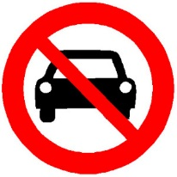](http://www.google.co.uk/url?sa=i&rct=j&q=&esrc=s&source=images&cd=&cad=rja&uact=8&ved=0ahUKEwjTh9fp-6bUAhUKPxQKHVj9D2AQjRwIBw&url=http://www.bestjewishstudies.com/shabbat-english&psig=AFQjCNHVNOcx1dXpLrqIBKuz2AGJ510Htw&ust=1496761070094831). On Shabbat there are 39 melachah (plural = Melachot) which are forbidden to Jews e.g. driving a car, using electricity, carrying objects from a private place to a public place (and vice versa), cooking and writing.

**Why are Jews not allowed to work?**

By not working or using any energy during Shabbat, Jews have a chance to enjoy themselves in ways which are different to other days of the week. It is an opportunity for the family to spend valuable time together in order to help keep Jewish families close.

[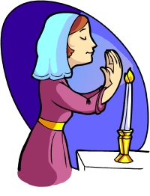](http://www.google.co.uk/url?sa=i&rct=j&q=&esrc=s&source=images&cd=&cad=rja&uact=8&ved=0ahUKEwidxpTy7abUAhWDuhQKHfJtCQcQjRwIBw&url=http://bje.org.au/course/judaism/kids/shabbat/symbols-objects/&psig=AFQjCNGH2BY77hg86O3jbojfsLnbqhWfhA&ust=1496757377001249)**Friday evening: Welcoming Shabbat**

The mother welcomes Shabbat to the home.

Before sunset on Friday evening, the mother will light two candles. She will do this **just** before the sun sets as Jews are not permitted to light a fire on Shabbat itself.

She lights **two** candles to represent the two commandments which are in the Torah regarding observing Shabbat, which are:

**“*Remember the Sabbath day*”** (Exodus 20:8) and

**“*Observe the Sabbath day*”** (Deuteronomium 5:12)

Then she will make a gesture with her hands as though she was welcoming Shabbat into her home. She will cover her eyes with her hands and say a blessing in Hebrew. Often the mother will use this moment to say a short prayer on behalf of her family.

This will be a holy time for the family, and following this, Shabbat has arrived.

**After welcoming Shabbat ...**

After welcoming Shabbat into the home, the Jewish men will walk to the Synagogue for afternoon prayers.

At the end of the service the Rabbi will take a cup of wine and say a blessing which gives thanks to God for giving Shabbat to Jews. This blessing is called kiddush.

[](http://www.google.co.uk/url?sa=i&rct=j&q=&esrc=s&source=images&cd=&cad=rja&uact=8&ved=0ahUKEwj0wfrb76bUAhVGUhQKHdAyAt0QjRwIBw&url=http://www.olv.co.nz/the-sign-of-peace/&psig=AFQjCNF0a9E3DmbSRBAYjb6Yq2g6xNTEUg&ust=1496757810719829)Before leaving the Synagogue the Jews will shake hands and wish each other a *Shabbat Shalom* (peaceful Shabbat).

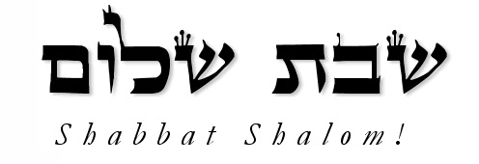

**Friday night meal**

After returning home from the synagogue, the father will

* Sit with his family by the table
* Bless his children in Hebrew
* Recite the kiddush

Nobody will eat from the moment Shabbat starts until they hear the kiddush.

Then the father will bless the Challot,

* The two challot represent manna (the miraculous bread which the Israelis ate during the journey through the wilderness).

* Challot are plaited loaves which have 12 plaits to represent the 12 loaves placed in the Temple in the old days on the night before Shabbat.

[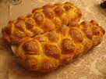](http://www.google.co.uk/imgres?imgurl=http://chaitimeblog.files.wordpress.com/2005/12/challot-450.jpg&imgrefurl=http://chaitimeblog.wordpress.com/&usg=__KVtWwFJLWeK7g9mOiupmBtVX7B0=&h=450&w=607&sz=57&hl=en&start=10&um=1&itbs=1&tbnid=nL64W_u3BmDYMM:&tbnh=101&tbnw=136&prev=/images?q=challot&um=1&hl=en&rlz=1R2GGIT_en-GB&tbs=isch:1)

[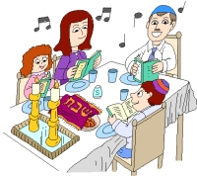](http://www.google.co.uk/url?sa=i&rct=j&q=&esrc=s&source=images&cd=&cad=rja&uact=8&ved=0ahUKEwjS99TS-qbUAhXHXBQKHTIiBrYQjRwIBw&url=http://bje.org.au/course/judaism/kids/shabbat/&psig=AFQjCNHUchRnVpuLhg6GFrFKolHWJdsjgQ&ust=1496760775049544)The father will dip pieces of the Challot in salt (to remind them of the sacrifices which took place in the Temple long ago) before sharing them.

Then the meal will begin.

This is a special meal as the Jews eat special foods and sing between the courses and stories of the Torah are read and Jewish tales are spoken. It is a relaxed and slow meal and a special time for the family to enjoy time together.

**Saturday morning during Shabbat**

**In the synagogue ...**

* The service in the Synagogue begins later but lasts longer than the usual weekly service.
* During the service, the Rabbi will read a special part of the Sefer Torah called the *Sidra*.
* During Sidra, 8 men are called to say blessings at particular times. The eighth man will read the *haftarah*.
* Invited speakers will then say some words and the Rabbi will use this opportunity to encourage the audience to abide by Judaism or will teach them something new.
* Before leaving the Synagogue, everyone will wish each other ‘Shabbat Shalom’ once more.

**In the home ...**

* After arriving home, the family will have another meal, similar to the Friday evening meal.
* The father will recite kiddush and will bless the challot, but will not bless the children.
* After the meal, the Jews will entertain themselves, making sure they keep to the 39 melachot.
* Later in the afternoon the Jewish men will walk to the Synagogue. They will read the first part of the previous week’s sidra from the sefer Torah then will study until it gets dark.

**The end of Shabbat ...**

[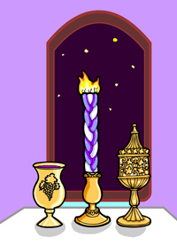](http://www.google.co.uk/url?sa=i&rct=j&q=&esrc=s&source=images&cd=&cad=rja&uact=8&ved=0ahUKEwiE4KX8_qbUAhXLtxQKHZ0fAAQQjRwIBw&url=http://bje.org.au/course/judaism/kids/shabbat/&psig=AFQjCNEawYpaw6cdBb3yC8674qHFuxgQjw&ust=1496761946391310)Shabbat ends when three stars appear in the sky on Saturday night. To note the end of the holy day, a special service will be held in the Synagogue. The congregation will recite the prayers of the week and ask for God’s blessing for the following week. At the end of the service the rabbi will perform havdalah (separation), a ceremony to mark the end of the holy day. He will bless a cup of win and sweet-smelling spices. He will give a third blessing over candlelight to show that Jews are relighting the fire once more. He blesses the wine once more and the holy day is separated from the ordinary day. As soon as the father returns from the synagogue he will also perform havdalah. Following this, Jews can begin to use electricity etc.

**Differences between the practices and opinion of Orthodox and Reformed Jews regarding observing Shabbat**

* Shabbat is important to many non-religious Jews as well as religious Jews.
* Orthodox Jews keep to all the rules and consequences of observing Shabbat which mean it is not permitted to undertake any work which would be necessary for building the first temple (or a modern definition of work by modern rabbis) during Shabbat.
* However, Conservative Jews and Reformed Jews tend to follow the original rule in Exodus which is ‘*do not work’* and regard it as a day of rest rather than a day to avoid doing particular activities
* For non-Orthodox Jews (including many who are not religious) Shabbat is a day for staying home from work but the use of technology is allowed.
* Jews disagree about whether or not it is acceptable to drive a car to the synagogue. Driving a car involves creating a spark, or lighting a fire, which is regarded as ‘work’, but many Reformed Jews argue that ‘work’ which helps to make Shabbat more holy (e.g. in order to go to the synagogue) is acceptable and can be justified.
* Many Reformed Jews believe that speaking to friends or family on the phone or even driving a car to see them is acceptable.
* On the other hand, many Orthodox Jews will switch the phone off or pull plugs from the socket in order to strictly obey the rules.
* There are as many different ways of celebrating Shabbat as there are of Jewish families.

**Why do Jews observe Shabbat?**

**The importance of observing Shabbat**

* Jews remember and celebrate God’s creation of the world. When they rest, they see themselves following the same pattern as God because God also rested on the seventh day after creating the world.
* The Ten Commandments say that they must keep the Sabbath-‘Remember the Sabbath day by keeping it holy’ (Exodus 20:8). It is one of the 613 mitzvot which Jews are obliged to keep as part of their Covenant with God.
* Jews remember the time when they were slaves of the Pharoah in Egypt and so they celebrate Shabbat every week in order to celebrate their freedom to rest today.
* Shabbat is a time for relaxing and spending valuable time with the family as family unity is very important to Jews. It unites Jews as families and socially, historically, and geographically.
* According to many Jews, Shabbat is the most important ‘festival’ or day of the year.
* Shabbat is regarded as a gift from God when the problems of the week can be forgotten.
* Even during times of Jewish persecution, they would make every effort to celebrate Shabbat as it was so important to them.
* Observing Shabbat is a part of Jewish identity and has helped to keep the religion alive.

**Challenges to observing Shabbat in the modern world**

* Some Jews believe that keeping all the rules go against the nature and meaning of Shabbat.
* It means making a great effort to ensure that they do not undertake any sort of ‘work’ – they must make detailed preparations beforehand. This means that Shabbat can be more trouble that it is worth.
* Jews are not permitted to use a car on the Shabbat and this is a problem for Jews who do not live near a synagogue and for other social reasons.
* Some would say that Shabbat is boring and repetitive because it happens every week. It loses its worth and status as it happens too often.
* It is not easy for Jews to socialise with non-Jewish friends during Shabbat even though the weekend is a convenient time for them to meet.
* It is not easy to go shopping if Jews celebrate Shabbat during the weekend and some shops are closed on Sundays.
* Jews must come home from school or work early in the winter to prepare for and welcome Shabbat. This means that children will miss out on their education and it could be difficult for a Jew to find a job which offers flexible hours or which allows them to leave work early.

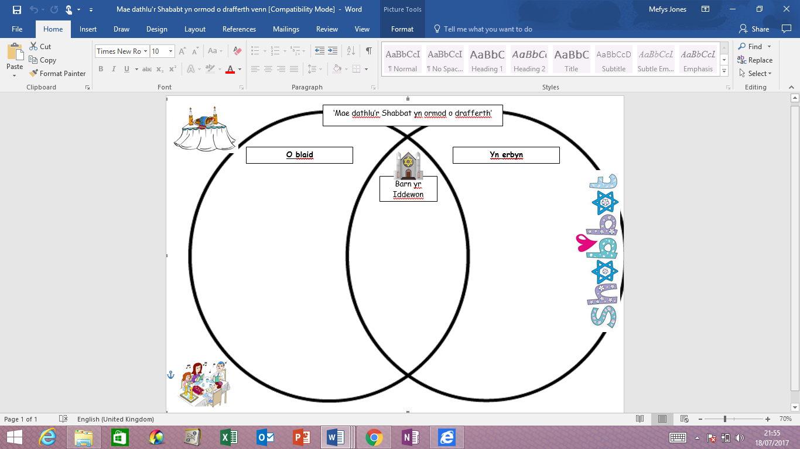

**‘Celebrating Shabbat is too much trouble.’** (15 marks)

|  |  |
| --- | --- |
| **Agree** | **Disagree** |
| Possibility that the true meaning will be lost as it happens too often | Opportunity for the family to spend time together |
| Perhaps people see it as a burden every week | Opportunity to rest every week |
| The preparations for celebrating Shabbat take a lot of time e.g cleaning the house and preparing food | An opportunity to worship God and study the Torah |
| It happens every week so maybe people do not enjoy celebrating it | It is one of God’s commands and so Jews should be happy to celebrate it every week |
| There are other festivals which the Jews could set aside to worship God e.g Pesach | A chance to think about God every week and take time from their busy lives |
| It is not possible for us to set aside a whole day of rest in our society today | A way to pass on traditions from one generation to the next |
|  |  |
| **Opinion of the Jews**   * One of the 10 Commandments * Gift from God * Emulates God resting on the 7the day after creating the world. | |

**‘CELEBRATING SHABBAT IS TOO MUCH TROUBLE.’** (15 marks)

***Discuss this statement showing that you have considered more than one viewpoint.*** (You must refer to religion and belief in your answer).



You must include arguments for the statement

 You must include arguments against the statement

 You need to include the opinion of religious believers

 You need to make a judgement e.g.’ ***Jews would not agree with the above statement because ….’***

 Use the present tense e.g. I believe, he believes, they believe

 You need to remember to make effective use of the writing frame e.g. ***Others would disagree with this because…***

You need to make use of key terms correctly e.g. 10 Commandments, God, Orthodox, Reform.

**Further points/planning:**

\_\_\_\_\_\_\_\_\_\_\_\_\_\_\_\_\_\_\_\_\_\_\_\_\_\_\_\_\_\_\_\_\_\_\_\_\_\_\_\_\_\_\_\_\_\_\_\_\_\_\_\_\_\_\_\_\_\_\_\_\_\_\_\_\_\_\_\_\_\_\_\_\_\_\_\_\_\_\_\_\_\_\_\_\_\_\_\_\_\_\_\_\_\_\_\_\_\_\_\_\_\_\_\_\_\_\_\_\_\_\_\_\_\_\_\_\_\_\_\_\_\_\_\_\_\_\_\_\_\_\_\_\_\_\_\_\_\_\_\_\_\_\_\_\_\_\_\_\_\_\_\_\_\_\_\_\_\_\_\_\_\_\_\_\_\_\_\_\_\_\_\_\_\_\_\_\_\_\_\_\_\_\_\_\_\_\_\_\_\_\_\_\_\_\_\_\_\_\_\_\_\_\_\_\_\_\_\_\_\_\_\_\_\_\_\_\_\_\_\_\_\_\_\_\_\_\_\_\_\_\_\_\_\_\_\_\_\_\_\_\_\_\_\_\_\_\_\_\_\_\_\_\_\_\_\_\_\_\_\_\_\_\_\_\_\_\_\_\_\_\_\_\_\_\_\_\_\_\_\_\_\_\_\_\_\_\_\_\_\_\_\_\_\_\_\_\_\_\_\_\_\_\_\_\_\_\_\_\_\_\_\_\_\_\_\_\_\_\_\_\_\_\_\_\_\_\_\_\_\_\_\_\_\_\_\_\_\_\_\_\_\_\_\_\_\_\_\_\_\_\_\_\_\_\_\_\_\_\_\_\_\_\_\_\_\_\_\_\_\_\_\_\_\_\_\_\_\_\_\_\_\_\_\_\_\_\_\_\_\_\_\_\_\_\_\_\_\_\_\_\_\_\_\_\_\_\_\_\_\_\_\_\_\_\_\_\_\_\_\_\_\_\_\_\_\_\_\_\_\_\_\_\_\_\_\_\_\_\_\_\_\_\_\_\_\_\_\_\_\_\_\_\_\_\_\_\_\_\_\_\_\_\_\_\_\_\_\_\_\_\_\_\_\_\_\_\_\_\_\_\_\_\_\_\_\_\_\_\_\_\_\_\_\_\_\_\_\_\_\_\_\_\_\_\_\_\_\_\_\_\_\_\_\_\_\_\_\_\_\_\_\_\_\_\_\_\_\_\_\_\_\_\_\_\_\_\_\_\_\_\_\_\_\_\_\_\_\_\_\_\_\_\_\_\_\_\_\_\_\_\_\_\_\_\_\_\_\_\_\_\_\_\_\_\_\_\_\_\_\_\_\_\_\_\_\_\_\_\_\_\_\_\_\_\_\_\_\_\_\_\_\_\_\_\_\_\_\_\_\_\_\_\_\_\_\_\_\_\_\_\_\_\_\_\_\_\_\_\_\_\_\_\_\_\_\_\_\_\_\_\_\_\_\_\_\_\_\_\_\_\_\_\_\_\_\_\_\_\_\_\_\_\_\_\_\_\_\_\_\_\_\_\_\_\_\_\_\_\_\_\_\_\_\_\_\_\_\_\_\_\_\_\_\_\_\_\_\_\_\_\_\_\_\_\_\_\_\_\_\_\_\_\_\_\_\_\_\_\_\_\_\_\_\_\_\_\_\_\_\_\_\_\_\_\_\_\_\_\_\_\_\_\_\_\_\_\_\_\_\_\_\_\_\_\_\_\_\_\_\_\_\_\_\_\_\_\_\_\_\_\_\_\_\_\_\_\_\_\_\_\_\_\_\_\_\_\_\_\_\_\_\_\_\_\_\_\_\_\_\_\_\_\_\_\_\_\_\_\_\_\_\_\_\_\_\_\_\_\_\_\_\_\_\_\_\_\_\_\_\_\_\_\_\_\_\_\_\_\_\_\_\_\_\_\_\_\_\_\_\_\_\_\_\_\_\_\_\_\_\_\_\_\_\_\_\_\_\_\_\_\_\_\_\_\_\_\_\_\_\_\_\_\_\_\_\_\_\_\_\_\_\_\_\_\_\_\_\_\_\_\_\_\_\_\_\_\_\_\_\_\_\_\_\_\_\_\_\_\_\_\_\_\_\_\_\_\_\_\_\_\_\_\_\_\_\_\_\_\_\_\_\_\_\_\_\_\_\_\_\_\_\_\_\_\_\_\_\_\_\_\_\_\_\_\_\_\_\_\_\_\_\_\_\_\_\_\_\_\_\_\_\_\_\_\_\_\_\_\_\_\_\_\_\_\_\_\_\_\_\_\_\_\_\_\_\_\_\_\_\_\_\_\_\_\_\_\_\_\_\_\_\_\_\_\_\_\_\_\_\_\_\_\_\_\_\_\_\_\_\_\_\_\_\_\_\_\_\_\_\_\_\_\_\_\_\_\_\_\_\_\_\_\_\_\_\_\_\_\_\_\_\_\_\_\_\_\_\_\_\_\_\_\_\_\_\_\_\_\_\_\_\_\_\_\_\_\_\_\_\_\_\_\_\_\_\_\_\_\_\_\_\_\_\_\_\_\_\_\_\_\_\_\_\_\_\_\_\_\_\_\_\_\_\_\_\_\_\_\_\_\_\_\_\_\_\_\_\_\_\_\_\_\_\_\_\_\_\_\_\_\_\_\_\_\_\_\_\_\_\_\_\_\_\_\_\_\_\_\_\_\_\_\_\_\_\_\_\_\_\_\_\_\_\_\_\_\_\_\_\_\_\_\_\_\_\_\_\_\_\_\_\_\_\_\_\_\_\_\_\_\_\_\_\_\_\_\_\_\_\_\_\_\_\_\_\_\_\_\_\_\_\_\_\_\_\_\_\_\_\_\_\_\_\_\_\_\_\_\_\_\_\_\_\_\_\_\_\_\_\_\_\_\_\_\_\_\_\_\_\_\_\_\_\_\_\_\_\_\_\_\_\_\_\_\_\_\_\_\_\_\_\_\_\_\_\_\_\_\_\_\_\_\_\_\_\_\_\_\_\_\_\_\_\_\_\_\_\_\_\_\_\_\_\_\_\_\_\_\_\_\_\_\_\_\_\_\_\_\_\_\_\_\_\_\_\_\_\_\_\_\_\_\_\_\_\_\_\_\_\_\_\_\_\_\_\_\_\_\_\_\_\_\_\_\_\_\_\_\_\_\_\_\_\_\_\_\_\_\_\_\_\_\_\_\_\_\_\_\_\_\_\_\_\_\_\_\_\_\_\_\_\_\_\_\_\_\_\_\_\_\_\_\_\_\_\_\_\_\_\_\_\_\_\_\_\_\_\_\_\_\_\_\_\_\_\_\_\_\_\_\_\_\_\_\_\_\_\_\_\_\_\_\_\_\_\_\_\_\_\_\_\_\_\_\_\_\_\_\_\_\_\_\_\_\_\_\_\_\_\_\_\_\_\_\_\_\_\_\_\_\_\_\_\_\_\_\_\_\_\_\_\_\_\_\_\_\_\_\_\_\_\_\_\_\_\_\_\_\_\_\_\_\_\_\_\_\_\_\_\_\_\_\_\_\_\_\_\_\_\_\_\_\_\_\_\_\_\_\_\_\_\_\_\_\_\_\_\_\_\_\_\_\_\_\_\_\_\_\_\_\_\_\_\_\_\_\_\_\_\_\_\_\_\_\_\_\_\_\_\_\_\_\_\_\_\_\_\_\_\_\_\_\_\_\_\_\_\_\_\_\_\_\_\_\_\_\_\_\_\_\_\_\_\_\_\_\_\_\_\_\_\_\_\_\_\_\_\_\_\_\_\_\_\_\_\_\_\_\_\_\_\_\_\_\_\_\_\_\_\_\_\_\_\_\_\_\_\_\_\_\_\_\_\_\_\_\_\_\_\_\_\_\_\_\_\_\_\_\_\_\_\_\_\_\_\_\_\_\_\_\_\_\_\_\_\_\_\_\_\_\_\_\_\_\_\_\_\_\_\_\_\_\_\_\_\_\_\_\_\_\_\_\_\_\_\_\_\_\_\_\_\_\_\_\_\_\_\_\_\_\_\_\_\_\_\_\_\_\_\_\_\_\_\_\_\_\_\_\_\_\_\_\_\_\_\_\_\_\_\_\_\_\_\_\_\_\_\_\_\_\_\_\_\_\_\_\_\_\_\_\_\_\_\_\_\_\_\_\_\_\_\_\_\_\_\_\_\_\_\_\_\_\_\_\_\_\_\_\_\_\_\_\_\_\_\_\_\_\_\_\_\_\_\_\_\_\_\_\_\_\_\_\_\_\_\_\_\_\_\_\_\_\_\_\_\_\_\_\_\_\_\_\_\_\_\_\_\_\_\_\_\_\_\_\_\_\_\_\_\_\_\_\_\_\_\_\_\_\_\_\_\_\_\_\_\_\_\_\_\_\_\_\_\_\_\_\_\_\_\_\_\_\_\_\_\_\_\_\_\_\_\_\_\_\_\_\_\_\_\_\_\_\_\_\_\_\_\_\_\_\_\_\_\_\_\_\_\_\_\_\_\_\_\_\_\_\_\_\_\_\_\_\_\_\_\_\_\_\_\_\_\_\_\_\_\_\_\_\_\_\_\_\_\_\_\_\_\_\_\_\_\_\_\_\_\_\_\_\_\_\_\_\_\_\_\_\_\_\_\_\_\_\_\_\_\_\_\_\_\_\_\_\_\_\_\_\_\_\_\_\_\_\_\_\_\_\_\_\_\_\_\_\_\_\_\_\_\_\_\_\_\_\_\_\_\_\_\_\_\_\_\_\_\_\_\_\_\_\_\_\_\_\_\_\_\_\_\_\_\_\_\_\_\_\_\_\_\_\_\_\_\_\_\_\_\_\_\_\_\_\_\_\_\_\_\_\_\_\_\_\_\_\_\_\_\_\_\_\_\_\_\_\_\_\_\_\_\_\_\_\_\_\_\_\_\_\_\_\_\_\_\_\_\_\_\_\_\_\_\_\_\_\_\_\_\_\_\_\_\_\_\_\_\_\_\_\_\_\_\_\_\_\_\_\_\_\_\_\_\_\_\_\_\_\_\_\_\_\_\_\_\_\_\_\_\_\_\_\_\_\_\_\_\_\_\_\_\_\_\_\_\_\_\_\_\_\_\_\_\_\_\_\_\_\_\_\_\_\_\_\_\_\_\_\_\_\_\_\_\_\_\_\_\_\_\_\_\_\_\_\_\_\_\_\_\_\_\_\_\_\_\_\_\_\_\_\_\_\_\_\_\_\_\_\_\_\_\_\_\_\_\_\_\_\_\_\_\_\_\_\_\_\_\_\_\_\_\_\_\_\_\_\_\_\_\_\_\_\_\_\_\_\_\_\_\_\_\_\_\_\_\_\_\_\_\_\_\_\_\_\_\_\_\_\_\_\_\_\_\_\_\_\_\_\_\_\_\_\_\_\_\_\_\_\_\_\_\_\_\_\_\_\_\_\_\_\_\_\_\_\_\_\_\_\_\_\_\_\_\_\_\_\_\_\_\_\_\_\_\_\_\_\_\_\_\_\_\_\_\_\_\_\_\_\_\_\_\_\_\_\_\_\_\_\_\_\_\_\_\_\_\_\_\_\_\_\_\_\_\_\_\_\_\_\_\_\_\_\_\_\_\_\_\_\_\_\_\_\_\_\_\_\_\_\_\_\_\_\_\_\_\_\_\_\_\_\_\_\_

[](http://www.google.co.uk/url?sa=i&rct=j&q=&esrc=s&source=images&cd=&cad=rja&uact=8&ved=0ahUKEwjkmYex9avUAhUnJ8AKHcg9AQgQjRwIBw&url=http://mattsmarketingblog.com/seo/finding-keywords/&psig=AFQjCNGgElqyIS6pfsdu-yJaJxV1I9DVpA&ust=1496930892337787)[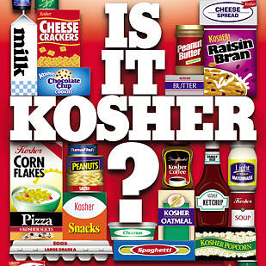](http://www.google.co.uk/url?sa=i&rct=j&q=&esrc=s&source=images&cd=&cad=rja&uact=8&ved=0ahUKEwjluYLU8avUAhUMIsAKHVU5BhYQjRwIBw&url=http://www.myjewishlearning.com/mixed-multitudes/explaining-kashrut-to-an-ignoramus/&psig=AFQjCNEbNPJB8pnVDuNRx_X0PqPU_sKGoQ&ust=1496930151198943)**Kashrut: Jewish rules about food**

**Key vocabulary:**

**Kosher** – Meaning = ‘correct’ or ‘suitable’. Foods which Jews are permitted to eat.

**Treifa** – Meaning = ‘broken’. Foods which Jews are not permitted to eat.

**Parev** - ‘neutral’ foods. Jews are permitted to eat these with meat or milk.

**Shochet** – a Jewish butcher.

**Shechitah** – the Jewish way of slaughtering an animal without pain.

Jewish food rules are a special type of mitzvot and together they are called **kashrut**. ‘Observing kosher’ is an important part of Jewish culture which means that they are more than just religious rules, but exactly how strictly they keep to the rules is usually a sign of how Orthodox the Jew is.

**Kosher animals**

***‘Of all the animals that live on land, these are the ones you may eat: you may eat any animal that has a divided hoof and that chews the cud.’ (Leviticus 11:2-3)***

In order for the animal to be kosher is must have the following two features:

* **Split hooves**
* **It chews the cud**\* (\*Cud is the name which is given on the small balls of grass which some animals form in their stomachs after grazing. They regurgitate the grass to their mouths and chew it a second time before digesting it).

[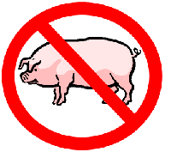](http://www.google.co.uk/url?sa=i&rct=j&q=&esrc=s&source=images&cd=&cad=rja&uact=8&ved=0ahUKEwjK6Jvv-6vUAhXGPRQKHemxBAYQjRwIBw&url=http://bhtimes.blogspot.com/2009_06_10_archive.html&psig=AFQjCNEpFbuKNI6S1jhWMsMCYBTBRboMmg&ust=1496932880282988)Examples of kosher animals: beef and lamb.

Examples of treifa animals: pig (ham, bacon, pork).

**Kosher fish**

***“Of all the creatures living in the waters of the seas and the streams, you may eat any that have fins or scales.” (Leviticus 11:9)***In order for fish to be kosher they must have the following two features:

* fins
* scales

Examples of kosher fish: Trout, salmon, tuna.

[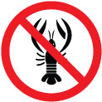](http://www.google.co.uk/url?sa=i&rct=j&q=&esrc=s&source=images&cd=&cad=rja&uact=8&ved=0ahUKEwiRnebH_6vUAhVEPhQKHVI6AT8QjRwIBw&url=http://www.glucosalive.com.au/index.php/free-from&psig=AFQjCNG9p4qBfoHH4Elu2LGZf_8bC0mijA&ust=1496933918384884)Examples of treifa fish: crab, lobster, prawns.

**Kosher birds**

A list of animals which Jews cannot eat is given in the Torah (Leviticus 11: 13-19). The list includes many birds of prey.

[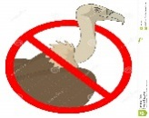](https://www.google.co.uk/url?sa=i&rct=j&q=&esrc=s&source=images&cd=&cad=rja&uact=8&ved=0ahUKEwi-sY--g6zUAhUHUBQKHYMJBY8QjRwIBw&url=https://www.dreamstime.com/royalty-free-stock-images-no-vulture-creative-design-image30367769&psig=AFQjCNGsEUnDUgvey7JsyoQZ3Al6Si9J2w&ust=1496934971815898)Examples of kosher birds: chicken, turkey.

Examples of treifa birds: eagle, vulture.

[](https://www.google.co.uk/url?sa=i&rct=j&q=&esrc=s&source=images&cd=&cad=rja&uact=8&ved=0ahUKEwimsbasjazUAhXP0RoKHcGmAxQQjRwIBw&url=https://www.autoworksmn.com/blog/adam-e2-80-99s-service-tip-3a-curing-a-misfire&psig=AFQjCNHZfVMiJ_zQRfjkLgzNhKKLaDIfbw&ust=1496937613378393)

**Remember:** A Kosher animal or bird can still be treifa is there is something wrong with its internal organs.

**Shechitah: the Jewish way of slaughtering animals**

In order for animals and birds to be Kosher, they must be slaughtered in a particular way and the name of this method is **Shechitah**.

Shechitah must be carried out by a trained butcher (**shochet**).

[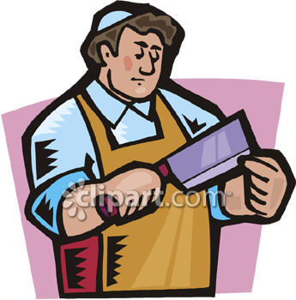](http://www.google.co.uk/url?sa=i&rct=j&q=&esrc=s&source=images&cd=&cad=rja&uact=8&ved=0ahUKEwjA06b7hazUAhVBsRQKHcq5D5QQjRwIBw&url=http://schools-demo.clipart.com/search/close-up?oid%3D3730408%26q%3Dbutcher%26s%3D1%26a%3Dc&psig=AFQjCNFzxSk6vm3hN95aYjWwzkjgS9vt1g&ust=1496935637531927)The bird / animal is slaughtered with a quick incision across the throat using a very sharp knife. The knife cuts smoothly through the vein which lowers the blood pressure in the brain and the animal is unconscious immediately. Although it is possible to feel something, the animal is already dead.   
  
Once this has happened, it must be ensured that there is no blood remaining in the meat. The blood must be drawn out, in 4 stages which included soaking the meat in water for 30 minutes, keeping the meat separately on thin boards so that the blood can flow away, covering every part of the meat with untreated salt for an hour, then rinsing the meat to get rid of the salt. This is done to carry out God’s will, because ‘the blood is the life’ (Deut. 12:23).

**Separating meat and dairy in a kosher kitchen**

***‘Do not cook a young goat in its mother’s milk.’ Exodus 23:19***

Across the centuries Jews have interpreted this above rule from the Torah to mean that Jews who keep kosher homes should not eat meat and dairy products together.

**Mixing meat and dairy products**

**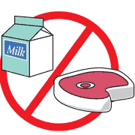**Jews are not to eat meat and dairy products together in the same meal. They must be kept apart when eating, preparing food and kept apart in the kitchen. Different crockery and cutlery are used, and these are washed and dried in a separate bowl and using different tea towels. They must wait a number of hours after eating meat before eating anything which contains milk, and around half an hour before eating anything which contains meat after eating dairy products.

**Parev Foods**

Foods which do not contain meat or dairy (i.e. vegetables, eggs) and which have not been prepared with an equipment used for meat or dairy products are called **parev** or parve. Parev foods can be eaten with meat or milk.

Sometimes, even after taking great care in the kitchen, meat or dairy products can become mixed up or spilt on each other. When this happens, Jews ask for the advice of the rabbi, who decides if the food and equipment are still kosher.

**Buying kosher food**

[](http://www.google.co.uk/url?sa=i&rct=j&q=&esrc=s&source=images&cd=&cad=rja&uact=8&ved=0ahUKEwj0_IbDh67UAhULXhoKHQr-Au8QjRwIBw&url=http://www.myjewishlearning.com/article/ask-the-expert-kosher-symbols/&psig=AFQjCNFKrC1kpj1RFOUrRc4Gb4C9jXiotg&ust=1497004762209073)Most food today contains colouring, flavouring and preservatives and these are not all kosher. In order to avoid the problem of knowing which products are kosher, there are rabbis which oversee the food which is produced. Rabbis will testify that the food is kosher using the label which is printed on the packet. This label is called **hechsher**.

Today, a wide variety of food carry the hechsher label. These include items such as sweets, chocolate, soup, margarine, oil, biscuits, butter, and cheese. Most of these foods are produced in Israel or the USA, and an increasing number of being produced in Britain. It is probably easier to keep a kosher home today than at any other time in the past.

[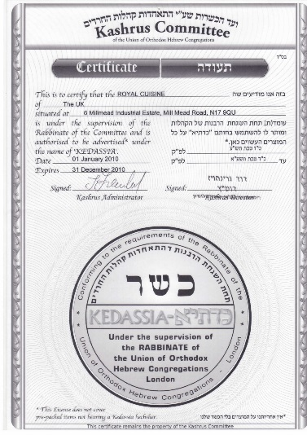](http://www.google.co.uk/url?sa=i&rct=j&q=&esrc=s&source=images&cd=&cad=rja&uact=8&ved=0ahUKEwj6gPngh67UAhUGbRQKHX36B-wQjRwIBw&url=http://royalecuisine.co.uk/accreditation/&psig=AFQjCNH_8yrcirQlpg2sh5crsNCzeSuUsg&ust=1497004840230363)The kosher butcher shop will show the licence given the board of rabbis. The board is responsible for ensuring that the butcher is doing everything properly. They often send inspectors out to look at the shop. If it is found that the butcher is selling food which is not kosher, then the shop will lose its licence immediately.

Kosher restaurants must also be licensed by the rabbi authority. These restaurants usually well meat or dairy products only.

**The importance of observing Kashrut**

* A command from God (*mitzvah*). According the Orthodox Jews, God’s Word is the *Torah*. What right do they have to choose and select which rules to keep?
* Judaism is a way of life – eating is part of everyday life.
* The home – the centre of the religion.
* Worshipping God on a basic level – thinking about God and respecting him even when eating.
* Maintaining their identity. It unites them as Jews, as God’s Chosen and holy Nation. Promotes a feeling of unity and closeness.
* Practices self-discipline. Disciplines people towards the holiness of the Covenant. Set apart. ‘Holy = ‘apart’.
* Shows their belief in God and that they accept his demands.
* Shows that they belong to a group of special and different people. Feeling of belonging, as though they are part of a close family.
* Keeps the tradition. An important part of their heritage.

**Different opinions between Orthodox Jews and Reformed Jews regarding observing Kashrut**

* Jews have different opinion about observing the rules of kashrut and how strictly they should be observed.
* Orthodox Jews will keep a kosher kitchen but some Orthodox Jews will choose to be vegetarian in order to avoid the problem of having to have two sets of kitchen items; or if they choose to eat meat they will only do so in a kosher restaurant.
* Reformed Jews will tend to stick to the rule of not mixing meat and dairy products, but not all believe that it is necessary that an animal is slaughtered in the shechitah method or that all the blood must be removed from a kosher animal.
* Most Reformed Jews do not believe that they must have the seal of approval of Jewish authorities for parev foods and fruit and vegetables.
* Not every Reformed Jew is overly concerned with eating foods which have been prepared by non-Jewish people using non-kosher saucepans, cutlery etc.
* However, Orthodox Jews believe that no meal can be kosher if it has be prepared by a non-Jew.
* For many secular and Reformed Jews, observing kosher has more to do with being loyal to Jewish traditions and cultural rather than adhering strictly to the mitzvot in the Torah.
* Many Orthodox Jewish practices go beyond the exact words of the Torah but Reformed Jews would argue that the Torah could be interpreted in different ways.
* Secular and Reformed Jews could argue that kashrut rules were not divine rules originally, but were introduced for health and safety reasons e.g. drawing the blood from meat and salting it are ways of preserving it and keeping it fresh, and checking fruit and vegetables for insects and bugs is a sensible idea!
* The morality of shechitah is a very contentious issue in Judaism. While some Jews argue that it is vital that they are given the right to use the shechitah method for religious freedom, others feel that civil authorities have a right to ban it for animal welfare reasons.

**Homework**

**(c) Explain why it is important for Jews to keep a kosher kitchen. [8]**

What is the success criteria for a C question?

............................................................................................................................................................................................................................................................................................................................................................................................................................................................................................................................................................................................................................................................................................................................................................................................................................................................................................................................................................................................................................................................................................................................................................................................................................................................................................................................................................................................................................................................................................................................................................................................................