**UNIT 1 Part A – CHRISTIANITY**

These terms are the **key concepts** for this unit – Christianity. There are 13 terms you must learn for the exam! You must learn their meanings as well as provide an example for each. This will be question (a) in the exam. You will also use some of these concepts in every other answer.

**Omnipotent**

All-powerful, almighty and unlimited nature of God.

**Omnibenevolent**

All-loving and good e.g God.

**God**

Supreme, Ultimate being. Ultimate power given worship.

**Inter-faith dialogue** Different faith/religious communities/groups coming together to understand each other better and to serve the wider community with respect that allows them to live peacefully alongside eachother in spite of differences in beliefs and ways of life.

**Agape**

Selfless, sacrificial, unconditional love. The highest types of love by Jesus’ sacrifice on

the cross for others and his teachings e.g

'Love your neighbour'.

**The Trinity**

The Three persons of God – God the Father, Son and Holy Spirit.

**Divine Command Theory**

The belief that something is right because God commands it.

**Omniscient**

The all-knowing nature of God.

**Other concepts you must learn:**

* **Incarnation:** ‘Made flesh.’ God became man/human in the person/form of Jesus.
* **Atonement:** The belief that Jesus’ death and resurrection healed the rift between humans and God. Opening the way for God and people to be 'at one' again.
* **Holy Spirit:** One of the three persons of the Holy Trinity. Jesus promised his disciples/followers that he would send the Holy Spirit after his Crucifixion and Resurrection. Christians believe that the Holy Spirit is present, as the power of God at work in the world.
* **Resurrection:** The belief that Jesus rose from the dead on Easter Sunday, conquering death.
* **Messiah:** The word means ‘the Anointed One'. The Messiah is the one believed to be sent by God to be humanity’s saviour. Christians believe this person to be Jesus.

**GOD**

**God**

➢ Creator and sustainer, omnipotence, omnibenevolence, omniscience, omnipresence

➢ Beliefs and teachings on Creation from the Genesis accounts (Genesis 1-3, esp. Genesis 1:1-3)

➢ Nature of Humanity: image of God, soul, moral, free will, rational, creative, fallen, (Genesis 1-3, esp. Genesis 1:26-28 and 2:15-17)

➢ Trinity: The three aspects of one God - Father (Luke 15:11-32), Son (John1:1-3, 14), Holy Spirit (John 14:25-26, Galatians 5:22-23)







What do you already know about God? Write your ideas.



**Task**

1.Watch the clip from ‘Bruce Almighty’ 23:17-28:41.

* What was going through Bruce’s mind as God read out the most recent entry from his life?
* Does the clip show the ideas about God accurately?

Include further ideas about God on page 2.

2. Watch the clip from ‘Extras’ 1:44-3:16. Discuss further within your group and complete the table.

|  |  |
| --- | --- |
| Why do some believe in God? | Why do some not believe in God? |
| 1.  2.  3.  4. | 1.  2.  3.  4. |

### Homework

Find out the meaning of the following terms:

#### Agnostic -

**Atheist -**

**Theist -**

**The nature of God**

Christians believe in one God – monotheism who is eternal. They use several words to describe the nature of God:

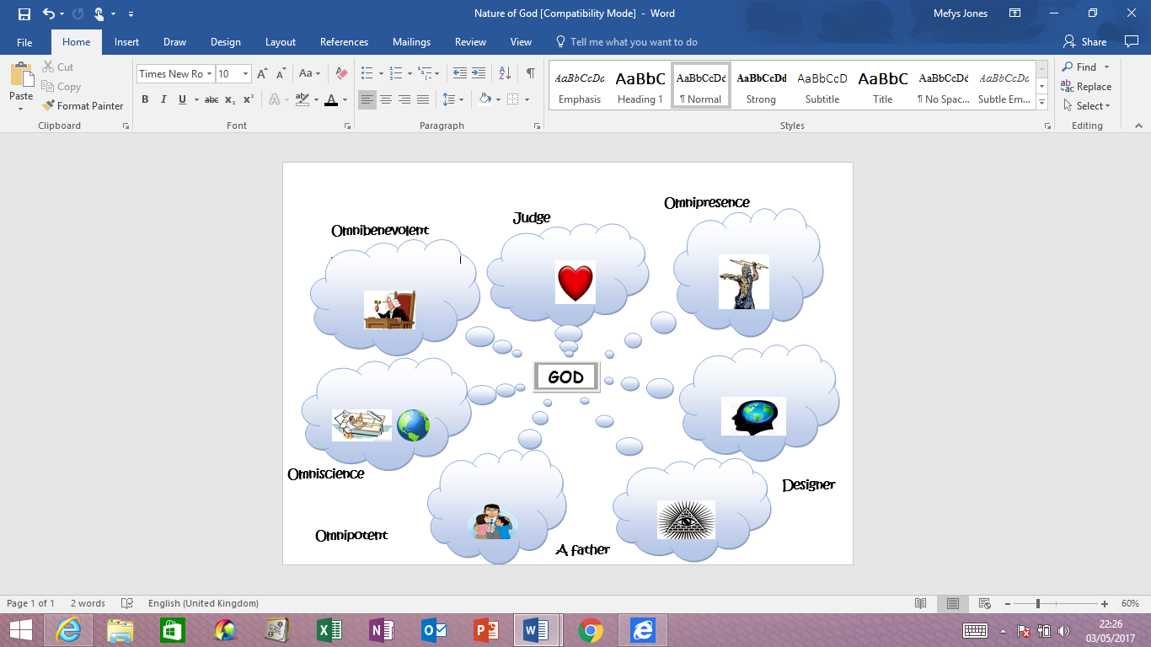

Link the terms with the pictures. Include any new terms about God on page 2.

**Complete the table**

|  |  |  |  |
| --- | --- | --- | --- |
| **CONCEPTS** |  | **MEANING** | **Example / Link in the Bible** |
| **Creator** | [Related image](http://www.google.co.uk/url?sa=i&rct=j&q=&esrc=s&source=images&cd=&cad=rja&uact=8&ved=0ahUKEwiU2sG6vuzSAhWESBQKHebgAYYQjRwIBw&url=http://biblestudy.pppst.com/genesis/creation.html&bvm=bv.150475504,d.ZGg&psig=AFQjCNEQahjSDaoc_4aBFoNe6fIQ7P1_dQ&ust=1490353672525398) | God is the creator and giver of all life. He is still involved with the world. He created humankind in his image. | *‘In the beginning God created the Heavens and the Earth.’* Gen 1:1. |
| **Sustainer** | [Related image](https://www.google.co.uk/url?sa=i&rct=j&q=&esrc=s&source=images&cd=&cad=rja&uact=8&ved=0ahUKEwi33ILKvuzSAhWEXRQKHX3aC7IQjRwIBw&url=https://clipartfest.com/categories/view/d0591ef6be4af4dd1c957cc6e0c8393d09bfef0d/gods-creation-of-the-world-clipart.html&bvm=bv.150475504,d.ZGg&psig=AFQjCNEQahjSDaoc_4aBFoNe6fIQ7P1_dQ&ust=1490353672525398) | God looks after everyone and everything, keeps everything in order and controls history - keeps it going. |  |
|  |  | All loving, good. God loved humanity that he sent Jesus to earth so that he could have eternal life. | *‘For God, so loved the world that he gave his only Son, that whoever believes in him shall not perish but have eternal life.’* John 3:16 |
| **Omnipotence**C:\Users\User\AppData\Local\Microsoft\Windows\INetCache\Content.Word\qrcode.39972154.png  **Moses -Plagues** | [Image result for all powerful god](https://www.google.co.uk/imgres?imgurl=http://1.bp.blogspot.com/_Duir49nSjdc/S74R0q5yVwI/AAAAAAAAAC0/wsZKbba-UNc/s1600/All%2Bpowerful%2BGod.png&imgrefurl=http://skycometgoddess-atheistgoddess.blogspot.com/2010/04/stalin-mao-zedong-and-hitler-were.html&docid=RNSGrWVqMsmU2M&tbnid=KDrZ5UFXv8QOTM:&vet=10ahUKEwjkt5-dkcjTAhWCJ8AKHX0vDxAQMwhLKCEwIQ..i&w=750&h=672&safe=strict&bih=641&biw=1366&q=all%20powerful%20god&ved=0ahUKEwjkt5-dkcjTAhWCJ8AKHX0vDxAQMwhLKCEwIQ&iact=mrc&uact=8) |  | O.T – God told Moses to lead the Jews out of Egypt. Pharaoh refused to let them go and God sent 10 plagues and parted the Red Sea to help the Jews escape from slavery. Jews believed God was all-powerful and in control. |
| **Omniscient**C:\Users\User\AppData\Local\Microsoft\Windows\INetCache\Content.Word\qrcode.39972290.png  Bruce Almighty | [Image result for Omniscient](https://www.google.co.uk/url?sa=i&rct=j&q=&esrc=s&source=images&cd=&cad=rja&uact=8&ved=0ahUKEwj0yIrckcjTAhVBBsAKHdvRAkoQjRwIBw&url=https://www.blackgate.com/2016/04/03/things-your-writing-teacher-never-told-you-the-multiple-personalities-of-omniscient-3rd-person-spotlight-on-reporter/&psig=AFQjCNFd9IWSyS77EYFMBzsI2ShJgHX1EA&ust=1493502768019581) |  |  |
|  | [Image result for everywhere](http://www.google.co.uk/url?sa=i&rct=j&q=&esrc=s&source=images&cd=&cad=rja&uact=8&ved=0ahUKEwiqqbznksjTAhVqI8AKHSiOBHIQjRwIBw&url=http://knowyourmeme.com/photos/533539-x-x-everywhere&psig=AFQjCNEC0l5K_vfzhyVYED5ce-pqo4Z-cw&ust=1493503066506959) |  |  |

**How did the universe begin? Gen 1:1-3**

For many religious believers, God is the cause/creator of the universe. There are many different views how the universe began.

GENESIS 1 - The Creation: Christians believe that God created the world. The story of creation can be found in the book of Genesis, the first book of the Bible. God created everything over seven days and ‘it was good.’

|  |  |
| --- | --- |
| Da **Day 1 - God created night and day.**  G God called the light Day and the darkness Night. | [Related image](https://www.google.co.uk/url?sa=i&rct=j&q=&esrc=s&source=images&cd=&cad=rja&uact=8&ved=0ahUKEwiclaG-yuzSAhUL6xQKHev6DTgQjRwIBw&url=https://commons.wikimedia.org/wiki/File:U%2B25D1.svg&bvm=bv.150475504,d.ZGg&psig=AFQjCNEQVHk82Dd33ZqnO814oDVbfWfYTQ&ust=1490356955811082) |

|  |  |
| --- | --- |
| Da **Day 2 - God created the heavens.**  G God made the heavens/sky and separated the waters. | [Image result for god creation day 2  heavens clipart](https://www.google.co.uk/url?sa=i&rct=j&q=&esrc=s&source=images&cd=&cad=rja&uact=8&ved=0ahUKEwiN1O-11ezSAhWLA8AKHbS_CokQjRwIBw&url=https://clipartfest.com/categories/view/cf75c1512d7e779eb6a4851c3c01d30ab4f9475f/first-day-of-creation-clipart.html&bvm=bv.150475504,d.ZGg&psig=AFQjCNFP5pNfXYkXGYkV8hcsF6bPB7R9bw&ust=1490359868940061) |

|  |  |
| --- | --- |
| Da **Day 3 - God created land and plants.**  G God said *‘Let the waters under the heavens be gathered together in one*  *place, and let the dry land appear.’* And God said *‘Let the earth put forth*  v*egetation, plants yielding seed, and fruit trees bearing fruit in which is*  *their seed, each according to its kind, upon the earth.’* | [Image result for god creation day 3 land and plants clipart](http://www.google.co.uk/url?sa=i&rct=j&q=&esrc=s&source=images&cd=&cad=rja&uact=8&ved=0ahUKEwjU7e-7zezSAhVICsAKHU93DBoQjRwIBw&url=http://childrenschapel.org/biblestories/twinkle.html&bvm=bv.150475504,d.ZGg&psig=AFQjCNHfQea978SqdzgmwHAhagcc2CunRg&ust=1490357747348008) |

|  |  |
| --- | --- |
| Da **Day 4 - God created the sun, moon and stars**  G God made the two lights to rule the day and night and the stars. | [Image result for god creation day 4 sun stars and moon  clipart](https://www.google.co.uk/url?sa=i&rct=j&q=&esrc=s&source=images&cd=&cad=rja&uact=8&ved=0ahUKEwi0ppXnzuzSAhXsDMAKHXGfCL8QjRwIBw&url=https://clipartfest.com/categories/view/b8c8b9fd926f2ed48118fab94337c1b3fbb4135a/earth-sun-and-moon-clipart.html&bvm=bv.150475504,d.ZGg&psig=AFQjCNFSFC6Q7MN6qvY1uXaslqDxRAlsTw&ust=1490358093511144) |

|  |  |
| --- | --- |
| Da **Day 5 - God created birds and fish.**  G God said *‘Let the waters bring forth swarms of living*  *creatures, and let birds fly above the earth across the heavens.’* | [Image result for god creation day 5 birds and fish  clipart](http://www.google.co.uk/url?sa=i&rct=j&q=&esrc=s&source=images&cd=&cad=rja&uact=8&ved=0ahUKEwjej_uZ0-zSAhVlI8AKHadDAaoQjRwIBw&url=http://www.icanteachmychild.com/day-5-of-creation-birds-fish/&bvm=bv.150475504,d.ZGg&psig=AFQjCNF62MEoj210EL0PbwB1fo3evOP1xA&ust=1490359256443682) |

|  |  |
| --- | --- |
| Da **Day 6 - God created living creatures including man.**  G God said, *‘Let us make man in our image, after our likeness; and let them them have dominion over the fish of the sea, and over the birds of* t*he air, and*  *over the cattle, and over all the earth, and over every creeping thing that creeps upon the earth.’* | [Image result for god creation  people](https://www.google.co.uk/url?sa=i&rct=j&q=&esrc=s&source=images&cd=&cad=rja&uact=8&ved=0ahUKEwiehLXU1-zSAhXJB8AKHazlC1MQjRwIBw&url=https://clipartfest.com/categories/view/aa68cc032964413fdf54acd8e105310825ecd46a/gods-creation-clipart.html&bvm=bv.150475504,d.ZGg&psig=AFQjCNFC7Sxf7EktD6wg4WsprxkA2eFsGw&ust=1490360489949120) |

|  |
| --- |
| **Day 7 – God rested:** *‘And on the seventh day God finished his work which he had done, and he rested on the seventh day from all his work which he had done.’*  **Watch the following clip** -https://www.truetube.co.uk/film/beginning |

|  |
| --- |
| **GENESIS 2:** God made Adam first and placed him in paradise, the Garden of Eden. He was formed from the dust of the ground and the breath of God (soul) making him the son of the earth and a child to God. God creates Eve out of Adam’s ribs. People were created in God’s image. God gives them one rule - not to eat from the tree of knowledge. |

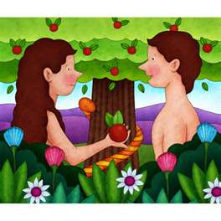

|  |
| --- |
| **GENESIS 3: The Fall**  Adam and Eve are tempted by the devil, in the form of a serpent, to eat the fruit from the tree against God’s will. In time, Eve gives in to the temptation, eats the fruit and gives some to Adam. They confess to God what they have done and as a punishment, He sends them out of the Garden of Eden to live somewhere else on the earth. They are no longer allowed to eat from the tree of life, which has given them eternal life, so death enters the world. |

|  |  |  |  |  |  |
| --- | --- | --- | --- | --- | --- |
| |  |  | | --- | --- | | **LITERALIST views** | **NON-LITERALIST views** | | Some Christians believe that the world was created in 6 days as Genesis says. This is a literalist view - believing something exactly as it is stated. | Other Christians believe that Genesis shows that God created the world and that the world would not exist without God. But they also accept scientific ideas and say that it is God who made the Big Bang happen. It is a way of showing that God is powerful. This is called a non-literalist view. | |  |

**What does the story in Genesis teach Christians?**



* God created everything for a purpose.
* The world was created out of nothing, therefore God is powerful.
* The beginning of the world and life was no accident.
* God created the world on his own - He did not have any help from anyone else. This shows that He is powerful.
* The creation stories can be read as myth (and not just literally).
* The creation stories are eternal stories.
* They are relevant today as ever.

**The nature of humanity**

**Watch the clip -** https://www.truetube.co.uk/film/problem-evil

1. After God finished creating the world, he said it was ‘good’. People were created in the **image of God** and God saw it was ‘very good’.God commanded that man was to look after and sustain the world. That is why Christians believe in stewardship – looking after the world - God’s creation.

***26Then God said, “Let us make mankind in our image, in our likeness, so that they may rule over the fish in the sea and the birds in the sky, over the livestock and all the wild animals, and over all the creatures that move along the ground.”27So God created mankind in his own image, in the image of God he created them; male and female he created them. 28God blessed them and said to them, “Be fruitful and increase in number; fill the earth and subdue it. Rule over the fish in the sea and the birds in the sky and over every living creature that moves on the ground.” Genesis 1:26-28***

2. Christians believe that God has given human beings a **soul** when he created them - the part of human nature which is spiritual and influences an individual’s personality. The soul allows people to relate and connect with God - It’s a reflection of the image of God. **Watch the clip – The Simpsons where Bart sells his soul. What does the clip teach us about the nature of the soul?** <https://www.youtube.com/watch?v=YzXcr6PdKes>

**3.Free will** – people ‘s ability to make choices in life. People were created with the ability to obey God or not according to their own choices. Eve chose to eat the fruit from the tree of life and disobey God. Some people turn against God-given reason and free will. People have abused the gift of free will and continue to sin e.g. crime, war.

# *15The Lord God took the man and put him in the Garden of Eden to work it and take care of it. 16And the Lord God commanded the man, “You are free to eat from any tree in the garden; 17but you must not eat from the tree of the knowledge of good and evil, for when you eat from it you will certainly die.” Genesis 2:15-17*

4.**Moral** – When making moral a decision our free will helps us to judge if an action

is right or wrong. Immoral acts (wrong behaviour) separates people from God e.g Adam and Eve. People are made in the **image of God,** but are sinful and in need of God’s forgiveness. People have ‘dominion’ (power) over the earth, and must show stewardship on behalf of God. Humans all have a sense of morality and are capable to respond to God. Jesus is a role model for humans.

**5.Rational –** Atheists do not believe in a God. They have a scientific, rationalview of how the world was created. Christians believe humans have God-given reason which divides humans form animals.

**6.Creative –** Humans have evolved into creative creatures. This is proof of God’s existence.

**7.Fallen** – Humans have God-given reason and free will to turn against God and

'fall'. The Fall (Genesis 3) shows when the relationship between God and people was broken. Jesus dying on behalf of people helped to restore the broken relationship with God.

**TASK**

**Create a mind map, summarizing the above beliefs.**

**Trinity**



**Task** Watch the clip It’s a Bugs life 46:01 - 50:12. Split into groups and discuss the different sub-groups that helped to build the bird.

Christians believe in One God. They think of God in three ways:

* God the Father
* God the Son
* God the Holy Spirit

These are not three different gods. The trinity is the Christian belief that there is One God in three persons:

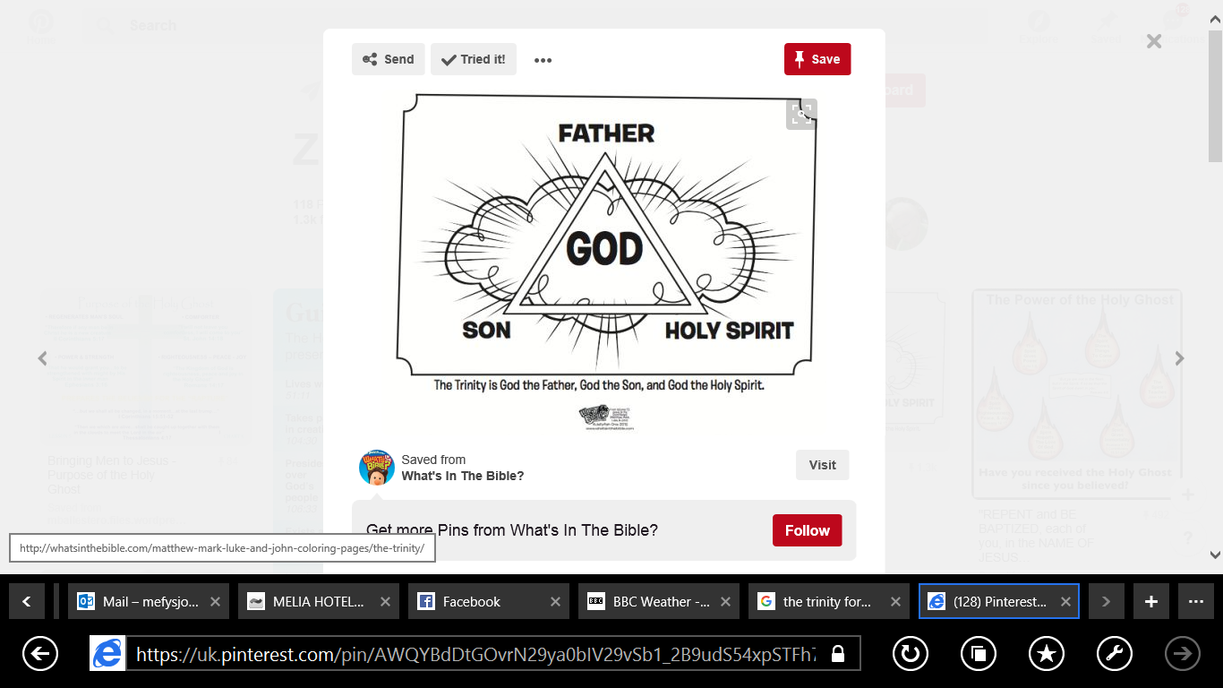

The three parts of the trinity do different things, although they work together.

* God is the Father – Creator
* Jesus is the Son – Saviour
* Holy Spirit – the one who gives new life

*‘The Father, the Son and the Holy Spirit’ - The 3 in 1, and 1 in 3.* This is called the Trinity – God in three forms.

|  |  |  |
| --- | --- | --- |
| St Patrick the Irish Patron Saint, described the Trinity as a Shamrock leaf – One whole leaf with three separate sections. | [Image result for water in different forms](https://www.google.co.uk/url?sa=i&rct=j&q=&esrc=s&source=images&cd=&cad=rja&uact=8&ved=0ahUKEwjF-JaH4P7SAhXFuBQKHTq3DnQQjRwIBw&url=https://mrbarberloveswater.wordpress.com/forms-of-water/&bvm=bv.151325232,d.ZGg&psig=AFQjCNFVkI1Mnw5Y-pjAsp3p9M58YpkqyQ&ust=1490981153115408)  Christians have tried to explain this belief using water, steam and ice –they look different but are the same substance. So, God the Father, God the Son and God the Holy Spirit are the same!! | [Image result for musical chord](https://www.google.co.uk/url?sa=i&rct=j&q=&esrc=s&source=images&cd=&cad=rja&uact=8&ved=0ahUKEwjfvOrE3_7SAhVJOxQKHfZ-B2EQjRwIBw&url=https://en.wikipedia.org/wiki/Chord_(music)&bvm=bv.151325232,d.ZGg&psig=AFQjCNE04_ILY9eIOun9qLX86BYN5Tp2wQ&ust=1490981069882980)  Think of a musical chord, which is a single musical identity, but made up of three separate notes e.g. the chord of C is one chord, but to make up that chord, there are 3 notes, ‘c’, ‘e’ and ‘g’. There are 3 notes, making up 1 chord = 3 in one. |

### Christian beliefs about God



One God.



Creator of the world- He looks after everyone and everything, keeps everything in order and controls history- sustains it-keeps it going. He created the world alone, which shows that God is powerful (omnipotent).



Father - He loves his people like a Father, and cares for them.



God for humans is beyond all understanding, and is a mystery. God is the name man gives to the mystery of life and creation. God is infinite (no ending).



Everywhere (omnipresent) and all-knowing (omniscient).



|  |
| --- |
| **Task – Read or watch The Parable of the Prodigal Son by Jesus (Luke 15:11-32). What does it tell us about the role of God as a father? https://www.youtube.com/watch?v=X_QCQ5i7NKs or** <https://www.youtube.com/watch?v=eqyV2lmdYso> |

### Christian beliefs about Jesus



**Read the following passage. What do we learn about God as the Son?**

|  |
| --- |
| **The Word Became Flesh: *In the beginning was the Word, and the Word was with God, and the Word was God. 2He was with God in the beginning. 3Through him all things were made; without him nothing was made that has been made …. 14The Word became flesh and made his dwelling among us. We have seen his glory, the glory of the one and only Son, who came from the Father, full of grace and truth.*** *(John 1:1-3, 14)* |

|  |
| --- |
| Jesus is the Son of God: Son of God - holiest person ever to have lived. God incarnatedhimself (made himself a man), and was born on earth in the form of Jesus. Jesus was divine (apart of God), and a human being at the same time. |
|  |

|  |
| --- |
| **Messiah/Christ:** Meaning - Anointed One – someone who has been chosen. Christians, believe  he will return to earth again as a King and Judge and bring peace on earth. |

|  |
| --- |
| **Jesus is the Lord:** He is equal with God his Father; ruler of the world and heaven; He directs  or guides a believer’s life. Jesus is the Redeemer: Meaning – saviour (saves), brings forgiveness. Jesus died on the crossso that people could have eternal life with God in heaven. |

[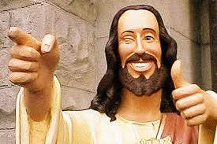](https://www.google.co.uk/url?sa=i&rct=j&q=&esrc=s&source=images&cd=&cad=rja&uact=8&ved=0ahUKEwi_9fmm39TTAhUM6RQKHbMzBm8QjRwIBw&url=https://senselessramblingsofthemindless.com/2014/06/07/the-image-of-jesus-christ/&psig=AFQjCNFeWfGrJCX3aNOG2RxHfDjEMae0gA&ust=1493935959000936)

|  |
| --- |
|  |

### Christian beliefs about God the Holy Spirit

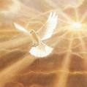

Invisible force or power that **inspires** Christians to do good things.



Holy Spirit is like the wind. Although you can’t see the wind, you can feel it and see the effect it has.



When Jesus left his disciples, they were worried; therefore, he told them that he would send a **‘comforter’** to help them- the Holy Spirit.



|  |
| --- |
| Watch the clip ‘Torronto Blessing.’ List how the Holy Spirit affects the individuals in the clip: |

**What are the gifts of the Holy Spirit according to the New Testament?**

|  |
| --- |
| ***25“All this I have spoken while still with you. 26But the Advocate, the Holy Spirit, whom the Father will send in my name, will teach you all things and will remind you of everything I have said to you. John 14:25-26*** |

|  |
| --- |
| ***22But the fruit of the Spirit is love, joy, peace, forbearance, kindness, goodness, faithfulness, 23gentleness and self-control. Against such things there is no law. Galatians 5:22-23*** |

______________________________________________________________________________________________________________________________________________________________________________________________________________________________________________________________________________________________________________________________________________________________

Gifts of the Holy Spirit: guides people; performs miracles– heals people; preach; speaking in tongues – speaking a language others cannot understand (like Harry Potter can speak parcelmouth).

**Homework**

**Success criteria for question a:**

**What do Christians mean by Omnibenevolent? (2)**

________________________________________________________________________________________________________________________________________________________________________________

**What do Christians mean by The Trinity? (2)**

________________________________________________________________________________________________________________________________________________________________________________

**Self-assessment**

|  |  |  |
| --- | --- | --- |
| **Mark** | **(+) against the success criteria** | **Teachers comments** |
|  |  |  |

**TASK - Do you remember how to answer question C?**

**Success criteria for question C**

**Explain Christian beliefs about God. (8)**

________________________________________________________________________________________________________________________________________________

________________________________________________ ________________________________________________________________________________________________________________________________________________________________________________________________________________________________________________________________________________________________________________________________________________

________________________________________________________________________________________________

________________________________________________________________________________________________

|  |  |  |  |
| --- | --- | --- | --- |
| **Peer assessment** | **Band/Mark** | **+** | **-** |
| **Marked by:** |  |  |  |
| **Teacher assessment** |  |  |  |

**Your comments to the above?**