TGAU – CRISTNOGAETH – DUW

Cynllun / Gweithgareddau dosbarth

Tua 3 wythnos o waith = 7-9 gwers

Gwers 1
- Cyflwyno’r cysyniadau yn fras i sicrhau dealltwriaeth.
- Cofnod – Gwybdaeth am Dduw.

Gwers 2- 3
- Clipiau Bruce Almighty/Extras.
- Trafodaeth.
- Opsiwn:

Gwefan Hwb – Chwilio am ystyr
Gweithgareddau rhyngweithiol neu ar y daflen
Natur Duw – carwsel Tasgau Annibynnol adref = Gwefan HWB

1.Tasg ymarfer - Sut un yw Duw?
http://resources.hwb.wales.gov.uk/VTC/200809/re/looking_for_meaning/cym/chwilio-am-ystyr/natur-duw/carwsel-natur-duw.swf

2.Sut un ydi Duw – cysylltu’r termau efo ystyr

Gwers 4
Y Creu

Opsiwn – gwefan Hwb
Gweithgaredd Rhyngweithiol – y creu
http://resource.download.wjec.co.uk.s3.amazonaws.com/vtc/2008-09/re/our_world/creation/part-1/GenesisCreation.htm

Order of Genesis – Saesneg Eduqas Digital Resources
http://resource.download.wjec.co.uk.s3.amazonaws.com/vtc/2015-16/15-16_13/Beliefs%20and%20teachings/eng/orderingGenesis.html

Gwers 5
Natur Dynoliaeth

Gwers 6-7
Y Drindod
In the film the various bugs and insects work together to build a giant bird to scare off the evil caterpillars. This suggests something of the different roles within the Trinity, and has the bugs needing to work together as one in order to get the job done. The clip opens with Flick pitching the idea of building a giant mechanical bird, and ends with all the bugs applauding the completed bird. Start time: 0:46:01, End time: 0:50:12, Clip length: 4 mins and 11 seconds. After watching the clip, get the class to split into groups and discuss the different sub-groups that helped to build the bird. For example:
• Ants collecting materials
• Flying circus bugs who held up outline
• Spider who used her web to keep everything together
Having got the group to come up with as many different roles as they could see and who did each role, get the groups to come back together and share their thoughts.

2.The song Me and My Shadow from Robbie Williams’ album Swing When You’re Winning presents a picture of two distinct individuals, who are also inseparable from one another. Click below to read the lyrics for yourself:
www.azlyrics.com/lyrics/robbiewilliams/meandmyshadow.html

The Trinity is often explained with reference to water: depending on the temperature, water appears as either a liquid (water), a solid (ice) or a vapour (steam). However in each case, it is still H2O. This is another imperfect image though, because God does not change between three states, but is constantly all three persons of the Trinity, and also one single God. St. Patrick’s explanation of the Trinity being like a shamrock – it is one plant and three leaves, so is three and one at the same time. Think of a musical chord, which is a single musical identity, but made up of three separate notes. For example the chord of C is one chord, yet to make up that chord, there are three notes, ‘c’, ‘e’ and ‘g’. There are three notes, yet they make up one chord, thus three in one.

Gwers 8
Tasgau ac adolygu’r uned.

** Gweler wefan CBAC – Adnoddau addysgol
** Gwefan Eduqas – Digital Resources.

** See WJEC website – Educational resources
** Eduqas Website – Digital Resources.

Cynllun gwaith- gwefan CBAC
Scheme of work – WJEC website
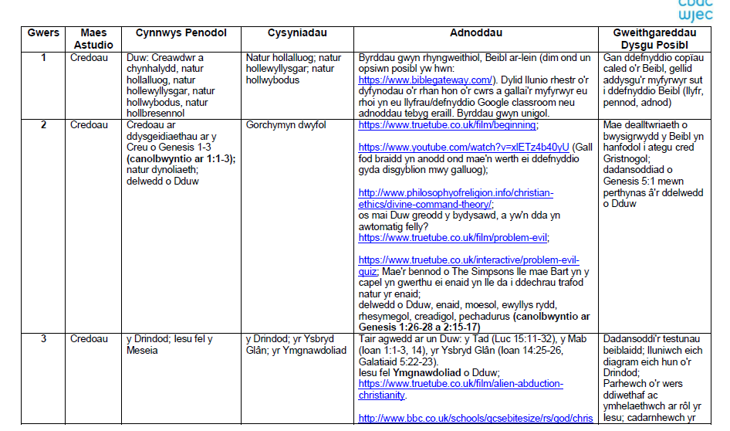

GUIDANCE FOR TEACHIN

