ISLAM

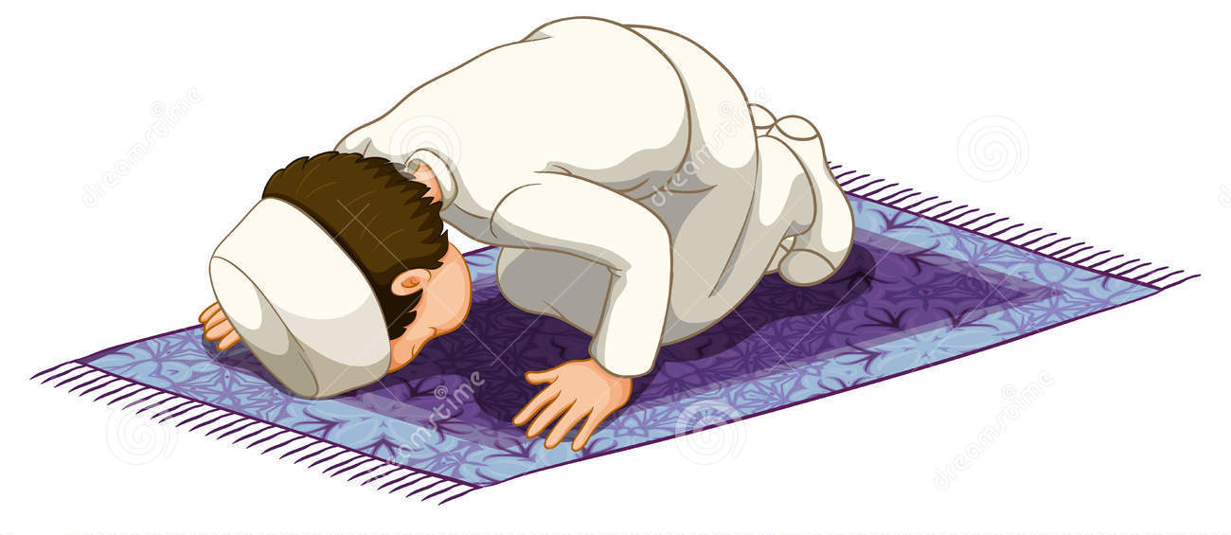

PRACTICES (Booklet 2)

Enw:

Sunni and Shi’a Muslims

There are two main groups within Islam – Sunni and Shi’a Muslims. Sunni Muslims are the largest group (85%) and Shi’a the smallest (15%). Both groups agree on the important beliefs and practices within Islam although there are some differences in opinion – mainly regarding who the rightful successor to Muhammad is.

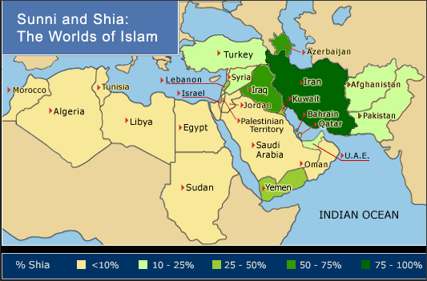

For Sunni Muslims, the Five Pillar of Islam sets out how they should practise their religion. Shi’a Muslims follow a similar set of rules which are called the Ten Obligatory Acts.

The Five Pillars of Islam for Sunni Muslims

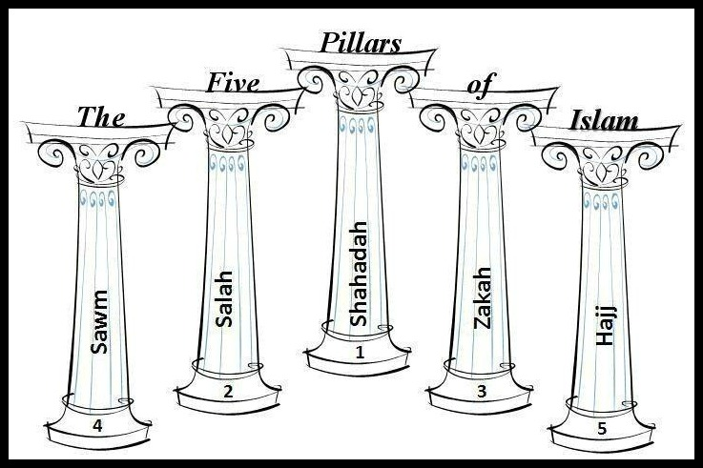

- Shahadah: the declaration of faith
- Salah: Prayer five times day
- Zakat: Charity, giving money to the poor
- Sawm: Fasting during the month of Ramadan
- Hajj: Pilgrimage to Makkah

You will study the first four of the pillars in Year 10 and the last pillar – Hajj – in Year 11.

Shahadah

Shahadah means ‘to witness or testify’. This is the Muslim creed (a sentence which sets out exactly what the Muslim believes) because it contains all that Muslims must believe to all themselves Muslims. The words of the Shahadah are:

“I bear witness that there is no god but Allah and that Muhammad is the prophet of God.”

The Shahadah is believed to be the central pillar which keeps the ‘House of Islam’ standing. The other four pillars are all outward expressions of this deeply held belief (that is, the other four are what Muslims actually do in everyday life because of their belief). Shahadah, the first pillar, leads to ibadah (worship) but Muslims cannot worship without faith (iman). So, Shahadah is the first and the most important pillar, as if one does not believe that, he is not a Muslim.
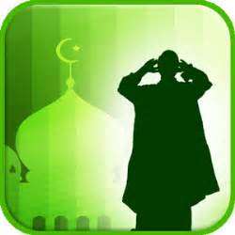
These words are used in many different situations:

- Prayer. The Shahadah is recited many times a day during the prayer ritual of salah. They are announced five times a day from the minaret of the mosque as the muezzin calls Muslims to prayer. The adhan (call to prayer) include the Shahadah. The words of the Shahadah are sometimes also known as the Kalimah prayer.

- Life and death. The words of the Shahadah are the first words newborns hear since their father whispers them into their ears. During the Aqiqah ceremony (when the baby is seven days old) the father will recite the Shahadah prayer again before shaving the hair of the baby, giving the hair’s weight in gold to charity and sacrificing and animal. They are also the last words a person will recite (or hear recited) before death. A Muslim soldier will say the words of the Shahadah when going into battle.

- Conversion. There are no ceremonies in Islam to welcome people into the religion (like baptism for Christians). Instead, all a person needs to do to become a Muslim is to recite the Shahadah in front of Muslim witnesses and then they become Muslim themselves. Some people prefer to call this ‘reversion’ rather than ‘conversion’. This is because they believe that we were all born worshippers of the true God and so when we discover faith we return (revert) to our natural faith.

- Monotheism. The Shahadah sets out Muslim beliefs about God – particularly the idea that there is only one God. This is called monotheism. Islam rejects polytheism (the belief in lots of gods – like Hinduism) and also atheism (the belief that there is no god). The Shahadah also shows that Muslims reject the Christian belief in the Trinity (God the Father, Son and Holy Spirit). Jesus (called Isa) is shown great respect in Islam but he is a great prophet, and not a divine being.

Importance of Shahadah

- Without belief, there is no practice. Without Shahadah, there would be no four other pillars
- This is what sets Islam out as being different from other religions
- This is what makes you a Muslim (either by Aqiqah ceremony or by conversion)
- It sets out one of the most important beliefs in Islam – that there is one God and Allah is his name.

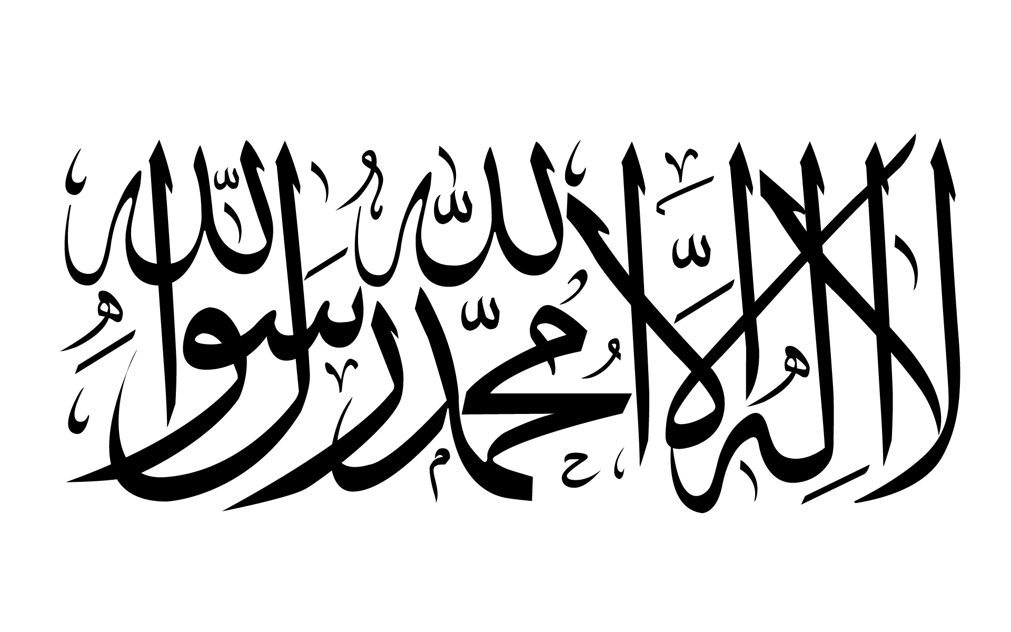

Shi’a Muslims and Shahadah

Shi’as also say that it is by reciting the Shahadah that one becomes a Muslim. However, there are two main differences in Shi’a and Sunni use of Shahadah:

- Shi’as agree with Sunnis that the oneness of God and guidance through the prophet Muhammad are essential to Islam. However, Shi’as add an extra part to the Shahadah where they say that ‘Ali is the vicegerent of God’. This is because they believe that Ali was appointed leader to the community by Muhammad.

- Shahadah is not one of the 10 Obligatory Acts for Shi’as, whereas it is the first of the 5 Pillars for Sunnis.

Question Practice

- What is meant by ‘shahadah’? (2)
- Describe how Muslims use the shahadah (5)
- Explain why Shahadah is important in Islam (8)

- ‘Shahadah is the most important of the Five Pillars of Islam’ (15) Discuss this statement showing that you have considered more than one point of view (15)

Salah

The second pillar is Salah – praying five times a day. For Muslims, prayer is the most important way to worship God and is a duty for all Muslims. Salah reminds Muslims to give thanks for God’s blessings and of the importance of submitting to God’s will. It is a physical, mental and spiritual activity that draws believers close to God.

‘So exalt God with praise of your Lord and be of those who prostrate to him. Worship your Lord util there comes to you a certainty (i.e. until you die)

Qur’an 15:98 - 99
‘Recite (O Muhammad) what has been revealed to you of the book and establish prayer. Indeed, prayer prohibits immortality and wrongdoing and the remembrance of God is greater. And God knows that which you do.’
Qur’an 29:45

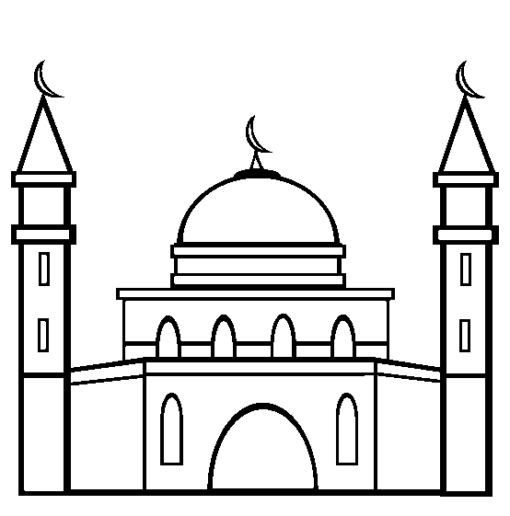
When do Muslims pray?

Salah should be performed five times a day;

Fajr: between dawn and sunrise
Zuhr: after midday until afternoon
As’r: between late afternoon and sunset
Maghrib: between sunset and the end of daylight
Isha: between sunset and dawn

The time for prayer is announced by the muezzin making the adhan (call to prayer) from the minaret of the mosque. In some Muslim countries, the muezzin climbs to the top of the minaret to call the adhan, however, many mosques now use loudspeakers.

Preparing to pray

Preparation for prayer is extremely important because coming into the presence of God requires a deep sense of respect. Prayer begins with a declaration of intent – niyyah. It must be a deliberate act, to set aside a few minutes to focus on God and enter into a state of ‘God consciousness’. This allows Muslims to concentrate on God’s greatness, to thank and praise him and ask for his forgiveness.

Before starting to pray, Muslims must practise wudu (washing). They wash specific parts of their body: hands, mouth, nose, face, arms, head and feet in particular order. This is an outward sign of the inner cleanliness needed to face God. Salah is a moment when a Muslim makes direct contact with God and so must be as pure as possible.

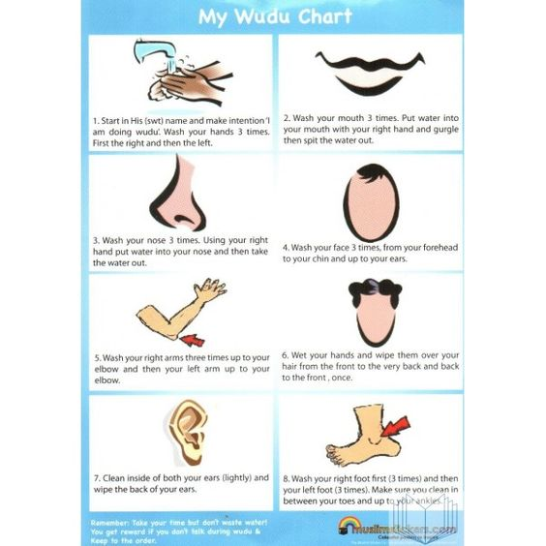

How do Muslims pray?

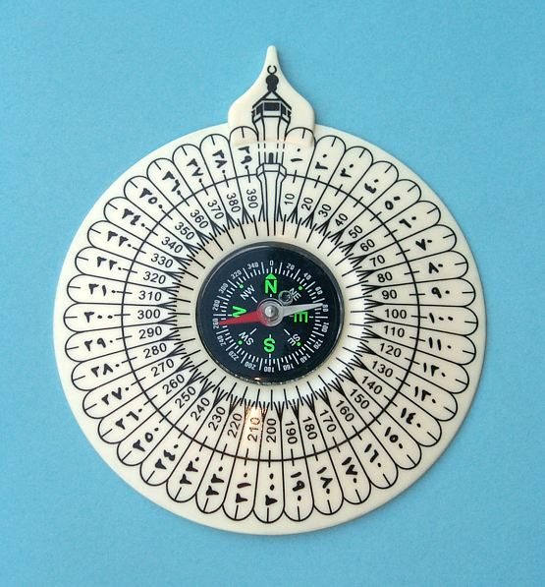
Muslims pray facing towards Makkah. When they are out and about Muslims will use a compass known as a Qibla finder to show the direction of Makkah. However, the mosque has a Qibla wall so that each worshipper knows which way to face. This wall is also known as the mihrab.

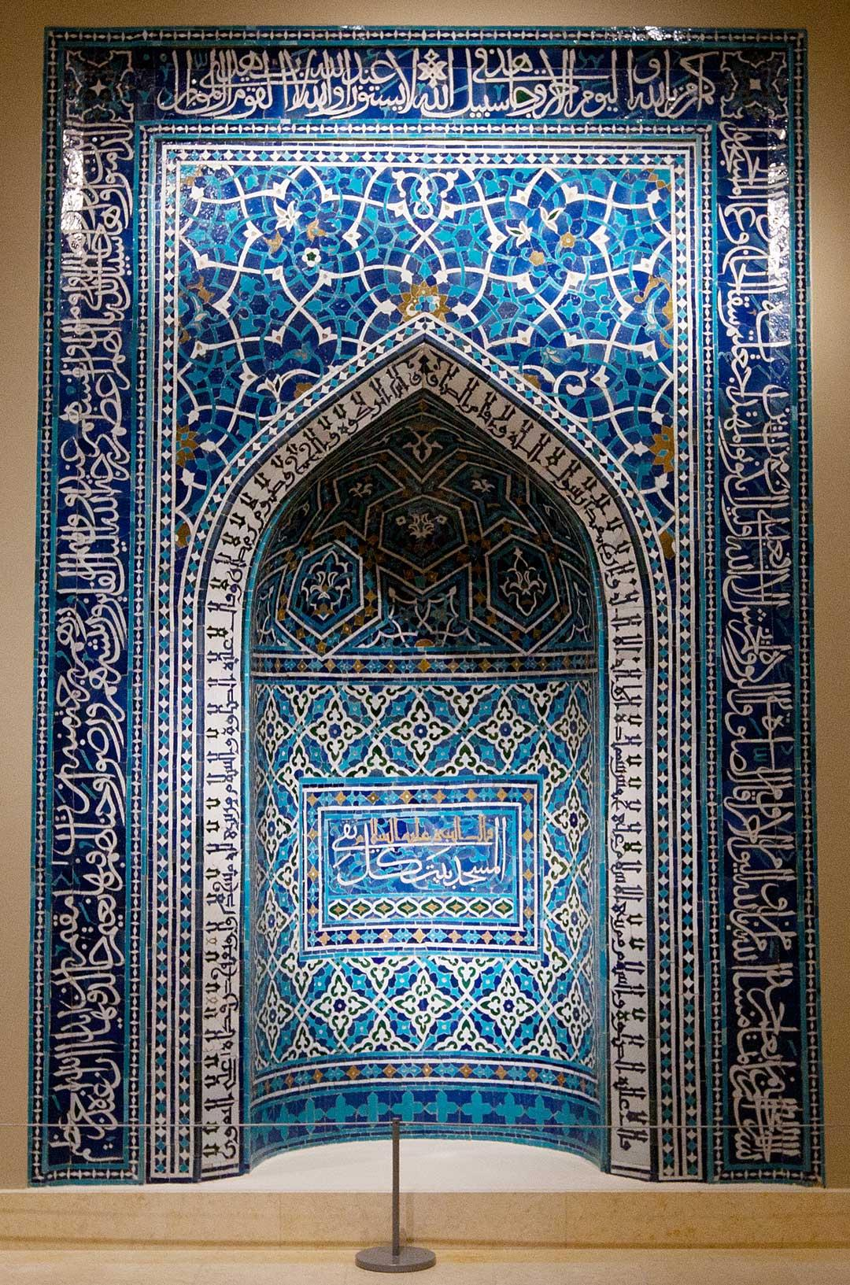
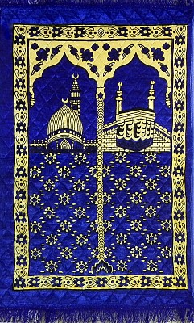

Praying at the mosque

Muslims can pray anywhere but always perform wudu beforehand whether this is at home, at work or at a train station. However, on a Friday, Muslims are expected to perform Jummah Prayers at the mosque. Jummah prayers are congregational (people coming together to pray). Jummah prayers take the place of Zuhr (usually lunchtime) and men attend the moque to pray. Women, traditionally, pray at home, but some choose to attend Jummah prayers and worship in a separate room to men.

During Jummah prayers, the men line up facing the mihrab (the Qibla wall) so that they are praying towards Makkah. During Jummah prayers the imam delivers a sermon called a khutbah and leads the congregation in two rakat of prayer. The khutbah will explain how to be a good Muslim and might address topical issues. This first sermon will be in the language of the country (e.g. Welsh or English). A second sermon is given, which is the same sermon each week and will be in Arabic.

Rakat

Rakat are a series of movements that a Muslim makes when praying. There are eight movements in one Rakat series. A Muslim will make a different number of Rakats depending on which prayer it is e.g.
Fajr = 2 Rakats
Zuhr = 4 Rakats.

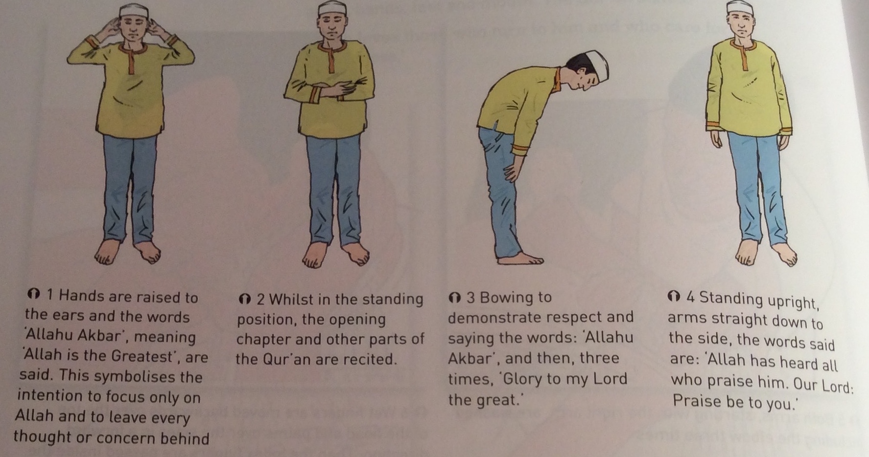
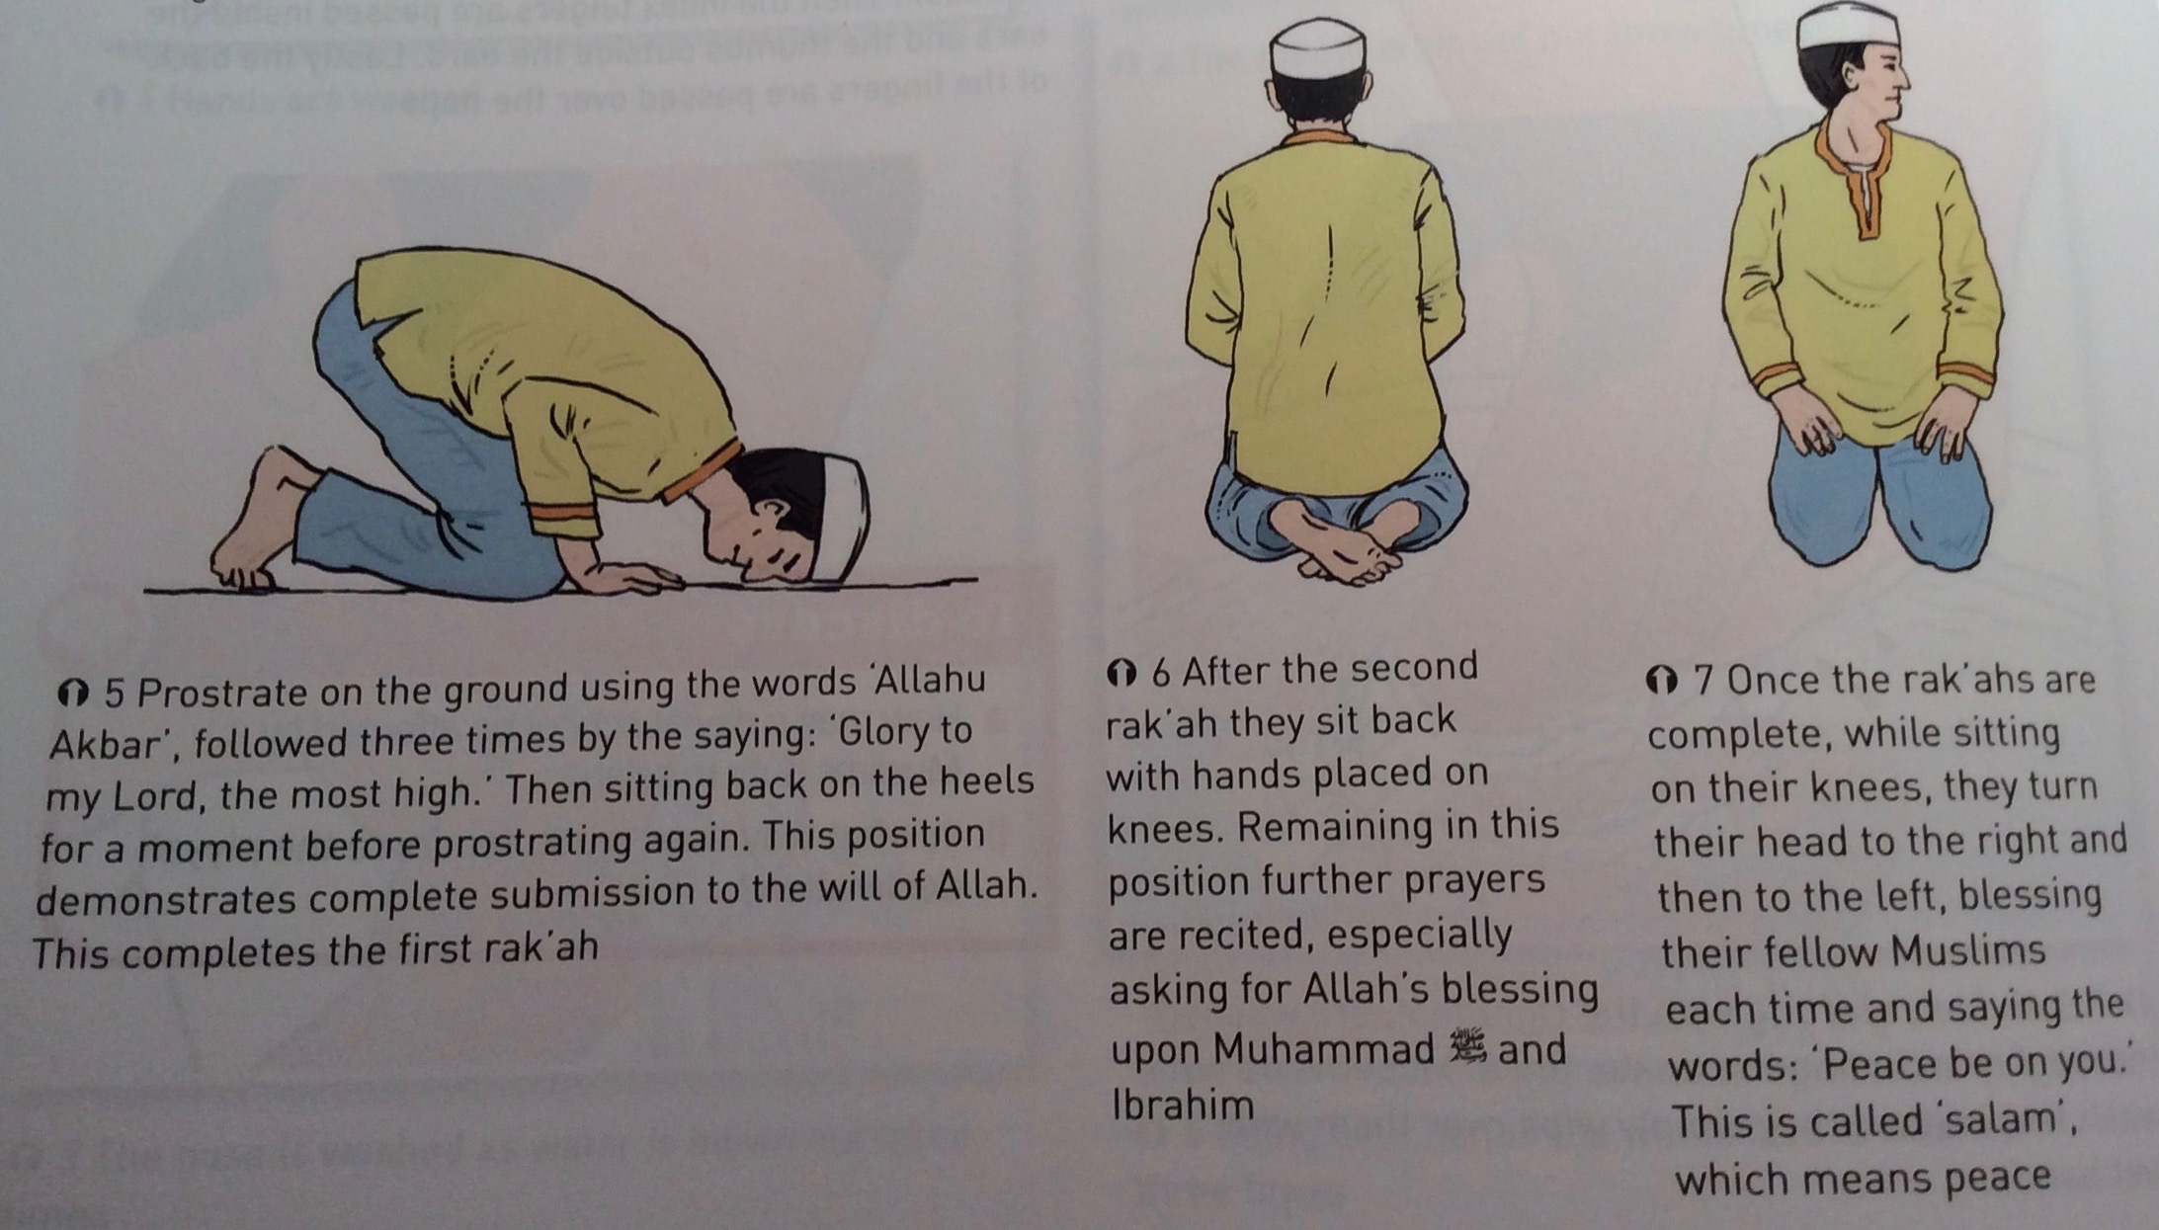

Du’ah Prayers

The salah prayers are a duty for all Muslims, five times a day, but people who love God will often choose to find time to make their own, personal prayers to God. These are called Du’ah prayers. There are no set times for these prayers – they happen whenever a Muslim might feel like it. Du’ah means ‘supplication’ or ‘asking’. They may include thanksgiving to Allah, or requests for his forgiveness or help.

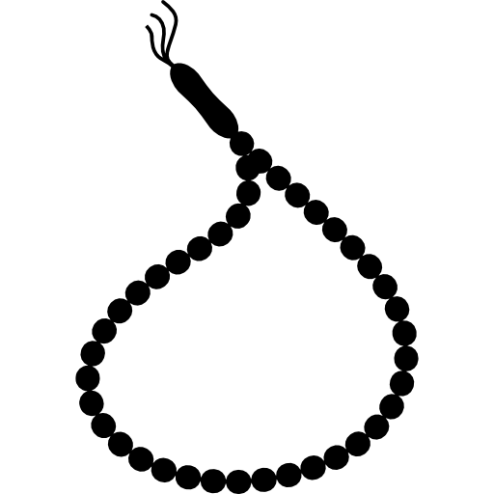
By performing Du’ah prayers, a Muslim is asking for Allah’s guidance and is showing faith that Allah is immanent (close by). Sometimes Muslims will use prayer beads – tasbih – that have 99 beads to help them pray.

Praying at home

Many Muslims say their prayers at home as a family, with the whole family joining in. They often have a special room which they keep ritually clean and never enter when wearing shoes. They will perform their wudu in the bathroom and have prayer mats which are kept facing Makkah. Salah is a great way of binding the family together since ‘the family which prays together stays together’. Prayer at home is also easier for some women, especially those with young children. Prayers are also said before mealtimes to thank Allah for the blessings of food.

Question Practice

a) What is meant by ‘Du’ah’? (2)
b) Describe how Muslims prepare for worship (5)
c) Explain why Muslims pray together at the mosque (8)
d) ‘Private prayer is more important than communal prayer’. Discuss this statement showing that you have considered more than one point of view (15)

Zakat

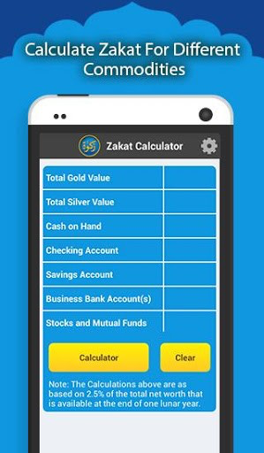
Zakat is the Third Pillar of Islam and is a tax on wealth that is paid once a year. It is often known as the charity tax. Whilst the Qur’an does not state exactly how much should be given, Sunni Muslims tend to give between 2½ - 10%. Poor people don’t have to pay zakat and Muslims use a nisab which sets out the minimum amount of money you have if you are eligible to pay zakat e.g. the UK nisab for 2015 was £2,220. So, a Sunni Muslim will pay 2½% of anything over £2,220 that he has in his account.

In Islamic countries, zakat is paid to the government who distribute it to those who are most in need. In the UK, zakat is either given directly to charities (e.g. direct debit to Islamic Relief) or collected at the mosque during Ramadan. It is given anonymously so that there is no arrogance or smugness about the amount given.
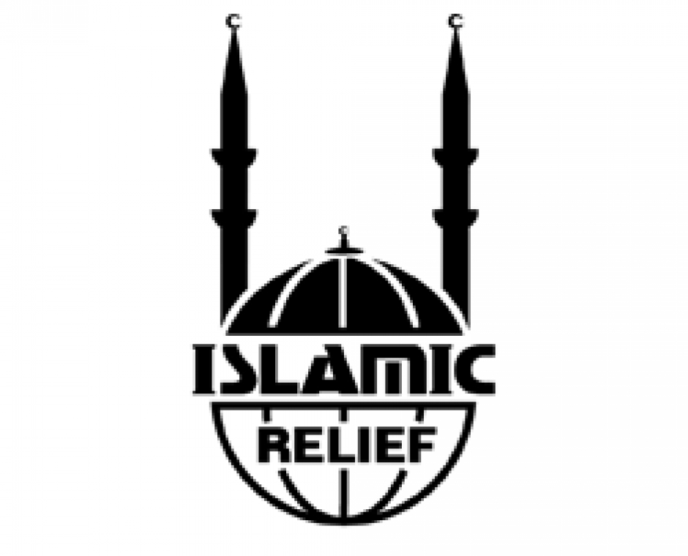

Zakat is a duty – Muslims must give to charity. However, many Muslims also give voluntarily to charity. This is known as sadaqah. Sadaqah is any good deed out of generosity or compassion. It could be a gift of time (e.g. working in a charity shop), helping others or a donation to charity. The word sadaqah means ‘sincerity’ and there is no rule as to when or how much should be given.

What might Zakat tax be used for?

- The poor e.g. may Muslims give to the charity Islamic Relief which helps in poor countries by providing clean water, medicine etc.
- It can help individuals e.g. giving money to someone who is too poor to be able to afford going on hajj (pilgrimage)
- It can pay for community projects e.g. building mosques
- It can pay for running education projects e.g. Qur’an lessons
Importance of Zakat

- Muslims must fulfil the duties of the 5 Pillars – zakat is the 3rd Pillar.
- The word ‘zakat’ means ‘purification’ because zakat is believed to purify a person’s heart of greed. Money can cut us off from other people and from Allah – zakat gives us the opportunity to share with others.
- Since zakat purifies a person’s heart then Allah is more likely to accept the prayers of a person who performs zakat.
- Each Muslim is personally responsible for ensuring that he pays zakat – no-one checks us on him. However, he knows that he will be accountable to Allah on Judgement Day.
- Paying zakat is a sign of a Muslim’s submission to Allah and of worshipping Allah.
- Humans are khalifahs (stewards) – they are Allah’s representatives on earth. We do not own the earth, we are looking after it for Allah. Therefore, we should not view our possessions as our own; they are on loan to us from Allah. We do not have an absolute right to spend our money as we choose.
- Muslims must follow the example of Muhammad. He was orphaned as a child and had a real concern for the poor. When he was the ruler in Madinah, there were many widows and orphans and Muhammad told people to care for all those in need. “The one who looks after and works for a widow and ofr a poor person is like a wwarrior fighting for God’s cause.” (Hadith).
- Shi’a Muslims follow khums (one of the Ten Obligatory Acts) as well as zakat. Khums demands that 20% of a person’s business wealth is given to charity.

Question Practice

a) What is meant by ‘Saddaqah’? (2)
b) Describe how zakat tax might be used (5)
c) Explain why paying zakat is important for Muslims (8)
d) ‘Giving money to charity should be a personal decision’. Discuss this statement showing that you have considered more than one point of view (15)

Sawm

The 4th Pillar of Islam is sawm – the practice of fasting (going without food) during the month of Ramadan. Sawm is commanded by Allah in the Qur’an:

“O you who believe, fasting has been prescribed for you just as it was prescribed for people before you so that you may become mindful of God.” Qur’an 2:183

During Ramadan, Muslims fast during hours of sunlight (i.e. between dawn and dusk). They may not:

- Eat
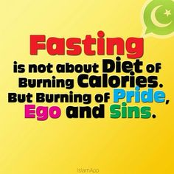
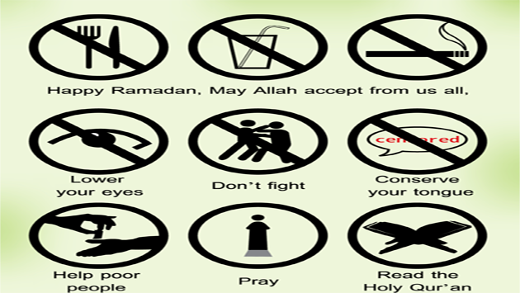
- Drink
- Smoke
- Lie
- Gossip
- Swear
- Get angry
- Have sex
- Have evil thoughts

Everyone above the age of puberty must fast except for:
- The elderly
- The sick
- People who are travelling (or doing exams)
- Breastfeeding mothers
- Menstruating women

However, these people must try to fast at another time or feed a poor person instead.

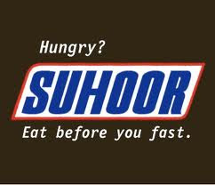
How do Muslims fast during Ramadan?

Muslims fast from dawn until dusk. Families have 2 special meals. The suhur meal is eaten just before dawn, and the iftar meal (often dates and water) is eaten after dusk, before the family eats a bigger meal. These meals are social events with families and neighbours gathering in mosques and houses to provide for each other. Ramadan brings a happy, community focus to Islamic society.

In the evenings, Muslims often goto the mosque for Taraweeh prayers. They read one section of the Qur’an so that, over the course of 30 days, the whole Qur’an will have been read. All Muslims attend the mosque on the 27th of Ramadan to celebrate Laylat-ul-Qadr – the Night of Power. This is remembered as the date of the first revelation of the Qur’an, when the Angel Jibril first visited the Prophet Muhammad.

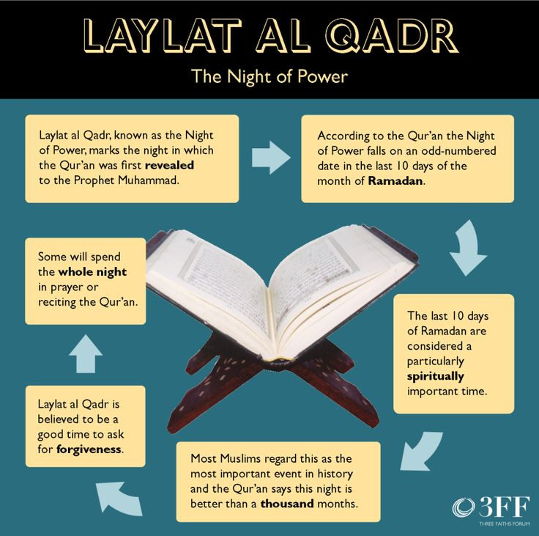

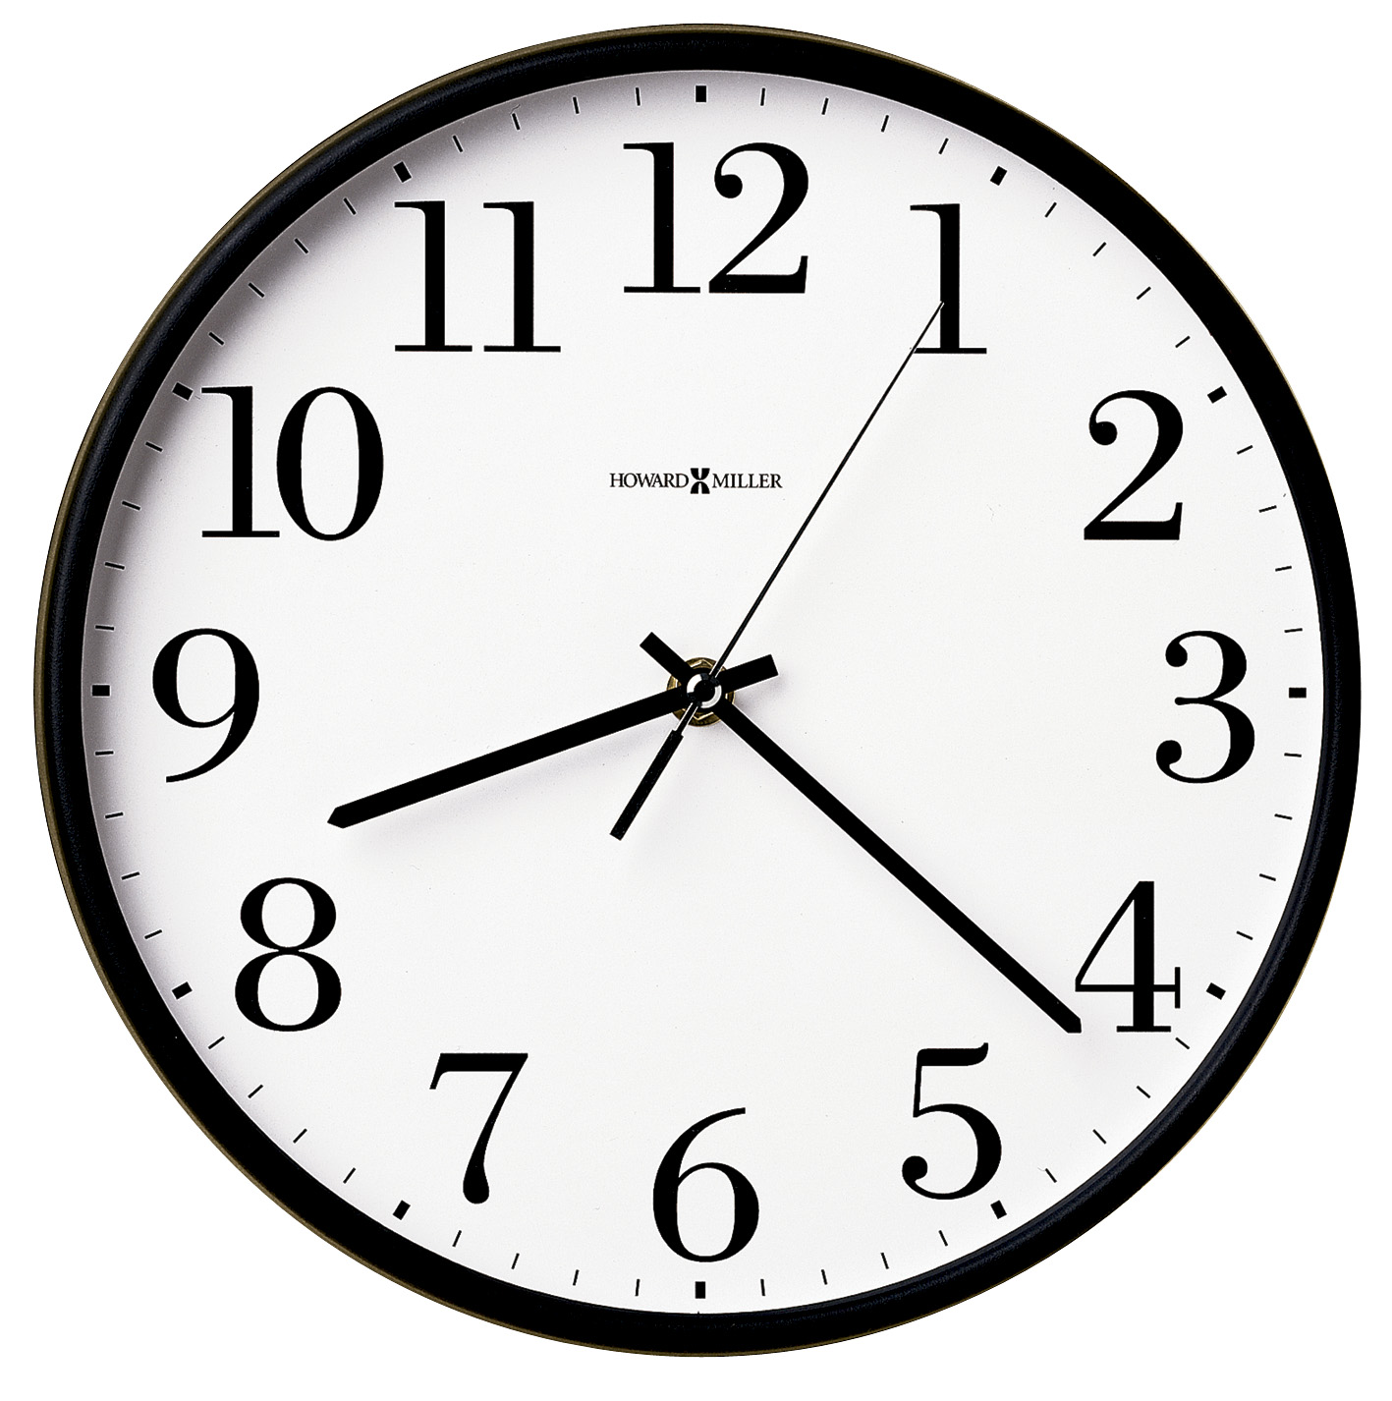
Standardising sawm

Some people argue that Ramadan should be standardised because in the UK, during the summer, a Muslim might need to fast for 19 hours. Countries closer to the equator only ever have to fast for a maximum of 15 hours. This can be difficult for British students doing their exams during the summer months.
The importance of sawm

- It is commanded in the 4th Pillar and shows obedience to Allah
- It follows the example of Muhammad
- It celebrates the fact that Allah has given humans the words of the Qur’an
- Fasting brings Muslims closer to Allah and helps them to feel Allah’s presence (taqwa)
- It encourages self-control and discipline
- It helps Muslims think of the poor and those who are hungry
- It unites the Muslim community (ummah)
- It recharges the spiritual batteries

Rules about halal and haram diet

Halal mean permitted. Haram means prohibited (not permitted). To ensure that meat is halal:

- The animal must be slaughtered by a Muslim. The carotid artery must be cut with a razor sharp knife with as little pain as possible.
- The Muslim must recite Shahadah whilst slaughtering the animal
- The animal must be alive at the time of slaughter
- The blood from the animal must be fully drained since eating blood is haram
- Pork is haram therefore the slaughter of cows, sheep etc cannot take place in the same place as a pig might be slaughtered
- The slaughterer must face Makkah
- Birds of prey are haram
- Alcohol is haram
- Meat products in shops must have the Halal Certificate logo on them

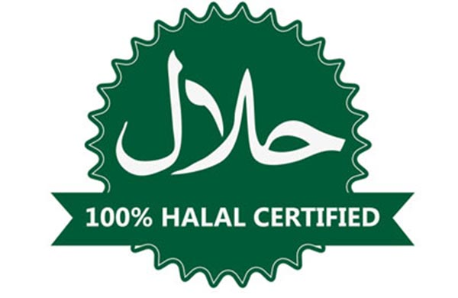

Question Practice

- What is meant by ‘Sawm’ (2)
- Describe how Muslims observe sawm (5)
- Explain why Muslims observe sawm (8)
- ‘Keeping sawm is unreasonable for British Muslims’ (15). Discuss this statement showing that you have considered more than one point of view (15)

