Practices that demonstrate beliefs about God (Judaism)

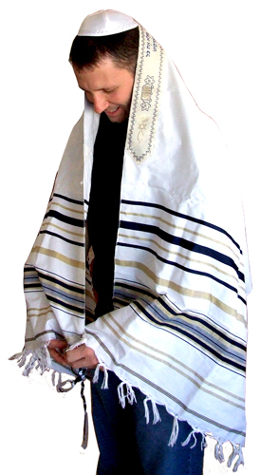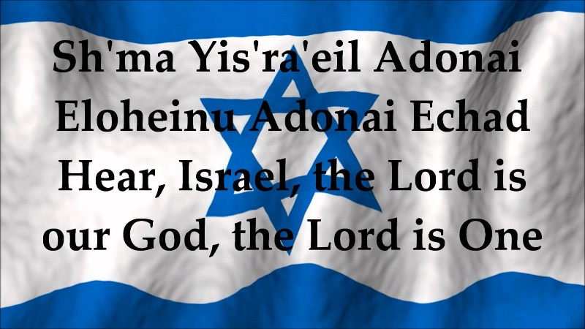

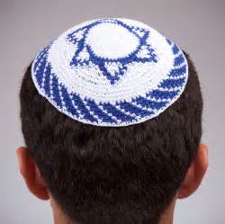

Contents:-

➢ Reciting the Shema in the morning and evening

* Reasons why Jewish men (and some Liberal Jewish women) wear the Tallit.
* Reasons why the Kippah is worn
* Reasons why God must not be depicted in art, and sometimes his full name is not (G-d)

Key Concept!

Prayer: The Shema

Prayer is an important practice in many religious. It is through prayer that believers contact God directly, and it can be done individually or in a group.

1. Think about the reasons why believers pray.

2. Think about how praying helps believers.

3. In your opinion, is praying an important practice for religious believers?

In Judaism, a very special prayer is recited at least every morning and every evening. This special prayer declares Jews belief in one God and confirms their belief in him too. In the synagogue Jews will recite the prayer carefully making sure that every word is pronounced clearly and they cover their eyes with their right hand.

The Shema is split into three sections in different parts of the Torah. Every section contains special commands which Jews must obey.

Part 1: Deuteronomy 6:4-9

In the first section of the prayer God addresses Israel and insists that his people obey him with all their heart. It is a mass prayer (group) where the Jewish community declare their belief in God which is central to their religion as well as the duties which they must perform, and Jews should recite the prayer while standing and facing Jerusalem (Amidah). The Shema is a morning and evening prayer, which can be recited in the home or in the Synagogue and the prayer is recited as the Torah scroll is taken out of the ark (in the Synagogue) on the Sabbath and other important festivals. It is every Jew’s desire to recite the Shema on his death-bed, but if it is not possible, anyone else who is present can recite the prayer and help the dying Jew to declare their faith in God.

Find the Shema prayer by looking at Deuteronomy 6:4-9 and write it in this box.

BBC – THE SHEMA

Look at this clip to see how the Shema is recited and followed daily.



Write the sentences which command Jews to do the following:-

|  |  |
| --- | --- |
| Love one God |  |
| Use different parts of the body to love God |  |
| Remember the words in their hearts |  |
| Pass the prayer on to the next generation |  |
| Think about the prayer constantly |  |
| **Recite the prayer every morning and**  **every evening** |  |
| Wear the Teffilin as an outward sign of their belief in God |  |
| Place Mezuzah on the door frames in their homes |  |

Part 2: Deuteronomy (11:13-21)

Here we see the commands which explain how to obey God and the consequences if these commands are not followed.

***“So if you faithfully obey the commands I am giving you today, to love the Lord your God and to serve him with all your heart and with all your soul, then I will send rain on your land in its season, both autumn and spring rains, so that you may gather in your grain, new wine and olive oil. I will provide grass in the fields for your cattle, and you will eat and be satisfied. Be careful or you will be enticed to turn away and worship other gods and bow down to them. Then the LORD’s anger will burn against you, and he will shut up the heavens so that it will not rain and the ground will yield no produce, and you will soon perish from the good land the LORD is giving you. Fix these words of mine in your hearts and minds; tie them as symbols on your hands, and bind them on your foreheads. Teach them to your children, talking about them when you sit at home and when you walk along the road, when you lie down and when you get up. Write them on the doorframes of your houses and on your gates, so that your days and the days of your children may be many in the land the LORD swore to give your ancestors, as many as the days that the heavens are above the earth”***

Within Judaism, there is a very important covenant between God and the chosen people (those who have been chosen by God). A covenant is a special agreement and this particular prayer is part of that as it lists the things which Jews must do (the commandments) as well as the consequences if they do not obey these commands. In the scriptures God made a covenant (agreement) with their leader, Abraham, and promised that he would never forget them. In return the Jews were expected to obey God’s laws and he gave them the Torah (teaching) so that they could live godly lives.

According to the second part of the Shema, what would happen if a Jew did not obey God?

Part 3: Numeri 15:37- 41

***“The LORD said to Moses: “Speak to the Israelites and say to them: Throughout the generations to come you are to make tassels on the corners of your garments, with a blue cord on each tassel. You will have these tassels to look at and so you will remember all the commands of the LORD, that you may obey them and not prostitute yourselves by chasing after the lusts of your own hearts and eyes. Then you will remember to obey all my commands, and will be consecrated to your God. I am the LORD your God, who brought you out of Egypt to be your God. I am the LORD your God”***

Here were see a specific command relating to Jewish dress to “***make tassels on the corners of your garments, with a blue cord on each tassel. You will have these tassels to look at and so you will remember all the commands of the LORD”*.** It is a very important practice within Judaism to wear a prayer shawl which is called the Tallit. Here are images of different types:-

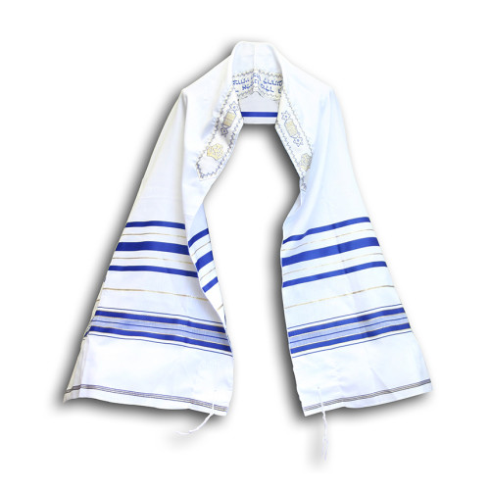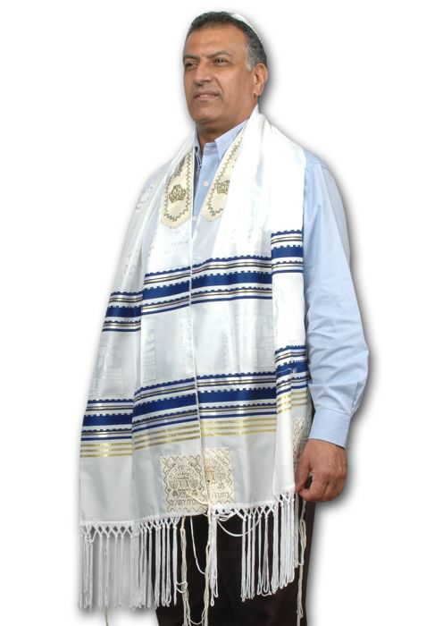

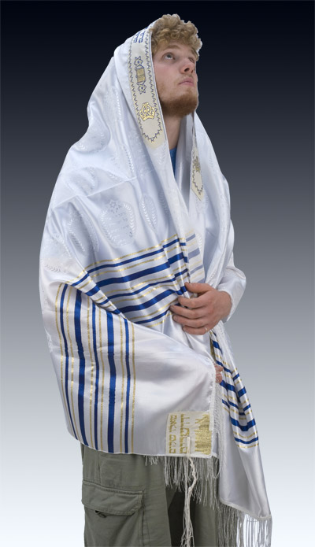

Examination Question

c) Explain the importance of the Shema to Jews. [8]

………………………………………………………………………………………………………………………………………………………………………………………………………………………………………………………………………………………………………………………………………………………………………………………………………………………………………………………………………………………………………………………………………………………………………………………………………………………………………………………………………………………………………………………………………………………………………………………………………………………………………………………………………………………………………………………………………………………………………………………………………………………………………………………………………………………………………………………………………………………………………………………………………………………………………………………………………………………………………………………………………………………………………………………………………………………………………………………………………………………………………………………………………………………………………………………………………………………………………………………………………………………………………………………………………………………………………………………………………………………………………………………………………………………………………………………………………………………………………………………………………………………………………………………………………………………………………………………………………………………………………………………………………………………………………………………………………………………………………………………………………………………………………………………………………………………………………………………………………………………………………………………………………………………………………………………………………………………………………………………………………………………………………………………………………………………………………………………………………………………………………………………………

Dress: Tallit

The prayer shawl is the clothing which is most commonly associated with prayer within Judaism. Usually, the shawl or Tallit is made of wool, cotton or pure silk with blue horizontal stripes. The Tallit is usually square or rectangular in shape, but is must have tassels on the four corners. The four are called tzitzit and they represent the covenant and the commandments which God has given the Jews. Orthodox Jews wear the Tallit during morning prayers in the home or in the Synagogue. The Tallit can be worn on the shoulders or on the head. Boys over 13 years old are also given the responsibility of wearing the Tallit. Within Liberal Judaism, men are also expected to wear the Tallit, but women are given a choice. Many believed that women also had the same responsibilities as men to keep God’s covenant and commandments, and that they should also wear the Tallit.

Dress: Kippah

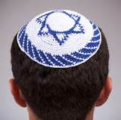The meaning of the word ‘Kippah’ is ‘dome’ and the word is used for the small cap which Jews wear. The cap is also referred to as Yarmulke or Koppel. Under Jewish law, men are required to cover their heads as a sign of respect towards God during prayer, when they are studying the Torah, reciting blessings or when entering the Synagogue. Despite this, there is some doubt as to whether this is a commandment or not. The Talmud notes that Jews should wear the Kippah. Traditionally, Jewish men wear the Tallit regularly, every day to show their awareness and obedience to a higher being, God. The Kippah separates human beings from God, and places him in a higher category than everyone else. It is unusual to see an Orthodox Jew without the Kippah today, and Liberal Jews vary in their decision to wear it or not. There are also a wide variety of different Kippah, of all colours and designs. By wearing the Kippah, the Jew shows his identity to the world and strengthens his faith in God.

Examination Question

b) Describe how Jews show respect to God in their clothes. [5]

……………………………………………………………………………………………………………………………………………………………………………………………………………………………………………………………………………………………………………………………………………………………………………………………………………………………………………………………………………………………………………………………………………………………………………………………………………………………………………………………………………………………………………………………………………………………………………………………………………………………………………………………………………………………………………………………………………………………………………………………………………………………………………………………………………………………………………………………………………………………………………………………………………………………………………………………………………………………………………………………………………………………………………………………………………………………………………………………………………………………………………………………………………………………………………………………………………………………………………………………………………………………………………………………………………………………………………………………………………………………………………………………………………………………………………………………………………………………………………………………………………………………

God (G-d)

Jews believe that there is only one God. He is a almighty being who has created the world and has chosen the Jews especially to be his people. Jews believe that God cannot be represented in any form and that it is not possible to give God an earthly form. God is beyond our imagination. In the second book in the Torah, God commands that no Jew shall make an image of God;

**'You shall not make for yourself an image in the form of anything in heaven above or on the earth beneath or in the waters below. You shall not bow down to them or worship them...'** (Exodus 20:4-5)

To this day, there are no images of God in Synagogues, and the only permanent decoration to be seen are the letter of the Hebrew alphabet.

Another practice which shows respect to God is the way that Jews refer to God as ‘G-d’ in Hebrew. The main reason for this traditional practice is to show that HE, as the supreme being, has the authority to receive the greatest respect possible. Another reason for this use of the word ‘G-d’ is that it is forbidden to destroy or delete God’s name and so by writing it like in this way, it is permitted without disrespecting God. Imagine if a Jew wrote a document on a computer which contained the name God, but after printing it he decided to throw it in the bin. By using ‘G-d’ it would not be a problem, but he would not be permitted to throw away anything with God’s name written on it correctly; this is forbidden. Jews show the greatest respect towards God, therefore by using the term ‘G-d’ there is no danger of disrespecting him.