JEWISH PRACTICES: WORSHIP
SYNAGOGUE- Place of assembly; building where Jews pray, study and meet in public.
SHABBAT - Day for spiritual renewal and rest. Starts on sunset on Friday evening and ends on sunset on Saturday evening.
HAFTORAH- part of one of the books of Nevi’im (prophets) which are read after a reading from the Torah
Judaism teaches that Jews should communicate with God every day. According to Judaism this can take place in a number of ways e.g. in prayer, worship in a synagogue, celebration of festivals and by helping others. Prayers can be said anywhere according to Judaism. Daily services are held in synagogues, but the Jewish community all come together to worship in services on the Shabbat. Many Jews make an effort to attend services in the synagogue on the Shabbat, even if they do not attend the synagogue every day.
There are 3 services in the synagogue on the Shabbat. Services are held in the Synagogue on Friday evening, Saturday morning (Shabbat morning) and Saturday afternoon. These times correspond to the times which sacrifices used to be made in the Temple years ago.

In order to hold a service in the Synagogue, ten men must be present. These ten men are called Minyan. The reason for this is to create a more spiritual experience than people would have just praying on their own. Jews believe that communal worship is less selfish than individual prayer. By praying together there is more responsibility and prayers are said on behalf of the whole community.

The service on Shabbat morning lasts longer than any of the other services held during the week. It can last up to 2-3 hours. The service will include important prayers such as the Shema, Amidah and the Kaddish. In every service a part of the Torah and the Haftorah will be read. The Rabbi will also say a prayer and will explain the readings.
At the end of the service the Kiddush blessing will be said. This is a blessing said over a cup of wine.

WHAT IS THE DIFFERENCE BETWEEN ORTHODOX JEWS AND REFORMED JEWS?
ORTHODOX | - One of the main Jewish groups,  - Keep strictly to the rules.
REFORMED | - One of the main Jewish groups,  - Do not keep strictly to the rules of the Torah

In an Orthodox synagogue there is a separate area for women to sit e.g. in a gallery, as the Talmud says that men and women can concentrate better on the worship if they sit apart. A cantor will be used in an Orthodox synagogue as no music is allowed. The cantor will lead the singing. Organs have not been allowed in Orthodox synagogues since the destruction of the Temple. The majority of the service is held in the Hebrew language in an Orthodox synagogue – but the prayer for the Royal family will be held in English in synagogues in England. Services on Shabbat in Orthodox synagogues being at around 9:00 am and will last for around 2 hours. Only men are allowed to read the Torah in Orthodox synagogues and only men are allowed to be part of the Minyan.
In a Reformed synagogue, men and women may sit wherever they wish. Women are also allowed to read the Torah. Organs/music are permitted in Reformed synagogues also. The language used in the Reformed Synagogue will be the language used in the country where that synagogue is located e.g. English in England. On the Shabbat the service will begin at about 10:30 onwards and will continue for about an hour, to an hour and a quarter. Reformed synagogues allow women to be a member of the Minyan which is required to start services on the Shabbat.
INTERNAL FEATURES OF THE SYNAGOGUE
There is no set design apart from the fact that they all face east, towards Israel and Jerusalem where the remains of the Temple are located. The architecture varies according to the date and location of the synagogue but most are of a simple design, which means that the synagogue can be adapted for use as a social centre.

BIMAH
The Bimah is a stage, usually in the middle of the Synagogue. The Torah scroll will be read from here. The Rabbi will stand here in an Orthodox Synagogue and face the congregation. There is enough room on the Bimah for more than one scroll. In a Reformed Synagogue the Bimah is usually nearer the front of the Synagogue near the arch.
At the bottom of the Bimah there are a few seats for the deacons. Everyone can see the scroll on the Bimah as seating is arranged on only three sides of the Bimah. In Orthodox synagogues, only men sit around the Bimah.

ARON HAKODESH
The ark is the most important place in the synagogue, for this is where the Torah scrolls are kept. It will be on a wall which faces Jerusalem. The Aron Hakodesh is so important that no one is permitted to sell an old ark in order to raise money for the synagogue. However, it is permitted to sell old seats or Bimah as they are not regarded so important. During some services the parochet (curtains in front of the ark) and the doors of the ark are opened e.g. during the 10 days of repentance between Yom Kippur festival and Rosh Hashannah.

THE TORAH SCROLLS
The Torah Scrolls are the most important items in the synagogue. They are made from animal skin and have been written by hand by Sofer. The Torah have been written in columns. Each end is stitched to a poll, called the ‘tree of life’. Each scroll is covered with a sheet of silk or velvet when it is not being used and is decorated with silver plate, similar to that of the high priest in the temple. The scrolls are carried carefully to the Bimah where each Sidra (part) will be read weekly. There should be at least 3 scrolls in each synagogue.
The Torah is so holy they must not be touched when they are read. In order to keep the correct place when reading the Torah, they use a Yad, which is a silver marker.
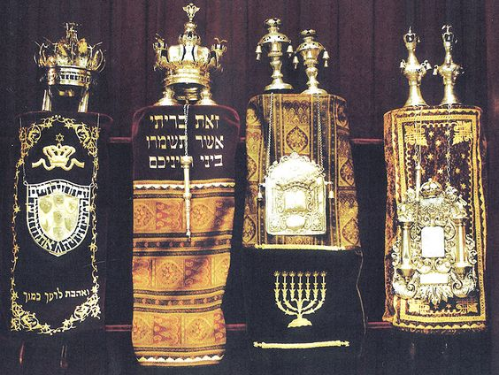

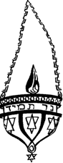
NER TAMID
Above the Aron hakodesh is the eternal light. The light is never extinguished. It reminds Jews of the menorah which was left burning in the temple. It is a symbol of the presence of God in the synagogue.

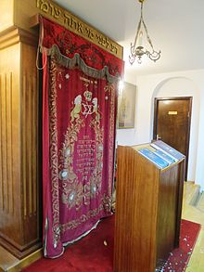
PAROCHET
In front of the ark are curtains called Parochet which open easily. Often they are made of velvet. Sometimes the symbols of the twelve tribes of Israel are shown on them.

MENORAH-
The Menorah is a candlestick with six arms. The Menorah commemorates how God created the world in six days and rested on the seventh.

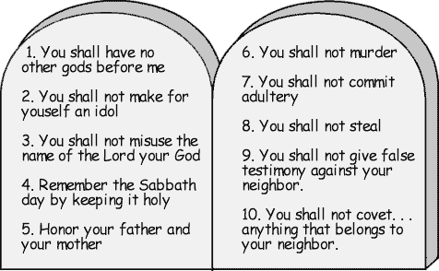
THE 10 COMMANDMENTS
Above the ark are the two slates of the 10 Commandments. These are the rules which God gave Moses on the Mount of Sinai. They are the most important rules for Jews. They include the rules regarding their relationship with God e.g. to keep one day to worship God, to worship God, not to use the Lord’s name in vain and not to make idols of God. They also contain rules which keep order in society e.g. Do not kill, do not steal.
SERVICE IN THE SYNAGOGUE
There must be a quorum of 10 people (men in Orthodox synagogues) who have come of age (have had a Bar/Bat Mitzvah ceremony) before a service can be held. This is called the Minyan.

When they are ready to read the Torah they take the Sefer Torah out of the Aron Hakodesh. The congregation will stand which the chosen men carry it to the Bimah. Some members of the congregation will kiss their talith (prayer shawl) and touch the velvet which covers the Sefer Torah.
The covers will be removed near the Bimah. It will be opened to the Sidra (part) which is to be read that week. A number of people (men only in Orthodox synagogues) will be called to the Bimah to read. This is regarded as a great honour. The blessing will be read over the reading. The Sidra will be read using the Yad. When the sidra has been read the Sefer Torah will be held up for the congregation to see.
They will read a part of the book of prophets called the Haftarah. A Siddur (prayer book) will be used during the service. Siddur means order. The words of the prayer come from the Tenakh e.g. Psalms. They must stand to pray to show respect to God, and the main prayer is called the amidah (standing) which includes 10 parts. The Hebrew word for prayer means ‘to judge ourselves’, which shows that it is the Jew’s desire to improve his life through prayer. The rabbi will preach. He will teach the people about the Jewish teachings. The prayer can also include a financial appeal towards a good cause. Then the prayers and blessings will be recited.

