Judaism – What does the religion teach about peace?
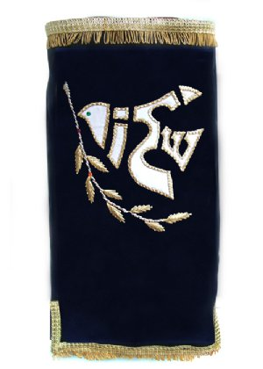
The greeting ‘Shalom’ means ‘peace’, which is desirable in the world.
PEACE
- The right to be in a safe haven
- Envy – forget it by embracing someone
- Abolish the desire to fight
- The end to turning a nation against a nation
- Face an enemy and turn it into love
- Light a candle to reflect hope
Is …SHALOM
A dove of peace that’s been embroidered on a Sefer Torah cover, the scrolls that includes the Jewish laws. The pigeon has been formed from the word ‘Shalom’ (peace) on a Hebrew epigraph

Facts
Jews look forward to the time of peace as it’s the condition of the Messianic Era arrival. The Jewish word for peace, shalom, is a general greeting. Jews uses it every week by wishing Shabbat Shalom to each other. Not only it’s the absence of war but also the state of living under favourable conditions that is necessary for prosperity. As it says in the Talmud: ‘So excellent is peace, because peace to Earth is like leaven to bread.’
Even though the Jews took part in a lot of wars, seeking peace and taking an active role in working towards reconciliation was never an obstruction. The most significant development was signing the peace agreement by Prime Minister Israel Yitzhak Rabin and President Yasser Arafat in Washington. The assassination of the Prime Minster put an end on his work in favour of the peace process.

The Talmud notes three things to keep the world safe: peace, truth and opinion.
Jews also see peace as the ideal state, and something Jews have to hope for and work towards; the best way to get the benefit and growth in society.
Jews see peace and harmony among people – without any violence as a foundation – that is the goal.
Peace and reconciliation should be offered before using any force or war. However, it is fine defending justice and life - even if they have to use force.
Jews do not consider that violence and war are always being used incorrectly if there’s justice. They accept that some types of wars can be justified morally and ethically, and sometimes acceptable to kill people.
Before declaring war or begin a battle there must be a genuine attempt to make peace and avoid conflict.
Jewish law only allows soldiers to be killed deliberately in war. Innocent citizens must have every opportunity to leave the field of battle before the battle begins.
In the Torah it states that God gives his clear approval to war. He is known as a warrior, and the Jews were shown leads to conflict, bringing victory to them and protecting them from the enemy. But the Torah also refers to peace often. At the same time, the Torah is full of Jewish yearning for peace.
Isaiah 2: 4
And he shall judge between the nations and reprove many peoples, and they shall beat their swords into ploughshares and their spears into pruning hooks; nation shall not lift the sword against nation, neither shall they learn war anymore.

Spider Diagram Chart
Re-read the notes on Peace and Jewish Confrontation and find out the facts to fill in the diagram.

Jewish response to peace and conflict

What is pacifism?
Believes that any violence or war is unacceptable. Refuses to use any power or violence e.g. through not joining the army.

Children of Abraham Project
This project was started by a Jewess and a Muslim man. They could see that communities didn’t know a lot about each other, and that it would be good for both sides to know more to try and promote peace.
The name Children of Abraham comes from the fact that Abraham is related to Jews and Muslim faiths as each other. The projects tries to create an understanding between Muslims and Jews throughout the world by using the internet.
Every week, pictures from Muslim and Jewish lives are explained in order to help people on both sides to understand their different beliefs and practices. Through chat rooms, young people can discover that they have more things in common than different. An open discussion is encouraged about difficult things such as suicide and military action on the West Side and Gaza.
Nadia Sheikh, a member of the Children of Abraham project has said: ‘It’s something that you feel that you have to do. Not only you diffuse peace and information, but you also have a better understanding. Your mind is much more open then.’

How to support peace?
Neve Shalom/Wahat al-Salam
An area in Israel is Neve Shalom/Wahat al-Salam (oasis of peace) where Jewish and Arabic families cohabit in peace. A lot of activities are held where Jewish and Arabic children play and learn together.
Research into the area by using -
http://wasns.org/
and watching the clip https://www.youtube.com/watch?v=snBOBIKCxI0

Conscientious Objectors
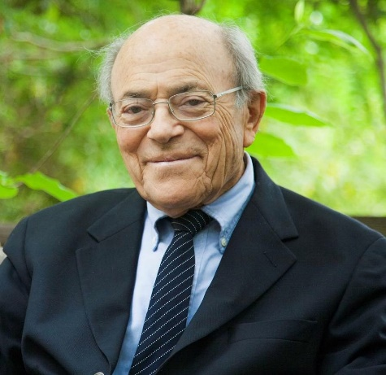
Leonard I. Beerman (April 9, 1921 – December 24, 2014) was an American Reform rabbi. He served for 37 years at Leo Baeck Temple in Los Angeles ^{[1]} as founding rabbi. He was known for his liberal political activism, his support of interfaith dialogue, and his advocacy of peace and a two-state solution in the Middle East.
Beerman was born in Altoona, Pennsylvania^{[3]} to Paul and Tillie Beerman. His father was a traveling salesman of women's lingerie, and his mother was a homemaker. He spent some of his later childhood in Owosso, Michigan, then returned to Altoona and studied at Penn State, from which he graduated in 1942.^{[4]} He served but did not see combat in the United States Marines during World War II, studied for the rabbinate at Hebrew Union College in Cincinnati, and briefly joined the Haganah in 1947 while studying for his rabbinical degree in Israel. In a later interview Beerman said that his pacifist convictions arose during his five months experience with the Haganah.
TASK
Use the website - https://www.beermanfoundation.org/ and research this man.

Jewish Teachings about forgiveness
Here’s a quote from Micah 7:18 where God is praised for his love. It also discusses forgiveness:
Who is a God like you,
who pardons sin and forgives the transgression
of the remnant of his inheritance?
You do not stay angry forever
but delights to show mercy.

Jews have teachings of Tenakh, for example it talks about how to treat enemies. Jews sees the importance of repentance.
Jews celebrate Rosh Hashanah. Rosh Hashanah’s role and the ten days of return, the central theme of Yom Kippur and Rosh Hashanah is forgiveness.
According to Jews, only victims can forgive because they suffered the wickedness.
TASK
Read the notes about Rosh Hashanah and Yom Kippur. Then, use the three colours – red, yellow and green.
Use ‘post it’ if you have any questions.
Traffic Light System
Parts that are confusing in red
Parts that you are not sure of in orange
Colour the easy parts you understand in green

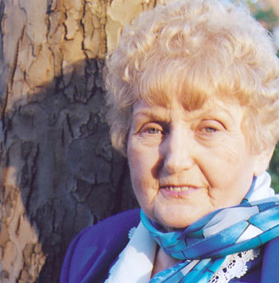
Example of forgiveness that derives from personal beliefs – Eva Kor
At the age of ten, twins Eva and Miriam Mozes, were taken to Auschwitz where Dr Josef Mengele used them for medical experiments. Both survived, but Miriam died in 1993 when she developed cancer of the bladder as a consequence of the experiments done to her as a child. Eva Kor has since spoken explicitly about her experiences at Auschwitz and founded The CANDLES Holocaust Museum in Indiana where she now lives. In 2003 the museum was destroyed in an arson attack, believed to be by white supremacists.

Miriam and I were part of a group of children who were alive for one reason only – to be used as human guinea pigs. During our time in Auschwitz we talked very little. Starved for food and human kindness, it took every ounce of strength just to stay alive. Because we were twins, we were used in a variety of experiments. Three times a week we’d be placed naked in a room, for 6–8 hours, to be measured and studied. It was unbelievably demeaning.
In another type of experiment they took blood from one arm and gave us injections in the other. After one such injection I became very ill and was taken to the hospital. Dr Mengele came in the next day, looked at my fever chart and declared that I had only two weeks to live. For two weeks I was between life and death but I refused to die. If I had died, Mengele would have given Miriam a lethal injection in order to do a double autopsy. When I didn’t die, he carried on experimenting with us and as a result Miriam’s kidneys stopped growing. They remained the size of a child’s all her life.
On 27 January 1945, four days before my 11th birthday, Auschwitz was liberated by the Soviet army. After nine months in refugee camps I returned to my village in Romania to find that no one from my family had survived.
Echoes from Auschwitz were a part of my life but I did not speak publicly about my experiences until 1978 after the television series The Holocaust was aired. People would ask me about the experiments but I couldn’t remember very much so I wanted to find other twins who were liberated with me. I wrote to newspapers asking them to publish an appeal for other survivors of Mengele to contact me. By 1980 I was sending out 500 letters a year – but still no response. In desperation, one day I decided to start an organization in which I would make myself President. People are always impressed if they get a letter from a president, and it worked. Finally I was able to find other twin survivors and exchange memories. It was an immensely healing experience.
In 1993 I was invited to lecture to some doctors in Boston and was asked if I could bring a Nazi doctor with me. I thought it was a mad request until I remembered that I’d once been in a documentary which had also featured a Dr Hans Munch from Auschwitz. I contacted him in Germany and he said he would meet with me for a videotaped interview to take to the conference. In July 1993 I was on my way to meet this Nazi doctor. I was so scared but when I arrived at his home he treated me with the utmost respect. I asked him if he’d seen the gas chambers. He said this was a nightmare he dealt with every day of his life. I was surprised that Nazis had nightmares too and asked him if he would come with me to Auschwitz to sign a document at the ruins of the gas chambers. He said that he would love to do it.
In my desperate effort to find a meaningful ‘thank you’ gift for Dr Munch, I searched the stores, and my heart, for many months. Then the idea of a Forgiveness letter came to my mind. I knew it would be a meaningful gift, but it became a gift to myself as well, because I realized I was not a hopeless, powerless victim. When I asked a friend to check my spelling, she challenged me to forgive Dr Mengele too. At first I was adamant that I could never forgive Dr Mengele but then I realized I had the power now…the power to forgive. It was my right to use it. No one could take it away.
On 27 January 1995, at the 50th anniversary of the liberation of Auschwitz, I stood by the ruins of the gas chambers with my children – Dr Alex Kor and Rina Kor – and with Dr Munch and his children and grandchild. Dr Munch signed his document about the operation of the gas chambers while I read my document of forgiveness and signed it. As I did that, I felt a burden of pain was lifted from me. I was no longer in the grip of hate; I was finally free.
The day I forgave the Nazis, privately I forgave my parents whom I hated all my life for not having saved me from Auschwitz. Children expect their parents to protect them; mine couldn’t. And then I forgave myself for hating my parents.
Forgiveness is really nothing more than an act of self-healing and self-empowerment. I call it a miracle medicine. It is free, it works and has no side effects.
I believe with every fibre of my being that every human being has the right to live without the pain of the past. For most people there is a big obstacle to forgiveness because society expects revenge. It seems we need to honour our victims but I always wonder if my dead loved ones would want me to live with pain and anger until the end of my life. Some survivors do not want to let go of the pain. They call me a traitor and accuse me of talking in their name. I have never done this. Forgiveness is as personal as chemotherapy – I do it for myself.

TASK
What came to your mind after reading Eva’s history and what did you learn about how she forgave? Note your response in the head.

