WELSH BACCALAUREATE
GLOBAL CITIZENSHIP
MOCK CHALLENGE

How can we address the refugee crisis in Syria?

NAME: ________________________
TEACHER: _____________________
CLASS: 10 __________

GLOBAL CITIZENSHIP MOCK CHALLENGE
Human Disaster Relief
PURPOSE

The purpose of the Global Citizenship Challenge is to develop learners’ skills, whilst providing opportunities to understand and respond appropriately to global issues. During the Global Citizenship Challenge learners will explicitly develop skills of Critical Thinking and Problem Solving and Creativity and Innovation and apply them in an appropriate manner.

BRIEF


There are many problems in the world that we should all help to resolve even if it happens hundreds or thousands of miles away, or where you live in Wales. How do you become a global citizen? You need to develop a human conscience and make judgments about the issues that matter and the type of world you want to live in. Being a global citizen gives you the power to bring about positive change to make this world a better place.
During this Challenge you will use a variety of information on the Syrian refugee crisis (Human Disaster Relief) to investigate different views of people and identify your own ideas on the Syrian refugee crisis. You then have to raise awareness of the crisis with your peers in a creative and innovative way. You should design your raising awareness so that it will appeal to your peers and make use of effective communication by providing a clear message which is memorable, original and relevant.

By completing this Challenge you will show that you can reason, make judgements and make decisions in order to create an informed personal standpoint on the Syrian refugee crisis and how this issue can be addressed. The raising awareness allows you to show how creative and innovative you can be in communicating your ideas and presenting your message to other people.

Text 1: REFUGEE CRISIS

Syria crisis: Fast facts
- 12 million Syrians have fled their homes because of conflict; half are children.
- 4 million Syrians are refugees; most are in Turkey, Lebanon, and Jordan.
- Children affected by the Syrian conflict are at risk of becoming ill, malnourished, abused, or exploited. Millions have been forced to quit school.
- More than 700,000 Syrian refugees and other migrants risked their lives this year to travel to Europe.

Why Syrians are fleeing: Three reasons
- Violence: Since the Syrian civil war began, more than 240,000 people have been killed, including 12,000 children. One million more have been wounded or permanently disabled. The war has become more deadly since foreign powers joined the conflict.
- Collapsed infrastructure: Within Syria, healthcare, education systems, and other infrastructure have been destroyed; the economy is shattered. An estimated 4.8 million people are in areas of Syria that are difficult to access because of the conflict. It’s hard for aid groups to reach them.
- Children’s safety: Syrian children — the nation’s hope for a better future — have lost loved ones, suffered injuries, missed years of schooling, and witnessed violence and brutality. Warring parties forcibly recruit children to serve as fighters, human shields, and in support roles, according to the U.S. State Department.

What are the refugees’ greatest needs?

Syrians fleeing conflict need all the basics to sustain their lives: food, clothing, health assistance, shelter, and household and hygiene items.

They need reliable supplies of clean water, as well as sanitation facilities.

Children need a safe environment and a chance to play and go to school.

Adults need employment options in case of long-term displacement.As winter comes, refugees need warm clothing, shoes, bedding, heaters, and heating fuel.

November 3, 2015 | By World Vision

NOTES FOR TEXT 1
FACTS:

RURU:

P

E

S

T

L

E

OTHER COMMENTS:

SOURCE 1 (INFOGRAPHS)
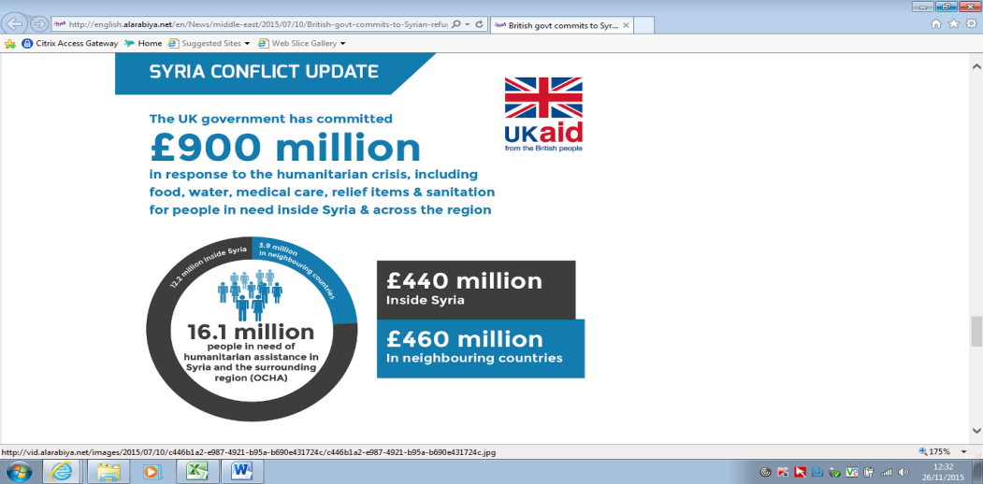
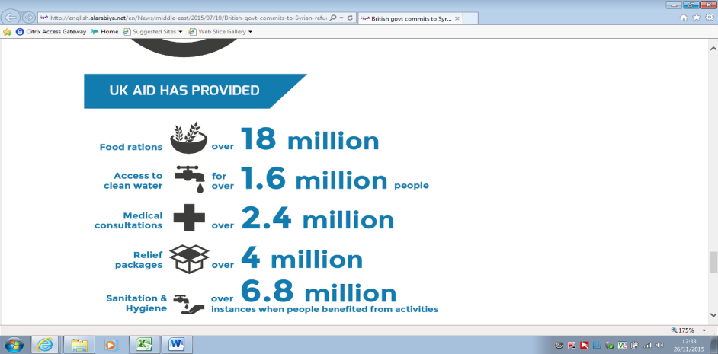
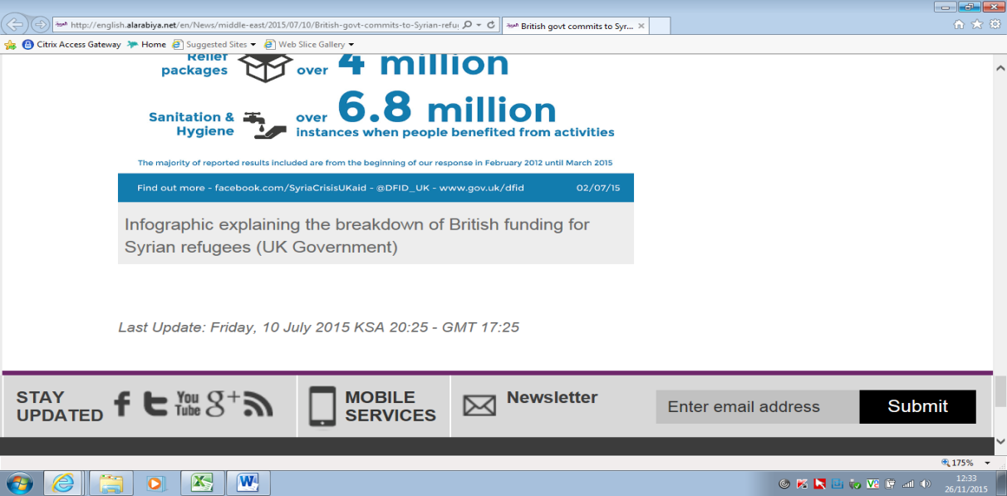
SOURCE 1

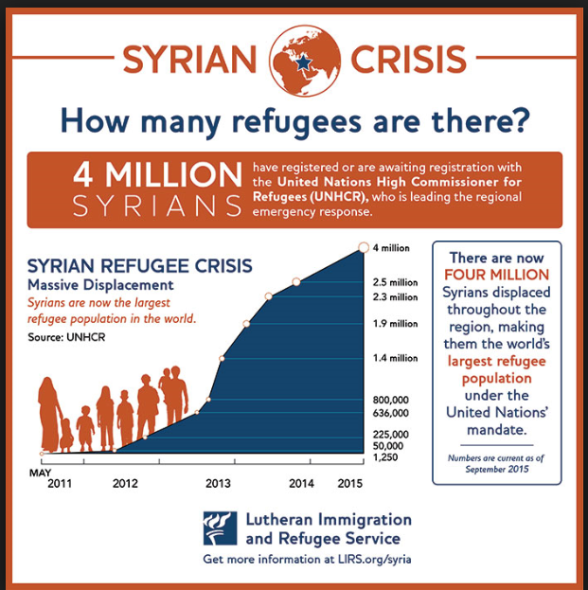

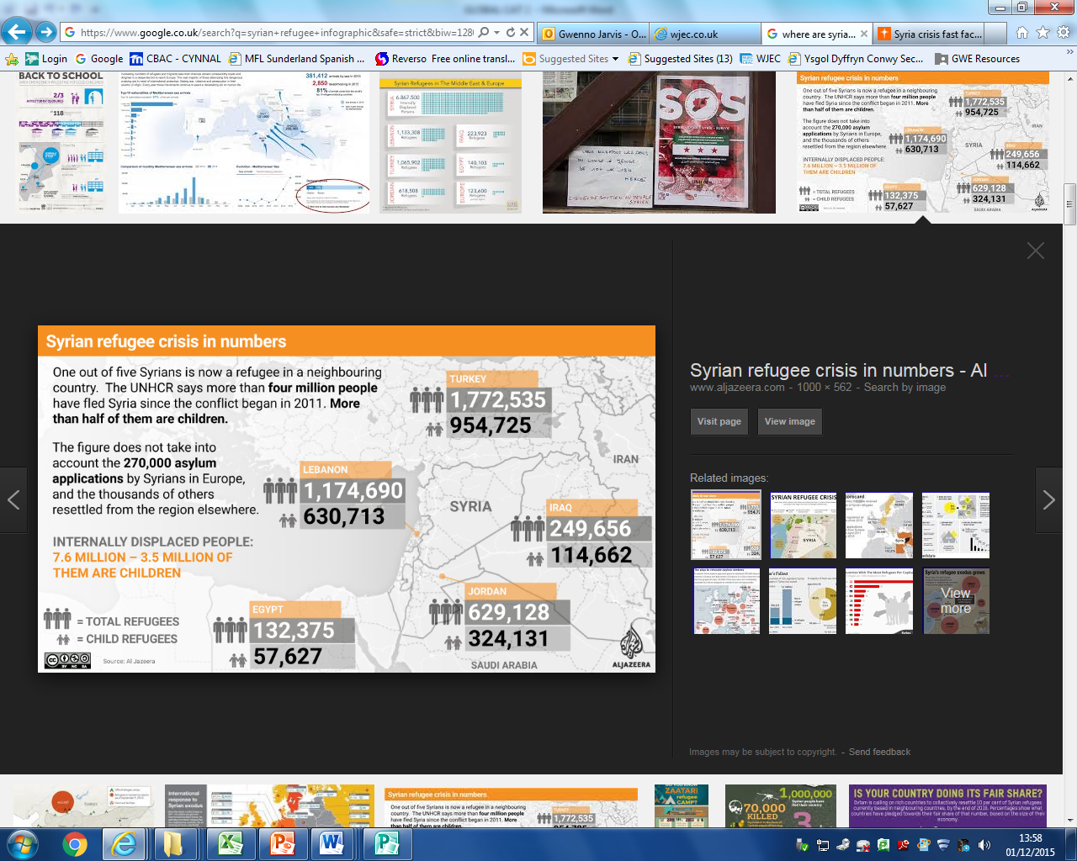

http://www.aljazeera.com 10 Jul 2015

SOURCE 3
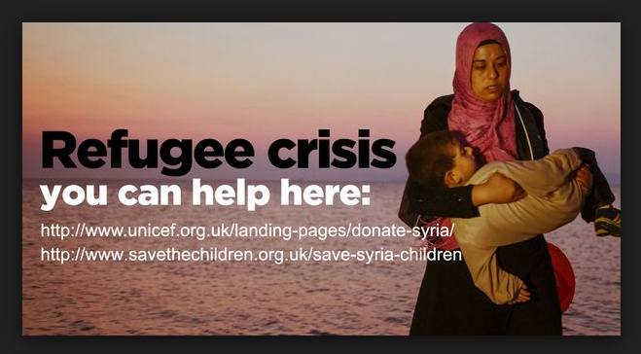
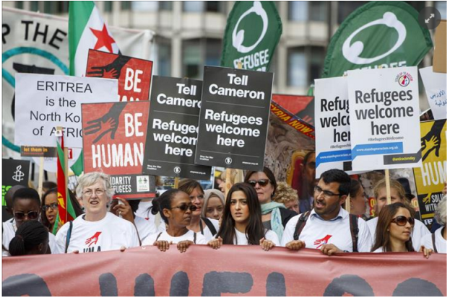

____________________________________________________________________________________________________________________________________________________
____________________________________________________________________________________________________________________________________________________

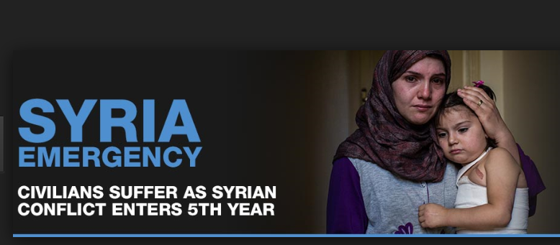

____________________________________________________________________________________________________________________________________________________

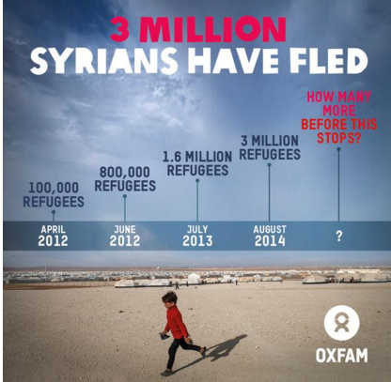
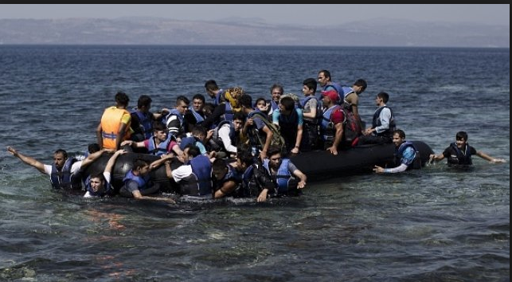

____________________________________________________________________________________________________________________________________________________
____________________________________________________________________________________________________________________________________________________

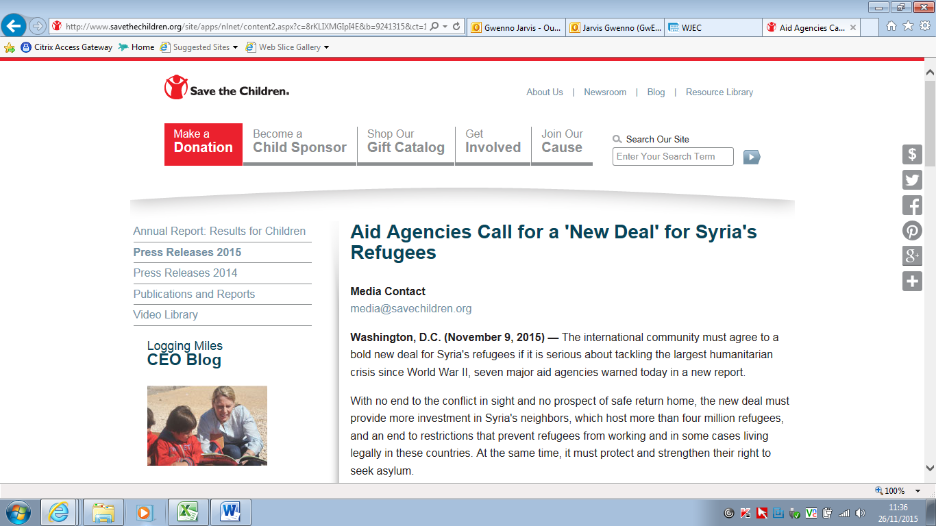
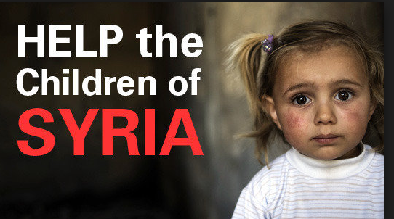
TEXT 2

Aid Agencies Call for a 'New Deal' for Syria's Refugees
Media Contact
media@savechildren.org
Washington, D.C. (November 9, 2015) — The international community must agree to a bold new deal for Syria's refugees if it is serious about tackling the largest humanitarian crisis since World War II, seven major aid agencies warned today in a new report.
With no end to the conflict in sight and no prospect of safe return home, the new deal must provide more investment in Syria's neighbours, which host more than four million refugees, and an end to restrictions that prevent refugees from working and in some cases living legally in these countries. At the same time, it must protect and strengthen their right to seek asylum.
"Many refugees are currently being condemned to a life in legal limbo with an array of restrictions which leave them in fear of arrest, detention and deportation," said the Secretary General of Norwegian Refugee Council Jan England.
"Their living conditions are deteriorating dramatically, forcing refugees to adopt extreme measures to cope, including increasingly to return to the warzone they fled or to risk their lives crossing to Europe. We need to help the host countries give refugees the opportunity to live dignified lives and make a positive contribution to the communities hosting them."
The agencies argue that a new, creative, long-term approach is needed. With the right help from international donors, Syria's neighbouring governments should develop policies that allow refugees to better support themselves financially without the risk of arrest by authorities. This would also allow refugees to contribute to the economy of the communities hosting them.
Unable to afford rent or food, and relying on dwindling aid, refugees are pushed into a spiral of destitution and debt. Some 70 percent in Lebanon lack the documents needed to stay in the country legally and many refugees in Jordan outside of camps are struggling to access medical and education services because they lack updated documents.
"We risk losing a whole generation of young Syrians – the same generation that will have to rebuild Syria once the conflict is finally over. With adults unable to earn a living, more and more children end up in work. Hundreds of thousands of children are missing years of education as the school systems in neighbouring countries are bursting at the seams and need much greater support," said Misty Buswell, Regional Advocacy Director at Save the Children.
"For over four years now, refugees have been living hand to mouth, relying on humanitarian aid, not knowing where the next meal comes from," said Oxfam's Executive Director, Winnie Byanyima.
"Experienced carpenters, farmers and teachers, among others, who we often meet, are struggling to keep a roof over their heads as they scrape money together to pay rent. Their skills should be put to good use, to allow them to provide for their families and support the economies of the countries hosting them. New jobs could also benefit the millions of Jordanians, Lebanese, Turkish, and Iraqis who are facing this crisis too."
"The international community needs to realize that, rather than a burden, as refugees are often wrongly portrayed, the evidence points to the contrary: that refugees who are legally able to work can make positive contributions to host economies with their diverse skills and experience," said Peter Klanso, Danish Refugee Council Middle East and North Africa Director.
Even with the right investment and policies, the scale of the crisis means that the most vulnerable refugees will need asylum outside of the region. Rich countries should provide a safe resettlement option for at least 10 percent of refugees, who are most in need, but they have only pledged to accept less than three per cent so far, and waiting time is far too long.
Save the Children gives children in the United States and around the world a healthy start, the opportunity to learn and protection from harm. We invest in childhood — every day, in times of crisis and for our future. Follow us on Twitter and Facebook.

NOTES FOR TEXT 2
FACTS:

RURU:

P

E

S

T

L

E

OTHER COMMENTS:

CLASSROOM DISCUSSION
- WATCH THE VIDEO CLIPS AND BEGIN TO FORM YOUR OWN OPINION ON THE ISSUE OF HOW TO ADDRESS THE REFUGEE CRISIS.

VIDEO 1: SIDRA’S LIFE IN A REFUGEE CAMP (8 minutes) https://www.youtube.com/watch?v=FFnhMX6oR1Q
VIDEO 2: MICHAEL SHEEN/UNICEF’S CAMPAIGN (1 minute) http://blogs.unicef.org.uk/2015/11/25/syrian-children-winter-refugee-camp
VIDEO 3: REFUGEES FLEEING SYRIA INTO TURKEY (1 MINUTE) http://www.theguardian.com/global-development/2015/jul/09/syria-refugees-4-million-people-flee-crisis-deepens

Notes from video evidence:

  - Classroom discussion
PESTLE FACTORS IMPACTING THE REFUGEE CRISIS:

ENVIRONMENTAL
POLITICAL
How can we address the refugee crisis in Syria?

LEGAL
ECONOMIC

TECHNOLOGICAL
SOCIAL

  - Group discussion. Discuss the crisis with your peers. Write down everybody’s opinion from your group in the grid on the following page.

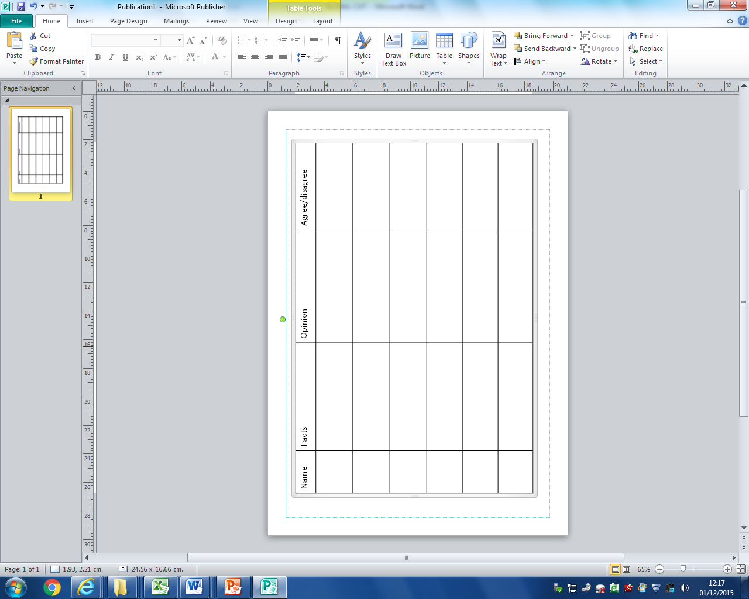
NOTES, VIEWPOINTS & ARGUMENTS ABOUT THE ISSUE
MAIN FACTS/ISSUES FROM DISCUSSION/VIDEOS

MY OPINION

How can we address the refugee crisis in Syria?

HOW SHOULD WE HELP? RAISE AWARENESS?

OTHER OPINIONS

1ST DRAFT OF PERSONAL STANDPOINT: How can we address the refugee crisis in Syria?
- Issue
- Facts from sources
- PESTLE
- RURU
- Group Outcome
- Opinion
- Way forward
________________________________________________________________________________________________________________________________________________________________________________________________________________________________________________________________________________________________________________________________________
________________________________________________________________________________________________________________________________________________________________________________________________________________________________________________________________________________________________________________________________________
________________________________________________________________________________________________________________________________________________________________________________________________________________________________________________________________________________________________________________________________________
________________________________________________________________________________________________________________________________________________________________________________________________________________________________________________________________________________________________________________________________________
________________________________________________________________________________________________________________________________________________________________________________________________________________________________________________________________________________________________________________________________________
________________________________________________________________________________________________________________________________________________________________________________________________________________________________________________________________________________________________________________________________________
________________________________________________________________________________________________________________________________________________________________________________________________________________________________________________________________________________________________________________________________________

MY RAISING AWARENESS PACK:
SWOT ANALYSIS OF MY IDEAS (you can use more paper if you want)
IDEA 2
IDEA 1
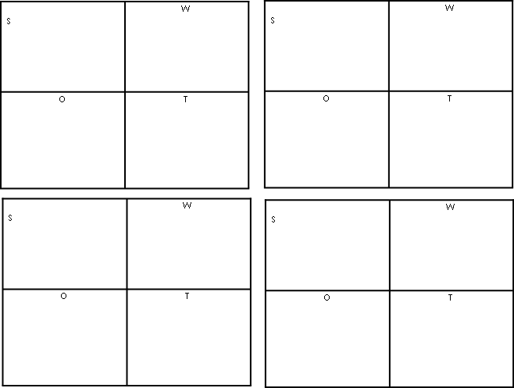
IDEA 4
IDEA 3

My chosen idea & reasons for choosing this one:
________________________________________________________________________________________________________________________________________________________________________________________________________________________________________________________________________________________________________________________________________
________________________________________________________________________________________________________________________________________________________________________________________________________________________________________________________________________________________________________________________________________

Development of my idea
On an A3 piece of paper, draw some plans & ideas for your raising awareness pack
Draw a sketch/make some notes for these questions below:
What will your raising awareness pack be? Draw a sketch of it.
Who is the audience?
How will you present it?
What type of layout will it have & why?
What font will you use & why?
How big will the writing/pictures/images be & why?
What type of language are you going to use & why? (Persuasive/emotive/descriptive..)
Which colours will you use & why?
What size will it be & why?
What materials will you need & why?
Will you be using characters? Who will they be?
Will you be using squares/circles/other shapes & why?

Don’t worry about scribbling ideas out and drawing new ones. This is just planning which is an important part of the process. You can be as creative as you want!!

MY REVIEW
Consider some of these points when writing a review of the whole process (analysis of texts, group discussion, PESTLE, RURU, SWOT, Raising Awareness pack, & Feedback):
- What global issue did you investigate?
- Is it a current issue?
- What was your main source of information? What other sources did you use/could you have used?
- How did you use the skills of critical thinking and problem solving?
- How did you make sure that the information you researched was reliable?
- Did you find your own sources? Where? How?
- What did you do well?
- What could you improve?
- What did you enjoy?
- What new skills did you learn from this task?
- What was the purpose of the task?
- What type of raising awareness pack did you choose? Why?
- Who is your audience?
- What software/programs did you use?
- What colours and why did you use?
- How did you make sure that your presentation was suitable for your audience?
- Use of images
- Use of other media e.g. animation, video and sound
- Use of text. How did you use text to target your audience effectively?
- What tools and techniques did you use to make your presentation/leaflet etc. more interesting?
- What did you do well with your raising awareness pack?
- What could you improve?
- What did you enjoy?
- What new skills did you learn from this task?
- Was your raising awareness pack successful? Why/why not?
MY REVIEW
________________________________________________________________________________________________________________________________________________________________________________________________________________________________________________________________________________________________________________________________________________________________________________________________
________________________________________________________________________________________________________________________________________________________________________________________________________________________________________________________________________________________________________________________________________________________________________________________________
________________________________________________________________________________________________________________________________________________________________________________________________________________________________________________________________________________________________________________________________________________________________________________________________
________________________________________________________________________________________________________________________________________________________________________________________________________________________________________________________________________________________________________________________________________________________________________________________________
________________________________________________________________________________________________________________________________________________________________________________________________________________________________________________________________________________________________________________________________________________________________________________________________
________________________________________________________________________________________________________________________________________________________________________________________________________________________________________________________________________________________________________________________________________________________________________________________________
________________________________________________________________________________________________________________________________________________________________________________________________________________________________________________________________________________________________________________________________________________________________________________________________
________________________________________________________________________________________________________________________________________________________________________________________________________________________________________________________________________________________________________________________________________________________________________________________________
________________________________________________________________________________________________________________________________________________________________________________________________________________________________________________________________________________________________________________________________________________________________________________________________
________________________________________________________________________________________________________________________________________________________________________________________________________________________________________________________________________________________________________________________________________________________________________________________________

