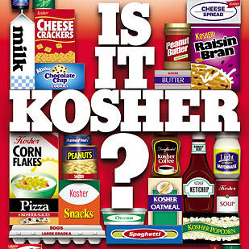
Kashrut: Jewish rules about food
Key vocabulary:
Kosher – Meaning = ‘correct’ or ‘suitable’. Foods which Jews are permitted to eat.
Treifa – Meaning = ‘broken’. Foods which Jews are not permitted to eat.
Parev - ‘neutral’ foods. Jews are permitted to eat these with meat or milk.
Shochet – a Jewish butcher.
Shechitah – the Jewish way of slaughtering an animal without pain.

Jewish food rules are a special type of mitzvot and together they are called kashrut. ‘Observing kosher’ is an important part of Jewish culture which means that they are more than just religious rules, but exactly how strictly they keep to the rules is usually a sign of how Orthodox the Jew is.
Kosher animals
‘Of all the animals that live on land, these are the ones you may eat: you may eat any animal that has a divided hoof and that chews the cud.’ (Leviticus 11:2-3)

In order for the animal to be kosher is must have the following two features:
- Split hooves
- It chews the cud*
(*Cud is the name which is given on the small balls of grass which some animals form in their stomachs after grazing. They regurgitate the grass to their mouths and chew it a second time before digesting it).
Examples of kosher animals: beef and lamb.
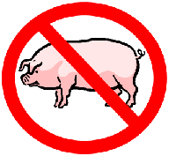
Examples of treifa animals: pig (ham, bacon, pork).

Kosher fish
“Of all the creatures living in the waters of the seas and the streams, you may eat any that have fins or scales.” (Leviticus 11:9)
In order for fish to be kosher they must have the following two features:
- fins
- scales
Examples of kosher fish: Trout, salmon, tuna.
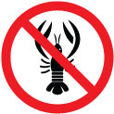
Examples of treifa fish: crab, lobster, prawns.
Kosher birds
A list of animals which Jews cannot eat is given in the Torah (Leviticus 11: 13-19). The list includes many birds of prey.
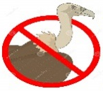
Examples of kosher birds: chicken, turkey.
Examples of treifa birds: eagle, vulture.

Remember: A Kosher animal or bird can still be treifa is there is something wrong with its internal organs.

Shechitah: the Jewish way of slaughtering animals
In order for animals and birds to be Kosher, they must be slaughtered in a particular way and the name of this method is Shechitah.
Shechitah must be carried out by a trained butcher (shochet).
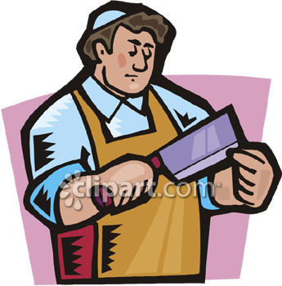
The bird / animal is slaughtered with a quick incision across the throat using a very sharp knife. The knife cuts smoothly through the vein which lowers the blood pressure in the brain and the animal is unconscious immediately. Although it is possible to feel something, the animal is already dead.
Once this has happened, it must be ensured that there is no blood remaining in the meat. The blood must be drawn out, in 4 stages which included soaking the meat in water for 30 minutes, keeping the meat separately on thin boards so that the blood can flow away, covering every part of the meat with untreated salt for an hour, then rinsing the meat to get rid of the salt.
This is done to carry out God’s will, because ‘the blood is the life’ (Deut. 12:23).
Separating meat and dairy in a kosher kitchen
‘Do not cook a young goat in its mother’s milk.’ Exodus 23:19
Across the centuries Jews have interpreted this above rule from the Torah to mean that Jews who keep kosher homes should not eat meat and dairy products together.
Mixing meat and dairy products
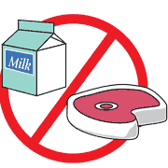
Jews are not to eat meat and dairy products together in the same meal. They must be kept apart when eating, preparing food and kept apart in the kitchen. Different crockery and cutlery are used, and these are washed and dried in a separate bowl and using different tea towels. They must wait a number of hours after eating meat before eating anything which contains milk, and around half an hour befor eating anything which contains meat after eating dairy products.
Parev Foods
Foods which do not contain meat or dairy (i.e. vegetables, eggs) and which have not been prepared with an equipment used for meat or dairy products are called parev or parve. Parev foods can be eaten with meat or milk.
Sometimes, even after taking great care in the kitchen, meat or dairy products can become mixed up or spilt on each other. When this happens, Jews ask for the advice of the rabbi, who decides if the food and equipment are still kosher.
Buying kosher food
Most food today contains colouring, flavouring and preservatives and these are not all kosher. In order to avoid the problem of knowing which products are kosher, there are rabbis which oversee the food which is produced. Rabbis will testify that the food is kosher using the label which is printed on the packet. This label is called hechsher.
Today, a wide variety of food carry the hechsher label. These include items such as sweets, chocolate, soup, margarine, oil, biscuits, butter and cheese. The majority of these foods are produced in Israel or the USA, and an increasing number of being produced in Britain. It is probably easier to keep a kosher home today than at any other time in the past.
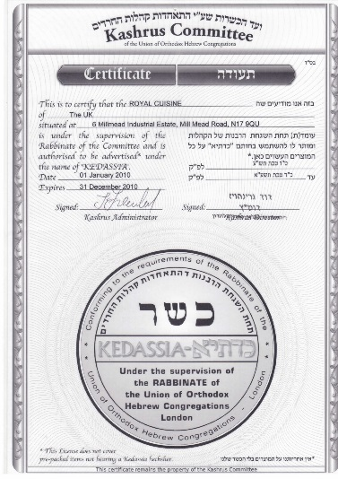
The kosher butcher shop will show show the licence given the board of rabbis. The board is responsible for ensuring that the butcher is doing everything properly. They often send inspectors out to look at the shop. If it is found that the butcher is selling food which is not kosher, then the shop will lose its licence immediately.
Kosher restaurants must also be licencesed by the rabbi authority. These restaurants usually well meat or dairy products only.

The importance of observing Kashrut

- A command from God (mitzvah). According the Orthodox Jews, God’s Word is the Torah. What right to they have to choose and select which rules to keep?
- Judaism is a way of life – eating is part of everyday life.
- The home – the centre of the religion.
- Worshipping God on a basic lefel – thinking about God and repecting him even when eating.
- Maintaining their identity. It unites them as Jews, as God’s Chosen and holy Nation. Promotes a feeling of unity and closeness.
- Practices self-discipline. Disciplines people towards the holiness of the Covenant. Set apart. ‘Holy = ‘apart’.
- Shows their belief in God and that they accept his demands.
- Shows that they belong to a group of special and different people. Feeling of belonging, as though they are part of a close family.
- Keeps the tradition. An important part of their heritage.

‘Of all religious laws and observances, the dietary laws have had the major share in fashioning and maintaining the distinctive character of the Jewish community’.
(A History of the Jewish Experience – Leo Trepp)

The challenges of observing kashrut

- Cost. Kosher food is scarce in Britain and is therefore more expensive. Financial cost of having two sinks, two ovens, two fridges.
- Kosher foods are scarce in Britain. Shochet are also scarce.
- Effort to keep meat products and dairy products separately and to wait hours between meals.
- Food in work canteens or schools not usually kosher i.e. they are treifa.
- Visting homes of friends who are not Jews.
- Restaurants in Britain do not provide kosher foods.
- Foods such as McDonald’s, KFC, Burger King etc., are popular in Britain – but these are not kosher in this country.
- Kashrut rules are irrelevant today. No need to keep to them for hygiene reasons.
- More important rules in the Jewish religion e.g. love God, Tzedek (charitable, helpful).
- Kashrut rules have an impact on the type of medicine which can be taken – some ingredients are treifa.

Different opinions between Orthodox Jews and Reformed Jews regarding observing Kashrut

- Jews have different opinion about observing the rules of kashrut and how strictly they should be observed.
- Orthodox Jews will keep a kosher kitchen but some Orthodox Jews will choose to be vegetarian in order to avoid the problem of having to have two sets of kitchen items; or if they choose to eat meat they will only do so in a kosher restaurant.
- Reformed Jews will tend to stick to the rule of not mixing meat and dairy products, but not all believe that it is necessary that an animal is slaughtered in the shechitah method or that all the blood must be removed from a kosher animal.
- The majority of Reformed Jews do not believe that they must have the seal of approval of Jewish authorities for parev foods and fruit and vegetables.
- Not every Reformed Jew is overly concerned with eating foods which have been prepared by non-Jewish people using non-kosher saucepans, cutlery etc.
- However, Orthodox Jews believe that no meal can be kosher if it has be prepared by a non-Jew.
- For many secular and Reformed Jews, observing kosher has more to do with being loyal to Jewish traditions and cultural rather than adhering strictly to the mitzvot in the Torah.
- Many Orthodox Jewish practices go beyond the exact words of the Torah but Reformed Jews would argue that the Torah could be interpreted in different ways.
- Secular and Reformed Jews could argue that kashrut rules were not divine rules originally, but were introduced for health and safety reasons e.g. drawing the blood from meat and salting it are ways of preserving it and keeping it fresh, and checking fruit and vegetables for insects and bugs is a sensible idea!
- The morality of shechitah is a very contentious issue in Judaism. While some Jews argue that it is vital that they are given the right to use the shechitah method for religious freedom, others feel that civil authorities have a right to ban it for animal welfare reasons.

Explain why it is important for Jews to keep a kosher kitchen. [8]
...........................................................................................................................................................................................................................................................................................................................................................................................................................................................................................................................................................................................................................................................................................................................................................................................................................................................................................................................................................................................................................................................................................................................................................................................................................................................................................................................................................................................................................................................................................................................................................................................................................................................................................................................................................................................................................................................................................................................................................................................................................................................................................................................................................................................................................................................................................................................................................................................................................................................................................................................................................................................................................................................................................................................................................................................................................................................................................................................................................................................................................................................................................................................................................................................................................................................................................................................................................................................................................................................................................................................................................................................................................................................................................................................................................................................................................................................................................................................................................................................................................................................................................................................................................................................................................................................................................................................................................................................................................................................................................................................................................................................................................................................................................................................................................................................................................................................................................

