HER MENTER A CHYFLOGADWYEDD CA5
KS5 ENTERPRISE AND EMPLOYABILITY CHALLENGE

ENW/NAME:
DOSBARTH/CLASS:
ATHRO MENTER/ENTERPRISE TEACHER:

CYNNWYS
HER MENTER A CHYFLOGADWYEDD CA5
- SUT I GREU BUSNES
- SUT I ADNABOD EICH SGILIAU A’I DATBLYGU O FEWN BYD GWAITH
- SUT I GYFLWYNO SYNIADAU BUSNES YN LLWYDDIANNUS
- CYNGOR AR EICH DYFODOL: ADDYSG UWCH, BYD GWAITH & RHEOLI ARIAN (TIWTORIAL)
- SUT I ADNABOD GWENDIDAU & CHRYFDERAU AC ADEILADU ARNYNT
SGILIAU HANFODOL & CHYFLOGADWYEDD
- CREADIGEDD & ARLOESEDD
- EFFEITHIOLRWYDD PERSONOL
- RHIFEDD
- LLYTHRENNEDD DDIGIDOL
- CYFRANOGIAD I’R HER

ASESIADAU (MARC ALLAN O 45 AM YR HOLL WAITH)
- ARCHWILIAD SGILIAU
- CYNNIG & CHYFLWYNIAD MENTER
- CYNLLUN CYRCHFAN (TIWTORIAL)
- CYFLWYNIAD MYFYRDOD PERSONOL
- TYSTIOLAETH O’R GWAITH (GWELER Y GRID ASESU AR Y DUDALEN NESAF)
CONTENT
KS5 ENTERPRISE & EMPLOYABILITY CHALLENGE
- HOW TO CREATE A BUSINESS
- HOW TO RECOGNISE YOUR SKILLS AND DEVELOP THEM IN THE BUSINESS WORLD
- HOW TO PRESENT BUSINESS IDEAS EFFECTIVELY
- ADVICE ON YOUR FUTURE CAREER: HIGHER EDUCATION, WORLD OF WORK & MANAGING YOUR MONEY (TUTORIAL)
- HOW TO RECOGNISE WEAKNESSES & STRENGTHS AND BUILD UPON THEM
EMPLOYABILITY & ESSENTIAL SKILLS
- CREATIVITY & INNOVATION
- PERSONAL EFFECTIVENESS
- NUMERACY
- DIGITAL LITERACY
- PARTICIPATION IN THE CHALLENGE

ASESIADAU (MARC ALLAN O 45 AM YR HOLL WAITH)
- ARCHWILIAD SGILIAU
- CYNNIG & CHYFLWYNIAD MENTER
- CYNLLUN CYRCHFAN (TIWTORIAL)
- CYFLWYNIAD MYFYRDOD PERSONOL
- TYSTIOLAETH O’R GWAITH (GWELER Y GRID ASESU AR Y DUDALEN NESAF)

TASGAU I’W HASESU

TRACIO TASGAU
DD1  Creadigedd & Arloesedd |  |  | DD2  Effeithiolrwydd Personol |  |  | DD3  Rhifedd |  |  | DD4  Llythrennedd Ddigidol |  |  | DD5  Cyfranogi i’r Her Menter a Chyflogadwyedd
TYSTIOLAETH
- Map meddwl o syniadau gwreiddiol & dadansoddiad SWOT o’r syniadau |  |  | - Awdit sgiliau |  |  | - Analeiddio costau rhedeg busnes |  |  | - Defnyddio excel i greu graff o awdit sgiliau |  |  | - Cynnig busnes effeithiol
- Ymchwil & Ymateb i ymchwil marchnad, masnacheiddio. |  |  | - Cynllun datblygu sgiliau & thystiolaeth o sut |  |  | - Analeiddio costau byw |  |  | - Defnyddio twitter (neu debyg) i hyrwyddo cynnyrch |  |  | - Cyflwyniad busnes effeithiol
- Prototeip dychmygus |  |  | - Cynllun gweithredu gan gynnwys cofnodion cyfarfodydd |  |  | - Datrys problem costau byw ar ol gadael ysgol (coleg v gwaith) |  |  | - Pasport cyrchfan: cadw, trefnu, rheoli & rhannu gwybodaeth |  |  | - Gwerthusiad personol effeithiol
- Gwerthusiad o’r broses cynllunio prototeip. |  |  | - Gwerthusiad o’i perfformiad

TRACKING TASKS
LO1  Creativity & innovation |  |  | LO2  Personal effectiveness |  |  | LO3  Numeracy |  |  | LO4  Digital Literacy |  |  | LO5  Participating in the Enterprise Challenge
TYSTIOLAETH
- Thinking map of original ideas & SWOT analysis of the ideas. |  |  | - Skills Audit |  |  | - Analysing the costs of running a business |  |  | - Using excel to create an analysis of skills audit |  |  | - An effective business proposal
- Research & respond to market research, commercialization. |  |  | - Skills development plan & showing how to progress |  |  | - Analysing living costs |  |  | - Using Twitter (or similar) to promote product |  |  | - An effective business pitch
- Imaginative prototype |  |  | - Action plan including minutes of meetings |  |  | - Problem solving: living costs after leaving school (college v work) |  |  | - Destination Passport: save, organise, manage & share information |  |  | - An effective personal reflection
- An evaluation of the process of developing the prototype |  |  | - An evaluation of their performance

1.4 Fedrwch chi enwi y gwahanol gwmniau/logos?

2.1 SGILIAU/SKILLS: Ewch i/Go to https://www.enterprisecatalyst.co.uk/ ac yna llenwch y dudalen hon/and then fill in the boxes.

2.3 & 2.4 Awdit Sgiliau yn seiliedig ar ganfyddiadau ‘Enterprise Catalyst’ / Skills Audit based on ‘Enterprise Catalyst’ findings.
Cryfderau/Strengths
Cymhelliant/Motivation

Hunangred/Self-belief

Parodrwydd i ddysgu/Willingness to learn

Mewnblyg/Allblyg/Introvert/Extrovert

Dechrau/Gorffen/Start/Finishing

Crwydro/Canolbwyntio/Digressing/Focussing

Oportiwnydd-Risg/Opportunistic/Risk

Arall/Other

Gwendidau/Weaknesses

Pa fath o weithiwr tîm wyt ti? /What type of team worker are you?

Pa adborth a gefaist am dy ddysgu personol ac arddulliau meddwl? / What feedback did you get on your personal learning and thinking methods?

Yn dy farn di pa fath o swyddi mewn busnes a fuasai’n dy siwtio di a pham? / In your opinion what sort of jobs in business would suit you and why?

3.1 RHEOLI’R PROSIECT (Tasgau tebygol) /MANAGING THE PROJECT (Possible tasks)
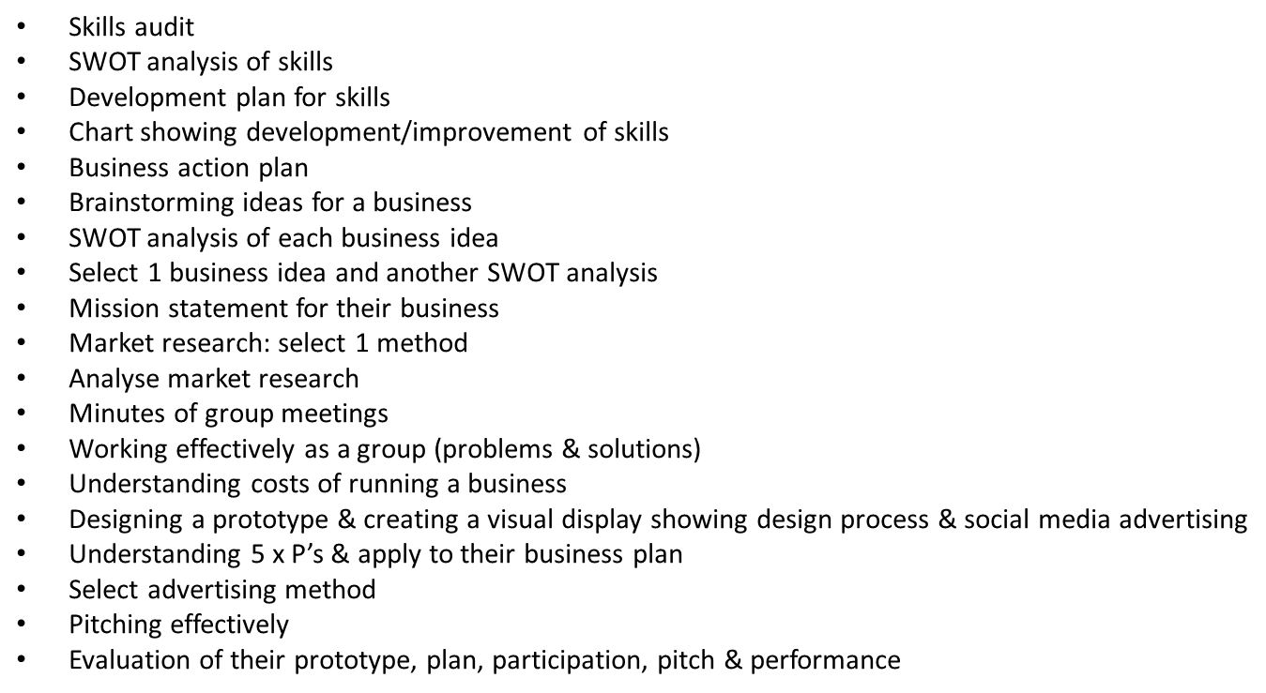
- Awdit sgiliau ar gyfer yr her
- Dadansoddiad SWOT o’r sgiliau
- Cynllun datblygu ar gyfer y sgiliau
- Siart yn dangos datblygiad o’ch sgiliau
- Cynllun gweithgarwch busnes
- Syniadau ar gyfer busnes
- Dadansoddiad SWOT o’r syniadau busnes
- Dewis 1 syniad a gwneud dadansoddiad SWOT ohono
- Datganiad cenhedaeth ar gyfer y busnes
- Ymchwil marchnad: dewis un dull
- Dadansoddiad o’r ymchwil marchnad
- Cofnodion o gyfarfodydd
- Gweithio yn effeithiol fel grwp (problemau & datrysiadau)
- Deal costau rhedeg busnes
- Cynllunio prototeip & chreu arddangosfa weledol yn dangos y broses cynllunio & sut i hysbysebu gyda cyfryngau cymdeithasol
- Deal y 5 x P & a’u defnyddio yn y cynllun busnes
- Dewis dull i hysbysebu
- Cyflwyno yn effeithiol
- Gwerthusiad o’r prototeip, cynllun, cyfranogiad, cyflwyniad & pherfformiad

3.2 Siart GANTT ar gyfer busnes/Gantt Chart for a Business

Defnyddiwch yr enghraifft hon i ddylunio siart eich hun ar Excel/ Use this example to create your own Gantt chart on excel
Project Tasks | Wk 1 | Wk 2 | Wk 3 | Wk 4 | Wk 5 | Wk 6

4.2 CWESTIYNAU AR GYFER SEFYDLU BUSNES/QUESTIONS IN PREPARATION TO SETTING UP A BUSINESS
PWY YW EICH CYSTADLEUWYR
WHO IS YOUR COMPETITION
- Gyda phwy y byddwch yn cystadlu?/Who are you competing with?

- Beth maen nhw’n ei wneud?/What do they do?

- Pa brisiau y maen nhw’n ei godi?/ What are their prices?

- Beth maen nhw’n dda am ei wneud?/ What are they good at?

- Beth maen nhw’n wael am ei wneud?/ What are they not as good at?

- Pam fod eich syniad/cynnyrch / gwasanaeth chi’n well na’u un nhw? / Why is your idea/product/service better than theirs?

- Pam fod pobl yn prynu ganddynt?/ Why do people buy their product/service?

- Ydyn nhw’n rhoi unrhyw ‘ecstras’?/ Do they give any ‘extras’?

- Beth allwch chi ddysgu ganddynt? / What can you learn from them?

- Gwnewch restr o’r holl wahanol grwpiau o gwsmeriaid a allai fod â diddordeb mewn prynu eich cynnyrch / gwasanaeth. Pam fyddai ganddynt ddiddordeb? Make a list of potential customers who would be interested in your idea/product/service. Why would they be interested?

4.3 Cynllun Busnes
(4.4 Templed wag ar gael yn y ffolder)

Cynnwys y cynllun busnes:
Gweledigaeth:  - Y syniad busnes  - Nodau busnes  - Yr hyn sy’n gwneud y busnes yn wahanol  - Ffactorau llwyddiant | Marchnata:  - Ymchwil i’r farchnad  - Hyrwyddo a hysbysebu | Rhedeg y Busnes:  Costau a derbyniadau
Gweledigaeth
1. Syniad Menter: Rhowch ddisgrifiad cryno o syniad eich menter

Esiampl 1: Hoffwn ddechrau busnes fy hun fel technegydd gwinadd. Bydd App yn cael ei ddatblygu ar gyfer y cwsmer i allu cymryd perchnogaeth dros dylunio eu gwinadd. Byddaf wedyn yn gosod y cynllun/llun ar eu gwinadd i safon uchel.
Esiampl 2: Fy mwriad yw cychwyn busnes yn gwerthu iogwrt arbennigol. Fy USP yw defnyddio cynnyrch organig lleol er mwyn hyrwyddo byw’n gynaliadwy yn yr ardal.
Esiampl 3: Byddaf yn cynhyrchu busnes ble fyddaf yn cynnig gwasaneth ffotagraffeg i’r cwsmeriaid rheiny sydd yn cymryd rhan mewn gweithgareddau awyr agored.

MAE GWEDDILL Y CYNLLUN YN SEILIEDIG AR Y CYNLLUN GWINADD

2. Nodau & Amcanion y Busnes: Beth ydych chi am ei gyflawni?

- Dennu canran fawr o’r farchnad.
- Sicrhau ffyddlondeb cynnyrch.
- Cyngor ar gyfer cwsmeriaid llai creadigol.
- Gwneud proffit yn fy mlwyddyn 1af.

- Rhoi rhyddid dylunio i’r cwsmeriaid.
- Ansawdd uchel i’r gwaith gorffenedig
- Cadw costau yn isel

3. Yr Hyn Sy’n Gwneud y Busnes yn Wahanol? Sut mae eich cynnyrch yn unigryw neu’n wahanol o’i gymharu â’r gystadleuaeth?

- App
- Cynllun unigryw
- Dylunio gartref
- Gwasanaeth symudol

Gweledigaeth
4. Ffactorau Llwyddiant: Pam ydych chi’n credu y bydd eich busnes yn llwyddiannus?

- USP
- Cymhelliant
- Uchelgeisiol
- Sgiliau Personol
- Costau sefydlog isel
- Defnyddio technoleg
- Marchnad darged iau

Marchnata
5. Ymchwil i’r Farchnad: Pwy yw eich cwsmeriaid?

- 5-60+
- genethod
- gwasanaethau
- proms
- priodasau
- partiion
- anrhegio penblwydd
- cartrefi yr henoed
Beth hoffai eich cwsmeriaid ei gael?

- gwerth eu harian
- gwasanaeth o ansawdd uchel
- sgiliau rhyngbersonol da
- dewis eang o gynlluniau ar gael
- mynediad i’r App 24/7
- ffasiwn cyfredol

6. Hyrwyddo a Hysbysebu: Sut a ble fyddwch chi’n hyrwyddo eich syniad busnes?

- Facebook/Twitter
- papur newydd
- clywed gan bobl eraill
- hysbysebu
- viral (pop ups/hyperlinks)
- cyflwyniad
- cardiau busnes
- pamphledi/posteri
- pensiliau/beiros
- ffair
- slogan/logo

Rhedeg y Busnes
7.Costau: Am ba bris y byddech chi’n gwerthu’r cynnyrch hwn i’r cwsmer ?
Costau Sefydlog:
eitem | £ y mis
Ffon symudol | 25.00
Gwiriant car | 82.00
Taliadau benthyciad car | 100.00
Peiriant UV | 80.00

Costau Ansefydlog:
eitem | £ y mis & nifer y gwinadd
Gwinadd Acrylic | 7.00 (y 100)
Polish | 11.00 (y 55)
Powdr | 4.00 (y 55)
UV Gel | 5.00 (y 55)
Acetone | 6.00 (y 55)

eitem | £ y mis
petrol | 40.00

Cost fesul uned | Y person | ‘Mark up’ | Proffit y person

Business Plan

Business plan contents:
Vision:  - The business idea  - Business aims  - What makes the business different  - Success factors | Marketing:  - Market research  - Promotion and advertising | Running the business:  - Costs and receipts

Vision
1. Enterprise Idea: Give a brief description of your enterprise idea

Example 1: I wish to start my own business as a nail technician. An App will be developed for the consumer to take ownership of designing their nails. I will then apply their chosen design to a high standard.
Example 2: My aim is to start a business selling specialist yogurt. My USP is using locally sourced organic products; highlighting the need for sustainable living in our area.
Example 3: I will be creating a business where I will offer a service to photograph individuals participating in outdoor activities.
The rest of the plan is based on Example 1 (Nails’ App):

2. Business Aims & Objectives: What do you want to achieve?

- Attract a large percent of the market share.
- Ensure brand loyalty
- Advisor for less creative customers
- Make a profit in my first year

- Give the consumers freedom of design
- High quality finish on the nails
- Keep fixed costs low

3. What Makes the Business Different? How is your product unique or different compared to the competition?

- An App
- Individual design
- Design at home
- Mobile service

Vision
4. Success Factors: Why do you believe your business will be successful?

- USP
- Drive
- Ambition
- Personal Skills
- Low fixed costs
- Use of technology
- Younger target market

Marketing
5. Market Research:
Who are your customers?

- 5-60+
- Girls
- Services
- proms
- weddings
- parties
- birthday treats
- care homes
What do your customers want?

- value for money
- high quality service
- good interpersonal skills
- vast range of designs available
- 24/7 App access
- up to date trends/fashion
6. Promotion and Advertising: How and where will you promote your business idea?

- Facebook/Twitter
- newspaper
- word of mouth
- advertise
- viral (pop ups/hyperlinks)
- presentation
- business cards
- leaflet/posters
- pencils/stationery
- fair
- slogan/logo

Running the Business
7.Costs: At what price will you sell this product to the customer?
Fixed Costs:
item | £ per month
phone | 25.00
Car insurance | 82.00
Car loan payments | 100.00
UV Machine | 80.00

Variable Costs:
item | £ per month & quantity of nails
Acrylic nails | 7.00 (per 100)
polish | 11.00 (per 55)
Powders | 4.00 (per 55)
UV Gel | 5.00 (per 55)
Acetone | 6.00 (per 55)

item | £ per month
fuel | 40.00

Unit cost | Per person | Mark up | Profit per person

5.3 ESIAMPL O SWOT ANALYSIS O FUSNES/EXAMPLE OF A SWOT ANALYSIS OF A BUSINESS

5.4 SWOT O FY SYNIADAU BUSNES & SWOT O’R SYNIAD TERFYNNOL
SWOT ANALYSIS OF MY BUSINESS IDEAS AND A SWOT ANALYSIS OF MY CHOSEN IDEA
Strengths/Cryfderau | Weaknesses/Gwendidau
Opportunities/Cyfleoedd | Threats/Bygythiadau
6.3 Ymchwil i’r farchnad/Market research
HOLIADUR ENGHREIFFTIOL
Helo, tybed a fyddai ots gennych fy helpu? Rwy’n aelod o fusnes bach sy’n meddwl gwerthu cynnyrch (neu wasanaeth) yn yr ardal ond, cyn dechrau gwneud hynny, rydym eisiau gweld beth yw ymateb pobl. (Gallech ddangos eich cynnyrch neu wasanaeth)
1. Pa mor aml ydych chi’n ei brynu? (Os nad ydynt wedi’i brynu, gofyn ‘Pam ddim?’)
2. Lle’r ydych yn ei brynu?
3. Pam ydych yn ei brynu?
4. Faint ydych yn ei dalu amdano?
5. Beth ydych yn ei hoffi amdano?
6. Beth allai fod yn well amdano?
7. Sut mae ein un ni’n cymharu â rhai eraill?
8. Fyddech chi’n fodlon prynu ein un ni?
9. Beth ydych yn ei hoffi am un ni?
10. Sut allai un ni fod yn well?
11. Beth yw pris da am un ni?
12. Unrhyw sylwadau neu awgrymiadau?
Bachgen / Merch
Grŵp oed: O dan 16 oed 16- 25 26-35 35+ oed
Galwedigaeth
Diolch ichi am eich amser a’ch cymorth.

EXAMPLE QUESTIONNAIRE
Hello, I wonder if you would mind helping me? I am a member of a small business which is planning to sell a product (or service) in the area but before we do, we are checking out people’s reactions. (You could show product or service)
1. How often do you buy it? (If not bought, ask ‘Why not?’)
2. Where do you buy it?
3. Why do you buy it?
4. What do you pay for it?
5. What do you like about it?
6. What could be improved about it?
7. How does ours compare with others?
8. Would you be willing to buy ours?
9. What do you like about ours?
10. What could be improved in ours?
11. What is a good price for ours?
12. Any other comments or suggestions?
Male/Female
Age group: Under 16 16- 25 26-35 35 plus
Occupation
Thank you for your time and help

Esiamplau Cadw Cofnodion/ Examples of Team Meetings
Minutes
of meeting held on ____________________ at ____________

in______________________
People present: (write the names of the people who attended the meeting)

7 Esiampl cadw cofnodion/Example of keeping a record of minutes
Cofnodio cyfarfod a gynhelir ar _________ yn ____________ am_____ Minutes of meeting held on __at ___ in _________
Presennol: (enwch y bobl oedd yn bresennol yn y cyfarfod) People present (write the names of the people who attended the meeting)
Ymddiheuriadau gan: (enwch y bobl nad oedd yn gallu mynychu) Apologies from: (write the names of the people who were unable to attend)
Eitem i’w drafod ar yr agenda  Agenda item | Crynodeb o’r hyn a drafodwyd  Brief summary of what was discussed | Pwyntiau gweithredu  Action points
Dylai rhain fod yn benodol a dylai pob pwynt gael ei ddilyn gan enw y person a fydd yn gyfrifol am weithredu y pwynt hwnnw.
These should be specific and each action point should be accompanied with somebody’s name who will be responsible for carrying out the action point

8.3 COSTAU/COSTINGS

9.1 DYFEISIWCH PROTOTEIP O’R CYNNYRCH/APP/GWASANAETH (4 PROTOTEIP GWAHANOL EFO ANODI/COSTAU/LLIWIAU/YMCHWIL MARCHNAD/SAIN/USP/MANYLION ERAILL)
DESIGN A PROTOTYPE OF THE PRODUCT/APP/SERVICE (4 DIFFERENT PROTOTYPES WITH ANNOTATION/COST/COLOURS/MARKET RESEARCH/SOUND/USP/OTHER DETAILS)

9.2 DEWIS Y PROTOTEIP TRWY BLEIDLAIS TWITTER/FACEBOOK/YMCHWIL MARCHNAD
USING MARKET RESEARCHTWITTER/FACEBOOK TO CHOOSE FINAL PROTOTYPE
Edrychwch ar yr esiamplau isod o’r gystadleuaeth #pitchtorich ble defnyddwyd Twitter i bleidleisio am y pitch gorau
Look at these examples from the competition #pitchtorich where Twitter was used as a voting tool

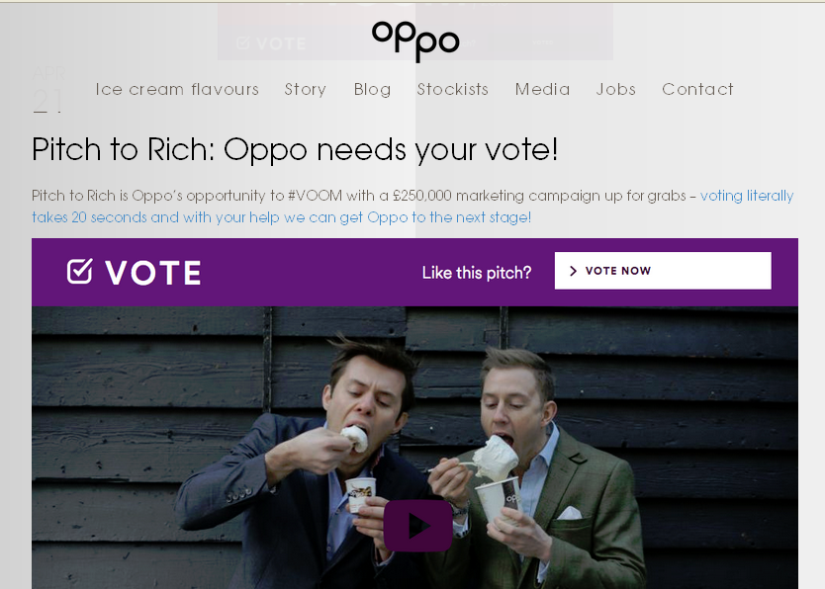

9.3 DADANSODDI CANLYNIADAU YR YMCHWIL/ANALYSING THE OUTCOME OF THE RESEARCH
Edrychwch ar yr esiampl isod o’r gystadleuaeth #pitchtorich/Look at the example below of #pitchtorich

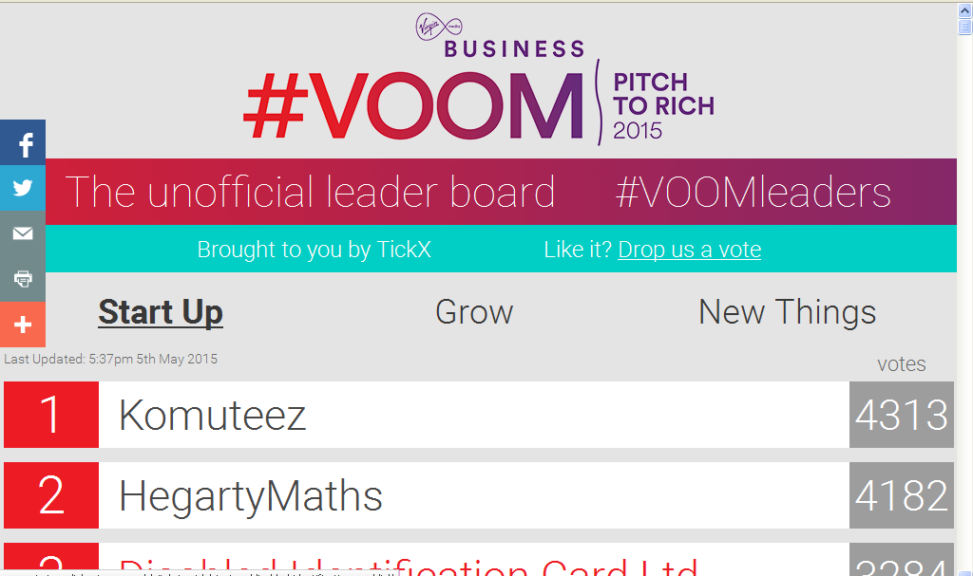

9.4 CYNLLUNIO ARDDANGOSFA: ‘MOODBOARD/ARDDANGOSFA WELEDOL/DESIGNING A VISUAL DISPLAY/MOODBOARD

10.2 FY NGHYNLLUN BUSNES: 4X P’S MY BUSINESS PLAN: 4 X P’S

11.3 HYRWYDDO A MARCHNATA: PA DECHNEG HYSBYSEBU FYDDAI ORAU AR GYFER FY MUSNES I A PHAM? PROMOTING & ADVERTISING: WHICH ADVERTISING TECHNIQUE WOULD BE BEST FOR MY BUSINESS AND WHY?
Method/Dull | Advantages/Manteision | Disadvantages/Anfanteision
Teledu/Television
Radio
Cinema
Papurau Newydd & Chylchgronnau/Newspapers and Magazines
Posteri/Posters
Pamphledi/Leaflets
Cyfryngau & erthyglau/Press release and news stories
Noddwyr/Sponsorship
Cymeradwyaeth/Endorsements

12.3 SYNIADAU AR GYFER FY NGHYFLWYNIAD (PITCH) AR GYFER FY MUSNES / IDEAS FOR MY PITCH FOR MY BUSINESS:
(Gwyliwch enillwyr y gystadleuaeth yn gwneud pitch yma/ Watch the winners of the competition pitching to Richard Branson here: http://www.virginmediabusiness.co.uk/pitch-to-rich/)

13.4 GWERTHUSIAD O’R BROSES I GYD & PHARATOAD AR GYFER FY NGHYFLWYNIAD MYFYRDOD PERSONOL
EVALUATING THE WHOLE PROSES & PREPARING FOR MY PERSONAL REFLECTION PRESENTATION
- Awdit sgiliau ar gyfer yr her
- Dadansoddiad SWOT o’r sgiliau
- Cynllun datblygu ar gyfer y sgiliau
- Siart yn dangos datblygiad o’ch sgiliau
- Cynllun gweithgarwch busnes
- Syniadau ar gyfer busnes
- Dadansoddiad SWOT o’r syniadau busnes
- Dewis 1 syniad a gwneud dadansoddiad SWOT ohono
- Datganiad cenhedaeth ar gyfer y busnes
- Ymchwil marchnad: dewis un dull
- Dadansoddiad o’r ymchwil marchnad
- Cofnodion o gyfarfodydd
- Gweithio yn effeithiol fel grwp (problemau & datrysiadau)
- Deal costau rhedeg busnes
- Cynllunio prototeip & chreu arddangosfa weledol yn dangos y broses cynllunio & sut i hysbysebu gyda cyfryngau cymdeithasol
- Deal y 5 x P & a’u defnyddio yn y cynllun busnes
- Dewis dull i hysbysebu
- Cyflwyno yn effeithiol
- Gwerthusiad o’r prototeip, cynllun, cyfranogiad, cyflwyniad & pherfformiad

9.4 Defnyddiwch y templed isod fel man c

9.4 Defnyddiwch y templed isod fel man cychwyn ar gyfer gwerthuso y broses i gyd/Use the template below to evaluate the whole process
GWERTHUSIAD O’R BROSES I GYD
Beth oedd y tasgau? | ●●● | SYLWADAU...sut aeth y dasg? A oedd angen addasu unrhywbeth?

