

How to create a Graph
- Open up a spreadsheet (Microsoft Excel)
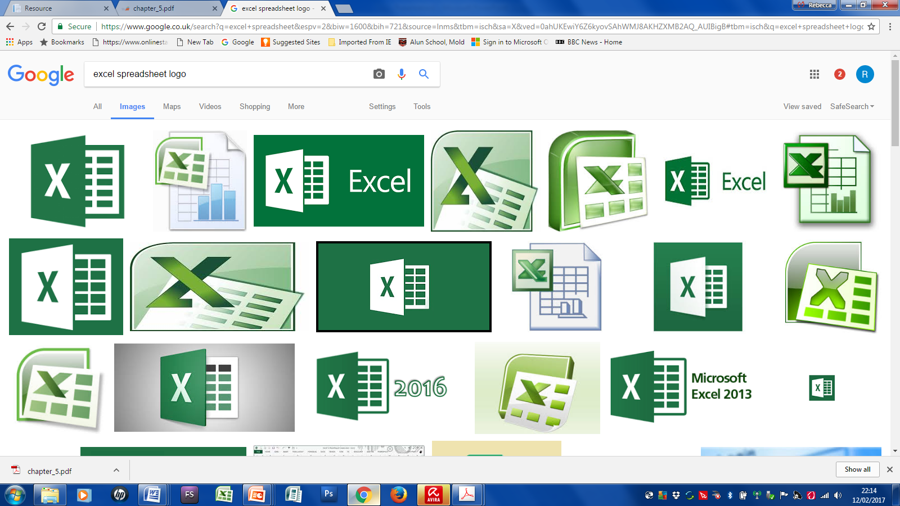
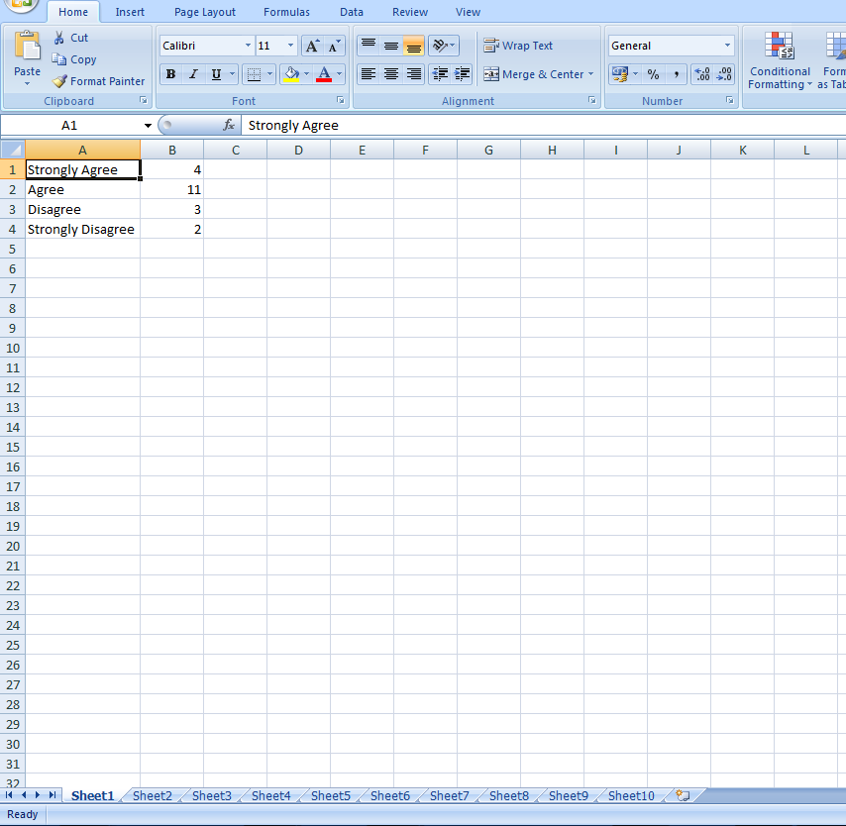
- Write out your responses in each cell and your results in the next cell e.g.
In this example Strongly Agree is in A1 and the result 4 is in B1
- To create a graph for each question, use 1 sheet for 1 graph.

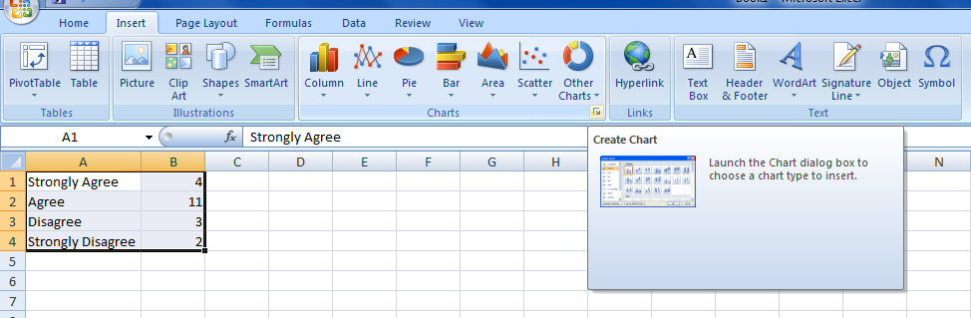
4. Highlight the responses and the result 5. Click on the insert tab and choose a suitable chart

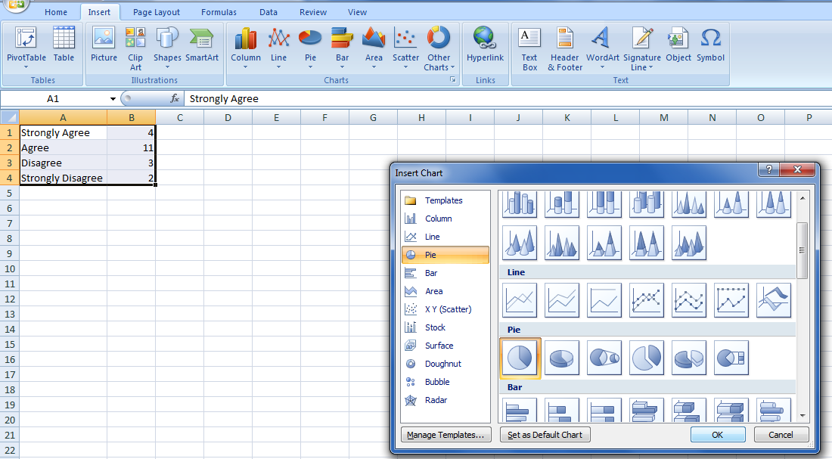

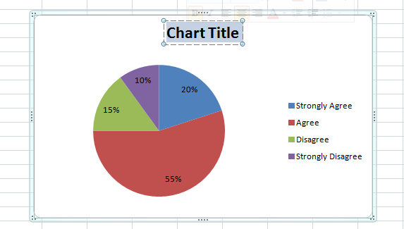
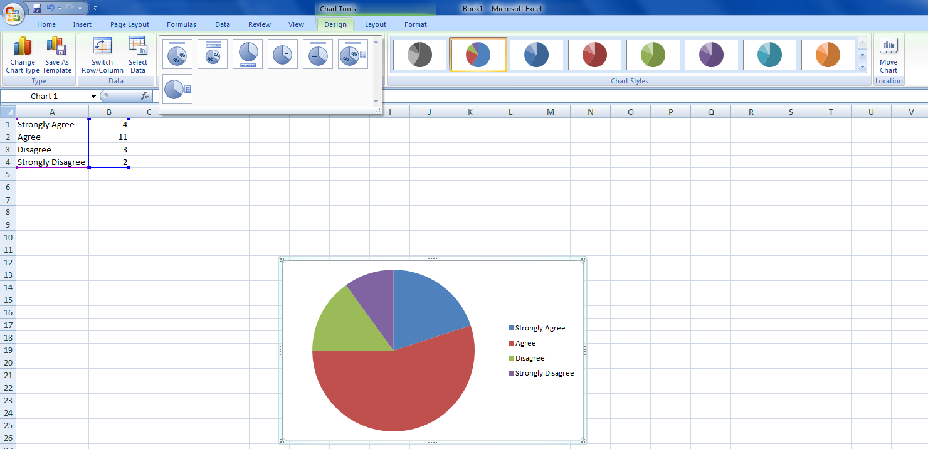
6. Once your graph has appeared, you will need to format it. First of all it will need a title/axis your graph. The question will be your title for the graph. You will need to select the design tool and choose an option that includes the chart title.

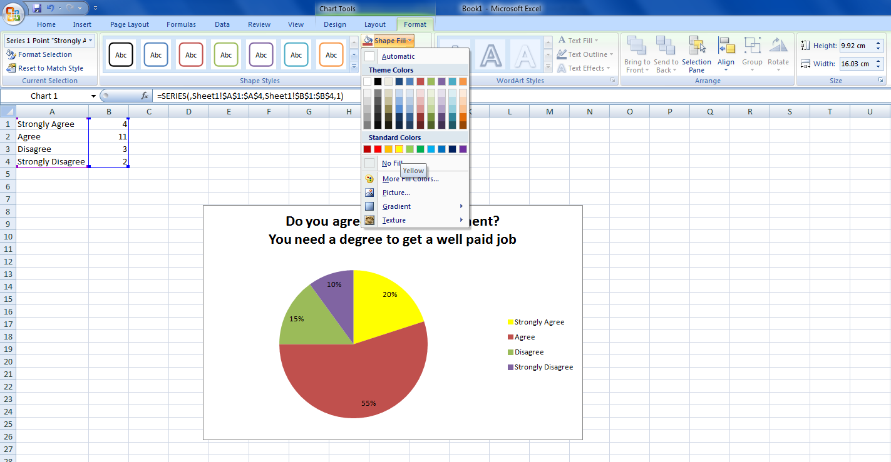
7. You can change the way your graph looks by selecting different colours, styles extra.

Select the “Format” tab at the top

Starter | Finish the Sentence
The information in the graph shows
Furthermore
This means that
This could result in
Analysing your Graphs
Copy and paste each graph into your Individual Project under the section “Primary Data Analysis”. You will need to analyse what your graph shows. You can use this template to help you write up your analysis for each graph. Remember once you have used the template, you turn your sentences into a paragraph.

