We have been studying…
Our lessons have been about ……
I’ve learned all about…
We are exploring…
Since doing this work I have changed my mind about....
My opinions are….
I felt….
I believe…
I can’t make up my mind about….
In my view……
Other people think….
This work has made me think about...
I have realised that….
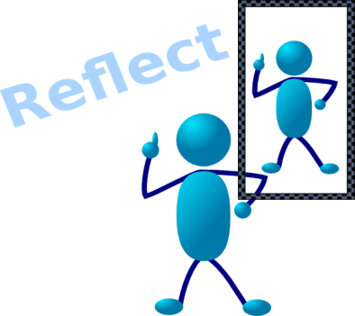
Choose two questions from each step



Work your way down the seven steps of reflection
The best bit of my work was…
What I enjoyed about it was….
I found it interesting when….
The good thing about this…
My best homework was….
What made the work worthwhile was…



I think my viewpoints is..
I could have improved my viewpoint by….
To make better progress with my viewpoint, I could have
If I started my viewpoint again I would…
Finding things out for my viewpoint has been….
The effort I put into my viewpoint was….
I am pleased with viewpoints because….


Nearly there



I did not like….
I didn’t understand….
I wish we hadn’t ….
What I found difficult was…



Now I understand more about…
I didn’t realise that ….
One thing that made me think was….
It’s surprising that….
I’m curious to learn more about…
I can’t be sure about….
One fascinating thing is…

The advice I would give to someone starting this work tomorrow is….
Overall my work has been…
From this work I have gained…
Generally this subject has been….
Finally I would like to say…

