Political Economic Social Technological Legal Environmental
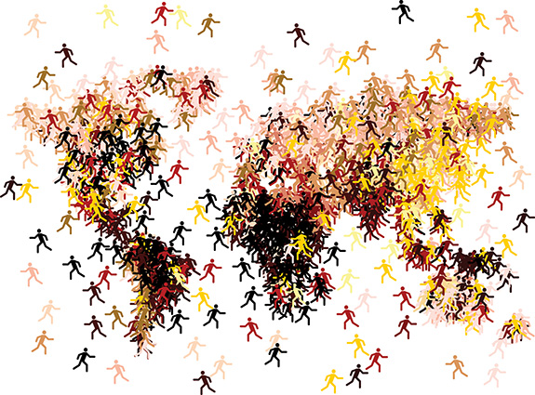
MIGRATION.

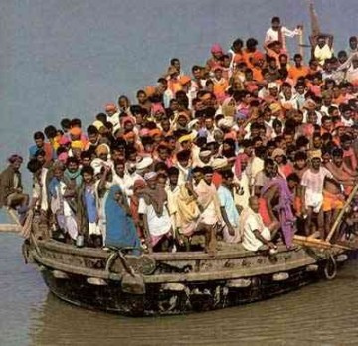

What is Migration?

What causes What are the effects
Migration? of Migration?
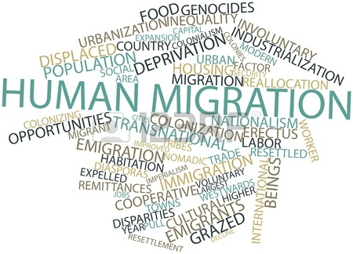

What do you think of migration?
Section | Page Number
Critical thinking question starters | 3
What is migration? | 5 - 12
Push and Pull factors, PESTLE and Migration. | 13 - 18
Political | 19-20
Economic | 21- 32
Facts and Opinions. | 33
Social | 34-43
Technology | 44- 49
Legislation | 50 - 62
Environment | 44- 50
Questionnaire | 63
Summary | 64
Contents.

INTRODUCTION.

Over the next few weeks you are going to be exploring information, news and ideas about migration. The aim of this project is for you to develop your own viewpoint about this important global issue and to develop the skills that you will need to complete a controlled assessment on another global issue. You will need to work swiftly but effectively in class. You will need to listen to your tutor, make notes, read articles, take part in debates and then finally complete a controlled assessment. In the controlled assessment you are to present your point of view about a global issue and then create a product that will allow you to promote this point of view. You will also learn what PESTLE stands for; use it in your controlled assessment and how to evaluate strengths and weaknesses.

 | Critical thinking question starters
CT1 | Who  What  Where  Why  When  How  Can you list three..?  Can you recall..?  How did… happen?  How would you describe…?  What can you say about…..?  What facts of ideas show…?
CT2 | Can you explain what is happening?  How would you compare….?  How can you show your understanding of…..?  What would result if…?  Can you make use of the fact….?  What approach would you use…?  What would result if…?  What elements would you choose to change…?  How would you categorise…?  Can you identify the different parts…?  Can you make a distinction between…?
CT3 | What changes would you make to solve….?  What could be done to minimise…..?  Suppose you could …....?  Can you predict the outcome if…..?  What facts can you compile….?  Can you elaborate on the reason for…?  Do you agree with ….?  How could you determine ….?  How would you test…?  Would it be better if…?  How would you evaluate…?  Based on what you know, how would you explain…?  What information would you use to support the view…?  How would you prioritise…?

What is Migration?

Using the internet, dictionaries and your own knowledge, find the definition of what migration is.
Migration is ______________________________________________________________________________________________________________________________________________________________________________________________________________________________________________________________________________________________________________________________________________________________________________________________________________________________________________________________________________________________________________________________
(LO 1, 3)

Why do people migrate? As a class, discuss the reasons why people migrate and then complete the following thought shower.
(LO 1, 2, 3, 4)

Why do people migrate?

You are now going to read two articles on migration. One is from Wikipedia and the other from The Guardian Online.
Are these reliable sources?
Why?

Wikipedia:
______________________________________________________________________________________________________________________________________________________________________________________________________________________________________________________________________________________________________________________________________________________________________________________________________________________________________________________________________________________________________________________________
The Guardian Online: ______________________________________________________________________________________________________________________________________________________________________________________________________________________________________________________________________________________________________________________________________________________________________________________________________________________________________________________________________________________________________________________________
(LO 1, 3, 4)

Human migration
From Wikipedia, the free encyclopedia
This article has multiple issues. Please help improve it or discuss these issues on the talk page.
This article is outdated. Please update this article to reflect recent events or newly available information. (November 2010)

This article needs additional citations for verification. Please help improve this article by adding citations to reliable sources. Unsourced material may be challenged and removed. (November 2007)

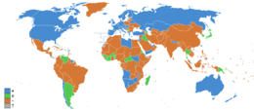
Net migration rates for 2011: positive (blue), negative (orange), stable (green), and no data (gray)
Human migration is the movement by people from one place to another with the intention of settling temporarily or permanently in the new location. The movement is typically over long distances and from one country to another, but internal migration is also possible. Migration may be individuals, family units or in large groups
Nomadic movements are normally not regarded as migrations as there is no intention to settle in the new place and because the movement is generally seasonal. Only a few nomadic peoples have retained this form of lifestyle in modern times. Also, the temporary movement of people for the purpose of travel, tourism, pilgrimages, or the commute is not regarded as migration, in the absence of an intention to settle in the new location.
Migration has continued under the form of both voluntary migration within one's region, country, or beyond and involuntary migration (which includes the slave trade, trafficking in human beings and ethnic cleansing). People who migrate into a territory are called immigrants, while at the departure point they are called emigrants. Small populations migrating to develop a territory considered void of settlement depending on historical setting, circumstances and perspective are referred to as settlers or colonists, while populations displaced by immigration and colonization are called refugees.

Migration statistics
There are many sources for estimates on worldwide migration patterns. The World Bank has published a yearly Migration and Remittances Factbook since 2008. The International Organization for Migration (IOM) has published a yearly World Migration Report since 1999. The United Nations Statistics Division also keeps a database on worldwide migration. Recent advances in research of migration via the Internet promise better understanding of migration patterns and migration motives.
It should be noted that substantial internal migration can take place within a country, either seasonal human migration mainly related to agriculture and tourism to urban places, or shifts of population into cities (urbanization) or out of cities (suburbanization). Studies of worldwide migration patterns however tend to limit their scope to international migration.
The World Bank Migration and Remittances Factbook of 2011 lists the following estimates for the year 2010: Total number of immigrants: 215.8 million or 3.2% of world population. Often, a distinction is made between voluntary and involuntary migration, or between refugees fleeing political conflict or natural disaster vs. economic or labour migration, but these distinctions are difficult to make and partially subjective, as the various motivators for migration are often correlated. The World Bank report estimates that as of 2010, 16.3 million or 7.6% of migrants qualified as refugees.
Structurally, there is substantial South-South and North-North migration, i.e. most emigrant from high-income OECD countries migrate to other high-income countries, and a substantial part (estimated at 43%) of emigrants from developing countries migrate to other developing countries. The top ten destination countries are the USA, Russian Federation, Germany, Saudi Arabia, Canada, the UK, Spain, France, Australia and India. The top ten countries of origin are: Mexico, India, the Russian Federation, China, Ukraine, Bangladesh, Pakistan, the UK, the Philippines and Turkey.
The top ten migration corridors worldwide are: 1. Mexico–United States; 2. Russia– Ukraine; 3. Ukraine–Russia; 4. Bangladesh–India; 5. Turkey–Germany; 6. Kazakhstan–Russia; 7. Russia–Kazakhstan; 8. China–Hong Kong; 9. China–United States; 10. Philippines–United States.
Remittance, i.e. funds transferred by migrant workers to their home country, is a substantial part of the economy of some countries. The top ten remittance recipients in 2010 were (estimates in billion US Dollar): 1. India (55; 2.7% of GDP), 2. China (51; 0.5% of GNP), Mexico (22.6; 1.8% of GDP), Philippines (21.3; 7.8% of GDP), France (15.9; 0.5% of GDP), Germany (11.6; 0.2% of GDP), Bangladesh (11.1; 7.2% of GDP), Belgium (10.4; 1.9% of GDP), Spain (10.2; 0.7% of GDP), Nigeria (10.0; 1.9% of GDP).
The Global Commission on International Migration (GCIM) was launched in 2003 and published a report in 2005. International migration challenges at the global level are addressed through the Global Forum on Migration and Development and the Global Migration Group, both established in 2006.
(From Wikipedia 2014).

UK gains £20bn from European migrants, UCL economists reveal
• Tax payments by European migrants far outweigh welfare
• Arrivals are better educated than British workforce

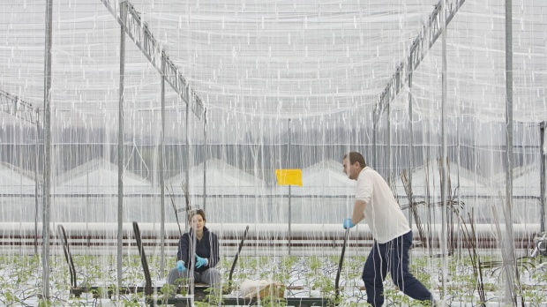
Migrant workers tending to tomatoes at the Baarda Nursery near Hull. Photograph: Gary Calton for the Guardian
Alan Travis, home affairs editor. Wednesday 5 November 2014
European migrants to the UK are not a drain on Britain’s finances and pay out far more in taxes than they receive in state benefits, a new study has revealed.
The research by two leading migration economists at University College also reveals that Britain is uniquely successful, even more than Germany, in attracting the most highly skilled and highly educated migrants in Europe.
The study, the Fiscal Impact of Immigration to the UK, published in the Economic Journal, reveals that more than 60% of new migrants from western and southern Europe are now university graduates. The educational levels of east Europeans who come to Britain are also improving with 25% of recent arrivals having completed a degree compared with 24% of the UK-born workforce.
It says that European migrants made a net contribution of £20bn to UK public finances between 2000 and 2011. Those from the 15 countries which made up the EU before 2004, including France, Germany, Italy and Spain, contributed 64% – £15bn more in taxes than they received in welfare – while east European migrants contributed 12%, equivalent to £5bn more.
The research by UCL’s centre for research and analysis of migration was undertaken to “fill the void” in the debate on immigration in which the contribution of unrestricted migration from within the EU has become the centre of intense political and public concern.
Prof Christian Dustmann, co-author of the study and director of the centre, said: “A key concern of the public debate on migration is whether immigrants contribute their fair share to the tax and welfare systems. Our new analysis draws a positive picture of the overall fiscal contribution made by recent immigrant cohorts, particularly of immigrants arriving from the EU.”
He said that the educational qualifications of new migrants to Britain, especially from western and southern Europe, was now extraordinarily high and higher than any other EU country. He said the UK would have had to spend £6.8bn on education to build up the same level of “human capital”. The study shows that not only are European migrants more highly educated than the UK-born workforce but they are less likely to be in receipt of state benefits – 43% less likely among migrants in the past decade – and more likely to be in employment. They are 7% less likely to live in social housing.
The report was criticised as being “shallow” by David Green of the centre-right thinktank, Civitas. He said that by focusing on taxes and benefits, the report had missed out some vital costs.
“People who migrate tend to be young, better educated and energetic. They make good employees here but they are a loss to their own country. If other European countries fail to prosper because their brightest and best have travelled to the UK, we are all worse off,” he said.
Green added that the survey also disregarded the waste of human capital involved in too many university migrants working as baristas or waiters.
The Conservative immigration minister James Brokenshire, responding to the UCL report, said: “Since 2010, we have reformed benefits, healthcare and housing rules to make them among the tightest in Europe and we continue to see an increase in the number of British citizens in work. In the past, the majority of growth in employment was taken up by foreign nationals; in the last year, three-quarters of it was accounted for by UK nationals.
“We are creating a system that is fair to British citizens and those who want to come here legitimately and contribute to our national life, but which is tough on those who flout the rules.”
(From The Guardian Online 2014)

People migrate for a number of reasons; these reasons can be Political, Economic, Social, Technological, Legal and Environmental, (PESTLE). In migrating from one country to live in another country there are normally push and pull factors at work.

PUSH and PULL factors in Migration.

Here is a list of push and pull factors which may push or pull a person from one country to another.

PUSH FACTORS | PULL FACTORS
Lack of services | Higher employment
Lack of safety | Better services
High crime rate | More wealth
Crop failure | Good climate
Drought | Safer, less crime
Flooding | Political stability
Poverty | More fertile land
War | Lower risk from natural disasters

Put these push and pull factors along with any other reasons that the class has discussed under the correct reason, (PESTLE analysis).

POLITICAL | ECONOMICAL | SOCIAL | TECHNOLOGICAL | LEGAL | ENVIRONMENTAL
(LO 1, 4)
Migration usually happens as a result of a combination of these push and pull factors. 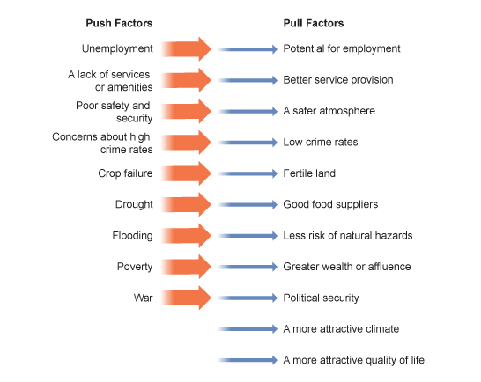

Create a poster on migration based on push and pull factors.

(LO 2, 4)

You should now reflect on the Strengths and Weaknesses of your
poster in raising awareness of Push and Pull Factors of Migration.
(LO 2, 4)
Strengths of poster | Weaknesses of poster



What do you know and understand about migration? What is your own personal standpoint on migration? Write about what you think of migration. ___________________________________________________________________________________________________________________________________________________________________________________________________________________________________________________________________________________________________________________________________________________________________________________________________________________________________________________________________________________________________________________________________________________________________________________________________________________________________________________________________________________________________________________________________________________________________________________________________________________________________________________________________________________________________
(LO 1, 2, 3, 4)
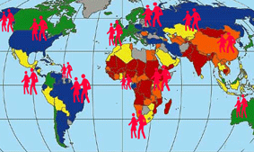

- Now that you have stated your opinion – take part in a class debate to see how other people feel. Remember – Hands up to speak.

- Has your opinion changed after listening to what others had to say? Write about whether your opinions have changed and write about the discussion, quoting what other individuals said, and whether or not you agree with their stand point. ____________________________________________________________________________________________________________________________________________________________________________________________________________________________________________________________________________________________________________________________________________________________________________________________________________________________________________________________________________________________________________________________________________________________________________________________________________________________________________________________________________________________________________________________________________________________________________________________________________________________________________________________________________________________________________________________________________________________________________
(LO 1, 2, 3)

POLITICS AND MIGRATION.

As you have learnt, there are many push and pull factors and reasons why people migrate, Political, Economic, Social, Technological, Legal and Environmental, (PESTLE) factors of migration.
According to the Organization for International Migration there are approximately 192 million people who live outside their place of birth. A majority of these people are migrant workers and they make up 3 percent of the world’s population. Human beings have always migrated from one place to another in search of better economic opportunities. But apart from economic factors, there are political factors that cause people to move from their home country to another country. War, persecution and the absence of political rights are the predominant political factors in migration. Research the political factors of migration and create a PowerPoint presentation on your findings. Include in your PowerPoint presentation:
- Definition of migration.
- Statistics.
- Images.
- A slide (at the end) with a list of where you have gotten your sources/information from, (bibliography)
After you have created your PowerPoint presentation show one of your peers, and ask them to give you written feedback on it that you are to keep.
(LO 1, 2, 3, 4)

You should now reflect on the strengths and weaknesses of your
PowerPoint presentation in raising awareness of Political Factors of Migration.
(LO 2)
Strengths of PowerPoint | Weaknesses of PowerPoint

ECONOMICS AND MIGRATION.

Many individuals migrate from one country to another due to economic reasons. These include more industries, better benefits, more employment, better employment, and to follow a particular career path.
Here is list of the most economically developed countries, and a list of the least economically developed countries. The most economic developed countries only have the first letter. Write in which countries you think they are.
(LO 1)
Most economically developed countries | Least economically developed countries.
1. N______________ | 1. Afghanistan
2. A_________________ | 2. Angola.
3. S_________________ | 3. Bangladesh.
4. N_______________ | 4. Benin.
5. U ___________________ | 5. Bhutan.
6. G________________ | 6. Burkina Faso.
7. N_______________ | 7. Burundi.
8. C_______________ | 8. Cambodia.
9. S__________________ | 9. Central African Republic.
10. D________________ | 10. Chad.
11. I______________ | 11. Comoros.
12. S________________ | 12. Dem. Rep of the Congo.
13. I________________ | 13. Djibouti.
14. U________________ | 14. Equatorial Guinea.
15. H_______and S________ | 15. Eritrea.

Read and reflect on the following statements. What is your opinion??

*Migration is harmful to UK jobs.
_______________________________________________________________________________________________________________________________________________________________________________________________________________________________________________________________________________________________________________________________________________________________________________________________________________________________________________________________________________________________________________________________________________________________________________________________________________________________________________________________________________________

*Migration is good for the UK. __________________________________________________________________________________________________________________________________________________________________________________________________________________________________________________________________________________________________________________________________________________________________________________________________________________________________________________________________________________________________________________________________________________________________________________________________________________________________________________________________________________________________________________________________________
(LO 1, 2, 3, 4)

Now read the following articles.

Immigrants fill one in five skilled British jobs

A Government-commissioned review by Prof John Perkins reveals how the UK is now reliant on migrants to fill large numbers of positions in skilled engineering industries
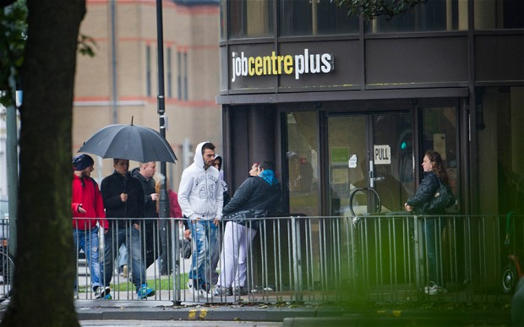
Migrant workers outside the Peterborough City Job Centre Plus Office Photo: David Rose
By Graeme Paton, 03 Nov 2013
Migrants are filling a fifth of jobs in key industries because of a lack of skilled British graduates, according to a Government-backed report.
Companies are forced to rely on foreign-born workers in a range of “strategically important” areas as children continue to shun maths and science subjects at school.
In all, migrants account for 20 per cent of workers in fields such as oil and gas extraction, aerospace manufacturing and computer, electronic and optical engineering.
The report warns that half of the 119 occupations featured on the Government’s “shortage occupation list” – which gives firms special dispensation to employ overseas staff – require engineering skills.
Another 20 per cent involve scientific and technical roles.
The shortage is so acute that universities are also filling courses with overseas applicants, with a third of places in engineering and technology subjects taken by non-British students, the report states.
The review, published by the Department for Business Innovation and Skills today, calls for drastic action to meet the “substantial demand” for engineers.
In response, the Government insisted it was making almost £49 million in funding available to raise engineering skills.
Last week David Cameron urged Britain to “say no” to Eastern European workers by improving the education system and helping young people compete with immigrants for jobs.
Figures published this year by the Office for National Statistics indicated that the number of foreign-born people finding jobs in the UK had increased by 225,000 to 4.26 million in a year, compared with a rise of just 192,000 British-born workers.
Business leaders have repeatedly warned of a severe shortage of British graduates qualified to fill engineering jobs, with Sir James Dyson, the inventor and entrepreneur, warning last year that up to 217,000 engineers would be needed within five years to plug gaps in the workforce.
Today’s report by Prof John Perkins, chief scientific adviser to the Department for Business, says more must be done to encourage British schoolchildren – particularly girls – to take qualifications that will lead to jobs in engineering.
It warns that there is a crippling shortage of skilled British workers despite the fact that almost a million 16 to 24-year-olds are currently without a job or education place.
“We owe it to our young people to equip them with the skills, including engineering skills, that British industry and the British economy needs now and will need in the future, and which can offer as many of them as possible rewarding and satisfying long-term careers,” the report says.
The report outlines the extent to which Britain depends on foreign workers to prop up key industries.
It says Britain “currently relies on inward migration for engineering skills”, adding “immigrants account for 20 per cent of professionals in strategically important sectors”.
The report cites the UK Border Agency’s Tier 2 shortage occupation list, which names those occupations where there are not enough resident workers to fill available jobs.
“The shortage occupation list reflects the extent to which the on-going increase in demand for specialist engineering skills outstrips the potential supply in the short term: engineering jobs dominate the list, accounting for half of the 119 job titles, with a further 20 per cent in closely related scientific and technical areas,” it says.
The report welcomes the fact that the Government allows employers to import engineers from overseas in key areas where there are shortages but insists this “should not be our long-term solution”.
The report adds: “Many employers have been forced to look overseas for workers with the expertise and experience needed to sustain their businesses and it is clear that migration will continue to be an important source of engineering skills for some time to come.
“But it is up to us, together, to ensure that the right skills become readily available to employers at home, and that they are no longer obliged to look further afield” for the workers they need.
The conclusions follow concerns that too many pupils have been pushed on to “soft” subjects such as media studies to boost school league table rankings.
It is feared that large numbers of girls have been put off careers in the field by stereotypical views about female vocations. Currently, fewer than one in 10 people working in engineering in Britain are women, less than any other European nation, the study adds.
In the short term, it recommends that those who have left the profession should be encouraged to return. Others who may have studied related subjects could be helped to “convert” by take a degree in engineering, the report says.
In response, the Government today announces a £30 million fund for employers to train staff and an £18 million investment in a new elite training facility at the Manufacturing Technology Centre in Coventry.
Vince Cable, the Business Secretary, said: “Engineering has a vital role to play in the future of UK Industry.
“It is important that we act now to ensure businesses have access to the skills they require to enable them to grow. We cannot do this alone so I am calling on employers and education professionals to get involved and inspire the next generation of engineers.”
The conclusions came as the National Centre for Universities and Business prepared to run its "Talent 2030" campaign, aimed at increasing the number of female engineers in the UK by encouraging more girls to study physics at school.
Dr David Docherty, chief executive, said: “Unless more women embark upon engineering careers, the industry will continue to draw from a narrow talent pool, threatening the UK’s competitiveness and economic growth.
(From the Telegraph online 2013).

Is immigration really a blessing or a curse?

Politicians are running scared of the electorate, yet the situation is more complex than they say
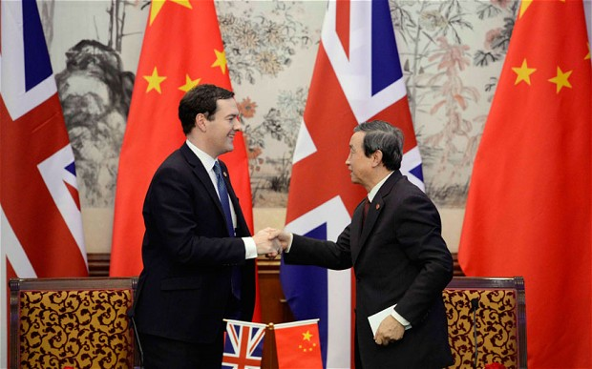
George Osborne’s recent visit to China was to tell people that if they have money or talent, there is no limit on their ability to come to Britain to learn or invest Photo: Reuters
By James Kirkup, 05 Nov 2013
They don’t work hard enough. They can’t be bothered to learn English properly, to master rudimentary mathematics or other basic skills. They choose welfare over work. So let’s clear the way for the industrious youngsters who take Lord Tebbit’s advice by travelling far and wide to find work. Yes, it’s time to limit the number of British people allowed to work in the UK, so that we can hire more immigrants.
That, at least, is the conclusion you might draw from reports this week from the National Institute for Economic and Social Research and University College London. The first found that British employers hire foreigners because they are more productive than the natives; the second that recent European immigrants pay £8.8 billion more in tax than they consume in public services. Employ more industrious foreigners, and growth will rise, the deficit shrink and taxes fall.
This may not be a popular prescription, but such reports are hardly going against the grain. Earlier this year, the OECD suggested that the deficit would be up to £16 billion larger if we relied on home-grown workers alone. The Office for Budget Responsibility predicts that if immigration falls dramatically, the public finances will face a £65 billion black hole because of lost tax revenues. And the Treasury puts 0.25 percentage point of GDP growth down to immigration.
Part of the economic upside is obvious: those who leave their country to labour in ours are inclined to work hard. As for talent, why would employers bother to hire them if they didn’t have skills we need?
Demographics are at play, too. Foreigners who come to work tend to be young, and Britain needs young people, because our elderly are living longer and we are having fewer children. So importing healthy folk who pay taxes and make few calls on the NHS and the state pension makes sound fiscal sense.
This is, however, time-limited. Young immigrants will become old immigrants. Some will return home, but others will settle and start consuming more services than they pay for, just like the natives. The UCL study suggests that immigrants who arrived in the Eighties and Nineties, then stayed and had children, now pay in only 85p for every £1 of services they consume.
Cold economic logic suggests we could simply import more young foreigners to support the older ones. But that puts relentless pressure on the population, and on public services. Yes, a bigger population means a bigger economy. But as the House of Lords Select Committee on Economic Affairs noted in 2008 – in a report which found “no evidence” that immigration had significant economic benefits – what matters is not GDP, but GDP per capita. There’s no point baking a bigger cake only to cut it into more slices.
Here, despite the Lords’ verdict, the evidence remains cloudy. A paper from the US last year analysing 147 countries found a “robust, positive effect of openness to immigration on long-run income per capita”. But many experts say this is far from conclusive, suggesting we give them a few more years to crunch the numbers.
Economists may not be certain about immigration, but that won’t stop politicians competing to echo what they firmly believe are voters’ concerns. And in the rush to pander, complex economic debates are almost inevitably overlooked in favour of suspiciously neat answers.
Perhaps the best example came at the 2010 election, when the Tories promised to reduce net immigration to the “tens of thousands”, a target the Coalition has not formally adopted (the Lib Dems said no) and may well miss anyway: it’s currently more than 170,000 a year.
Leaving aside the daftness of targeting net immigration (which could be done by driving more Brits into retirement on the Costa del Sol), the message was clear: immigration is bad and reducing it good. Labour has fallen in line, promising (yet another) new law to cut net immigration.
Yet privately, some senior Tories now worry that the pledge was too crude, reinforcing the notion of “immigrants” as a homogenous mass and obscuring the fact that some really do benefit the economy. Hence David Cameron and George Osborne’s recent visits to India and China, to tell people that if they have money or talent, there is no limit on their ability to come to Britain to learn or invest. Hence, too, Theresa May’s announcement today of a “VIP” visa service for wealthy foreign businessmen.
The Prime Minister knows that some immigration is positive: in his “global race”, Britain must woo international talent or fall behind. He won’t budge from the “tens of thousands” target – but he, like all politicians, will eventually have to accept that the costs, benefits and consequences of immigration are too complicated and important to be squeezed into trite slogans and simplistic promises.
They’ll resist, of course, fearful of upsetting an electorate they think is deaf to arguments for a more sophisticated approach. But they might give a moment’s thought to a recent YouGov poll which found that, while people do think immigration drives down wages for the low-paid, more think it has been good for the economy than bad – and even more believe the NHS would collapse without it. Whatever the conclusions of the great immigration debate, perhaps the most important is that the voters are usually far more intelligent, and open-minded, than the politicians give them credit for.
(From the Telegraph online 2013).



Analyse the effect economics has on migration take into account what you have just read.
Is it really the migrants’ fault that they are taking up a lot of the UK’s jobs? Why? ____________________________________________________________________________________________________________________________________________________________________________________________________________________________________________________________________________________________________________________________________________________________________________________________________________________________________________________________________________________________________________________________________________________________________________________________________________________________________
What actions must the UK government put into place in order to make jobs more accessible to British people? ____________________________________________________________________________________________________________________________________________________________________________________________________________________________________________________________________________________________________________________________________________________________________________________________________________________________________________________________________________________________________________________________________________________________________________________________________________________________________

Is migration good or bad? __________________________________________________________________________________________________________________________________________________________________________________________________________________________________________________________________________________________________________________________________________________________________________________________________________________________________________________________________________________________________________________________________________________________________________________________________________________________________________________________________________________________________________________________________________
(LO 1, 2, 3, 4)

- Now that you have stated your opinion – take part in a class debate to see how other people feel. Remember – Hands up to speak.

- Has your opinion changed after listening to what others had to say? Write about whether your opinions have changed and write about the discussion, quoting what other individuals said, and whether or not you agree with their stand point. _________________________________________________________________________________________________________________________________________________________________________________________________________________________________________________________________________________________________________________________________________________________________________________________________________________________________________________________________________________________________________________________________________________________________________________________________________________________________________________________________________________________________________________________________

(LO 1, 2, 3)
You are to produce a leaflet to try to convey you opinion on the pros and cons of migration in regards to employment in the UK. You should research some suitable statistics and record them in the box below, then produce your leaflet.

You should now reflect on the strengths and weaknesses of your leaflet in raising awareness of the pros and cons of migration in relation to employment in the UK.
Strengths of PowerPoint | Weaknesses of PowerPoint

(LO 2)

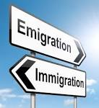

Facts and Opinions on Migration.
Here are some statements based on migration. Some are facts and some are opinions. State whether these statements are facts or opinions.
- Allowing for those who leave, foreign migration reached 333,000 in 2007, three times the level of 1997. ___________________
- Migration is a bad thing. _______________________
- Immigrants are all lazy. _____________________
- The total of migrants who have arrived since 1997 is about 3 million. ________________________
- In 2007 one in three London residents were born outside the UK. ______________________
- Immigrants take all the British peoples’ jobs. _____________________________
- Immigrants are more skilled than the British people. ____________________________
- There are many reasons why people migrate. _________________________________
- Migration is the movement of people from one place to another. _____________________________
- All immigrants choose to migrate. _________________
- Migration needs to be reduced. ____________________
- Migration is a new issue within the UK. ______________
(LO 1)

SOCIAL ISSUES AND MIGRATION.

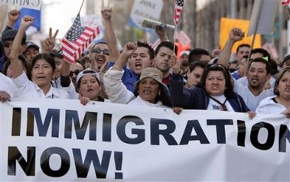Policy debates about immigration generally focus on the impact of immigration upon the economy, and its social and cultural impact. The social impact of immigration, on the other hand, has usually been seen as negative. Immigrants are seen as taking up valuable resources, making it more difficult to cohere communities and undermining a sense of national identity.
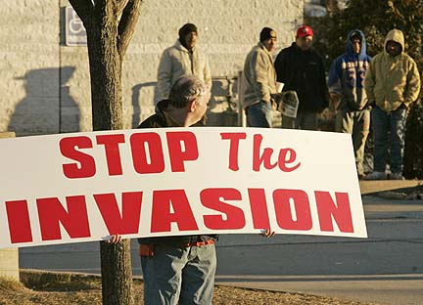
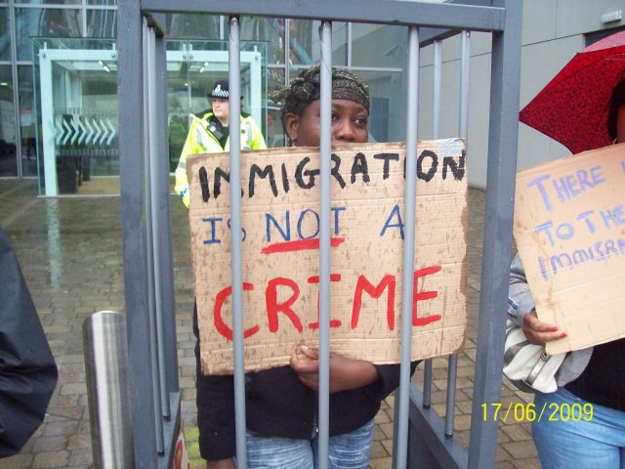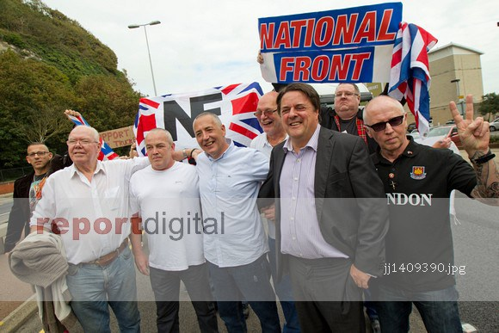

What do you think the social issues are of migration? ________________________________________________________________________________________________________________________________________________________________________________________________________________________________________________________________________________________________________________________________________________________________________________________________________________________
(LO 1, 2)

There are two articles on the next pages about the social issues of migration.
One from http://www.telegraph.co.uk and the other is from http://www.dailymail.co.uk
Are these reliable sources of information?

Multiculturalism has left Britain with a toxic legacy

Its principal effect has been to harden the lines between ethnic groups.
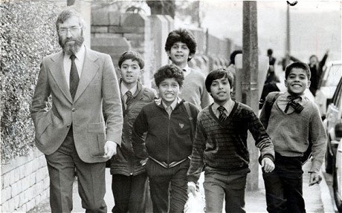

Ray Honeyford, headmaster at Drummond Middle School in Bradford, first raised the issue of how to integrate immigrants in 1984 Photo: Steve Bent. By Alasdair Palmer, 11 Feb 2012
How are we going to integrate immigrants into British society, so that they participate fully in it, sharing and respecting its values? That question is even more pertinent today than it was in 1984, when Ray Honeyford, who died last week, first raised it publicly.
Immigration from non-EU countries has increased enormously in the last 30 years. It has been running at more than 100,000 a year for a decade. But by no means all of the new arrivals, many of whom come from what are categorised as ethnic minorities, have found it easy to adopt British values.
Labour ministers, as they dismantled almost all immigration controls, imagined that there would be no problem about integration. They thought the only issue would be racism from the local population. That was a mistake. Some of the arriving groups have deep commitments to religious views that place women in a subordinate position, and which lead them to think that practices such as homosexuality are an abomination that should be severely punished.
Values that most of us would think of as essential elements of being British – tolerance, recognising the importance of equality before the law, or even the primacy of democratic elections as the way of deciding who should govern – have not been accepted by a significant minority of immigrants. Some even wish to cut themselves off from liberal and tolerant Britain completely. They hope to perpetuate their own religious values by having their own education system.
Does it matter? The doctrine of “multiculturalism” says it does not. In the 1980s, multiculturalism’s high noon, Bradford city council adopted a policy that declared that every section of the “multicultural, multiracial city” had “an equal right to maintain its own identity, culture, language, religion and customs”. That was precisely what alarmed Ray Honeyford. He saw it as creating a divided Britain, where different communities did not interact with each other and all sense of a common identity was lost, replaced by a Babel of languages and conflicting cultures.

Revealed: How racial prejudice has risen over the past decade as migration and fear of Islamist terrorism has shaken Britons
- 30% of Brits are 'very' or 'a little' prejudiced against people of other races
- Figure has been rising since the start of the 21st century when it was 25%
- 32% of men and 29% of women report being prejudiced based on race
- Racist attitudes highest in the West Midlands and lowest in London
- The over-55s, unqualified and manual workers most likely to be prejudiced
By Steve Doughty for the Daily Mail, 29 May 2014
Racism in Britain has risen over the past decade, according to research published yesterday.
It found that the number of Britons who admitted they were prejudiced on grounds of race began to go up in 2002.
However, the racism estimates prepared by the NatCen Social Research group showed that since 2011 levels of prejudice have fallen.
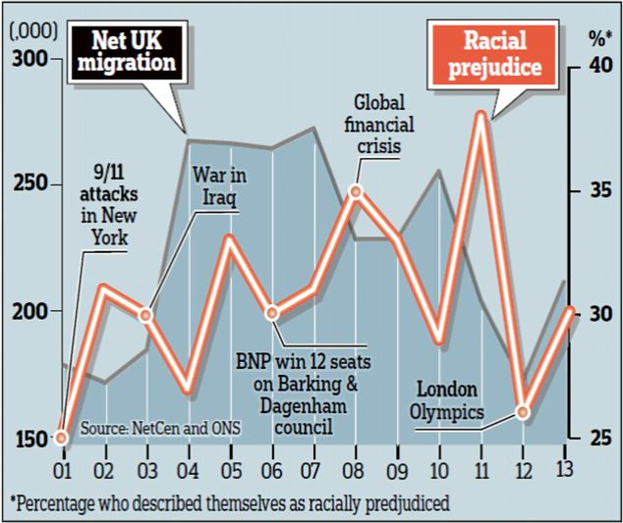

The research group has been asking a question about whether people think themselves racially prejudiced every year since 1983 as part of its British Social Attitudes survey.
The most recent findings, taken from replies by 2,149 people in the summer of 2013, found that 30 per cent did say they were prejudiced against people of another race.
Numbers of self-declared racists shot up in 2002, a year when 9/11 provoked concerns about militant Islamism and when numbers of asylum seekers topped 100,000 for the first time, to 31 per cent. This figure fell back to 27 per cent the following year.
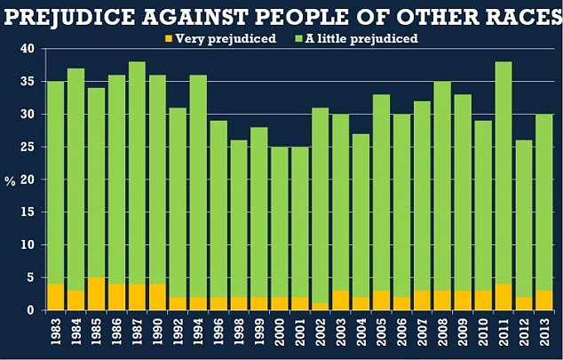

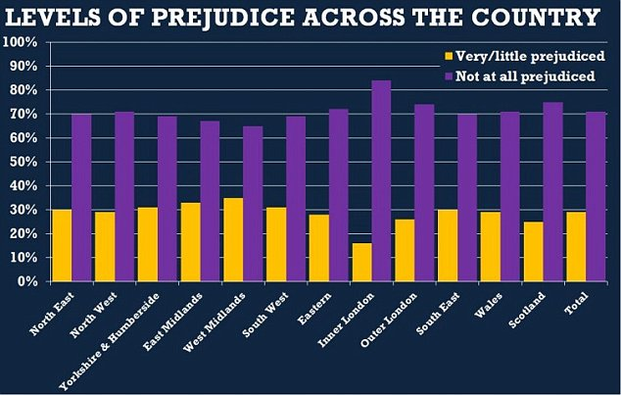
Although the report makes little mention of migration statistics, there appears to be a correlation between rising levels of racism and the open door immigration policy of Tony Blair’s government.
The figures for those admitting prejudice climbed through the decade as Labour admitted more than three million immigrants, including more than a million workers from Eastern European countries and high migration – lawful and unlawful – from outside Europe.
The self-declared racism level reached 35 per cent in 2008 and a peak of 38 per cent – which matched 1980s rates – in 2011.
The findings provoked complaints from Labour and race campaigners that prejudice is still rising and calls for new official efforts to stamp it out.

Prejudice appears to have risen sharply over the past 12 years among women and among the middle-aged generation who were born between 1960 and 1979.
Less skilled working men – the people whose jobs and earnings are most threatened by migrant workers – were among those who were most likely to say they were prejudiced.
More than four out of ten who said they were prejudiced gave their politics as ‘other’ than the main parties – possibly indicating Ukip sympathies.
The most prejudiced regions were the West and East Midlands. However, one in four Labour supporters, one in six Londoners, one in five of those with a university degree, one in four professionals, and one in four under-35s said they were racially prejudiced.
NatCen figures tend to shoot up and down each year, probably as a result of the small numbers of people consulted in the survey, but the results averaged out underline the trends. Research chief Penny Young said the ‘marked turning around’ in the figures after 2001 suggested the change could be linked to the impact of the terrorist attacks in September 2001 in the US.
This compared with 25 per cent who said the same in 2001, and well over 30 per cent in the 1980s and early 1990s.
Numbers of self-declared racists shot up in 2002, a year when 9/11 provoked concerns about militant Islamism and when numbers of asylum seekers topped 100,000 for the first time, to 31 per cent. This figure fell back to 27 per cent the following year.
But Tory critics pointed out that the levels of racial prejudice professed by people in the survey are much lower than they were 25 years ago and that there is a plain connection between the impact of migration and the number of people who call themselves racist.
More than four out of ten who said they were prejudiced gave their politics as ‘other’ than the main parties – possibly indicating Ukip sympathies.
The most prejudiced regions were the West and East Midlands. However, one in four Labour supporters, one in six Londoners, one in five of those with a university degree, one in four professionals, and one in four under-35s said they were racially prejudiced.
NatCen figures tend to shoot up and down each year, probably as a result of the small numbers of people consulted in the survey, but the results averaged out underline the trends. Research chief Penny Young said the ‘marked turning around’ in the figures after 2001 suggested the change could be linked to the impact of the terrorist attacks in September 2001 in the US.
She said that fears over immigration were another likely contributing factor. Up until 2001, she said, the decline in self-reported race prejudice had seemed ‘inexorable’. The figures, leaked to the Guardian newspaper, led to charges that racism is increasing.
Douglas Carswell, MP for Clacton, said: ‘What these figures show us is that racism is on the decline. The Muslim Council of Britain said it was ‘concerned’ over rising racism and Islamophobia. ‘These findings should act as a wake-up call for both the government and non-governmental organisations,’ a spokesman said.

ARE THE RESEARCHERS BIASED? NATCEN FAVOURS GUARDIAN WITH DATA
NatCen, the organisation which produced the survey showing rising levels of racial prejudice, prides itself on being ‘Britain’s leading centre for independent social research’.
It proclaims that its clients include ‘government, think tanks, charities, businesses, universities and other research organisations’ and its website displays the logos of influential charities such as Age UK, Shelter, Mind, RNIB and Comic Relief.
However, a glance at the finance figures for NatCen Social Research betray that its very generous funding comes overwhelmingly from one source – the taxpayer.
In fact, according to the 2013 annual report, a total of around three quarters of its £41.5million income came directly from the state, and most of the rest was indirect public subsidy.
Despite its dependence on taxpayers, NatCen has not ensured that its report is freely available, even-handedly across all media. Instead it favours one limited-circulation Left-wing newspaper for publicising its work.
The racial prejudice material is expected to be part of its state-funded British Social Attitudes survey, usually published at the end of the summer.
The findings appeared yesterday, however, in the Guardian, accompanied by quotes from the NatCen chief executive Penny Young and a website commentary by NatCen director of society and social change Alison Park.
Does NatCen itself lean towards the Left? Some rival researchers think so. But its managers and trustees are impeccable representatives of the academic and statistical good and great. The link with the Guardian, however, means the question can be asked.

Here are also some comments made based on these two articles.

*Multiculturalism is exactly what it says on the packet, forcing people with nothing in common to live side by side, not that this country has any areas of this concept neither has any country in the world, and this country should accept it is not multicultural it is seperatism it has allowed it and it has thrived, based on the fact of nothing in common, bit like appartheid really, based on nothing in common, instead of colour.

*I believe that at the next general election we will see a great upsurge in support for parties such as the BNP and UKIP. When we start enacting sane policies over immigration - no illegals, kicking out foreigners (and their families) suspected of terrorist activities or convicted of any crimes, no government financial support until they are given citizenship with 5/10 years taxpaying behind them, no family perks, we will see the true side of our recent arrivals. Although there are many exceptions, far too many are take, take, take, not give and the British have had enough.

*In over-crowded Britain, an ever -increasing population and an acceptable quality of life are incompatible. Topping up an ageing population with ‘young blood’ is not an option ,especially when the consequence is a hideous combination of third world birthrates and developed world consumption of resources ,most of which must be paid for by exports.
Moreover Britain has no shortage of labour but rather a lack of jobs, especially at the lower end of the skills range, where immigrants have usurped the indigenous workforce.

*Because I want my country as it was I AM A RACIST.

*This is ridiculous our country pioneers and literally forces multiculturalism and diversity. I would say we are probably the LEAST racist country/people on the planet. From personal experience I see much more racism and less integration in other groups
*I remember back in 2005, when I first came to England and went to the job centre to look for work, I was using the phone there to enquire about a job and I was struggling a bit with understanding the man on the phone, as you would, being a first-timer. The man on the other side was exceptionally understanding and helpful to me, and at the end of our conversation he said "welcome to England". That was one of my first experiences of England, I don't know whether this is relevant to the article.
*Fearful of change to your community is not racist. Fearful of your way of life being irrevocably changed is not racist. Fearful of being swamped by an ethnic majority is not racist. It is just that in this country we are not allowed to express our genuine fears. So, it’s not racist. Just human behaviour.

You are to write a letter to David Cameron. Your letter should be based on the social impact of migration. You should include some statistics and write about the different types of social issues that migration can affect. (LO 1, 2, 3, 4)

You should now reflect on the strengths and weaknesses of your
letter in raising awareness of the social impact of migration.

Strengths of letter | Weaknesses of letter
(LO 2)

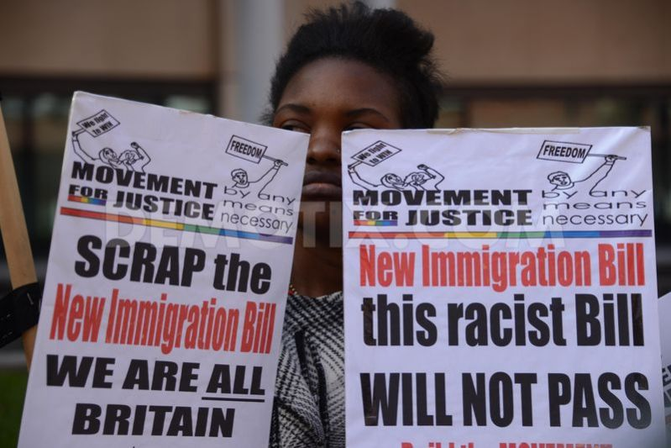

ENVIRONMENTAL AND TECHNOLOGICAL ISSUES AND MIGRATION.

Losses due to environmental hazards (e.g., earthquakes, hurricanes) and technological hazards (e.g., nuclear waste facilities, chemical spills) are both on the rise. One response to hazard-related losses is migration. The impacts of natural hazards on society are substantial and are on the rise (Abramovitz 2001). Indeed, estimates suggest that between 1/5 and 1/4 of the Earths’ human population was affected by natural hazards during the 1970s and 1980s (Abramovitz 2001). Even so, impacts are expected to increase. Predictions to 2030 suggest an increase in number of people migrating due to environmental and technical hazards.

Read the following research paper by By Anthony Oliver-Smith, (2006). Due to the length of this, some information has been edited out.

Disasters and Forced Migration in the 21st Century
Migration, whether permanent or temporary, has always been a traditional response or survival strategy of people confronting the prospect, impact or aftermath of disasters (Hugo 1996). However, today, more than ever, the complex nature of disasters such as Hurricane Katrina in the city of New Orleans, bring with them an enormous potential for the uprooting of large numbers of people. The increasing complexity of disasters is rooted in the interplay of social and economic factors in the environment, exacerbating the vulnerability of people and environments and intensifying their impacts when they occur. Hurricane Katrina’s impact on New Orleans was compounded by an excessive dependence on technology and half a century’s assault on the natural defenses of the environment of southern Louisiana, leaving the city tragically vulnerable. Virtually the entire population of the city has been displaced, a large proportion of it perhaps permanently, presenting a host of profound economic, social and psychological challenges to individuals, communities and all levels of government.
Despite technological and scientific advances, disasters are, increasing in impact and scope through the combined effects of economic, social, demographic, ideological and technological factors. Greater numbers of people are more vulnerable to natural and other hazards than ever before, due in part to increases in population, but more so to their location in dangerous areas. However, regardless of region, some form of displacement of individuals and communities frequently results from the threat or impact of a disaster.
Both disaster and forced migration are terms that are used to describe a wide variety of environmental and social processes. Perhaps because the term is so widely and loosely used, disasters are quite difficult to define. Although the term “disaster” actually refers to a process, essentially the disruption of social functions, it is generally employed to characterize an event or agent such as Hurricane Mitch or the Northridge Earthquake.
The complexity of disasters today is demonstrated by the processes in which they can combine with and compound each other. For example, in 1998 Hurricane Mitch (a natural agent) produced floods in Honduras (a socio-natural phenomenon) that inundated warehouses full of pesticides and fertilizers (a technological hazard), producing what might be called a compound or complex disaster (Jansen 2003). In 2004, Hurricane Ivan threatened New Orleans with just the same conflation of dangers. Hurricane Katrina has just fully realized the nightmare of Ivan. There is no question that environmental changes, particularly in the form of degradation, have increased the severity of socio-natural disasters. Moreover, disasters, singly or in combination, can further be compounded by the incidence of political upheaval, such as war, ethnic cleansing, or terrorism, or social factors such as racism, exclusion or religious persecution. And disasters can contribute to political instability that can lead to conflict with the potential to displace people and lead to migration.
To the degree that disasters force people to relocate either temporarily or permanently, disaster victims have been seen as a subset of the category of environmental refugees, a term that has generated a considerable amount of recent debate. As associated with disasters, the phenomenon of forced migration is also complex. Unless explicitly limited to referring to permanent, involuntary transfer to distant locations, the concept of forced migration refers to a variety of demographic movements, such as: flight, evacuation, displacement, resettlement, as well as forced migration.
- Flight – escape
- Evacuation – removal of people from harm’s way
- Displacement – the uprooting of people from a home ground
- Resettlement – relocation of people to new homes
- Forced migration – people must move to a new and usually distant place
If the threat of disaster is immediate, flight or escape to the closest safe location is a frequent response. An impending threat may result in an evacuation that resembles flight or may be more organized, administrated by internal or external agents. Displacement similarly can occur as the result of flight or be more planned in the sense that people are organized and obliged to move from one residence site to another either temporarily or permanently. If the movement is thought to be permanent, resettlement in the form of the creation of a new residence site may actually be the outcome. Finally, as mentioned earlier, forced migration involves permanent, longer distance moves generally into completely different environments. Some of the forms of demographic movement may lead to others—flight or evacuation, for example, may lead to displacement and resettlement or eventually to forced migration.
There is little question that some disasters, but not all, force people to migrate. The nuclear accident at Chernobyl forced many thousands of Ukrainians to migrate out of the contaminated zone. Had the disaster not occurred, there probably would not have been any significant out-migration. Such cases as Chernobyl, with widespread and long-lasting physical and economic danger, seem to be occurring more frequently. The South Asian tsunami clearly displaced millions and now Hurricane Katrina has uprooted more than a hundred thousand people, the majority perhaps permanently. Many disasters actually also trigger a wide variety of factors both prior to and after onset that displace people.
Since the 1980s researchers have linked the issue of environmental change with human migration. Environmental studies have traditionally focused on the natural world, the impacts of pollution, deforestation, soil erosion, degradation, desertification and other environmental processes on human beings have also been a source of both interest and concern to ecological and social scientists. Indeed, the impacts of many of these processes have often been framed as “disastrous” because they create stress, disrupt normal social processes, and force people to adapt by making temporary adjustments or permanent changes in how, where and when they do things in life. There are also human-induced environmental change, such as desertification, deforestation, or soil erosion, compounded by natural and man-made disasters, which could and have could force as many as 50 million people to migrate from their homes by 2010.
It is important to remember here that a disaster is also not defined in terms of the event itself, but in terms of both the processes that set it in motion and the post-event processes of adaptation and adjustment in recovery and reconstruction. Forced migration can be part of the process prior to the event or after, but it is not inevitable. Disasters can act as triggers or accelerators of imminent change or change already underway. For example, migration of elites from highland Peru to coastal cities had been going on for more than half a century in 1970. The Peruvian earthquake of 1970 unquestionably accelerated that process. By the same token, migration of rural peoples to highland towns and cities was also very intense during the same time period, but was made more so by the fact that disaster aid distribution in the form of housing was primarily located in urban areas (Oliver-Smith 1992).
The Great Flood of 1927 in the lower Mississippi Valley displaced nearly 700,000 people, approximately 330,000 of whom were African Americans who were subsequently interned in 154 relief “concentration camps” where they were forced to work. Although there were many reasons for African Americans to leave the South, the flood and its consequences were the final motivation for thousands to migrate. When Hurricane Andrew hit Miami-Dade County in 1992, it inflicted nearly 30 billion dollars worth of damage and displaced roughly 353,000 people temporarily. Forty thousand of the displaced (roughly 11%) permanently migrated. But, of the 40,000 that migrated about half (20,000) moved only about a half an hour’s drive north, sparking a population boom in Plantation and other Broward County communities.
Refugees, earthquake victims and displacees experience uprooting and relocation and must cope with the consequent stresses and the need to adapt to new or radically changed environments. All may experience privation, loss of homes, jobs, and the breakup of families and communities. All must mobilize social and cultural resources in their efforts to reestablish viable social groups and communities and to restore adequate levels of material life. These are important similarities that we must recognize and understand both to minimize displacement and to assist in the material reconstruction and the social reconstitution of communities. The catastrophic losses from Hurricane Katrina demonstrate in horrific fashion the urgent need to develop the conceptual, strategic and material tools to confront the increasing challenges of natural hazards made even more potent and complex by climate change, increasing population densities and environmental degradation in the 21st century.
(For the full paper please go to: http://understandingkatrina.ssrc.org/Oliver-Smith/)

Now that you have read the research paper on environmental and technological issues and migration, by Anthony Oliver-Smith, (2006) you are going to create a poster on how environmental and technological disasters can lead to migration. You are first to look at some more environmental and technological disasters that have resulted in the residents having to move, (migrate) and write down some statics in the following box. You are to include these statistics on your poster. (LO 1, 2, 3, 4)

You should now reflect on the Strengths and Weaknesses of your
poster in raising awareness of environmental and technological issues and Migration. (LO 2)

Strengths of poster | Weaknesses of poster

- Now that you have researched social, environmental and technological issues and migration – take part in a class debate to see how other people feel. Remember – Hands up to speak.
(LO 1, 2, 4)

- Has your opinion changed after listening to what others had to say? Write about whether your opinions have changed and write about the discussion, quoting what other individuals said, and whether or not you agree with their stand point. ______________________________________________________________________________________________________________________________________________________________________________________________________________________________________________________________________________________________________________________________________________________________________________________________________________________________________________________________________________________________________________________________________________________________________________________________________________________________________________________________________________________________________________________________________________________________________________________________________________________________________________________________________________

LEGISLATION (LAW) AND MIGRATION.

The number of migrants a country receives is influenced by the countries migration legislation (laws) and policy. Countries such as the UK operate a points based system depending on their skills, previous income and age. This system gives some people visas to allow them entry into the UK for work – especially where there is a shortage of labour in that sector.
Migration laws are complex, and change in different countries, even within the EU.

How can legislation have an impact on migration?
What do we mean by legislation? Listen to your teacher discussing this first and then make some notes here:-

(LO 1, 2)

There are two sources on the next pages about migration and legislation.
One is from http://www.theguardian.com/uk , the second is from https://www.gov.uk/government Are these reliable sources of information? (LO 1, 2, 4)

The Guardian.

The Uk Government.

Immigration Bill

Factsheet: Overview of the Bill
The Immigration Minister Mark Harper MP said:
“The United Kingdom has a long and proud history of immigration. Our immigrant communities are a fundamental part of who we are and we are a richer and stronger society because of them.
“But the public expects and deserves an immigration system that is fair to British citizens and legitimate immigrants and tough on those who abuse the system and flout the law.
“The Immigration Bill will stop migrants abusing public services to which they are not entitled, reduce the pull factors which draw illegal immigrants to the UK and make it easier to remove people who should not be here.
“We will continue to welcome the brightest and best migrants who want to contribute to our economy and society and play by the rules. But the law must be on the side of people who respect it, not those who break it.”

Background:
Immigration is down by almost a fifth since its peak in 2010 and net migration is down by a third. The Immigration Rules have been reformed to cut out abuse where it was rife while at the same time maintaining the UK’s position as an attractive place to live and work for the brightest and best from around the world. But there is still more to do.
As things stand, it is too easy for people to live and work in the UK illegally and take advantage of our public services. The appeals system is like a never-ending game of snakes and ladders, with almost 70,000 appeals heard every year. The winners are foreign criminals and immigration lawyers – while the losers are the victims of these crimes and the public. It is too difficult to get rid of people with no right to be here.
This is not fair to the British public and it is not fair to legitimate migrants who want to come and contribute to our society and economy.

What we are going to do:
• Reform the removals and appeals system, making it easier and quicker to remove those with no right to be here;
• End the abuse of Article 8 – the right to respect for private and family life;
• Prevent illegal immigrants accessing and abusing public services or the labour market.

How we are going to do it: The Bill will make it:
(i) easier to identify illegal immigrants by extending:
• powers to collect and check fingerprints;
• powers to search for passports;
• powers to implement embarkation controls;
• powers to examine the status and credibility of migrants seeking to marry or enter into civil partnership.
(ii) easier to remove and deport illegal immigrants by:
• cutting the number of decisions that can be appealed from 17 to 4 – preserving appeals for those asserting fundamental rights;
• extending the number of non-suspensive appeals. Where there is no risk of serious irreversible harm, we should deport foreign criminals first and hear their appeal later;
• ensuring the courts have regard to Parliament’s view of what the public interest requires when considering Article 8 of the European Court of Human Rights in immigration cases;
• restricting the ability of immigration detainees to apply repeatedly for bail if they have previously been refused it.
(iii) more difficult for illegal immigrants to live in the UK by:
• requiring private landlords to check the immigration status of their tenants, to prevent those with no right to live in the UK from accessing private rented housing;
• making it easier for the Home Office to recover unpaid civil penalties;
• prohibiting banks from opening current accounts for migrants identified as being in the UK unlawfully, by requiring banks to check against a database of known immigration offenders before opening accounts;
• introducing new powers to check driving licence applicants’ immigration status before issuing a licence and revoking licences where immigrants are found to have overstayed in the UK.

In addition the Bill also contains measures to:
• introduce a new requirement for temporary migrants who have only a time-limited immigration status to make a contribution to the National Health Service;
• give the Office of the Immigration Services Commissioner new powers to better regulate the immigration advice sector, to protect migrants from exploitation and prevent spurious and inappropriate applications which waste public funds and delay the handling of immigration cases;
• simplify the current fees legislation, which is spread across a number of different Acts, amending the criteria and process in regards to the Home Office’s ability to charge fees for immigration services. Taken together, these measures aim to make the UK the least attractive destination for illegal immigrants, reinforcing the message that we welcome legal migrants who contribute to our economy and society but we will take firm action against those who break the rules.
The Bill will benefit:
British citizens and legal migrants by:
• Deterring illegal migrants from coming to the UK in the first place;
• Allowing the Home Office more effectively to identify, and enforce the removal, of illegal migrants;
• Encouraging more of those people who are here unlawfully to leave;
• Reducing the cost to the taxpayer of the immigration system through fewer appeals and more cost recovery through fees;
• Reducing pressure on services therefore freeing up capacity for the lawfully resident population.

Next steps:
• We intend the Bill to complete its Parliamentary passage during the third session of this Parliament and once Royal Assent has been received, for the measures in the Bill to be implemented from summer 2014 onwards.

Q&A:
Why is there nothing in the Bill to stop migrants accessing benefits?
DWP have already taken powers in the Welfare Reform Act to prevent illegal migrants from receiving contributory benefits and statutory payments (such as Statutory Maternity Pay) if they have no right to work in the UK at the point of claim. The government are also taking steps to further tighten migrant access to benefits. New powers in primary legislation are not required for this:
• The Home Office is creating a new statutory presumption that the EU right to reside as a jobseeker, and consequently access to benefits, will stop after six months – unless the person can prove they are actively seeking work and have a real chance of getting a job. To introduce this measure we will amend the Immigration (European Economic Area) Regulations 2006 to come into effect in January 2014.
• DWP are also strengthening the Habitual Residence Test. All migrants, including British nationals returning from a period living or working abroad, have to satisfy the test to claim income related benefits. DWP have improved the question set and this will be supported by an intelligent by design IT system that will tailor the questions asked to individual circumstances. The strengthened test will be introduced by the end of 2013.

Tighter immigration laws catching out long-term legal migrants – report
Legal Action Group calls for creation of specialist unit to deal with applications by those whose passports lack required stamps

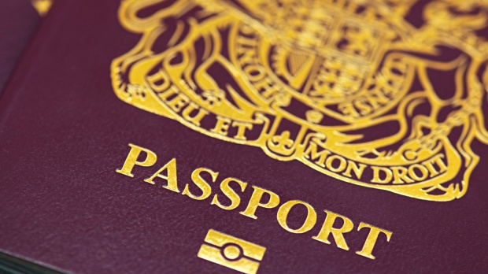
A British passport. Photograph: Alamy
Mark Tran, http://twitter.com/@marktran15 October 2014
Thousands of migrants who have lived and worked legally in Britain for decades, in many cases having arrived in the country as children, are falling victim of the government’s more restrictive immigration laws, according to a report by the charity Legal Action Group.
Thousands of long-term resident migrants – many of whom were educated, married and raised families in Britain – have been caught out by recent legislative changes that have left them in a legal limbo and often without a job, even though until recently they could work and claim benefits legally.
Several ran into difficulties after losing their original passports, which contained the crucial indefinite leave to remain (ILR) stamps. Others found it hard to achieve the necessary points to meet stricter requirements for ILR.
One case highlighted in Chasing Status (pdf), the report from Legal Action Group, is that of Aubrey (not his real name), 53, who came to England from Jamaica in 1973 at the age of 12.
His Jamaican passport was stamped with indefinite leave to remain. But when it was replaced after he lost it four years ago he did not apply to the Home Office for the ILR stamp. As a single father on a tight budget, he had not wanted to pay £600 for something he assumed was not that necessary.
That oversight came back to haunt him. Under the 2006 Immigration, Asylum and Nationality Act, which introduced civil penalties for employers hiring those without permission to work, Aubrey was asked by his employer of three years for his documents. What his employer wanted was not proof of his work record (P60s and P45s), but proof of his immigration status, which he lacked because he did not have the ILR stamp in his passport.
Aubrey was suspended without pay in February because he could not prove to official satisfaction his legal right to live and work in this country. He has been unemployed since then, having to borrow money from family and friends.
Roopa Tanna, a solicitor at the Islington Law Centre, took up his case. She issued judicial review proceedings against the Home Office, which filed a defence but then decided to concede before a judge considered the case.
The ordeal was harrowing for Aubrey despite the positive outcome. “I’ve lived here as a child, all of a sudden I felt like a criminal,” he said. “Now I know what an alien feels like.”
Fiona Bawdon, the author of Chasing Status, said it was hard to put a number on such cases but at a “guesstimate” it was in the low 10,000s.
Collecting evidence is not straightforward. Aubrey had to retrace his life and amass paperwork from his father, brother, sister and sick mother.
Others in the report spoke of their frustration at the rigidity and slowness of the much-criticised UK Border Agency, now replaced by UK Visas and Immigration.
The report suggests a number of changes to deal with the problem of “surprised Brits” – so-called because of their sudden bureaucratic rejection by the country they have lived in for decades – including the creation of a specialist Home Office unit to deal with such applications, and permission for applicants to continue working or to receive benefits while their applications are dealt with.
The 2014 Immigration Act, which restricts access to NHS services and required a status check by private landlords, represents a further effort to make Britain a “hostile environment” for illegal immigrants, the report says.
“Government policies designed to be tough on migrants via employer checks, landlord checks, Department for Work and Pensions checks are having disastrous consequences for migrants who have been in the UK for many years often having arrived here as children,” said Tanna.
“They are in reality British having contributed to British society by working, paying taxes and raising families. Suddenly, as a consequence of the ‘get tough’ policies, they find themselves sacked from their jobs, unable to support themselves and facing spiralling debt – in short, their lives falling apart because they are now expected to prove their status when they never were.”
The Home Office said it worked closely with local authorities and other groups to ensure that people with an “uncertain immigration status” received appropriate support in this “complex area of work”.
“When these people are brought to our attention we will consider their immigration status,” said a spokesman. “However, it is up to anyone who does not have an established immigration status to regularise their position, however long they have been here. All applications are considered in line with the immigration rules and nationality legislation, taking account of any compelling or compassionate circumstances.”

Reflect on the following statements. What is your opinion?
Migration/immigration laws are a waste of time.

Migration is not a major issue; media has made it a problem.

(LO 1, 2, 3, 4)

Read the following article on legislation and migration and how it has changed through the years.

UK immigration acts through the ages

The government has published its Immigration Bill, which will change the rules on access to the NHS and impose tougher penalties for illegal working. But what legislation has been passed over the last century or so?

Aliens Act 1905
This targeted "undesirable aliens" - such as paupers, lunatics, vagrants and prostitutes - who could be refused entry.

British Nationality and Status of Aliens Act 1914
This granted the common status of British subject upon those persons who had specified connections with the Crown's dominions.

British Nationality Act 1948
The Empire's dominions each adopted their separate citizenships, but retained the common status of British subject.

Commonwealth Immigrants Act 1968
This required certain potential migrants to supply proof that either they, their parents or grandparents had been born in Britain.

Immigration Act 1971
Commonwealth citizens lost their automatic right to remain in the UK, meaning they faced the same restrictions as those from elsewhere. They would in future only be allowed to remain in UK after they had lived and worked here for five years.
A partial "right of abode" was introduced, lifting all restrictions on immigrants with a direct personal or ancestral connection with Britain.

Immigration Act 1988
This act ensured that only one wife or widow of a polygamous marriage had a right to enter the country.
It also ensured people with freedom of movement in the European Community did not need leave to enter or remain in the UK.

Asylum and Immigration Act 1996
It became a criminal offence to employ anyone unless they had permission to live and work in the UK.

Immigration and Asylum Act 1999
The act removed benefits from asylum seekers and created the National Asylum Service to house them, taking pressure off local authorities.

Nationality, Immigration and Asylum Act 2002
This created the first English test and citizenship exam for immigrants and introduced measures against bogus marriages.

Asylum and Immigration Act 2004
This act introduced a single form of appeal that remains to this day and made it a criminal offence to destroy travel documents. It limited access to support for those told to leave the UK.

Immigration, Asylum and Nationality Act 2006
A five-tier points system for awarding entry visas was created.
Those refused work or study visas had their rights of appeal limited.
The act brought in on-the-spot fines of £2,000, payable by employers for each illegal employee, which could include parents taking on nannies without visas.

UK Borders Act 2007
This provided the UK Border Agency with powers to tackle illegal working and automatically deport some foreign nationals imprisoned for specific offences, or for more than one year.
It gave immigration officers police-like powers, such as increased detention and a search-and-entry roles.
The act brought in the power to create compulsory biometric cards for non-EU immigrants.

Borders, Citizenship and Immigration Act 2009
This act amended the rules so people from outside the European Economic Area had to have residential status for eight years before being eligible for naturalisation.
Those seeking naturalisation through wedlock had to be married for five years first.
The act also allowed immigration and customs officers to perform some of each other's roles and imposed a duty on home secretaries to safeguard children.
Now that you have stated your opinion and read some more information on migration legislation – take part in a class debate to see how other people feel. Remember – Hands up to speak.
Based on what you heard in the debate- has your opinion changed?
Record new information in the box below. (LO 1, 2, 3, 4)

You should now record your Personal Standpoint. What is your
Opinion on Migration Legislation? What is this based on?
Are your sources reliable? You can use the resources that you have been given and other sources of information. (LO 1, 2, 3, 4)

Create A questionnaire to find out what people understand, think and feel about migration. Do not ask people within your class, (for their knowledge and understanding will be good) but students and members of staff from other classes. Find out about:
- How many immigrants people think are living within Wrexham, (you will also have to find out the approximate number of immigrants that are living in Wrexham).
- What reason/s do people think is the most common reason why people migrate?
- What they think should happen in regards to migration.
- Possible laws that people think should be introduced in regards to migration.
- Anything else you think is work asking/finding out about in relation to migration.
(LO 1, 2, 3, 4)
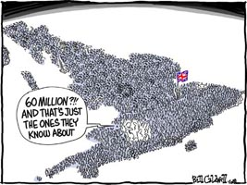

End of unit summary.

In the space below, identify 5 key words or phrases you would use when producing a piece of work on Migration in relation to the following areas:
- Politics and Migration.

- Economics and Migration.

- Social Issues and Migration.

- Technological issues and Migration.

- Legislation and Migration.

6. The Environment and Migration.

(LO 1, 2)

