**Hollbresennol**

**Barnwr**

[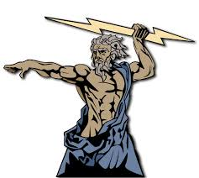](https://www.google.co.uk/imgres?imgurl=http://1.bp.blogspot.com/_Duir49nSjdc/S74R0q5yVwI/AAAAAAAAAC0/wsZKbba-UNc/s1600/All%2Bpowerful%2BGod.png&imgrefurl=http://skycometgoddess-atheistgoddess.blogspot.com/2010/04/stalin-mao-zedong-and-hitler-were.html&docid=RNSGrWVqMsmU2M&tbnid=KDrZ5UFXv8QOTM:&vet=10ahUKEwjkt5-dkcjTAhWCJ8AKHX0vDxAQMwhLKCEwIQ..i&w=750&h=672&safe=strict&bih=641&biw=1366&q=all%20powerful%20god&ved=0ahUKEwjkt5-dkcjTAhWCJ8AKHX0vDxAQMwhLKCEwIQ&iact=mrc&uact=8)



**Hollgariadus**



http://www.fotosearch.com/CSP684/k6840113/

**Tad**



**DUW**

**All loving**

**All loving**

**Hollalluog**

**All loving**

**Creawdwr/ Dylunydd**

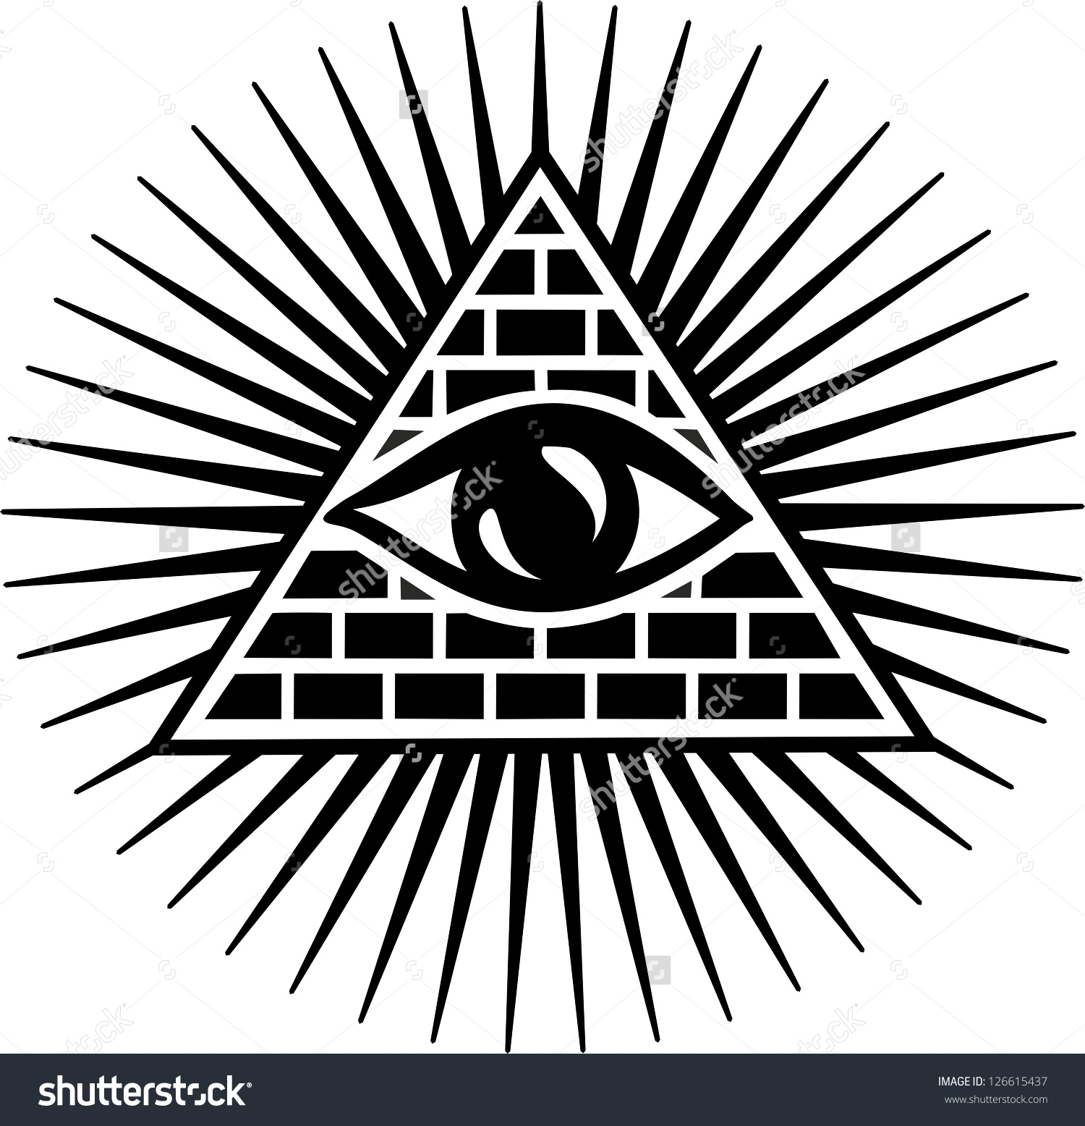

**Hollwybodus**