The origin and value of human life.

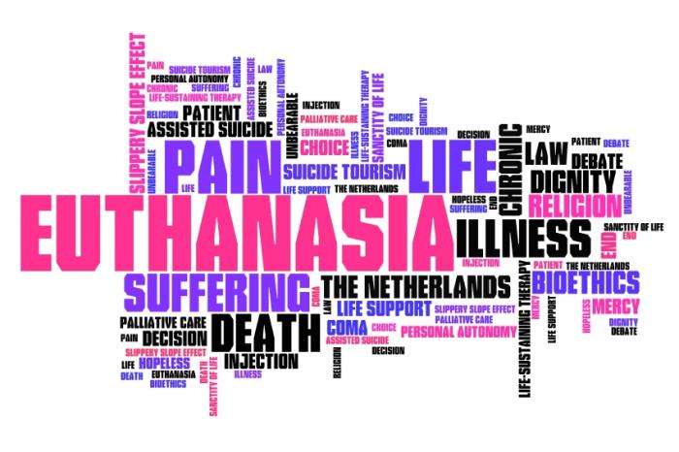
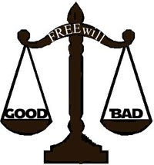

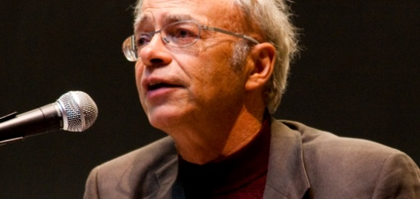

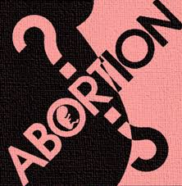

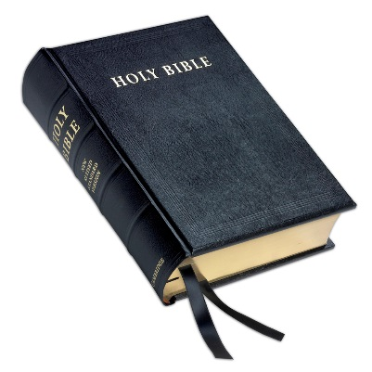

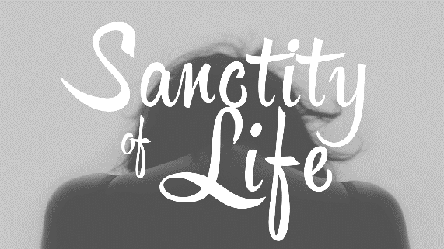
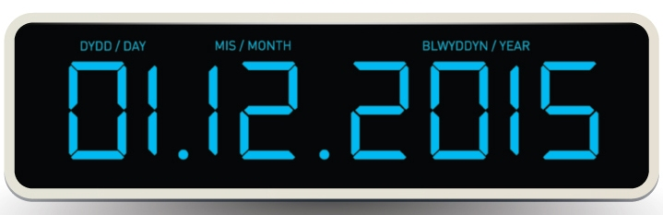

PART B
Theme 1: Issues of Life and Death
This theme requires all candidates to consider religious and non-religious beliefs about the
nature of life and death and the origins and value of the universe and human life.
Candidates are expected to make relevant references to scripture and other sources of authority as well as the beliefs of Humanists and Atheists.
Where appropriate, candidates must consider diverse viewpoints.
Christianity
The specification requirements…
Judaism

Key Concepts
afterlife
environmental responsibility
euthanasia
evolution
abortion
quality of life
sanctity of life
soul
Learners should be able to explain and apply these concepts in relation to the theme.

Christianity

SPEC - 1)Diverse Christian beliefs, teachings and attitudes toward the origin and sanctity of human life: Genesis 1:31, Jeremiah 1:5

Every Life Matters
Most people, whether or not they are religious, think that a human life is something special. We only have to see the efforts made by Doctors / Nurses / Fire Fighters etc to see that. For religious believers, the reason why human life is special is because it is a gift from God. They refer to the term SANCTITY OF LIFE to refer to their belief that human life is precious. Some believe a human life is of greater value than an animal’s because they think God give humans souls.

No one should take life or deny it e.g. Abortion / Euthanasia
SANCTITY OF LIFE
Life in all its forms is sacred
A humanist View - Most non-believers (atheists or agnostics) also think that human life is unique and special. They do not believe that God created us, and many do not believe that there is life after death. BUT, this does not lessen the importance of human life.
In fact, some say that human life is SO valuable because this is the only life we have, so ‘let’s make the most of it’. Great efforts therefore should be made to preserve human life and not destroy it.

The belief in the sanctity of life raises many moral issues:-
- How we treat human beings.
- Attitudes to death and the taking of life – Abortion / Euthanasia
- Attitudes to medical treatments – especially transplants, transfusions, life-support machines.

Christianity and the Sanctity of Life

Christianity believes that human life is God-given. There are many passages in the Bible that tell Christians this. St. Paul wrote:-
‘Don’t you know that your body is the temple of the Holy Spirit, who lives in you and who was given to you by God? You do not belong to yourself but to God’
(I Corinthians 6:19)

For thou didst form my inward parts,
Thou didst knit me together in my mother’s womb.
Thou knowest me right well;
My frame was not hidden from thee,
When I was being made in secret,
Intricately wrought in the depths of the earth;
Thy eyes beheld y unformed substance;
In thy book were written, every one of them,
The days that were formed for me,
When as yet there were none of them.
(Psalm 139:13, 1)

- God is interested and involved in each human’s life;
- Life is sacred and a gift from God;
- Only God should take life away;
- Jesus showed in his teaching that all life should be valued (e.g. Matthew the Tax Collector / Mary Magdalene / Lepers etc.)

The implications of the sanctity of life belief

If someone believes that human life is precious, it will affect how they treat their own body and how they treat other people’s bodies. This has huge implications for all stages of human life from conception, through life, to the moment of death and possibly care of that body after death.

Human life is sacred because God declared mankind to be very good.
“God saw all that he had made, and it was very good” (Genesis 1:31). This all-encompassing declaration of the goodness of God’s creation included the making of man.

Human life is sacred because God cherishes us and has a purpose for every moment of our lives.
“Before I formed you in the womb I knew you, before you were born I set you apart; I appointed you as a prophet to the nations” (Jeremiah 1:5).

SPEC - 2) Diverse Christian attitudes towards abortion and euthanasia, including Catholic and Church in Wales' views on beginning and end of life issues

(b) Describe religious teachings about the value of human life. [5]

…………………………………………………………………………………………………………...

……………………………………………………………………………………………………………

……………………………………………………………………………………………………………

……………………………………………………………………………………………………………

……………………………………………………………………………………………………………

……………………………………………………………………………………………………………

……………………………………………………………………………………………………………

……………………………………………………………………………………………………………

……………………………………………………………………………………………………………

……………………………………………………………………………………………………………

……………………………………………………………………………………………………………

……………………………………………………………………………………………………………

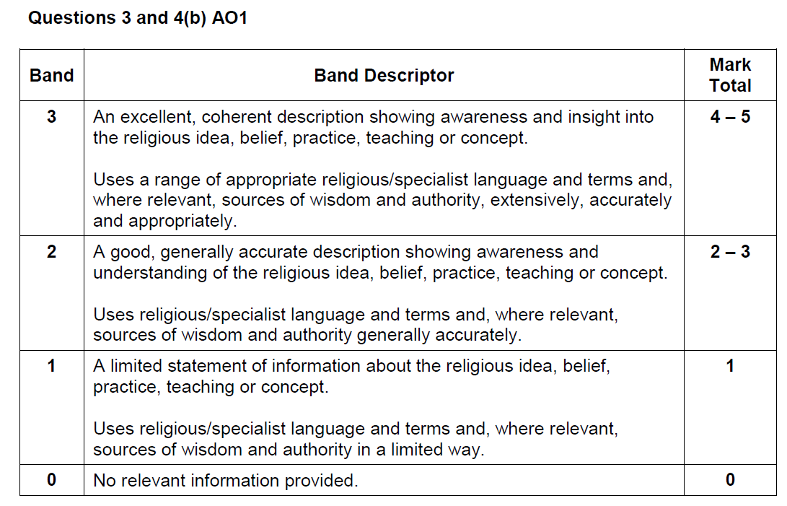
Sanctity of Life
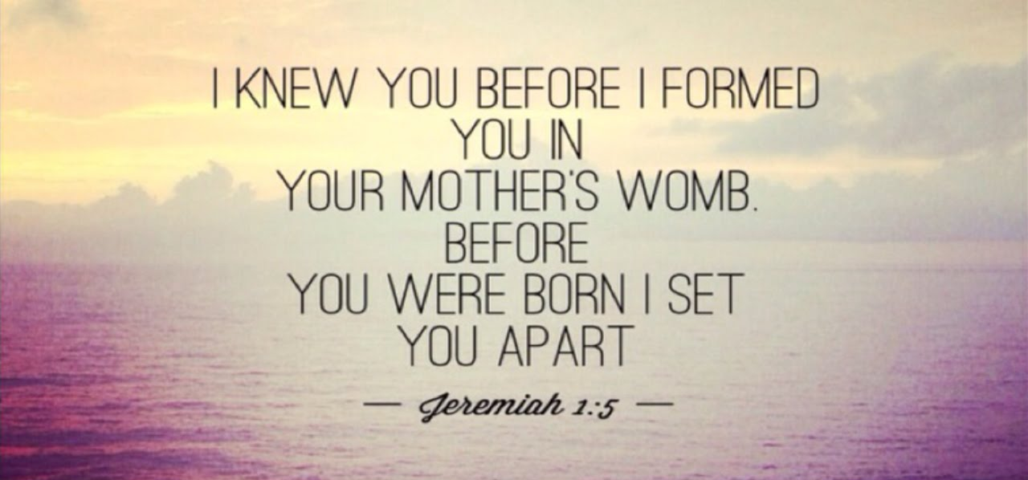

Exploring:

Sanctity of Life
Pikuach Nefesh

Pikuach Nefesh Today
“G-d created mankind in His own image, in the image of G-d He created them; male and female He created them”
(Genesis 1:27)

Judaism
Sanctity of Life
- Life was created by G-d and man was made in His own image
- Several of each species were created but man was created ‘alone’
- As life comes from G-d, it is a sacred/holy gift and should be preserved
- Each life has a purpose and is valuable
- G-d takes life, just as He created it
The sanctity of life is not an easy issue. The statements seem like common sense, but when you start to apply them to life issues today it may create some ‘grey areas’ and differences of opinion.

The Jewish attitude to the sanctity of life
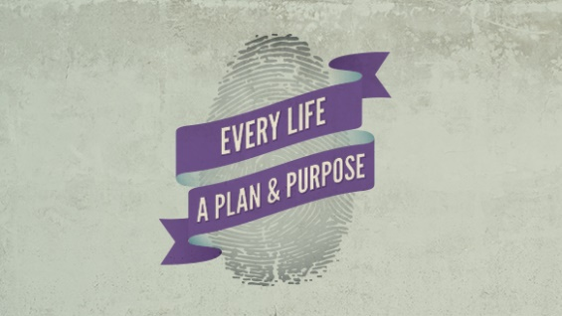
From as early as the creation story in Genesis, it is clear that every part of creation was special. However, the Talmud suggests that as a man was made ‘alone’ and in His image,
G-d ‘breathed’ life into humanity and gave him free will (unlike all other creations which are subject to nature, controlled by G-d and instinct). Humans do not own their bodies, they simply have them for use until G-d decides he wants to end that use. Humans are given a soul and were created to carry out tikkun olam (A Jewish concept defined by acts of kindness performed to perfect or repair the world) and to seek out of a close relationships with G-d. The former Chief Rabbi of Orthodox Jews in the UK, Rabbi Sacks, stated that ‘in whatever body or whatever disabled mind, there is a soul cast in the image of G-d.’

What so scriptures say?
“Keep my decrees and my laws, for the man who obeys them will live by them. I am the Lord.”
(Leviticus 18:5)

“You shall sanctify yourselves and be holy, for I am holy.” (Leviticus 11:44)

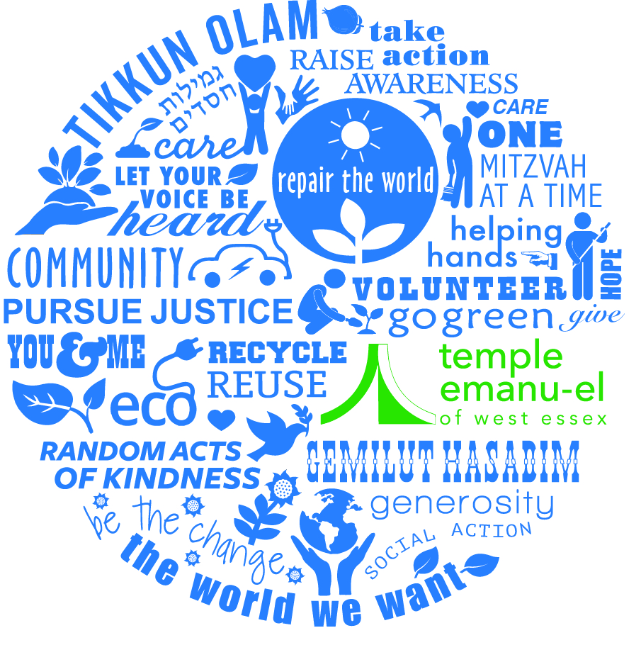
Life is sacred and must be preserved. Even Shabbat rules can be broken to save a life, for example, and ill person should be driven to hospital on Shabbat, even though driving is An activity not normally allowed on Shabbat.
Each Jewish person, it is believed, has a purpose. To live as
G-d wants though the Torah and mitzvot. They are aiming to repair the world by their actions, changing the evil of this world to create peace and harmony and worship of G-d. Humans have a duty to make sure their lives are purposeful and that they make the most of the gift of life.
No human has the right to take a life, unless in self-defence,
or as a punishment (capital punishment is still part of the law
in many countries), or in the case of war. The 6th
Commandment says, “Do not murder.” This seems very clear,
but when it comes to issues like abortion and euthanasia it
can become more complicated. In these situations, taking
a life might prevent suffering. When there are rules, they
might seem obvious, when they are thought about, they
become more complex and less clear.
Pikuach Nefesh – Saving a Life
Pikuach Nefesh is the principle that the preservation of human life takes precedence over all else, because life is sacred.
Leviticus 18:5 says, “Keep my decrees and laws, for the man who obeys them will live by them. I am the Lord.”
The Talmud (B.Yoma 84b) discusses a number of cases as examples in which Biblically mandated laws can be disregarded for the sake of saving a life.emphasises the word ‘live’ in this statement. The idea is that people will ‘live by’ the law – it will help them to survive and will protect their lives. The Talmud emphasises this and making the point that they will not ‘die’ by the law. Hence the idea of saving a life is seen as more important than keeping the law.
Shabbat gives us a really good way to understand the principle of Pikuach Nefesh, The laws about Shabbat state that no work may be done. However, if a person’s life is in danger, the laws of Shabbat should be broken in order to save that life. It actually becomes a requirement to break the law in cases where life is at risk. Life is the most important factor.
But what if it was not certain that life was at risk? The rabbis decided that in order to be safe, a person should act as if the life was indeed at risk. By acting this way, it saves the time which would be taken to think about the situation, and so makes the saving of life more likely, as well as reducing the chances of judging a situation wrongly, hence leading to someone’s death.
Pikuach Nefesh is also extended beyond saving life to preventing life-shortening issues, so for example, preventing the loss of a limb, or blindness. Pikuach Nefesh demands a person do everything in their power to save the life of another, so includes organ donation – as long as the donation does not put the giver at risk.
It has also been said that autopsy can be a form of pikuach nefesh, if what is learnt from this action later helps to save the lives of others, so for example reveals new medical knowledge on an illness/condition.

Pikuach Nefesh in Action Today
- On certain festivals like Yom Kippur, Jews must fast. However, a sick person is obliged to break the fast. It is the right thing to do to observe fasting, but when fasting puts a person’s life at risk then it is seen as sinful.
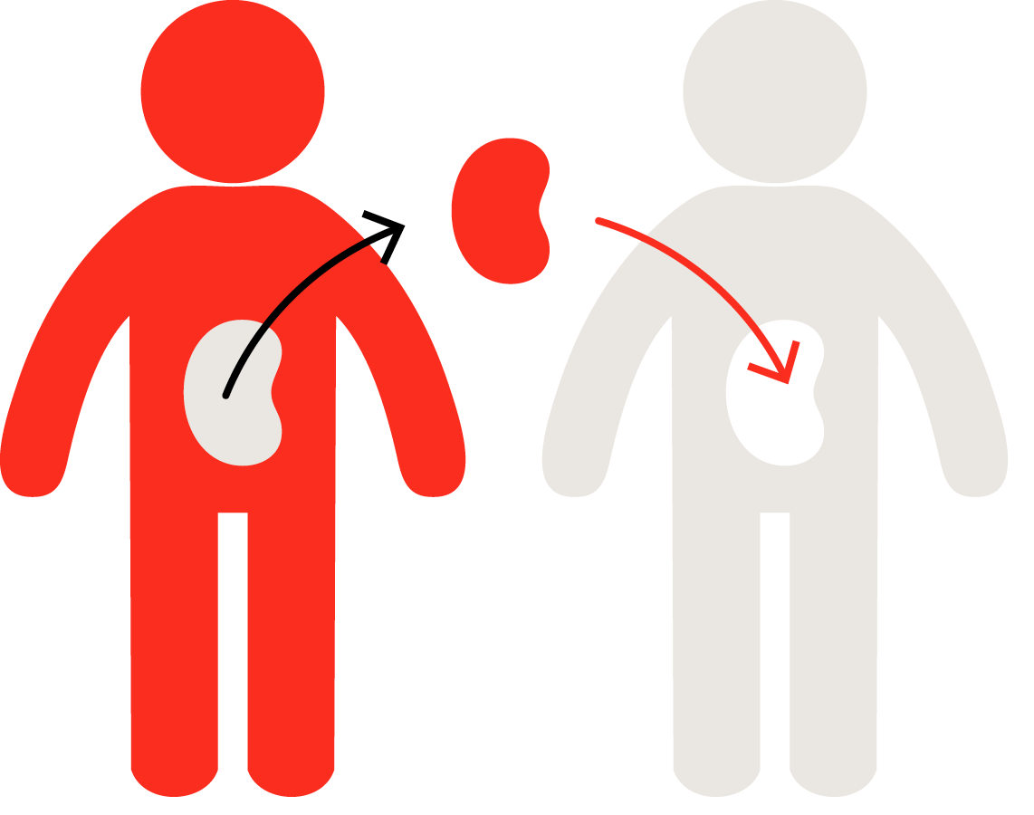
- Hatzola provides 24/7 emergency medical service, working closely with NHS services. Volunteers provide this service, which is based around being a first responder and ambulance provision. It also runs First Aid courses, gives first aid advice and gives patient support. All their work is totally funded through donations.
- In terms of health issues, for example, organ donation, pikuach nefesh can be seen in action. Jewish law states that a body should be buried whole. However, if, when the person is dead, their organs can be used for a specific named person (rather than organs being stored) to save their life then this should be done under the pikuach nefesh principle. Also, to give away a kidney for this use would also be acceptable from a living donor.
- Health workers can work on Shabbat and use pagers and telephones to save lives. Abortion is seen as acceptable is the life of the mother was in danger (even though to take a life is against the Commandments). The mother’s life is actual life and so is more important than that of the foetus, which is only the promise of or potential life. Pikuach nefesh again is the overriding idea here.
- In terms of the environment, (www.greenfaith.org), pikuach nefesh is the principle used to protect us. One of the projects they have been involved in has been an interfaith one to change chemical policy in the USA. It has been the case that too many chemicals are used on the land to fertilise crops which can get into and poison water supplies. Law change now means companies have to be more responsible, which helps to protect the lives of all.

Questions:
- Why is human life so special?
……………………………………………………………………………………………………………………………..
……………………………………………………………………………………………………………………………..
……………………………………………………………………………………………………………………………..
- What did G-d give to humanity that he did not give to other creatures?
……………………………………………………………………………………………………………………………..
- What does Genesis 1:27 say about humanity’s special status?
……………………………………………………………………………………………………………………………..
……………………………………………………………………………………………………………………………..
- Why don’t humans own their bodies?
……………………………………………………………………………………………………………………………..
- Which rules can be broken to save a life?
……………………………………………………………………………………………………………………………..
- What is the aim of life as a Jewish person?
……………………………………………………………………………………………………………………………..
- When might a human have the right to take a life?
……………………………………………………………………………………………………………………………..
- Which commandment seems clear but might be difficult to follow in some cases?
……………………………………………………………………………………………………………………………..
- What is Pikuach Nefesh?
……………………………………………………………………………………………………………………………..
- What does Leviticus 18:5 say?
……………………………………………………………………………………………………………………………..
……………………………………………………………………………………………………………………………..

What word does the Talmud emphasise?
……………………………………………………………………………………………………………………………..
- What is the idea of saving a life seen as?
……………………………………………………………………………………………………………………………..
……………………………………………………………………………………………………………………………..
- How did the rabbis say we should act?
……………………………………………………………………………………………………………………………..
……………………………………………………………………………………………………………………………..
- What does Pikuach Nefesh demand?
……………………………………………………………………………………………………………………………..
……………………………………………………………………………………………………………………………..
- Why might autopsy be acceptable in Judaism?
……………………………………………………………………………………………………………………………..
……………………………………………………………………………………………………………………………..
- What is expected of a sick person during a fast, such as Yom Kippur?
……………………………………………………………………………………………………………………………..
- Who can work on Shabbat and why?
……………………………………………………………………………………………………………………………..
……………………………………………………………………………………………………………………………..
- How is the principle of Pikuach Nefesh involved with the environment?
……………………………………………………………………………………………………………………………..
……………………………………………………………………………………………………………………………..
Challenge Box!
- How important is the belief in the sanctity of life? Explain your answer and give at least one other argument (from a different point of view)!
- If all laws can be broken in order to save a life, what does this say about the value of life? Why do you think that this does not extend to animal life? Explain your answer and give at least one other argument (from a different point of view)!

(from the spec…)
Judaism
- Life is the greatest blessing
- Life is a gift from God who decides when it should end
- The importance of pikuach nefesh – to preserve life
- There will be differences between believers in the same tradition
- Interpretation of scriptures and sacred texts causes considerable debate among many members of the faith; therefore it is a personal decision
- Diverse Jewish attitudes towards abortion and euthanasia
- Ethics of the Fathers 4:29, Mishnah Oholot 7.6
- Sanctity of Life is a precedence for all religions
- Reference to specific sources of authority
- Guidance may be sought by prayer
Abortion

QUALITY OF LIFE - When a person feels of value and capable of contributing to life
The extent to which life is meaningful and pleasurable e.g. free from undue pain and stress.

Abortion = The termination of a pregnancy before birth i.e. the foetus is taken out of the mother’s womb.

To many people, the issue of abortion, although it is often a matter of conscience, is to do with choice and rights:
- The choices and rights of the mother, and whether she wants and is able to have the baby;
- The rights of the child not yet born, to be alive and grow independently;
- The choice about making decisions in accordance with one’s own conscience;
- The right of religious believers to consider how their beliefs impact on such an issue.

As with many issues, it is not always simply a matter of making up your own mind – there are other people’s views to consider:

It’s my choice. I can’t Hang on a minute – it’s You need to think of the
have a baby now – it partly my child too. I’m long-term effects of an
will ruin my career. sure we can work something abortion, as well as what
out together. seems important now.

I want to stand by my But what about us grandparents? As your religious leader, I
sister; but I really hate We don’t believe it is right to urge you to consider the
the idea of her having take away a life! principles of the sanctity
an abortion. of life before reaching a
decision.

As a neighbour, I think she should just make up her own mind!
She’s the one who’ll have the baby anyway.
What is Legal in Britain?
A woman does not have an automatic right to an abortion in Britain. Two doctors must agree that:-
- The mother is less than 24 weeks pregnant;
- The mothers' physical or mental health is at risk;
- The baby is likely to be born severely physically or mentally handicapped;
- The birth would have a seriously bad effect on other children in the family.

Those against abortion say that it is wrong to kill unborn babies. They ask what right we have to dispose of a life because it’s inconvenient, or not up to the standard we expected. Human life is special and killing it is murder.

Those for abortion argue that it is the quality of life that matters. If either the mother or the baby is going to suffer a miserable or painful life if the pregnancy continues, then abortion should be allowed.

Abortion and Christianity

“Abortion should be avoided at all cost, if possible. However, in an imperfect world, in some situations ending a pregnancy might be the lesser of two evils.”
(Methodist Church)
- There is no single view on abortion, and individual Christians differ in their response. Some Christians even disagree with the particular view of their denomination;
- Roman Catholic Churches and Orthodox Churches generally forbid abortion because they believe that life is sacred and given by God;
- Some Christians are against abortion although they believe that there are some circumstances which may make it allowable e.g. if the mother’s life is in danger. They are called Pro-Life Christians;
- Many Christian denominations leave it open to individual Christians to decide for themselves whether or not abortion is right in their own particular circumstances.
- Generally, Christians do have concerns about abortion because of their belief in:
- The Sanctity of life;
- People being in the image of God;
- All life – whatever form – is precious.

‘Do not commit murder’ (Exodus 20)
‘Children are a gift from the Lord; they are a real blessing’ (Psalm 127)
‘The only one who has the right to take away a life is the One who created it.’
Mother Teresa

From the first moment of his existence, a human being must be recognized as having the rights of a person – among which is the inviolable right of every innocent being to life. (Catechism of the Catholic Church)

Bible makes no mention of abortion. Roman Catholic Church forbids abortion.
All life is created by God in his own image and is known to him because in the Bible it states “I knew you before I formed you in your mother’s womb”
Evangelicals are strongly opposed to abortion and fear a society which readily accepts the destruction of human life in abortion will soon extend that to the old and the handicapped.
The Church of England combines strong opposition to abortion with recognition that there are strictly limited circumstanced where it is the lesser of two evils.

Abortion - Judaism
Abortion is an issue which is usually analysed differently by different groups as it is not explicitly referred to in the Torah. However, Judaism generally regards abortion as an act which should not be practiced.
Within Orthodox Judaism abortion is seen as an act that is considered worse than contraception as it not only disobeys God’s will but also destroys potential life. However, every situation is dealt with separately and a Rabbi should be consulted to give advice on such matters.
Reform Jews accept that abortion isn’t accepted but in some circumstances allow it. In these circumstances they do not use it as a form of birth control and understand that it might have life changing reproductions.
Abortion can often be regarded as murder, therefore goes against the 8th of the 10 Commandments, ‘Thou shall not kill’. It is never acceptable to abort a foetus because of the inconvenience it causes with regards to future plans or a woman’s career for example.

According to the Mishnah:-
Whoever destroys one life is as if he destroys the whole world, and whoever preserves a life is as if he preserved the whole world’.
Judaism believes in the sanctity of life therefore life should be protected, especially as life is a gift from God. However, if the pregnancy in any way threatens the life of the other, all Jews regard abortion as acceptable as the mother’s life is more important.
The Mishnah Ohalot (7.6) states:-
If a woman has (life-threatening) difficulty in childbirth, one dismembers the embryo within her, limb by limb, because her life takes precedence over its life.
The Mishnah states clearly that the woman’s life takes priority over that of the embryo, and that the embryo can and should be terminated.
Some Jews also accept abortion where the child will be born with any deformities.
Rabbi Moshe Fernstein, states that screening of embryos is forbidden if the only purpose to do so is to check the baby for any defects which might lead to an abortion.
Rabbi Eliezar Waldenberg on the other hand, suggests that abortion for the sake of the baby is sometimes acceptable, only if the abortion takes place within the first trimester and that the deformity would cause suffering. This view would generally be accepted by Reform Jews as the embryo has relatively low value during this time. Reform Jews would also allow abortion in the circumstances of rape or incest.

Judaism - Abortion - Summary
Abortion is generally prohibited.
Rabbinic legislation stipulates if less that 41 days gestation an abortion may happen under certain circumstances .e.g. mothers’ life is in danger, mental health of mother or genetic disease.
The Mishnah states “If a woman is difficult labour her child must be cut up while it is still in her womb since the life of the mother is more important than the life of the foetus. But if the greater part of the child has emerged it may not be damaged, since one life cannot be more important than another” (Oholit 7:6)
Abortion is not viewed as an acceptable means of birth control; it is only legitimate in a narrow range of cases.
The fertilised egg is a potential life and must not be destroyed without reason; it does not however have the same status as a person already born.
According to the Talmud the zygote is simply water until 40 days after conception.
This makes abortion in the early period more acceptable than during the rest of the pregnancy.
The Talmud states that a foetus does not achieve full rights until birth, specifically, when the forehead emerges.
Jewish law makes provisions for an unusually young or old mother, the victim of rape and the mother’s mental health.
Judaism expects every case to be considered on its own merits and the decision to be made after consultation with a Rabbi.
According to the Mishnah “whoever destroys one life is as if he destroyed a whole world, and whoever preserves a life is as if he preserved the whole world” (Sanhedrin 4:5).
Killing a foetus after 41 days breaks God’s command in Genesis 1:28 to go forth and multiply.
A foetus is made in God’s image and likeness.
The foetus has a high status in Jewish law this is demonstrated by the fact that desecration of the Sabbath is permitted to save the life of the foetus.
There is no consistent view on what level of threat to the mother is needed to justify an abortion and the term is more a guideline than a strict principle and may be interpreted broadly even by Orthodox Rabbis.
Ethics of the Fathers 4:22
‘Those who are born will die, and the dead will live. The living will be judged, to learn, to teach and to comprehend that He is G-d, He is the former, He is the creator, He is the comprehender, He is the judge, He is the witness, He is the plaintiff, and He will judge. Blessed is He, for before Him there is no wrong, no forgetting, no favoritism, and no taking of bribes; know, that everything is according to the reckoning. Let not your heart convince you that the grave is your escape; for against your will you are formed, against your will you are born, against your will you live, against your will you die, and against your will you are destined to give a judgement and accounting before the king, king of all kings, the Holy One, blessed be He.’

Discuss Does abortion cause promiscuity?
Should abortion be allowed up to 24 weeks?
Do you think unborn foetuses have rights?
Should fathers get a say in an abortion?
Should full term abortions be allowed for any reason?
Is abortion the same as murder?
Should two doctors have to agree on an abortion?
Should religious countries have to legalise abortion?
Euthanasia

Whose life is it anyway?
Sometimes, after a terrible accident where people have become paralysed or seriously injured and are in long-term pain, they feel that they no longer want to carry on living. Or perhaps a person has a terminal illness, and is getting progressively worse, and they feel that there might be a time when they will not want to go on living. No quality of life.

Such people feel it is their life, and that they should have a choice whether or not to go on living. They feel that euthanasia should be allowed.

Euthanasia literally means ‘gentle death’, and is sometimes referred to as ‘mercy killing’.
It is:-
i) The speeding up of death, through the use of drugs or other medical ways,
ii) Helping a person to die.
Euthanasia is illegal in Britain, and anyone helping a person to die can be arrested.
There are situations other than the two above where some people think that euthanasia should be allowed:
a) When people are on life-support machines for a long time and there is no real hope of them recovering;
b) When a person is in a coma and is not likely to regain consciousness;
c) When a person is completely dependent on others for all basic needs.

There are 3 different kinds of euthanasia:
- Voluntary euthanasia - where a person has asked someone to help them die. This is not suicide, which is taking one’s own life; it is getting help from someone to speed up one’s death.
- Passive euthanasia - this is allowing someone to die and not taking any steps to prevent the death, or not resuscitating the person after a heart attack or other trauma. It also includes giving a person such high doses of painkillers that they die more quickly, often in less pain.
- Non-voluntary euthanasia - This is when the person who dies is not able to make a decision themselves, such as when a life-support machine is switched off.
Euthanasia is very controversial both for religious, agnostic and atheist people.
Arguments FOR Euthanasia
- People should have the right to do as they wish with their own lives, including choosing when and how they die;
- If the future is going to be full of pain and suffering + the patient will lose their dignity, death would be the best option for many people;
- Euthanasia prevents the patient becoming a burden on the family;
- If there is no getting better anyway then medical resources can be better spent elsewhere;
- More and more people are living longer, and it may be that in the future the state could not afford to support all those who need it;
- Animals that are terminally ill are ‘put to sleep’. The same should be offered to humans. People should be given the choice.

Arguments AGAINST Euthanasia
- Making euthanasia legal would make doctors go against the Hippocratic Oath that they have made at the beginning of their profession;
- Puts a lot of responsibility and pressure on the doctors;
- Patients would lose confidence and faith in their doctors;
- Human life is sacred and must not be played with;
- Hospices show that people can die in dignity and without too much pain;
- All human beings are precious. It is God who gives life and only God can take life away.

Euthanasia – The Christian View
Most Christians are against euthanasia. WHY?
- Life is sacred. God gives life and only God should take life.
‘In his hand is the life of every living thing and the breath of all mankind.’ (Job 12:10)
- ‘Thou shalt not kill’ (The 6th of the Ten Commandments);
- Christians believe that Hospices provide a secure and dignified ending to people who are terminally ill e.g. Ty Gobaith / Hope House);
- Old people and the terminally ill should not feel that they are a burden and that they should rush their death;
- ‘Where there’s life, there’s hope’. There have been cases where someone has woken up after being in a coma for 15 years. A miracle might happen;
- Doctors sign a Hippocratic Oath i.e. they promise that they will do everything in their power to extend life. Euthanasia forces doctors to go against their Hippocratic Oath. To assist in euthanasia is to become involved in murder.

However, some Christians believe that euthanasia is acceptable in some cases e.g.
- God has given people freewill so it is up to us to decide when we die;
- Love should be shown to people who are terminally ill and who are in great pain. Sometimes euthanasia would be a release from such pain.

Is it ever right to end someone’s life?

- EXIT, otherwise known as the Voluntary Euthanasia Society, is an organisation that has campaigned for the right for people to have the choice to decide about their own death, especially when facing extreme pain, disability or a progressive disease that takes away something of the quality of life.

- Part of what they do is provide people with a Medical Emergency Card, which tells doctors what the person’s wishes are about being resuscitated or having their life prolonged when there is no likelihood of real independent life.
- The organisation also recommends that people complete a Living Will while alive and well, so that should they ever be in a critical condition or supported mechanically to be alive, the doctors know their personal wishes.
- The Dignitas Clinic in Switzerland also offers the service for terminally ill patients to ‘Live with dignity, to Die with dignity’.
Summary…
All Christians believe that euthanasia breaks the commandment “thou shall not murder” (Exodus 20:13)
The Bible makes it clear that humans are not meant to choose when they die.
“For everything there is a season, and a time for every matter under heaven; a time to be born and a time to die, a time to plant and a time to pluck what is planted” (Ecclesiastes 3:1-4)
Most Christians argue that people do not own their lives.
Life is God’s gift and only he has the right to terminate it.
Christians use palliative care to support the dying and their families.
The process of dying is spiritually important and should not be interrupted.
Death is to be surrounded by God’s love and euthanasia rejects God’s love and presence. Many denominations believe that the period just before death is a profoundly spiritual time and it is wrong to interfere with this as it interrupts the spirit moving towards God.
Christians feel that even the smallest legalisation of euthanasia would lead to a slippery slope where the ill and elderly could feel obliged to commit euthanasia to avoid being a burden.
Birth and death are part of the life processes which God created and so we should respect them. No human being has the authority to take the life if any innocent person, even if that person wants to die. To propose euthanasia for an individual is to judge that the current life of that person is not worthwhile, this goes against the intrinsic worth and dignity each person has. Arguments based on the quality of life are irrelevant as all life is valuable as it is created in God’s image.
All Christians believe in the importance of palliative care to support the dying. They believe the use of painkillers to help suffering as they do not believe death should be prolonged.
Euthanasia has been condemned by the Catholic Church since 1943. The Catechism states “whatever its motives and means, direct euthanasia consists in putting an end to the lives of handicapped, sick or dying persons it is morally unacceptable.” (2277)
However the Catholic Church allows the turning off of life support machines because the Catechism also states “Discontinuing treatment that is burdensome, dangerous, extraordinary or disproportionate to the expected outcome can be legitimate, it is the refusal of overzealous treatment” (2278)
The Catholic Church also agree with the use of painkillers to alleviate suffering, even at the risk of hastening death as the Catechism states it “can be morally in conformity with human dignity if death is not willed as an end or a means” (2279)

Euthanasia - Judaism
Euthanasia is the term used for ending someone’s life before their natural time and is often regarded as ‘gentle death’. Judaism regards the ending of one’s life, to help ease one’s suffering or to put someone out of their misery as murder. As a result, it is forbidden even if a sick person requires the help to die.
Jews regard life as sacred and a gift from God. They also believe that life should be preserved at all costs. God is the only one who can decide on the time of death. However, Jews believe that praying to God and asking for death (either personally, or over a loved one) is allowed.
There are many different kinds of euthanasia. Active euthanasia is regarded as killing or assisting someone to die on purpose. This can be done by a friend or relative, or by a doctor and is deliberate. Judaism regards active euthanasia as forbidden and what the patient or individual wants does not matter. Active euthanasia is regarded as murder therefore goes against teachings of the Torah and of the 10 commandments, ‘thou shall not kill’.
However, some Reform Jews regard Passive euthanasia as acceptable. Passive euthanasia is to deliberately not help or give the patient/ individual the help or medication that they need in order to live. In other words, this means that if something is an impediment to the natural process of death and the patient only survives because of it, it is permitted under Jewish law to withdraw that thing. For example if a patient is certain to die, and is only being kept alive by a ventilator, it is sometimes permissible to switch off the ventilator since it is impeding the natural process of death. According to the BBC, Rabbi Moshe Feinstein and Rabbi Shlomo Zalman Auerbach believe that a dying patient should not be kept alive by artificial means. This means that the treatment the patient is receiving does not cure the illness but prolongs the patient's life temporarily and the patient is suffering great pain. However, Orthodox rabbi Eliezer Waldenberg, believs that the withholding or withdrawing of any sort of therapy is forbidden, but he does allow the administration of pain medication, even if that medication could potentially have adverse effects.
According to the Talmud, there once was a Rabbi who was being burned alive by flames by the Romans. He was urged by his pupils to open his mouth in order to inhale flames so that he could end his life sooner. The Rabbi felt that this would go against his beliefs and that the only person who could end his life was the one that created is, God. "It is better that He who gave [me my soul] should take it rather than I should cause injury to myself."
Even thought, euthanasia is generally not accepted within Judaism, the first example of euthanasia comes from the book of Judges in the Bible:-
‘And a certain woman threw an upper millstone upon Abim’elach’s head, and crushed his skull. The he called hastily to the young man his armor-bearer, and said to him, “Draw your sword and kill me, lest men say of me, ‘A woman killed him.” And his young man thrust him through, and he died”.
Another popular example from the Bible comes from the second book of Samuel (1:1-16) when an injured King Saul ordered a young soldier to kill him during battle. The young man returns to King David and explained what happened. Kind David ordered this young man to be murdered himself, to show that euthanasia was equivalent to murder and that no one should take another’s life.
“Then David called one of his men and said, “Go, strike him down!” So he struck him down, and he died. For David had said to him, “Your blood be on your own head. Your own mouth testified against you when you said, ‘I killed the Lord’s anointed.’” (2 Samuel 1:15)

http://www.patientsrightscouncil.org/site/belgium/
http://www.dailymail.co.uk/news/article-3491951/Belgianlawmakers-
vote-world-s-death-demand-law-mean-no-doctor-stoppatient-
wants-die.html
https://www.youtube.com/watch?v=eo8Hn0DEcpw
http://www.bbc.co.uk/news/world-europe-37335846
Summary…

Jewish faith teaches life is a blessing from God, hastening death is the same as murder. This applies to euthanasia and assisted suicide. Active euthanasia is always forbidden even if the person wants to die. Our lives are not ours to dispose of as we wish.
Dr Rachamin Melamed Cohen said “the message of Judaism is that one must struggle until the last breath of life. Until the last moment, one has to live and rejoice and give thanks to the creator”
Only God gives life so only God can take it away. Human bodies are his property and only he can decide their fate.
Fred Rosner states “to Jews life has infinite value … man was created in the image of God, humans beings are old and must be treated with dignity and respect, both during life and death”
Shulhan Arukh believes dying person has the same rights as the alive and “it is forbidden to cause him to die quickly”
The Talmud states that “he who shoots a man as he falls off a cliff to certain death is guilty of murder” even though he life was only shortened by a few minutes.
There is no reference in the Torah to euthanasia but Jews apply the commandment “thou shalt not murder” as well as other passages about death and suicide.

http://www.nhs.uk/conditions/Euthanasiaandassistedsuicide/Pages/
Introduction.aspx
http://www.telegraph.co.uk/news/uknews/law-andorder/
9480227/Tony-Nicklinson-breaks-down-as-High-Courtrejects-
his-right-to-die-plea.html
http://www.dignityindying.org.uk/

Donald Trump on abortion:
https://www.washingtonpost.com/news/wonk/wp/2016/11/15/whatabortion-
could-look-like-in-an-america-without-roe-v-wade/
A very touching and intriguing story:
http://www.bbc.co.uk/news/health-38012267

SPEC - 3) Welsh laws regarding: organ donation and Christian responses to it.
Organ Donating

On the 1st of December 2015, Wales became the first UK country to introduce a soft opt-out system for organ and tissue donation.
The new system will make it easier for people in Wales to become organ donors.
You must be 18+
If you haven’t registered a decision to opt-in or opt-out of organ donation, you will be treated as having no objection to being an organ donor. This is called deemed consent.
Deemed consent means that if you do not register a clear decision either to be an organ donor (opt in) or not to be a donor (opt out), you will be treated as having no objection to being a donor.
This is the main change introduced by the Human Transplantation (Wales) Act 2013. It came into effect on 1 December 2015.
Deemed consent applies to people over the age of 18 who live and die in Wales. Deemed consent does not apply to living donation.
Which organs can be transplanted?
Kidneys, heart, liver, lungs, pancreas and the small bowel can all be transplanted.
Techniques are improving all the time and we may soon be able to transplant other parts of the body to help even more people.

If you know you want to be a donor then you can:
- Register a decision to be a donor (opt-in) or
- Choose to do nothing and have your consent deemed. By doing nothing you will be treated as having no objection to organ donation.
If you know you don’t want to be a donor, then you can:
- Register a decision not to be a donor (opt-out).
See also…
http://www.telegraph.co.uk/news/nhs/12026298/Organ-donation-Groundbreaking-law-change-in-Wales-means-all-adults-become-donors.html

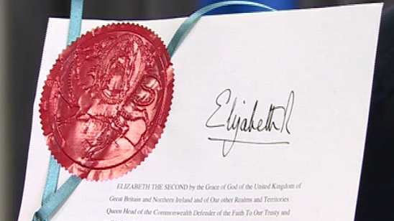
10 September 2013

Organ donation: Presumed consent to start in December 2015

Health Minister Mark Drakeford said the legislation would make a 'major difference' to people's lives

People in Wales will be presumed to have agreed for their organs to be donated after death from December 2015.
Wales will be the first UK nation to introduce a system where consent is assumed unless people have opted out.
The legislation, described by ministers as the "most significant" the Welsh assembly had passed.
Currently, people across the UK join a voluntary scheme and carry a card if they wish to donate organs.
A two-year information campaign is planned in Wales, to ensure everyone is aware of the changes.
“The shortage of human organs continues to cause otherwise preventable deaths and suffering” Carwyn Jones First Minister
First Minister Carwyn Jones said: "The Human Transplantation (Wales) Act 2013 is arguably the most significant piece of legislation passed by the National Assembly for Wales since it acquired full law making powers in 2011.
"Many people will wait years for a transplant but sadly, many die waiting on the list.
"The shortage of human organs continues to cause otherwise preventable deaths and suffering.
"This law will not only help reduce the waiting list, but will also help save lives by reducing the number of people who needlessly die waiting for an organ transplant."
The Welsh government hopes to raise transplant rates by 25%. As happens now, organs could go to recipients anywhere in the UK, not just in Wales.
Glossary
Consent – Giving permission for something to happen
Opt out – Choosing not to do something Legislation – Laws
Read the article
What ‘ethical issues’ arise from this article?
Do you agree with the system in Wales?

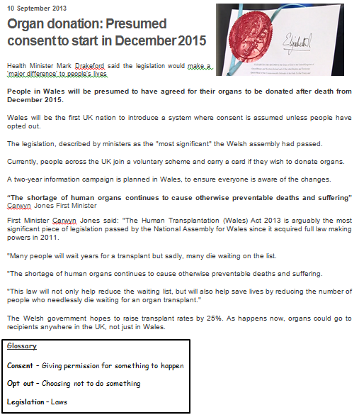
Read the article
What ‘ethical issues’ arise from this article?
Do you agree with the system in Wales?

STRETCH YOUR LEARNING…
Would you agree with an opt out approach?

“In eternity we will neither have nor need our earthly bodies: former things will pass away, all things will be made new.” Revelation
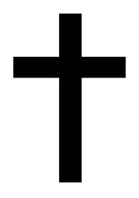

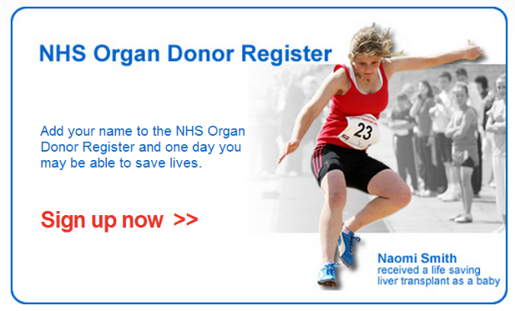

Name:
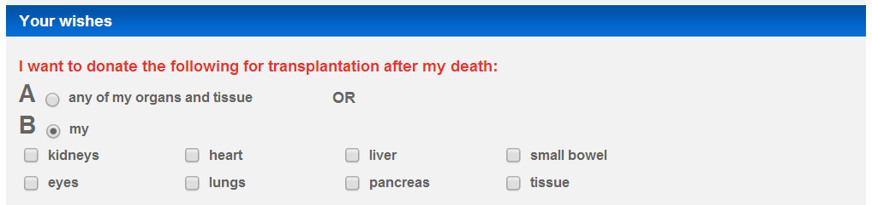

Explain your choice…

I agree/disagree… because…
It saves lives | You are dead, you do not need your organs anyway | It should be a personal choice
Death of a loved one is sad, agreeing to donate organs brings happiness out of that sadness | We do not know what happens after we die, we may need our body! | There is a shortage of organs, people are dying unnecessarily

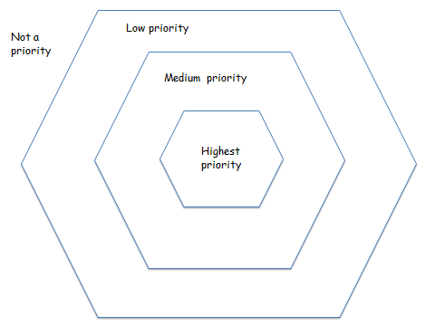
Decision Making… Who should get the transplant?
Children | Alcoholics/Drugs users
Educated people | People who have already had one transplant
Uneducated people | People who have been on the waiting list the longest
Pensioners | Convicted criminals
People who are willing to pay | British citizens
Immigrants | Tax payers
People under 30 | Parents
People on the organ donor register themselves | People not on the organ donor register themselves
People on benefits | People expected to die the soonest without a transplant

Christian & Jewish Views on Organ Donating

http://organdonationwales.org/FAQs/Religious-perspectives/?lang=en
Are there religious objections to organ and tissue donation?
No. All the major religions of the UK support the principles of organ donation and transplantation. However, within each religion there are different schools of thought, which mean that views may differ. All the major religions accept that organ donation is an individual choice.
Leaflets have been produced by NHS Blood and Transplant (NHSBT) which focus on each of the six major religions in the UK. :
  - Buddhism
  - Christianity
  - Hinduism
  - Islam
  - Judaism
  - Sikhism
What about the different religious views on the new soft-opt out system for organ donation in Wales?
We (nhs) have worked with religious leaders across Wales to discuss the new organ donation system and how this sits alongside beliefs towards organ donation in general. This work has also included engagement with different BAME and faith communities across Wales.
Religious leaders and faith groups play an important role in explaining the new system to their communities. So we have provided religious leaders and faith groups with information to help explain the new system to their communities, so that everyone can then make an informed decision about organ donation under the new system.

Christianity and organ donation
Sacrifice and helping others are key themes across all forms of Christianity, and therefore a decision to donate organs is seen as a positive thing.
Christians should be encouraged to help others in need. They look upon organ donation as an act of love, and a way of following Jesus' example.
All mainstream Protestant denominations support organ donation, whether they see it as an individual choice motivated by compassion, or encourage it as an act of charity.
The Vatican strongly supports organ donation. Pope John Paul II, in an address to the participants of the Society for Organ Sharing, said:
With the advent of organ transplantation, which began with blood transfusion, man has found a way to give of himself, of his blood and of his body, so that others may continue to live.
Pope John Paul II
Eastern Orthodox Christianity, most Pentecostal and evangelical churches also support organ donation, as do the Amish.

http://www.bbc.co.uk/religion/religions/christianity/christianethics/organs.shtml

Judaism and organ donation

In principle, Judaism supports and encourages organ donation in order to save lives (pikuach nefesh).
This principle can sometimes override the strong objections to any unnecessary interference with the body after death (nivul hamet), and the requirement for immediate burial of the complete body.
As all cases are different, Jewish law requires consultation with a competent Rabbinic authority before consent is granted.
If an organ is needed for a specific, immediate transplant then it could be considered a great honour for a Jew to donate organs to save another person's life.
But if the organs were being donated into an organ bank, or for medical research, then this may be looked on less favourably.
There is also the concern that during the transplant operation, the doctor may remove the organ that is being donated before the patient is actually dead according to Jewish law. This could be seen as effectively killing the patient, which is obviously forbidden.
One who saves a single life - it is as if he has saved an entire world
Pirke D'Rav Eliezer, Chapter 48

http://www.bbc.co.uk/religion/religions/judaism/jewishethics/organs.shtml

Non-religious views on:
1) Quality of life over sanctity of life in relation to abortion and euthanasia (the views of Peter Singer - 'speciesism')

A humanist discussion of… ABORTION

Humanists seek to live good lives without religious or superstitious beliefs. They use reason, experience and respect for others when thinking about moral issues, not obedience to dogmatic rules. So in thinking about abortion a humanist would consider the evidence, the probable consequences, and the rights and wishes of everyone involved, trying to find the kindest course of action or the one that would do he least harm.
Abortion is an issue that demonstrates the difficulties of rigid rules in moral decision making. Medical science has advanced to the point where we have options that were unthinkable even a few generations ago and where old rules cannot cope with new facts.

Some medical facts
- Some very premature babies can now be kept alive, which has altered ideas about when foetuses become human beings with human rights. The law in England and Wales is based on the fact that after 24 weeks the foetus is often viable, in that with medical assistance it can survive outside the womb.
- Many illnesses and disabilities can now be diagnosed long before birth.
- Some very ill or disabled babies who would probably once have died before or shortly after birth can now be kept alive.
- The sex of a foetus can be known well before birth (and some parents would like to be able to choose the sex of their child).
- Genetic research makes it increasingly likely that parents will be able to know, or even to choose, other characteristics for their unborn child. A few will want to reject some foetuses.
- Abortions can be performed safely, though they can occasionally cause medical or
- Psychological problems.

These are in themselves morally neutral medical facts, but they bring with them the necessity to make moral choices and to consider who should make those choices.
Doctors? Politicians? Religious leaders? Medical ethics committees? Individual women?
Their partners?

What does the law say?
- The law in England, Scotland and Wales permits abortion before the twenty-fourth week of pregnancy if two doctors agree that there is a risk to the life or the mental or physical health of the mother if the pregnancy continues, or there will be a risk to the mental or physical health of other children in the family.
- However, there is no time limit if there is a substantial risk that the baby will be born severely disabled, or there is a grave risk of death or permanent injury (mental or physical) to the mother.
- In effect this means that almost every woman who wants an abortion before the twenty-fourth week can obtain one. However, some women who do not realise that they are pregnant till too late (perhaps because they are very young or because they are menopausal) may not be able to have abortions though they would have qualified on other

Some views on abortion

Regardless of our advanced medical understanding of the procedure itself, abortion remains a complex moral issue; with contemporary views on the matter differing greatly. Here are some common starting points useful for thinking about the ethics of abortion –

The sanctity of life

Some religious people think that all human life is sacred, that life begins at conception, and so abortion is always wrong. The idea of life at conception often leads to the belief that contraception is also wrong.

"Playing God"

The rights of the woman and the foetus
But a humanist would argue that the idea of "sacredness" is unhelpful if one has to choose between risking the life of the mother or the life of the unborn foetus. This is very rare these days so the choice most often concerns the quality of life of either the mother or the foetus or both. The humanist would also oppose the related belief that contraception is wrong since this leads to even more unwanted pregnancies as well as heightened risk of sexually transmitted illnesses.
People often argue that it is not for the woman undergoing or the doctor carrying out the abortion "to play God" and that it is for God to decide matters of life and death. But it could be said accordingly that all medical interventions are "playing God" since any medication, vaccination or operation may have kept you alive longer than "God" planned. Thus a humanist says we have to decide for ourselves how we use medical powers. Arguments which invoke God are unconvincing to those who do not believe in gods, and laws should not be based on claims which rely on religious faith as this excludes people who hold other belief systems. Those who believe that life begins at conception argue that foetuses therefore have full human rights, including the right to life. This basic right, it is argued, overrides the right of the woman to choose if she wants to be pregnant or not. For humanists the issue of rights is more complex. Some (non-religious) moral philosophers have argued that full consciousness begins only after birth or even later, and so foetuses and infants are not full human beings with human rights. Other humanists may work on a kind of sliding scale, believing for example that the zygote one day after conception has no rights but the foetus one day before birth does have a right to be protected. Views of when abortion is morally permissible might be defined (as the law on abortion is) by the idea of viability (when the foetus can survive outside of the womb). Alternatively, evidence of when the foetus can feel pain may be considered by the humanist to be an important factor (a recent article in medical journal JAMA estimated that foetuses are not developed enough to feel any pain until after about 29 weeks. JAMA Vol 294, p 947) Even if certain rights are given to foetuses, humanists believe we must never forget the rights of the woman involved. Some people believe that a woman has absolute rights over her own body which override those of any unborn foetus. You might like to read Judith Jarvis Thomson's "A Defence of Abortion" (see bibliography below) which states a feminist case for abortion very clearly.

The Humanist View
Through reasoned consideration of the issues above, humanists conclude that abortion is often a morally acceptable choice to make. This choice is personal; the law does not impose abortion on anyone who does not want one or want to perform one. Humanists value life and value happiness and personal choice, and many actively campaigned for legalised abortion in the 1960s. Although humanists do not think all life is "sacred" they do respect life, and much in this debate hinges on when one thinks human life begins. We have seen that humanists tend to think that a foetus does not become a person, with its own feelings and rights, until well after conception. Because humanists take happiness and suffering into consideration, they are usually more concerned with the quality of life rather than the right to life, if the two come into conflict. The probable quality of life of the baby, the woman, rights and wishes of the father and the rest of the family, and the doctors and nurses involved, would all have to be given due weight. There is plenty of room for debate about how much weight each individual should have, but most humanists would probably put the interests of the woman first, since she would have to complete the pregnancy and likely care for the baby, whose happiness would largely depend on hers. She also exists already with other responsibilities and rights and feelings that can be taken into account - unlike those of the unborn foetus which cannot be so surely ascertained. Of course all possible options should be explored and decisions should be informed ones.
Adoption of the unwanted baby might be the best solution in some cases, or on reflection a woman might decide that she could look after a sick or disabled child. Or she might decide that she cannot offer this child a life worth living and abortion is the better choice. She will need to consider the long-term effects as well as the immediate ones. It is unlikely to be an easy decision, and requiring an abortion is a situation that most women would prefer to avoid.
For society as a whole, as well as for the children themselves, it is better if every child is a wanted child. However, abortion is not the best way of avoiding unwanted children, and improved sex education, easily available contraception, and better education and opportunities for young women, can all help to reduce the number of abortions. But as long as abortion is needed as a last resort, most humanists would agree that society should provide safe legal facilities. The alternatives, which would inevitably include illegal abortions, are far worse. Efficient sex education is crucial in reducing unwanted pregnancies

Questions to think about and discuss
- Is abortion in the case of pregnancy after rape more justified than other abortions?
- Would a humanist favour abortion if a woman wanted one because her pregnancy was interfering with her holiday plans? Why (not)?
- Why do humanists think contraception is better than abortion?
- Are there any good arguments against adoption of unwanted babies?
- Should doctors and nurses impose their moral views on patients? Yes? Sometimes? Never?
- Should religious people impose their views on abortion on non-religious people? Yes? Sometimes? Never?
- Should parents be able to choose the sex of their child? Should they be able to abort a foetus of the "wrong" sex?
- At what point does a foetus become a human being? Does this affect the humanist view of abortion? Does this affect your view of abortion?
- Can infanticide (the killing newborn infants) ever be right?
- Should abortion ever be carried out on a non-consenting woman, e.g. one too young to give legal consent or one in a coma?
- How are you deciding your answers to these questions? What principles and arguments influence your answers?
- How is the humanist view on this issue similar to that of other worldviews you have come across?

Peter Singer on Abortion
http://www.heraldsun.com.au/news/opinion/peter-singer-abortion-the-dividing-lines/news-story/89794a5a647787ed2298febc8895c642?sv=c8ca196a8cd3fb64b27ff7ddde8e0dbf
August 24, 2007 3:00pm

Should abortion be a crime? Peter Singer and others in the fields of psychology and faith pass their verdicts on whether the Government is on the right path with its plans to decriminalise the practice.
For a woman who does not want to have a child, pregnancy and birth is a severe hardship.
To force anyone to endure an avoidable hardship of that kind is contrary to our general belief in promoting individual freedom and choice. Such a denial of freedom could only be justified if there was a very compelling reason for it.
Opponents of abortion think there is a very compelling reason for denying freedom in these circumstances. They regard abortion as murder. Killing an embryo or foetus, they say, takes an innocent human life.
Susie Allanson's opinion Archbishop Denis Hart's opinion
Defenders of a woman's right to choose sometimes challenge this claim. They deny that the embryo or foetus is a human life. The abortion debate then focuses on the question, "When does a human life begin?"
I think this is the wrong question to ask. In a strictly biological sense, the opponents of abortion are right to say that abortion ends a human life.
When a woman has an abortion, the foetus is alive, and it is undoubtedly human – in the sense that it is a member of the species homo-sapiens. It isn't a dog or a chimpanzee.
But mere membership of our species doesn't settle the moral issue of whether it is wrong to end a life. As long as the abortion is carried out at less than 20 weeks of gestation – as almost all abortions are – the brain of the foetus has not developed to the point of making consciousness possible.
In that respect, the foetus is less developed, and less aware of its circumstances, than the animals that we routinely kill and eat for dinner.
That is why the foetus is "innocent". It doesn't have the capacity to do anything wrong – or anything right.
Even when the foetus does develop a capacity to feel pain – probably in the last third of the pregnancy – it still does not have the self-awareness of a chimpanzee, or even a dog.
When this is pointed out, some opponents of abortion respond that the foetus, unlike the dog or chimpanzee, is made in the image of God, or has an immortal soul. They thereby acknowledge religion is the driving force behind their opposition.
But there is no evidence for these religious claims, and in a society in which we keep the state and religion separate, we should not use them as a basis for the criminal law, which applies to people with different religious beliefs, or to those with none at all.
Other opponents say the foetus has the potential to become a person, that is, a thinking, rational being, like ourselves, and the dog or chimpanzee do not have that potential. But why should mere potential give a being a right to life?
The world already has more than six billion people. We are heading for more than nine billion by 2050. The more people there are, the greater the pressure on the Earth's environment and the greater the difficulty in giving them all even a minimally decent life. Do we really want every potential person to become an actual person?
In fact, with modern medical technology, the argument from potential rapidly leads to absurdity.
Arguably, the foetus first becomes a being of moral significance when it develops the capacity to feel pain, sometime after 20 weeks of gestation.
We should be concerned about the capacity of foetuses to suffer pain in late-term abortions. On the rare occasions when such abortions are necessary, they should be performed in a way that minimises the possibility of suffering.
PETER SINGER is Professor of Bioethics at Princeton University, Princeton, New Jersey, and Laureate Professor in the Centre for Applied Philosophy and Public Ethics at the University of Melbourne.

2) 'Right to Choose', 'Dignity in Dying' (euthanasia)
The Humanist View

What is euthanasia? - Some definitions
- Euthanasia originally meant "a gentle and easy death", and is now used to mean "the act of inducing an easy death", usually referring to acts which terminate or shorten life painlessly in order to end suffering where there is no prospect of recovery.
- Voluntary euthanasia, sometimes called "assisted suicide", is used in cases where the sufferer has made it clear that s/he wishes to die and has requested help to bring this about.

The problem
Arguments about euthanasia often hinge on the "right to life" and the "right to die". The first is a widely accepted basic human right and moral value, based on the fact that people generally want to live. But what should we do when seriously ill people no longer want to live? Do they have a right to die? Sufferers sometimes wish to commit suicide but do not have the physical strength or the means to do it painlessly.
Like many problems of medical ethics, this has become more pressing recently. A century ago most people died quite quickly (and probably painfully) if they had serious injuries or illnesses. Nowadays they can be treated, sometimes cured, and often kept alive almost indefinitely. Codes of conduct formulated centuries ago, for example those found in sacred texts, or the Hippocratic oath, cannot necessarily help us with twentieth century problems of medical ethics.

Some views on euthanasia
Humanists think that in a lot of circumstances voluntary euthanasia is the morally right course of action to take. Many religious people, however, think that euthanasia is always morally wrong, regardless of whether the suffering person really wants to die.
In order to decide which approach one takes to the issue, it is helpful to consider some of the common arguments made against voluntary euthanasia –
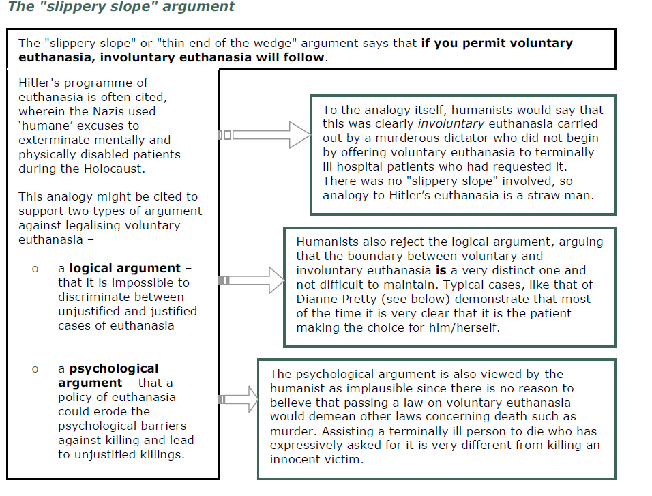

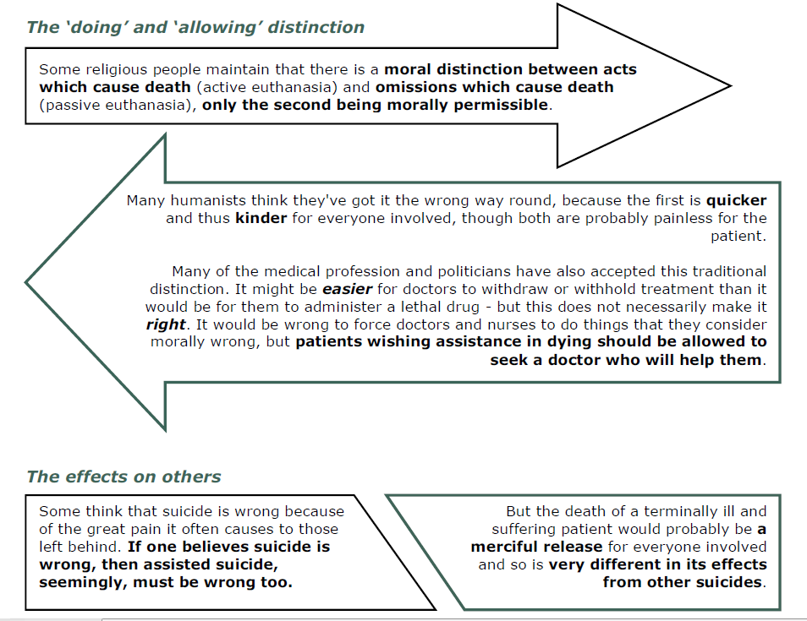
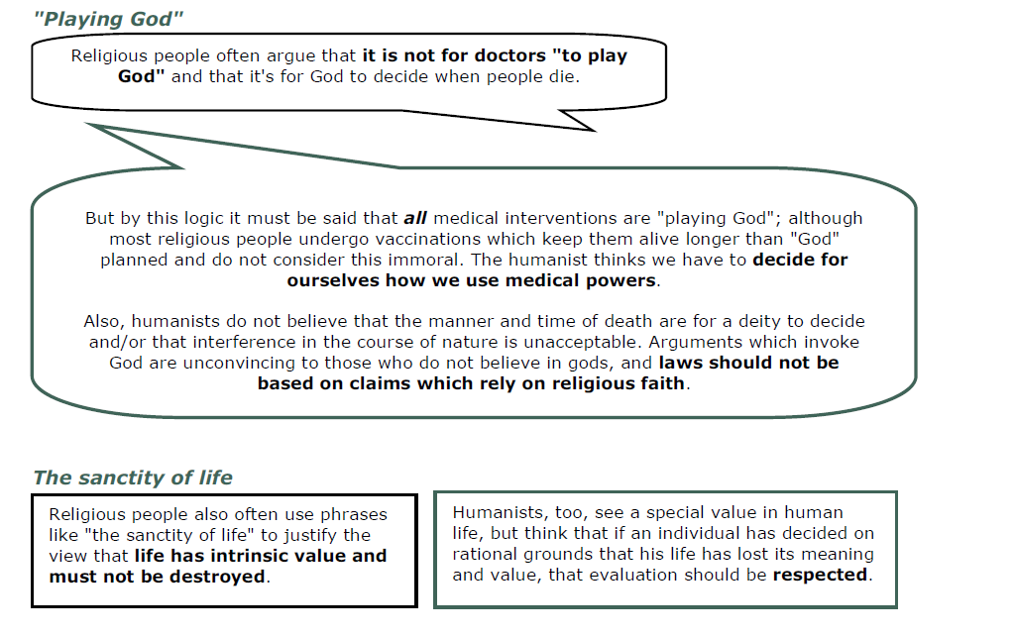

The humanist view
Humanists are non-religious people who live by moral principles based on reason and respect for others, not obedience to dogmatic rules. They promote happiness and fulfilment in this life because they believe it is the only one we have. Humanist concern for quality of life and respect for personal autonomy lead to the view that in many circumstances voluntary euthanasia is the morally right course.
People should have the right to choose a painless and dignified end, either at the time or beforehand, perhaps in a "living will". The right circumstances might include: extreme pain and suffering; helplessness and loss of personal dignity; permanent loss of those things which have made life worth living for this individual. To postpone the inevitable with no intervening benefit is not a moral act.
Individuals should be allowed to decide on such personal matters for themselves; if someone in possession of full information and sound judgement decides that her continued life has no value, her wishes should be respected.
While humanists generally support voluntary euthanasia, they also uphold the need for certain safeguards. These may include counselling, the prevention of pressure on patients, clear witnessed instructions from the patient, the involvement of several doctors, no reasonable hope of recovery– measures which would prevent involuntary euthanasia.

There is no rational moral distinction between allowing someone to die and actively assisting them to die in these circumstances: the intention and the outcome (the death of the patient) are the same in both cases, but the more active means is probably the more compassionate one. The BHA supports attempts to reform the current law on voluntary euthanasia.

In the news
There have been several high-profile legal battles over the right to die in the UK. Perhaps most famously is the case of Dianne Pretty, a woman in the terminal phase of motor neurone disease who wanted assurance that her husband would not be prosecuted if he helped her commit suicide. Although suicide has been legal since 1961, assisting a suicide remains a crime, punishable by up to fourteen years in prison.
Dianne and her husband fought an unsuccessful legal battle which ended on April 29th 2002 when the European Court of Human Rights dismissed her claim that the British courts were breaching her human rights by refusing to allow her husband to help her commit suicide. Dianne, who was paralysed from the neck down, had to be fed through a tube and used a computer attached to her wheelchair to communicate, died after suffering breathing difficulties three days after the ruling – the frightening death she wanted to avoid.

Questions to think about and discuss
- Could euthanasia ever be right in cases where the patient cannot give consent? Who should make the decision?
- What makes a life worth living?
- Should seriously depressed people be helped to die?
- Should doctors and nurses impose their moral views on patients? Yes? Sometimes? Never?
- Should religious people impose their moral views on non-religious people? Yes? Sometimes? Never?

Sanctity of Life vs. Quality of Life
Peter Singer (founder of preference utilitarianism) is an atheist, and so rejected the sanctity of life principle as he said humans are not made in the image of God, making the principle “out of date and irrelevant”. Instead he focussed on the quality of someone’s life, and said that if someone’s quality of life is poor they should have the right to decide that their life can end and put them out of their suffering. Someone’s life is respected because of its quality, not simply because they are alive, and Singer argues that it is better to let someone judge the quality of their own life (as they are the only one who can truly do so) and let them decide whether they want to carry on living, rather than intuitively saying that human life should be respected.
The debate, which is effectively solved by preference utilitarianism, is whether someone has to decide for themselves whether their life is worth living or if someone else has the right to decide for them. Two recent cases have been at the opposite end of the spectrum in this instance, one mother who killed her terminally ill daughter after she tried to kill herself but could not and asked her mother to help her, and one mother whose son was unable to communicate his decision to die so she took it upon herself to perform the task for him.
Kay Gilderdale is a mother whose terminally ill daughter Lynn tried to kill herself and, failing, asked her mother to help her. From a preference utilitarian perspective this would be perfectly acceptable – Lynn communicated her preference to die and so the shots of morphine her mother gave her were only carrying out Lynn’s own wishes. Frances Inglis, on the other hand, gave her brain damaged son a fatal injection of heroin after doctors told her he couldn’t feel any pain but she did not believe them. This would not be acceptable from a preference utilitarian perspective as Thomas could not communicate whether or not it was his preference to die, despite the fact that Frances claimed she did so out of compassion.

See also
www.humanism.org.uk
www.dignityindying.org.uk

SPEC 3) Emphasis on life before death rather than after-life - Situationist / relativist approach rather than doctrinal or absolutist

The Relativist
In some situations we make exceptions such as self-defence where lethal force may be necessary, or in the case of war.
Because this is the case we should be able to ask then whether abortion or euthanasia can be considered as one of these exceptions.
There are many examples where we it seems clear than both euthanasia and abortion should be considered right.
BUT
- Just because something is right, does that make it a good for human kind?
- Can death ever be good for a human?
- If we consider abortion the killing of an innocent being then even though it may be morally right to abort the foetus does that make it a good?
Something that is positive for a person?

Conclusion
- How we decide if abortion or euthanasia is right depends as we said on our ethical stance.
- Are we relativist or deontologists?
- If we give moral value to the situation and the consequences then we might take a different moral view from the absolutist deontological view that abortion is always evil.

Necessary evil
- Perhaps abortion and euthanasia can be considered a ‘necessary evil’
- One which is necessary in order to do good.
- Though for many religious perspectives, a necessary evil, is (or should be) an impossibility.
- If death can ever be a good is a difficult question.
- Surely, if you are saving life or upholding the quality of life then it is up the person involved and if they consider it ‘good for them’ then maybe it is a ‘good’.
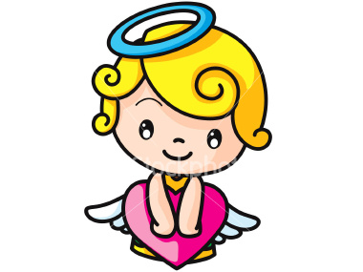

Review
- When we say something is good it means it has either intrinsic goodness or is positive for a person.
- Abortion and euthanasia cause death
- Death is not usually considered a good
- A deontologist would consider it evil especially the religious
- A relativist would be able to consider it right but does that make it good?
- Maybe it could be necessary evil?

