Workings and final answer.

What have we learned?

What other mathematical techniques do we need to apply?

What useful information do we know?

**REMEMBER**! Accuracy and spelling of key words * Appropriate paragraphing and sequencing of information presented * Correct phrasing – capitals, punctuation.

What do we want to find out?

Mathematics Unit 3: Apples

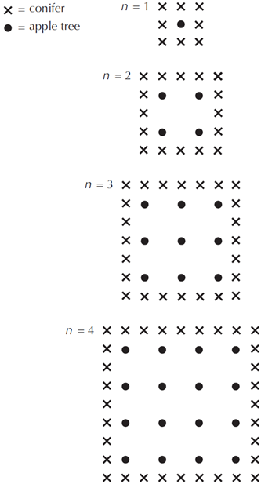

A farmer plants trees in a square  
pattern. In order to protect the  
apple trees against the wind he  
plants conifer trees all around the  
orchard.

Here you see a diagram of this  
situation where you can see the  
pattern of apple trees and conifer  
trees for any number (n) of rows  
of apple trees:

**QUESTION 3.1**  
Complete the table:

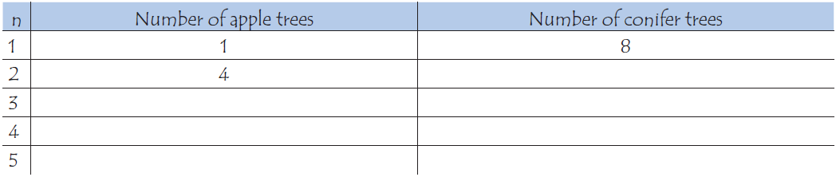

Workings and final answer.

What have we learned?

What other mathematical techniques do we need to apply?

What useful information do we know?

**REMEMBER**! Accuracy and spelling of key words * Appropriate paragraphing and sequencing of information presented * Correct phrasing – capitals, punctuation.

What do we want to find out?

Mathematics Unit 3: Apples



**QUESTION 3.2**  
There are two formulae you can  
use to calculate the number of  
apple trees and the number of  
conifer trees for the pattern  
described:

Number of apple trees = $n^{2}$

Number of conifer trees = $8n$

where $n$ is the number of rows of  
apple trees.

There is a value of $n$ for which the number of apple trees equals the number of conifer trees. Find the value of $n$ and show you method of calculating this.



There are two formulae you can  
use to calculate the number of  
apple trees and the number of  
conifer trees for the pattern  
described:

Number of apple trees = $n^{2}$

Number of conifer trees = $8n$

where $n$ is the number of rows of  
apple trees.

**QUESTION 3.3**  
Suppose the farmer wants to make a much larger orchard with many rows of trees. As the farmer makes the orchard bigger, which will increase more quickly: the number of apple trees or the number of conifer trees? Explain how you found your answer.

Workings and final answer.

What have we learned?

What other mathematical techniques do we need to apply?

What useful information do we know?

**REMEMBER**! Accuracy and spelling of key words * Appropriate paragraphing and sequencing of information presented * Correct phrasing – capitals, punctuation.

What do we want to find out?

Mathematics Unit 3: Apples