Workings and final answer.

What have we learned?

What other mathematical techniques do we need to apply?

What useful information do we know?

**REMEMBER**! Accuracy and spelling of key words * Appropriate paragraphing and sequencing of information presented * Correct phrasing – capitals, punctuation.

What do we want to find out?

Mathematics Unit 16: Bookshelves

**QUESTION 16.1**To complete one set of bookshelves a carpenter needs the following components:  
4 long wooden panels,  
6 short wooden panels,  
12 small clips,  
2 large clips and  
14 screws.  
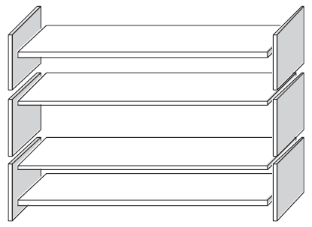

The carpenter has in stock 26 long wooden panels, 33 short wooden panels, 200 small clips, 20 large clips and 510 screws.

How many sets of bookshelves can the carpenter make?