Workings and final answer.

What have we learned?

What other mathematical techniques do we need to apply?

What useful information do we know?

**REMEMBER**! Accuracy and spelling of key words * Appropriate paragraphing and sequencing of information presented * Correct phrasing – capitals, punctuation.

What do we want to find out?

Mathematics Unit 21: Skateboard

Eric is a great skateboard fan. He visits a shop names SKATERS to check some prices.  
At this shop you can buy a complete board. Or you can buy a deck, a set of 4 wheels, a set of 2 trucks and a set of hardware, and assemble your own board.  
The prices for the shop’s products are: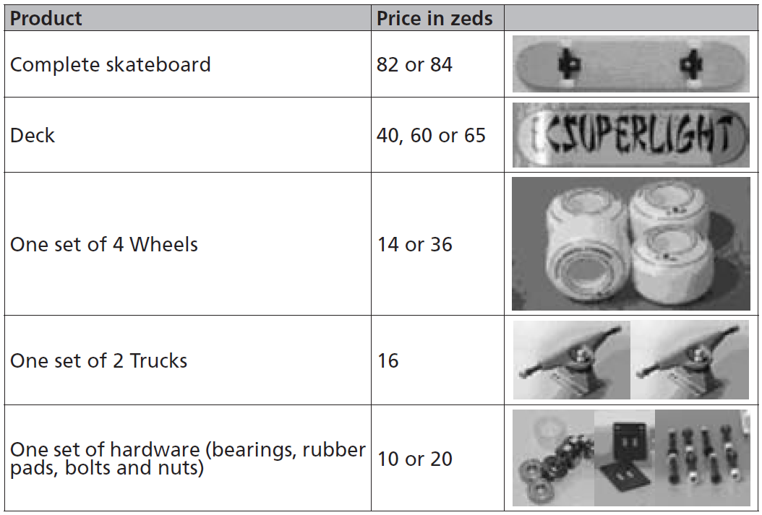  
**QUESTION 21.1**Eric wants to assemble his own skateboard.  
What is the minimum price and the maximum price in this shop for self-assembled skateboards?

Workings and final answer.

What have we learned?

What other mathematical techniques do we need to apply?

What useful information do we know?

**REMEMBER**! Accuracy and spelling of key words * Appropriate paragraphing and sequencing of information presented * Correct phrasing – capitals, punctuation.

What do we want to find out?

Mathematics Unit 21: Skateboard

 **QUESTION 21.2**The shop offers three different decks, two different sets of wheels and two different sets of hardware. There is only one choice for a set of trucks. How many different skateboards can Eric construct?

1. 6
2. 8
3. 10
4. 12

  
**QUESTION 21.3**Eric has 120 zeds to spend and wants to buy the most expensive skateboard he can afford.  
How much money can Eric afford to spend on each of the 4 parts? Put your answer in the table below.  
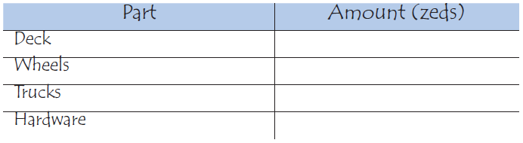

Workings and final answer.

What have we learned?

What other mathematical techniques do we need to apply?

What useful information do we know?

**REMEMBER**! Accuracy and spelling of key words * Appropriate paragraphing and sequencing of information presented * Correct phrasing – capitals, punctuation.

What do we want to find out?

Mathematics Unit 21: Skateboard