Workings and final answer.

What have we learned?

What other mathematical techniques do we need to apply?

What useful information do we know?

**REMEMBER**! Accuracy and spelling of key words * Appropriate paragraphing and sequencing of information presented * Correct phrasing – capitals, punctuation.

What do we want to find out?

Mathematics Unit 22: Staircase

**QUESTION 22.1**

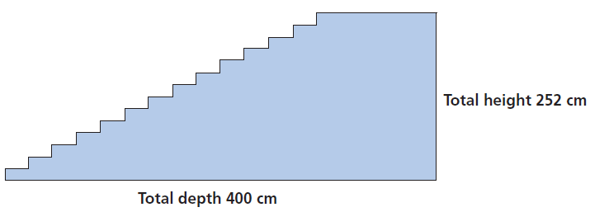

The diagram above illustrates a staircase with 14 steps and a total height of 252 cm:

What is the height of each of the 14 steps?