Workings and final answer.

What have we learned?

What other mathematical techniques do we need to apply?

What useful information do we know?

**REMEMBER**! Accuracy and spelling of key words * Appropriate paragraphing and sequencing of information presented * Correct phrasing – capitals, punctuation.

What do we want to find out?

Mathematics Unit 25: The Best Car

A car magazine uses a rating system to evaluate new cars, and gives the award of “The Car of the Year” to the car with the highest total score. Five new cars are being evaluated, and their ratings are shown in the table.

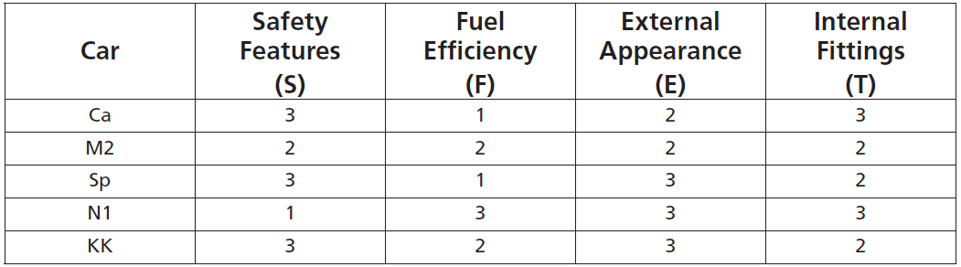

The ratings are interpreted as follows:  
3 points = Excellent; 2 points = Good; 1 point = Fair

**QUESTION 25.1**To calculate the total score for a car, the car magazine uses the following rule, which is a weighted sum of the individual score points: Total score = $\left(3×S\right)+F+E+T$  
Calculate the total score for car “Ca”.

Five new cars are being evaluated, and their ratings are shown in the table.



**QUESTION 25.2**

The manufacturer of car “Ca” thought the rule for the total score was unfair.

Write down a rule for calculating the total score so that car “Ca” will be the winner. Your rule should include all four of the variables, and you should write down your rule by filling in positive numbers in the four spaces in the equation below.

Total score = $…×S+…×F+…×E+…×T$.

Workings and final answer.

What have we learned?

What other mathematical techniques do we need to apply?

What useful information do we know?

**REMEMBER**! Accuracy and spelling of key words * Appropriate paragraphing and sequencing of information presented * Correct phrasing – capitals, punctuation.

What do we want to find out?

Mathematics Unit 25: The Best Car