Workings and final answer.

What have we learned?

What other mathematical techniques do we need to apply?

What useful information do we know?

**REMEMBER**! Accuracy and spelling of key words * Appropriate paragraphing and sequencing of information presented * Correct phrasing – capitals, punctuation.

What do we want to find out?

Mathematics Unit 26: Step Pattern

**QUESTION 26.1**

Robert builds a step pattern using squares.

Here are the stages he follows.

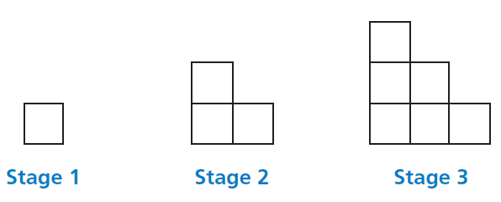

As you can see, he uses one square for Stage 1, three squares for Stage 2 and six for Stage 3.

How many squares should he use for the fourth stage?