Workings and final answer.

What have we learned?

What other mathematical techniques do we need to apply?

What useful information do we know?

**REMEMBER**! Accuracy and spelling of key words * Appropriate paragraphing and sequencing of information presented * Correct phrasing – capitals, punctuation.

What do we want to find out?

Mathematics Unit 35: Reaction Time

In a Sprinting event, the ‘reaction time’ is the time interval between the starter’s gun firing and the athlete leaving the starting block. The ‘final time’ includes both this reaction time, and the running time.  
The following table gives the reaction time and the final time of 8 runners in a 100 metre sprint race.  
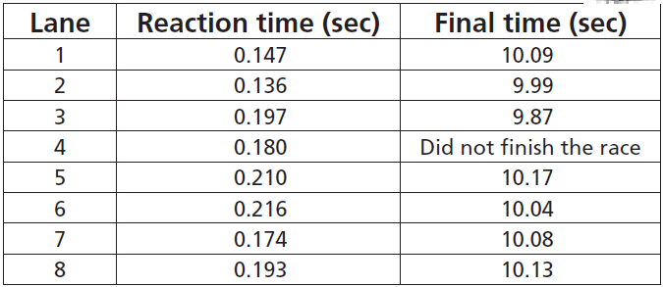 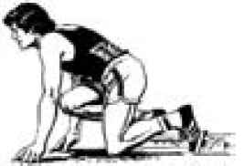**QUESTION 35.1**  
Identify the Gold, Silver and Bronze medallists from this race. Fill in the table below with the medallists’ lane number, reaction time and final time.  
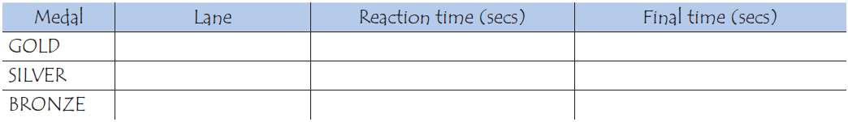

   
**QUESTION 35.2**  
To date, no humans have been able to react to a starter’s gun in less than 0.110 second. If the recorded reaction time for a runner is less then 0.110 second, then a false start is considered to have occurred because the runner must have left before hearing the gun.  
If the Bronze medallist had a faster reaction time, would he have had a chance to win the Silver medal?  
Give an explanation to support your answer.

Workings and final answer.

What have we learned?

What other mathematical techniques do we need to apply?

What useful information do we know?

**REMEMBER**! Accuracy and spelling of key words * Appropriate paragraphing and sequencing of information presented * Correct phrasing – capitals, punctuation.

What do we want to find out?

Mathematics Unit 35: Reaction Time