CWESTIWN 1
Arholwr yn unig
Mae’r cwestiwn hwn yn sôn am Effaith y Rhyfel Byd Cyntaf
Astudiwch y ffynhonnell isod ac yna atebwch y cwestiwn sy’n dilyn.
Ffynhonnell A
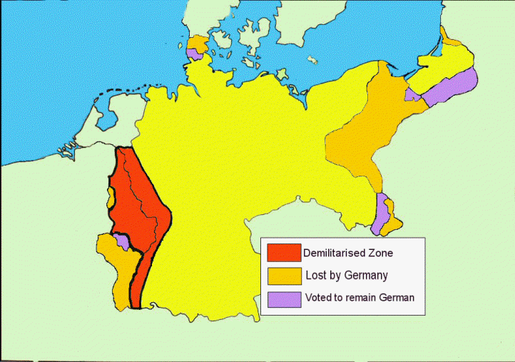

[Map yn dangos amodau tiriogaethol Cytundeb Versailles]
Defnyddiwch Ffynhonnell A a'r hyn rydych chi'n ei wybod i ddisgrifio cymalau tiriogaethol Cytundeb Versailles [6]
Arholwr yn unig

------------------------------------------------------------------------------------------------------------------------------------------------------------------------------------------------------------------------------------------------------------------------------------------------------------------------------------------------------------------------------------------------------------------------------------------------------------------------------------------------------------------------------------------------------------------------------------------------------------------------------------------------------------------------------------------------------------------------------------------------------------------------------------------------------------------------------------------------------------------------------------------------------------------------------------------------------------------------------------------------------------------------------------------------------------------------------------------------------------------------------------------------------------------------------------------------------------------------------------------------------------------------------------------------------------------------------------------------------------------------------------------------------------------------------------------------------------------------------------------------------------------------------------------------------------------------------------------------------------------------------------------------------------------------------------------------------------------------------------------------------------------------------------------------------------------------------------------------------------------------------------------------------------------------------------------------------------------------------------------------------------------------------------------------------------------------------------------------------------------------------------------------------------------------------------------------------------------------------------------------------------------------------------------------------------------------------------------------------------------------------------------------------------------------------------------------------------------------------------------------------------
Trowch drosodd.

CWESTIWN 2
Arholwr yn unig
Mae’r cwestiwn hwn yn ymwneud sôn am yr heriau yng Ngweriniaeth Weimar
Disgrifiwch yr hyn ddigwyddodd yn ystod gwrthryfel y Spartaciaid ym mis Ionawr 1919 [8]
--------------------------------------------------------------------------------------------------------------------------------------------------------------------------------------------------------------------------------------------------------------------------------------------------------------------------------------------------------------------------------------------------------------------------------------------------------------------------------------------------------------------------------------------------------------------------------------------------------------------------------------------------------------------------------------------------------------------------------------------------------------------------------------------------------------------------------------------------------------------------------------------------------------------------------------------------------------------------------------------------------------------------------------------------------------------------------------------------------------------------------------------------------------------------------------------------------------------------------------------------------------------------------------------------------------------------------------------------------------------------------------------------------------------------------------------------------------------------------------------------------------------------------------------------------------------------------------------------------------------------------------------------------------------------------------------------------------------------------------------------------------------------------------------------------------------------------------------------------------------------------------------------------------------------------------------------------------------------------------------------------------------------------------------------------------------------------------------------------------------------------------------------------------------------------------------------------------------------------------------------------------------------------------------------------------------------------------------------------------------------------------------------------------------------------------------------------------------------------------------------------------------------------------------------------------------------------------------------------------------------------------------------------------------------------------------------------------------------------------------------------------------------------------------------------------------------------------------------------------------------------------------------------------------------------------------------------------------------------------------------------------------------------------------------------------------

CWESTIWN 3
Mae’r cwestiwn hwn yn sôn am oresgyniad y Ruhr 1923
Astudiwch y ffynhonnell isod ac yna atebwch y cwestiwn sy’n dilyn.
Ffynhonnell B
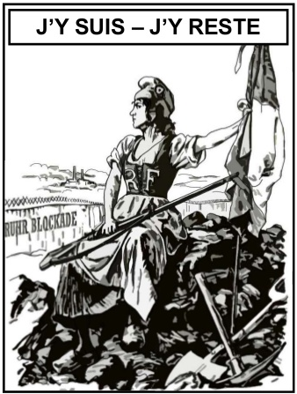

[Cartŵn Prydeinig o Punch 1923. Mae’r ysgrifen yn golygu ‘Dwi yma – Dwi’n aros yma’]

Beth oedd pwrpas Ffynhonnell B? [8]

[Defnyddiwch fanylion o Ffynhonnell B a’r hyn rydych chi'n ei wybod a’i ddeall am y cyd-destun hanesyddol i ateb y cwestiwn.]

------------------------------------------------------------------------------------------------------------------------------------------------------------------------------------------------------------------------------------------------------------------------------------------------------------------------------------------------------------------------------------------------------------------------------------------------------------------------------------------------------------------------------------------------------------------------------------------------------------------------------------------------------------------------------------------------------------------------------------------------------------------------------------------------------------------------------------------------------------------------------------------------------------------------------------------------------------------------------------------------------------------------------------------------------------------------------------------------------------------------------------------------------------------------------------------------------------------------------------------------------------------------------------------------------------------------------------------------------------------------------------------------------------------------------------------------------------------------------------------------------------------------------------------------------------------------------------------------------------------------------------------------------------------------------------------------------------------------------------------------------------------------------------------------------------------------------------------------------------------------------------------------------------------------------------------------------------------------------------------------------------------------------------------------------------------------------------------------------------------------------------------------------------------------------------------------------------------------------------------------------------------------------------------------------------------------------------------------------------------------------------------------------------------------------------------------------------------------------------------------------------------------------------------------------------------------------------------------------------------------------------------------------------------------------------------------------------------------------------------------------------------------------------------------------------------------------------------------------------------------------------------------------------------------------------------------------------------------------------------------------------------------------------------------------------------------------------------------------------------------------------------------------------------------------------------------------------------------------------------------------------------------------------------------------------------------------------------------

CWESTIWN 4
Mae’r cwestiwn hwn yn sôn am y digwyddiadau yn y Ruhr yn 1923.
Astudiwch y ffynonellau isod ac yna atebwch y cwestiwn sy’n dilyn.
Ffynhonnell C
Erbyn Ionawr 1923 roedd y Ffrancwyr wedi colli amynedd gyda’r Almaenwyr. Gorymdeithiodd lluoedd Ffrainc a Gwlad Belg i’r Ruhr i hawlio’r nwyddau yr oedd arnynt eu hangen i’w digolledu wedi i’r Almaen fethu â thalu iawndaliadau. Gweithredodd llywodraeth yr Almaen bolisi o ‘wrthsafiad goddefol’ gan dalu gweithwyr drwy brintio mwy o arian. Achosodd hyn i chwyddiant godi ac erbyn Ebrill 1923 roedd y llywodraeth yn gwario 7 gwaith yn fwy na’r hyn yr oedd yn ei dderbyn mewn refeniw. Canlyniad hyn oedd gorchwyddiant, wrth i werth y marc ddisgyn yn sydyn gan fynd yn ddiwerth.

[Yr haneswyr Greg Lacey a Keith Shephard yn ysgrifennu mewn gwerslyfr hanes TGAU, Yr Almaen 1918-1945 (1997)]
Ffynhonnell D
Mae gen i gof byw iawn o ddiwrnodiau cyflog bryd hynny. Roedd yn rhaid i mi fynd gyda’r rheolwr i’r banc mewn Benz agored chwe sedd, oedd yn llawn i’r ymylon â bwndeli ar fwndeli o bapurau miliwn marc. Byddem yn dychwelyd drwy’r strydoedd cul heb fawr neb yn ein plagio. A phan dderbyniant eu cyflogau, ni fyddai’r gweithwyr hyd yn oed yn trafferthu cyfrif nifer y papurau ymhob bwndel.

[A question from a Nazi math’s textbook, 1933]

[Cyfweliad gyda gweithiwr o gwmni cludiant ar gyfer llyfr o atgofion personol, Life during the Weimar (1968)]

Pa un o'r ffynonellau sydd fwyaf defnyddiol i hanesydd sy’n astudio economi Weimar a digwyddiadau 1923? [12]
[Dylech gyfeirio at y ddwy ffynhonnell yn eich ateb a defnyddio’r hyn rydych chi'n ei wybod a’i ddeall am y cyd-destun hanesyddol.]
--------------------------------------------------------------------------------------------------------------------------------------------------------------------------------------------------------------------------------------------------------------------------------------------------------------------------------------------------------------------------------------------------------------------------------------------------------------------------------------------------------------------------------------------------------------------------------------------------------------------------------------------------------------------------------------------------------------------------------------------------------------------------------------------------------------------------------------------------------------------------------------------------------------------------------------------------------------------------------------------------------------------------------------------------------------------------------------------------------------------------------------------------------------------------------------------------------------------------------------------------------------------------------------------------------------------------------------------------------------------------------------------------------------------------------------------------------------------------------------------------------------------------------------------------------------------------------------------------------------------------------------------------------------------------------------------------------------------------------------------------------------------------------------------------------------------------------------------------------------------------------------------------------------------------------------------------------------------------------------------------------------------------------------------------------------------------------------------------------------------------------------------------------------------------------------------------------------------------------------------------------------------------------------------------------------------------------------------------------------------------------------------------------------------------------------------------------------------------------------------------------------------------------------------------------------------------------------------------------------------------------------------------------------------------------------------------------------------------------------------------------------------------------------------------------------------------------------------------------------------------------------------------------------------------------------------------------------------------------------------------------------------------------------------------------------------------------------------------------------------------------------------------------------------------------------------------------------------------------------------------------------------------------------------------------------------------------------------------------------------------------------------------------------------------------------------------------------------------------------------------------------------------------------------------------------------------------------------------------------------------------------------------------------------------------------------------------------------------------------------------------------------------------------------------------------------------------------------------------------------------------------------------------------------------------------------------------------------------------------------------------------------------------------------------------------------------------------------------------------------------------------------------------------------------------------------------------------------------------------------------------------------------------------------------------------------------------------------------------------------------------------------------------------------------------------------------------------------------------------------------------------------------------------------------------------------------------------------------------------------------------------------------------------------------------------------------------------------------------------------

CWESTIWN 5
Mae’r cwestiwn hwn yn sôn am fywyd yn yr Almaen Natsïaidd.
A oedd Putsch Neuadd Gwrw Munich yn llwyddiant mawr i Hitler a’r Natsïaid? [16]
Defnyddiwch yr hyn rydych chi'n ei wybod a’i ddeall am y mater i gefnogi’ch ateb. Mae marciau am sillafu, atalnodi a defnyddio gramadeg ac iaith arbenigol yn gywir yn cael eu rhoi am y cwestiwn hwn. [3]

------------------------------------------------------------------------------------------------------------------------------------------------------------------------------------------------------------------------------------------------------------------------------------------------------------------------------------------------------------------------------------------------------------------------------------------------------------------------------------------------------------------------------------------------------------------------------------------------------------------------------------------------------------------------------------------------------------------------------------------------------------------------------------------------------------------------------------------------------------------------------------------------------------------------------------------------------------------------------------------------------------------------------------------------------------------------------------------------------------------------------------------------------------------------------------------------------------------------------------------------------------------------------------------------------------------------------------------------------------------------------------------------------------------------------------------------------------------------------------------------------------------------------------------------------------------------------------------------------------------------------------------------------------------------------------------------------------------------------------------------------------------------------------------------------------------------------------------------------------------------------------------------------------------------------------------------------------------------------------------------------------------------------------------------------------------------------------------------------------------------------------------------------------------------------------------------------------------------------------------------------------------------------------------------------------------------------------------------------------------------------------------------------------------------------------------------------------------------------------------------------------------------------------------------------------------------------------------------------------------------------------------------------------------------------------------------------------------------------------------------------------------------------------------------------------------------------------------------------------------------------------------------------------------------------------------------------------------------------------------------------------------------------------------------------------------------------------------------------------------------------------------------------------------------------------------------------------------------------------------------------------------------------------------------------------------------------------------------------------------------------------------------------------------------------------------------------------------------------------------------------------------------------------------------------------------------------------------------------------------------------------------------------------------------------------------------------------------------------------------------------------------------------------------------------------------------------------------------------------------------------------------------------------------------------------------------------------------------------------------------------------------------------------------------------------------------------------------------------------------------------------------------------------------------------------------------------------------------------------------------------------------------------------------------------------------------------------------------------------------------------------------------------------------------------------------------------------------------------------------------------------------------------------------------------------------------------------------------------------------------------------------------------------------------------------------------------------------------------------------------------------------------------------------------------------------------------------------------------------------------------------------------------------------------------------------------------------------------------------------------------------------------------------------------------------------------------------------------------------------------------------------------------------------------------------------------------------------------------------------------------------------------------------------------------------------------------------------------------------------------------------------------------------------------------------------------------------------------------------------------------------------------------------------------------------------------------------------------------------------------------------------------------------------------------------------------------------------------------------------------------------------------------------------------------------------------------------------------------------------------------------------------------------------------------------------------------------------------------------------------------------------------------------------------------------------------------------------------------------------------------------------------------------------------------------------------------------------------------------------------------------------------------------------------------------------------------------------------------------------------------------------------------------------------------------------------------------------------------------------------------------------------------------------------------------------------------------------------------------------------------------------------------------------------------------------------

