Proof Reading
Exercise Three
Find and correct the errors in the advertisement below. There are seven errors.

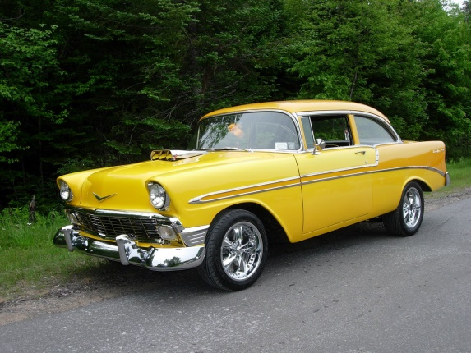
Car for sail

- One careful owner
- Full mot
- In excellent condition
- New tires
- Great two drive
I have really enjoyed owning this car but I know need to let her go! I don’t have the time to show her the love and attention that she needs. You will really enjoy driving this car and people will luck at you as you zoom passed them.

