Cristnogaeth / Rhan 3 -
MORALITY
In this unit we will look at some of Jesus’s teachings on how people Christians should live their lives and treat other people. What did Jesus teach? How should people respond to their enemies? Do we have to forgive others? Must we help others? Is being wealthy a good thing?
Morality deals with what is ‘right’ and ‘wrong’ in life. As we decide in life which ‘right’ path we should follow we often turn to different sources of authority for advice. List some of them on the wall here…..

Why is it so difficult to know what’s ‘right’ and ‘wrong’ in life? (Discuss)

e.g. Is it ALWAYS wrong to kill?
Is adultery ALWAYS wrong?
Is it ALWAYS wrong to go to war?

Consider these 6 scenarios …
Topic | It’s ‘right’ | It’s ‘wrong’ | My reasons / comment
Absolute morality…… | Relative morality….
There are two types of morality:-

Divine Command

Why do Christians follow and obey the words of Jesus?
Give 4 reasons

We find the words of Jesus in four books which together are called
the G___________________ …

__________ ________ ___________ and ____________

What did Jesus teach about morality?
(1)A choice to be made
(Matthew 7:13-14)

Note 2 things you learn here about being a Christian
- ____________________________________________________________________________________________________________________________
- ____________________________________________________________________________________________________________________________

Loving others
Jesus often spoke of the special love that Christians should show other people. The name of this kind of love is agape

Agape

(2) Loving and serving others Parable of the Sheep and the Goats
Matthew 25: 31 - 46
Write a very short summary of the parable

The message of this parable is….:-
_______________________________________________________________________________________________________________________________________________________________________________________________________________________________________________________________________________________________________________________________________________
How has this parable influenced the work of the Salvation Army?
(3)Enemies Matthew 5:43 - 44
Jesus taught that the right way to respond to enemies is to….
- ________________________________ a
- __________________________________

(4) How should Christians love others? John 13: 34 - 5
How should they love other people?
“_________________________________________
_________________________________________”

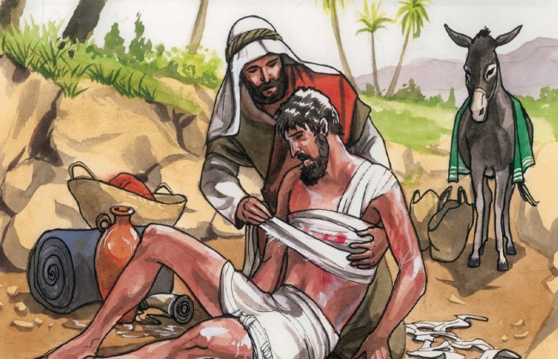
(5) Love who? Luke 10:25 - 37 Parable of the Good Samaritan

One of Jesus best known parables illustrates what it means to ‘love your neighbour as yourself’

Summary of the parable | The parable’s message for Christians
(6) Jesus talks about forgiveness Matthew 6:5-15
One day Jesus explained how his followers should pray. The ‘Lord’s Prayer’ states that Christians have to forgive others or……
__________________________________
__________________________________
__________________________________
__________________________________
__________________________________

(7)More on forgiveness - Matthew 18:21-22
Is it enough to forgive others 7 times? What did Jesus say?
“____________________________________________________________________________”

(8) Jesus speaks of forgiveness while dying Luke 23:34
What was on his mind when Jesus was dying on the cross? - he spoke of forgiveness and said…..
“______________________________
_______________________________
_______________________________”
These words show Christians that:-
- ____________________________________________________________________________________________________________________________
- ____________________________________________________________________________________________________________________________

(9) Being rich Matthew 6:19-21
Copy out verse 20
________________________________________________________________________________________________________________________

The message here is….
________________________________________________________________________________________________________________________________________________________________________________________________________________________________

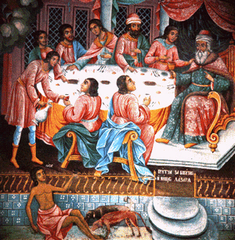
(10)The Rich man and Lazarus Luke 16:19-21
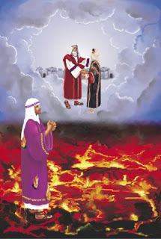
Write a short summary of this parable - in 4 main points
Jesus here taught that…….
____________________________________________________________________________________________________________________________________________________________________________________________________________________________________________________________________________________________________________________________________________________________________________________________________________________________________________________________________________________

REVISION: Jesus teaching on MORALITY
Teaching | Messagea | How might Christians respond to these teachings?
1
2

3

4.

5
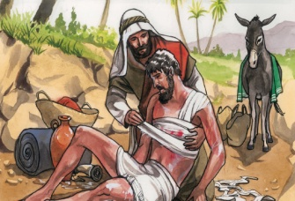

6
7
8
9
10

