Question 1 examples- Germany in Transition 1919-1939
This question is about the impact of the First World War
Source A
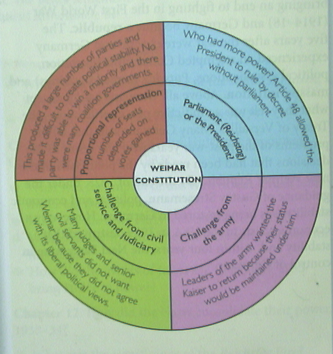

[A diagram from a GCSE textbook illustrating the flaws of the Weimar Constitution]
Use Source A and your own knowledge to describe the weaknesses of the Weimar Constitution. [6]

This question is about the impact of the First World War
Source A
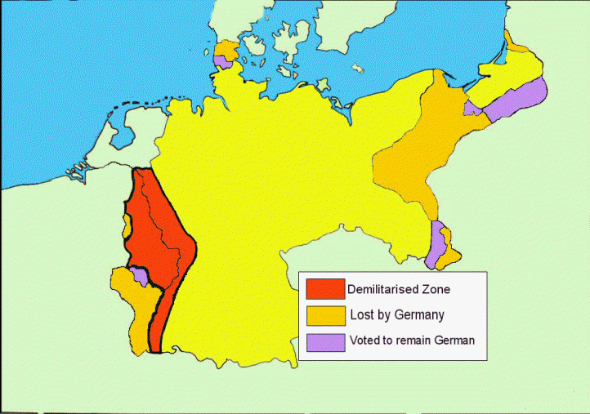

[Map showing the territorial terms of the Treaty of Versailles]
Use Source A and your own knowledge to describe the territorial clauses of the Treaty of Versailles [6]
This question is about the impact of the First World War
Source A
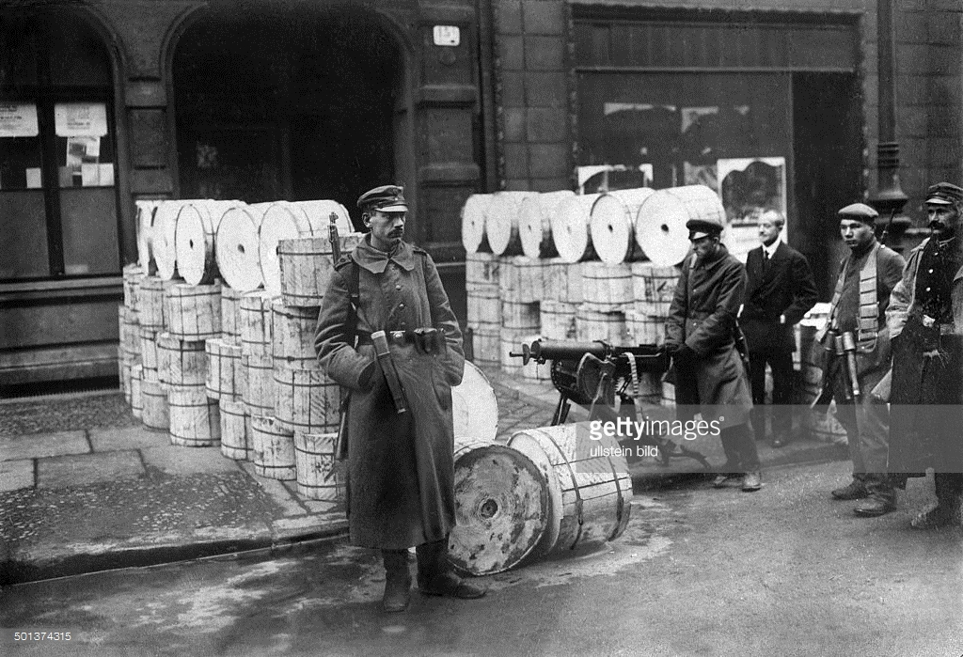

[Spartacists outside the government’s newspaper offices during their revolt in January 1919]

Use Source A and your own knowledge to describe the Spartacist revolt in January 1919. [6]

This question is about the recovery of the Weimar
Source A
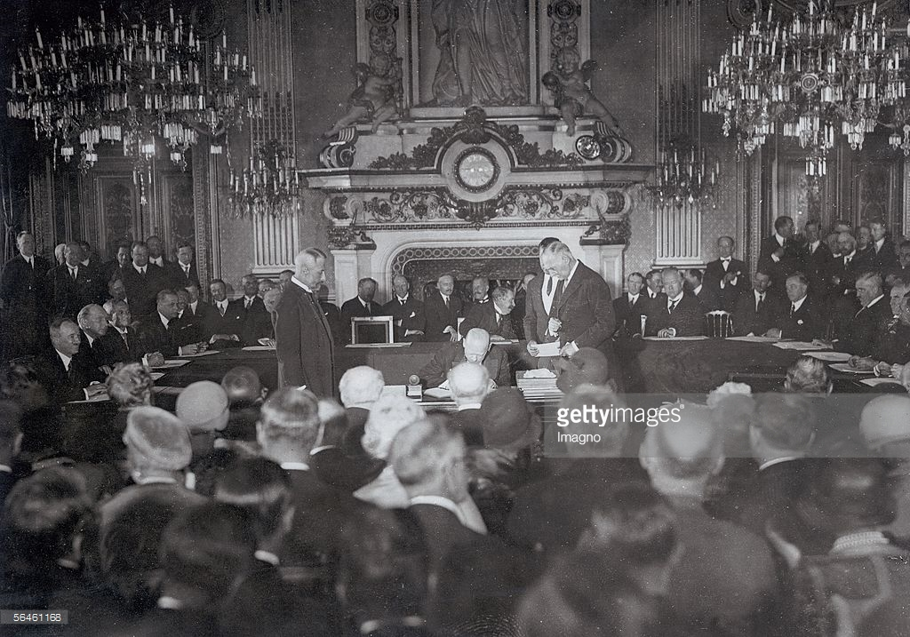

[Stresemann signing the Locarno Pact, 1925]
Use source A and your own knowledge to describe the Locarno Pact of 1925. [6]

This question is about the recovery of the Weimar
Source A
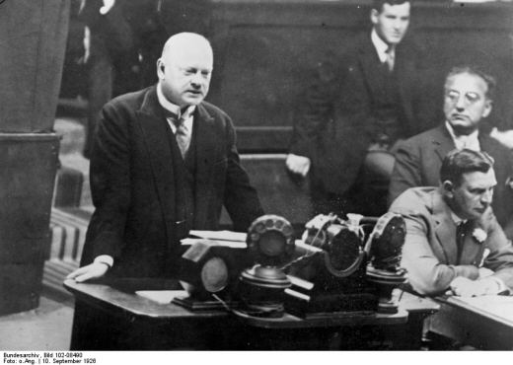

[Gustav Stresemann, German Minister for Foreign Affairs gives his inaugural speech on the occasion of Germany being admitted to the League of Nations.]

Use source A and your own knowledge to describe why joining the League of Nations was a success for Germany. [6]

This question is about the end of the Weimar
Source A

[A table illustrating election results from 1924 to 1933]
Use source A and your own knowledge to describe what happened to the Nazi vote from 1924 to 1933. [6]

This question is about the end of the Weimar
Source A
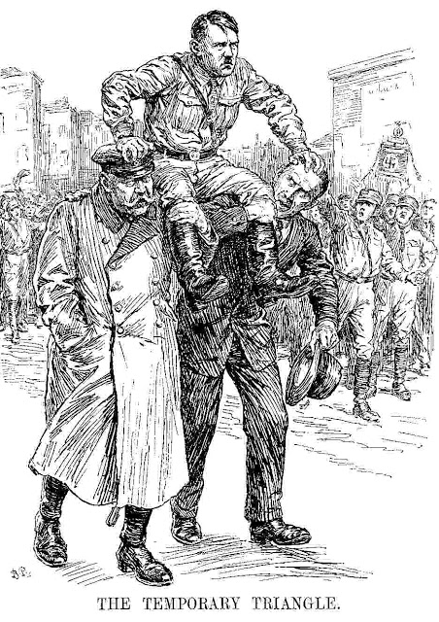

[Cartoon from the British magazine, Punch, January 1933, which shows Hitler being carried on the shoulders of Hindenburg and von Papen]

Use source A and your own knowledge to describe the relationship between Hitler, Hindenburg and von Papen [6]

This question is about the Nazi consolidation of power.
Study the source below and then answer the question which follows.
Source A
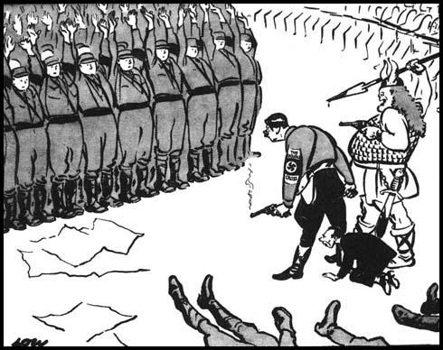
They salute with both hands now
[A cartoon which appeared in the London Evening Standard, 3 July 1934.]

Use Source A and your own knowledge to describe the role of violence in consolidating Nazi power. [6]
[18 x answer lines]

This question is about the Nazi consolidation of power.
Study the source below and then answer the question which follows.
Source A
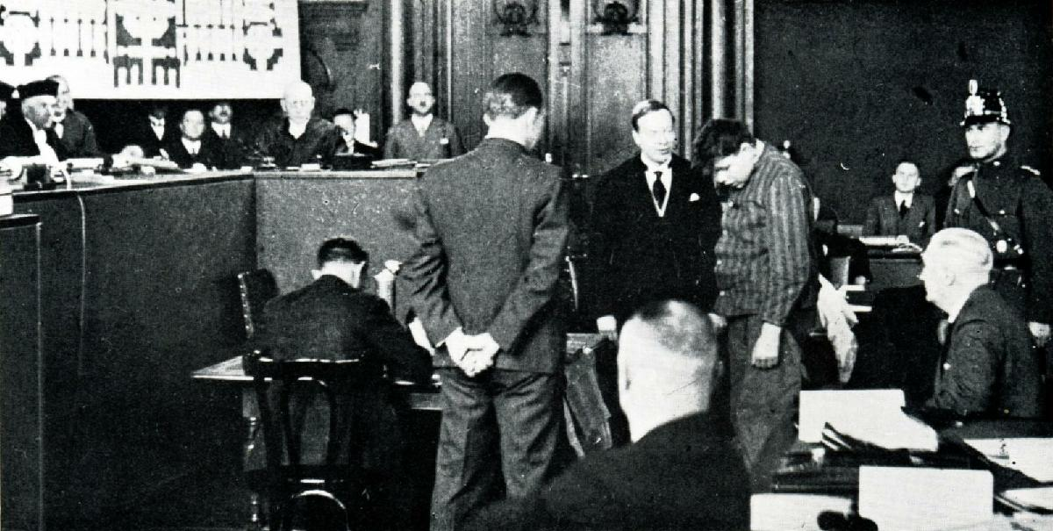
[A picture showing the trial of Marinus van der Lubbe for the burning of the Reichstag. Van der Lubbe is wearing a striped jacket. ]

Use Source A and your own knowledge to describe how the Nazis used the Reichstag Fire to consolidate their power. [6]
[18 x answer lines]

This question is about the Nazi economic, social and racial policy
Study the source below and then answer the question which follows.
Source A
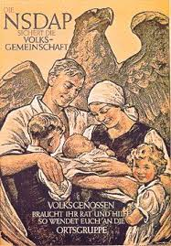
[A Nazi poster of 1937 showing the central role of women. It says ‘The Nazi Party protects the national community’ ]

Use Source A and your own knowledge to describe the role of women in Nazi Germany. [6]
[18 x answer lines]

This question is about the Nazi economic, social and racial policy
Study the source below and then answer the question which follows.
Source A
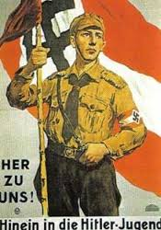
[A recruiting poster for the Hitler Youth, 1933. It says: ‘Join us in the Hitler Youth’]

Use Source A and your own knowledge to describe the role of the Hitler Youth Movement in Nazi Germany. [6]
[18 x answer lines]

This question is about terror and persuasion
Study the source below and then answer the question which follows.
Source A
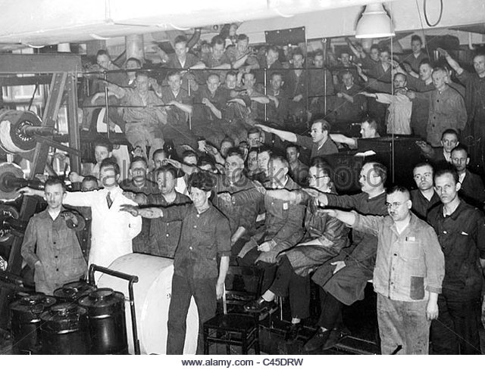
[Factory workers listening to a radio broadcast by Hitler, 1934]

Use Source A and your own knowledge to describe how media was used to persuade German Citizens to support the Nazi Party. [6]
[18 x answer lines]

This question is about Nazi economic, social and racial policy
Study the source below and then answer the question which follows.
Source A
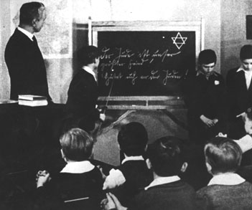
[Jewish schoolchildren being humiliated in front of their class. The writing on the board reads ‘The Jews are our greatest enemy!’ And ‘Be aware of the Jew!’]

Use Source A and your own knowledge to describe how the Nazis discriminated against Jews. [6]
[18 x answer lines]

This question is about Nazi economic, social and racial policy
Study the source below and then answer the question which follows.
Source A
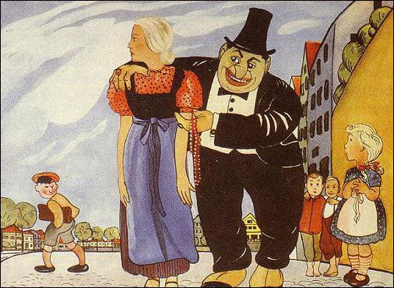
[Illustration from a German textbook used by primary schools (c. 1934)]

Use Source A and your own knowledge to describe how the Nazis controlled education in Germany. [6]
[18 x answer lines]

This question is about Nazi economic, social and racial policy
Study the source below and then answer the question which follows.

Source A

Use Source A and your own knowledge to describe what happened to unemployment under Nazi rule. [6]

This question is about Nazi economic, social and racial policy
Study the source below and then answer the question which follows.

Source A
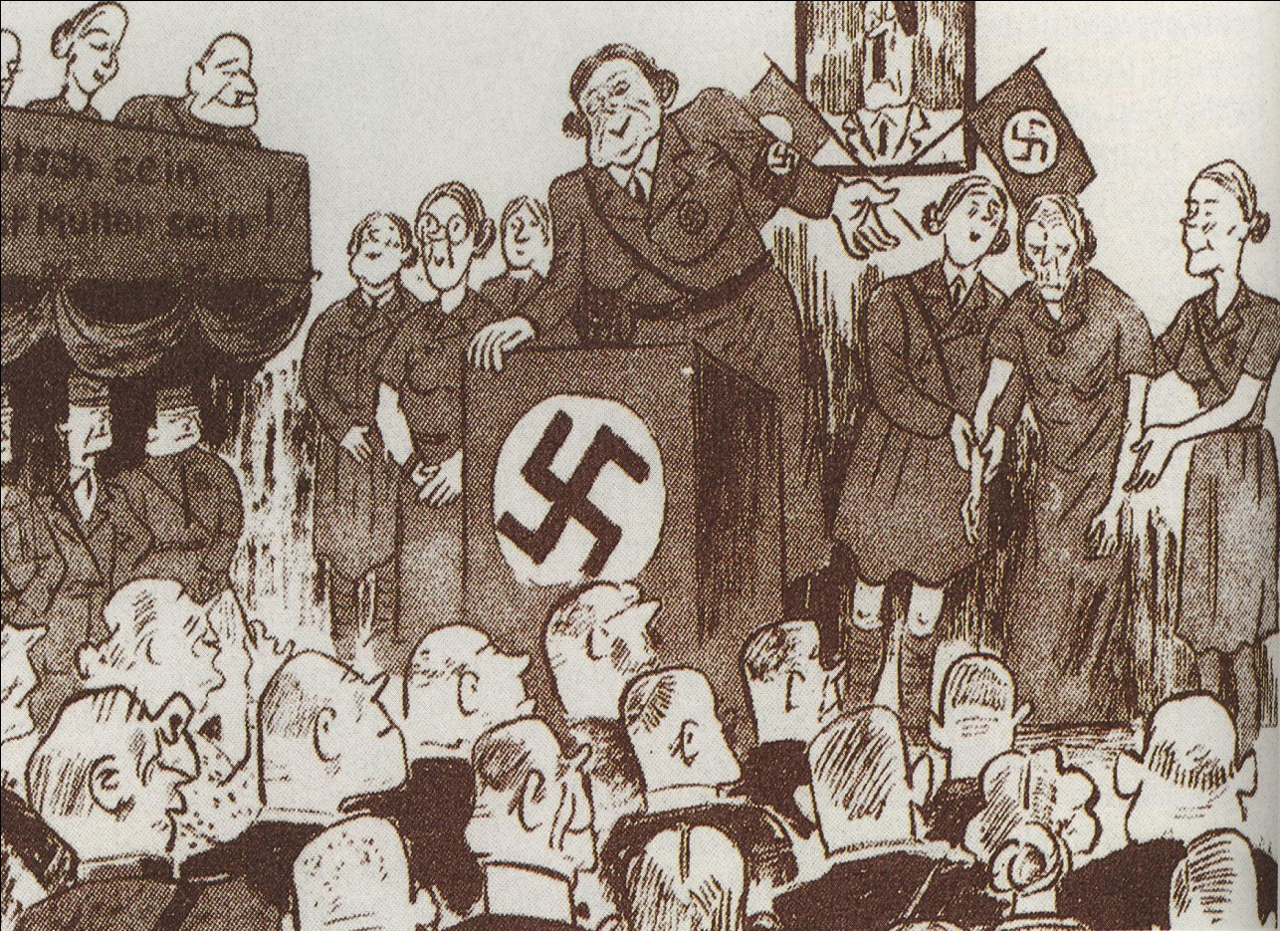

[A German cartoon from the 1930s with the caption ‘Introducing Frau Mueller who up to now has brought 12 children into the world’.]

Use Source A and your own knowledge to describe the role of women in Nazi Germany. [6]

This question is about Nazi economic, social and racial policy
Study the source below and then answer the question which follows.

Source A
Girls usually had a different curriculum from boys. They also studied domestic science and eugenics (how to produce perfect offspring by selecting ideal qualities in the parents).

[Germany 1918-1945 (GCSE textbook) by Greg Lacey and Keith Shepherd.]
Use Source A and your own knowledge to describe the education girls received under the Nazis. [6]

This question is about Terror and persuasion
Study the source below and then answer the question which follows.
Source A
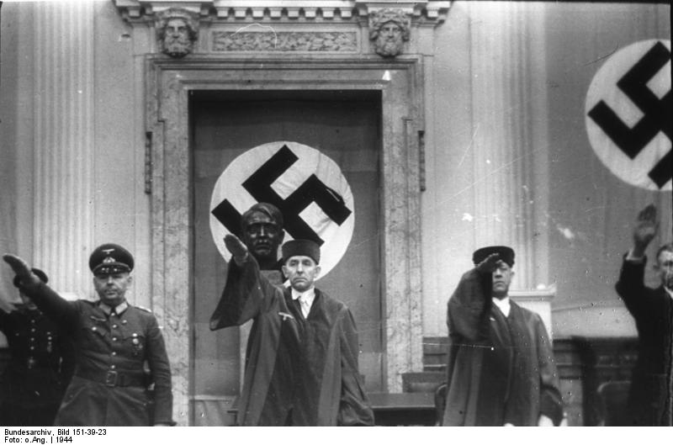

[Judge Roland Freisler, State Secretary of the Reich Ministry of Justice. Here, he is presiding over a People’s Court.]

Use Source A and your own knowledge to describe the how the legal system was controlled under the Nazis.
This question is about Hitler’s foreign policy
Study the source below and then answer the question which follows.
Source A
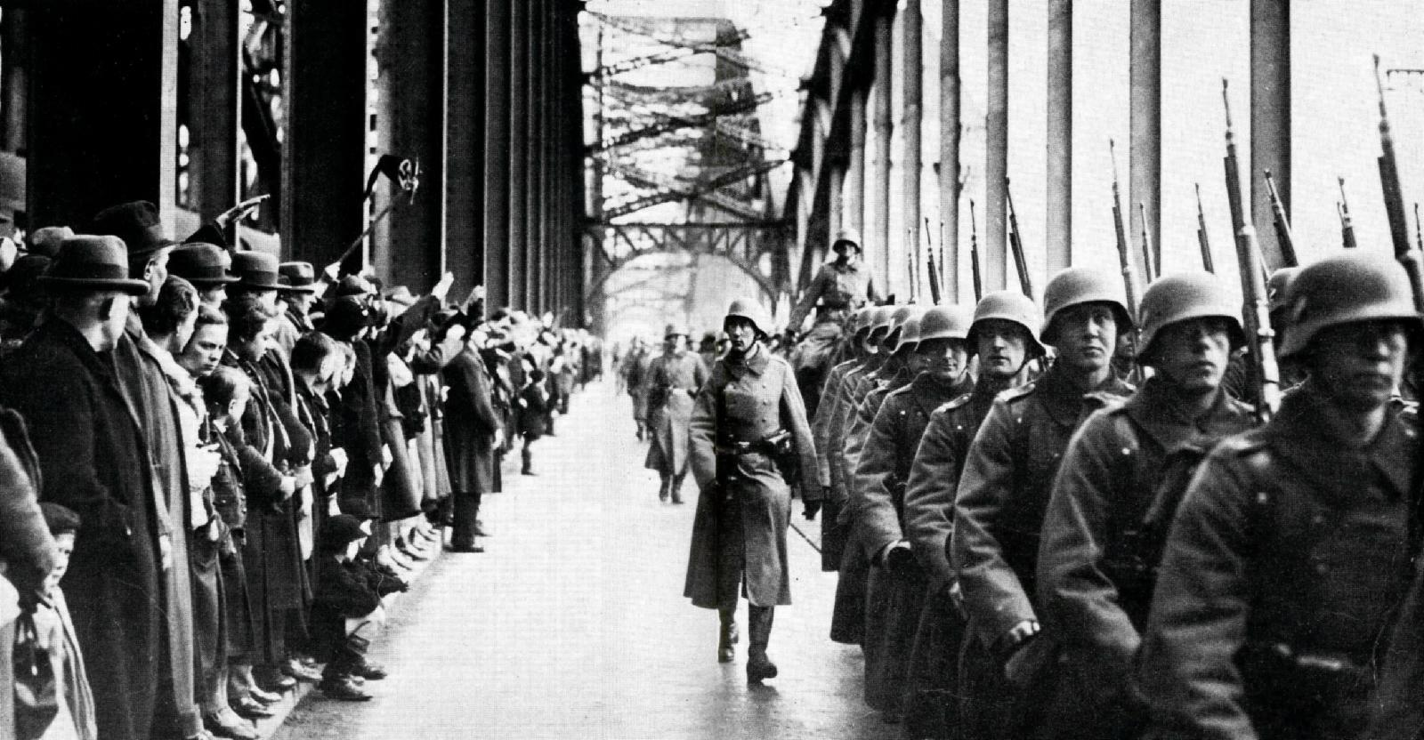

[German troops entering Cologne, in the Rhineland, in March 1936.]

Use Source A and your own knowledge to describe German re-occupation of the Rhineland.

Study the source below and then answer the question which follows.
Source A
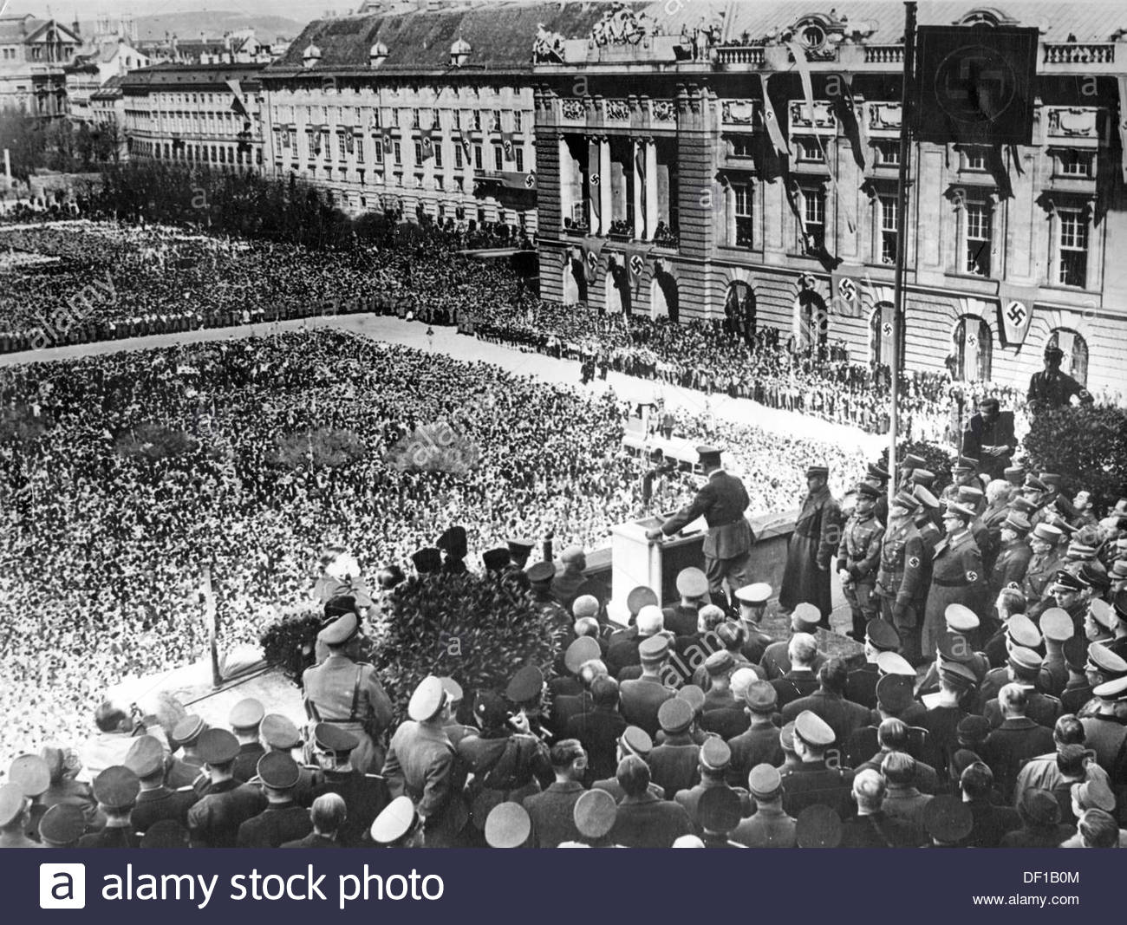

[Nazi propaganda showing Hitler on the balcony of the Hofburg, Vienna, announcing the annexation of Austria to the German Reich to a crowd of people on the 15th March 1938]

Use Source A and your own knowledge to describe the Anschluss of 1938.

