STARTER TASK – Calculating Percentages Mentally
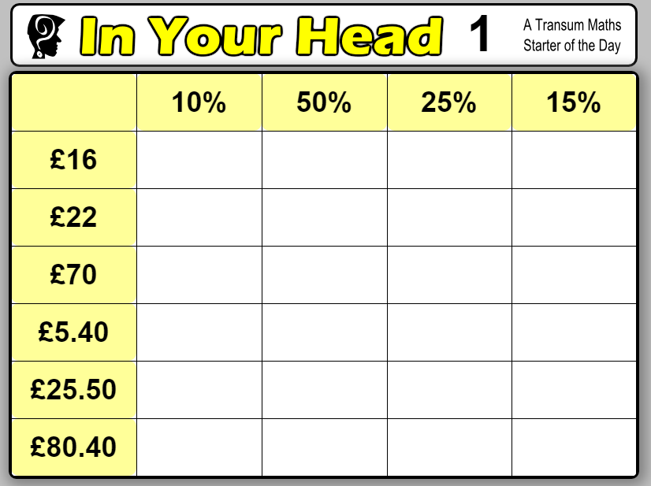http://www.transum.org/Software/SW/Starter_of_the_day/starter_September29.ASP

