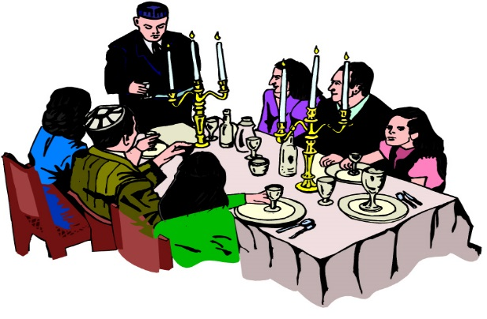
The importance of the home for worship in Judaism: challenges and advantages of observing Shabbat (Exodus) 20:8-10)
- Following the destruction of the Temple in 70 A.D, worship moved from the Temple to the home and the synagogue.
- The home was regarded as a 'small sanctuary' or 'small temple.'
- The Pharisees made the home part of religious activities when introducing ceremonies like Shabbat.
- Everything which takes place in the home reminds the Jews of God.
- The main events of the rites which form the milestones of Jewish life are prepared or held in the home e.g circumcision and mourning practices.
- Jewish children are educated in the home.
- Children can learn in several ways, such as copying or repeating what their parents do - kedusha.
- In the home also, it is a chance for parents to teach their children the history of the religion e.g. the Holocaust.

"It is the woman who usually determines the spiritual character of the home. It is the mother who is most often called upon to answer her children's daily questions. It is the extent of the mother's faith, the strength of her values and beliefs that plays the dominant role in shaping the spiritual character of the next generation". (H.H. Donin: To Raise A Jewish Child)
Observing Shabbat: Exodus 20:8-10
‘Remember the Sabbath day, by keeping it holy. Six days you shall labour and do all your work, but the seventh day is a Sabbath to the Lord your God. On it you shall do no work, neither you, nor your son or daughter, nor your male or female servant, nor your animals, nor any foreigners residing in your towns; for in six days the Lord made the heavens and the earth, the sea, and all that is in them, but he rested on the seventh day. Therefore, the Lord blessed the Sabbath day and made it holy.’
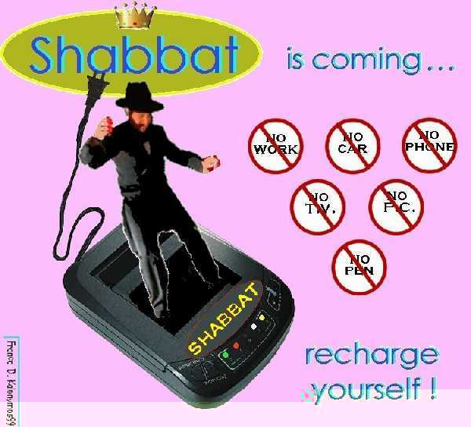
What is Shabbat?
- Every week Jews observe a holy day called Shabbat.
- Shabbat is the most holy day of the year, apart from Yom Kippur.
- Shabbat is a day of complete rest, and it is also called Saboth or Shabbos.
- It is a day which is given to studying the Torah, praying, and spending valuable time with the family.
- In the Talmud, God told Moses,
“I have an important gift in my treasury, its name is ‘Saboth’. Go and tell the Israelites that I wish to give it to them”.
- As Rabbi Saadia Gaon said in the tenth century, it is a chance

“…to rest from the burden of work in order to gain some information and pray some more, and to enable people to meet and discuss …” – this is the Shabbat.

When is Shabbat celebrated?

Shabbat begins at sunset on Friday evening …

… and continues until three stars appear in the sky on Saturday night.

Preparing for Shabbat
Shabbat is a special day, and Jews try to ensure that the atmosphere of the home is different from the rest of the week. All preparations must be made in advance, as no work can be done on Shabbat itself.

Preparations for Shabbat:
- All the preparations must be made in advance as no Jews can undertake any work during Shabbat itself e.g shopping or cooking.
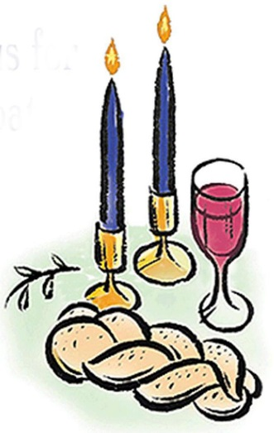
- The best crockery and dishes will be taken out ready for Shabbat.
- The table will be laid, remembering the candlesticks, the challot and the wine.
- The house must be cleaned and tidied before Shabbat begins.
- The television and other items which use electricity will be covered as the use of electricity is not permitted during Shabbat.
- Jews will wash as an act of purity and change into their best clothes in order to be ready to welcome Shabbat.

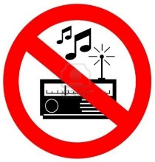
The 39 Melachot
During Shabbat, Jews are not permitted to do any work at all (unless lives are in danger). These rules have been adapted to suit modern life today.
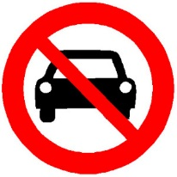
On the Shabbat there are 39 melachah (plural = Melchot) which are forbidden to Jews e.g. driving a car, using electricity, carrying objects from a private place to a public place (and vice versa), cooking and writing.

Why are Jews not allowed to work?

By not working or using any energy during Shabbat, Jews have a chance to enjoy themselves in ways which are different to other days of the week. It is an opportunity for the family to spend valuable time together in order to help keep Jewish families close.

Friday evening: Welcoming Shabbat
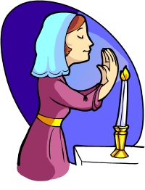
The mother welcomes Shabbat to the home.

Before sunset on Friday evening, the mother will light two candles. She will do this just before the sun sets as Jews are not permitted to light a fire on Shabbat itself.

She lights two candles to represent the two commandments which are in the Torah regarding observing Shabbat,
which are:

“Remember the Sabbath day” (Exodus 20:8) and
“Observe the Sabbath day” (Deuteronomium 5:12)

Then she will make a gesture with her hands as though she was welcoming Shabbat into her home.

She will cover her eyes with her hands and say a blessing in Hebrew. Often the mother will use this moment to say a short prayer on behalf of her family.

This will be a holy time for the family, and following this Shabbat has arrived.

After welcoming Shabbat ...
After welcoming Shabbat into the home, the Jewish men will walk to the Synagogue for afternoon prayers.

At the end of the service the Rabbi will take a cup of wine and say a blessing which gives thanks to God for giving Shabbat to Jews. This blessing is called kiddush.
Before leaving the Synagogue the Jews will shake hands and wish each other a Shabbat Shalom (peaceful Shabbat).

Friday night meal
After returning home from the synagogue, the father will
- Sit with his family by the table
- Bless his children in Hebrew
- Recite the kiddush
Nobody will eat from the moment Shabbat starts until they hear the kiddush.

Then the father will bless the Challot,

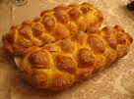
- The two challot represent manna (the miraculous bread which the Israelis ate during the journey through the wilderness).

- Challot are plaited loaves which have 12 plaits to represent the 12 loaves placed in the Temple in the old days on the night before Shabbat

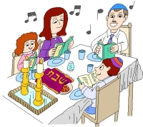
The father will dip pieces of the Challot in salt (to remind them of the sacrifices which took place in the Templ long ago) before sharing them.

The the meal will begin.
This is a special meal as the Jews eat special foods and sing between the courses and stories of the Torah are read and Jewish tales are spoken.
It is a relaxed and slow meal and a special time for the family to enjoy together.

Saturday morning during Shabbat
In the synagogue ...
The service in the Synagogue begins later but lasts longer than the usual weekly service.
During the service the Rabbi will read a special part of the Sefer Torah called the Sidra.
During Sidra 8 men are called to say blessings at particular times. The eighth man will read the haftarah.
Invited speakers will then say some words and the Rabbi will use this opportunity to encourage the audience to abide by Judaism or will teach them something new.
Before leaving the Synagogue everyone will wish each other ‘Shabbat Shalom’ once more.

In the home ...
After arriving home, the family will have another meal, similar to the one they had the previous evening. The father will recite kiddush and will bless the challot, but will not bless the children.

After the meal, the Jews will entertain themselves, making sure they keep to the 39 melachot.
Later in the afternoon the Jewish men will walk to the Synagogue. They will read the first part of the previous week’s sidra from the sefer Torah then will study until it begins to get dark.

The end of Shabbat ...

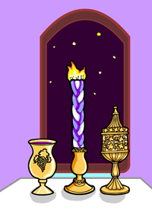
Shabbat ends when three stars appear in the sky on Saturday night. To note the end of the holy day, a special service will be held in the Synagogue.
The congregation will recite the prayers of the week and ask for God’s blessing for the following week.
At the end of the service the rabbi will perform havdalah (separation), a ceremony to mark the end of the holy day. He will bless a cup of win and sweet-smelling spices. He will give a third blessing over candlelight to show that Jews are relighting the fire once more. He blesses the wine once more and the holy day is separated from the ordinary day.
As soon as the father returns from the synagogue he will also perform havdalah. Following this, Jews can begin to use electricity etc.

Differences between the practices and opinion of Orthodox and Reformed Jews regarding observing Shabbat

- Shabbat is important to many non-religious Jews as well as religious Jews.
- Orthodox Jews keep to all the ruls and consequences of observing Shabbat which mean it is not permitted to undertake any work which would be necessary for building the first temple (or a modern definition of work by modern rabbis) during Shabbat.
- However, Conservative Jews and Reformed Jews tend to follow the original rule in Exodus which is ‘do not work’ and regard it as a day of rest rather than a day to avoid doing particular activities
- For non-Orthodox Jews (including many who are not religious) Shabbat is a day for staying home from work but the use of technology is allowed.
- Jews disagree about whether or not it is acceptable to drive a car to the synagogue. Driving a care involves creating a spark, or lighting a fire, which is regarded as ‘work’, but many Reformed Jews argue that ‘work’ which helps to make Shabbat more holy (e.g. in order to go to the synagogue) is acceptable and can be justified.
- Many Reformed Jews believe that speaking to friends or family on the phone or even driving a car to see them is acceptable.
- On the other hand, many Orthodox Jews will switch the phone off or pull plugs from the socket in order to strictly obey the rules.
- There are as many different ways of celebrating Shabbat as there are of Jewish families.

Why do Jews observe Shabbat?

The importance of observing Shabbat

- Jews remember and celebrate God’s creation of the world. When they rest, they see themselves following the same pattern as God for God also rested on the seventh day after creating the world.
- The Ten Commandments say that they must keep the Sabbath-
‘Remember the Sabbath day by keeping it holy’ (Exodus 20:8). It is one of the 613 mitzvot which Jews are obliged to keep as part of their Covenant with God.
- Jews remember the time when they were slaves of the Pharoah in Egypt and so they celebrate Shabbat every week in order to celebrate their freedom to rest today.
- Shabbat is a time for relaxing and spending valuable time with the family as family unity is very important to Jews. It unites Jews as families and socially, historically and geographically.
- According to many Jews, Shabbat is the most important ‘festival’ or day of the year.
- Shabbat is regarded as a gift from God when the problems of the week can be forgotten.
- Even during times of Jewish persecution they would make every effort to celebrate Shabbat as it was so important to them.
- Observing Shabbat is a part of Jewish identity and has helped to keep the religion alive.

Challenges to observing Shabbat in the modern world
- Some Jews believe that keeping all the rules go against the nature and meaning of Shabbat.
- It means making a great effort to ensure that they do not undertake any sort of ‘work’ – they must make detailed preparations before hand. This means that Shabbat can be more trouble that it is worth.
- Jews are not permitted to use a car on the Shabbat and this is a problem for Jews who do not live near a synagogue and for other social reasons.
- Some would argue that Shabbat is dull and monotonous as it happens every week. It loses its worth and status as it happens too often.
- It is not easy for Jews to socialise with non-Jewish friends during Shabbat even though the weekend is a convenient time for them to meet.
- It is not easy to go shopping if Jews celebrate Shabbat during the weekend and shops are closed on Sundays.
- Jews must come home from school or work early in the winter in order to prepare for and welcome Shabbat. This means that children will miss out on their education and it could be difficult for a Jew to find a job which offers flexible hours or which allows them to leave work early.

‘Observing Shabbat takes too much time.’
Discuss this statement showing that you have considered more than one viewpoint.
(You must refer to religion and creed in your answer.) [15]
...........................................................................................................................................................................................................................................................................................................................................................................................................................................................................................................................................................................................................................................................................................................................................................................................................................................................................................................................................................................................................................................................................................................................................................................................................................................................................................................................................................................................................................................................................................................................................................................................................................................................................................................................................................................................................................................................................................................................................................................................................................................................................................................................................................................................................................................................................................................................................................................................................................................................................................................................................................................................................................................................................................................................................................................................................................................................................................................................................................................................................................................................................................................................................................................................................................................................................................................................................................................................................................................................................................................................................................................................................................................................................................................................................................................................................................................................................................................................................................................................................................................................................................................................................................................................................................................................................................................................................................................................................................................................................................

