Worship in the Synagogue
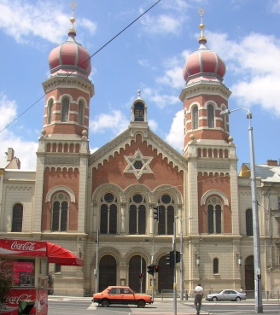
KEY CONCEPTS
- Synagogue – a Jewish house of worship, often having facilities for religious instruction; an assembly or congregation of Jews for the purpose of religious worship.
- Aron Hakodesh - a cabinet containing the scrolls of the Torah (the five books of Moses). The ark is the holiest place in the synagogue, both because it contains the sacred writings of Judaism and because it represents the original ark of the Jewish people.
- Ner Tamid –Everlasting light which burns above / in front of the Ark. Symbolises God’s everlasting presence.
- Rabbi – A spiritual leader within the Jewish community and a chief religious official of a Synagogue who delivers a sermon. A Jewish teacher or scholar; qualified to rule on questions of Jewish law.
- Orthodox - a Jew who adheres faithfully to the principles and practices of traditional Judaism as evidenced chiefly by a devotion to and study of the Torah, daily synagogue attendance if possible, and strict observance of the Sabbath, religious festivals, holy days, and the dietary laws.
- Reform - a Jew who adheres to a system of religious worship adapted from Orthodox Judaism to meet the demands of contemporary life, frequently simplifying or rejecting traditional religious law and custom.

**You will need to know these for the (a) question in the exam
worth 2 marks. Here is an example of this type of question! **

(a) What is meant by ‘Rabbi? [2]

…………………………………………………………………………………………........................................................ …………………………………………………………………………………………........................................................ …………………………………………………………………………………………........................................................ …………………………………………………………………………………………........................................................
The importance of the Synagogue
What is a Synagogue?
The Synagogue is a Jewish place of worship, and means ’to come together’ or ‘assembly’. Originally, Jews worshipped in the Temple in Israel; but after it was destroyed in 70 A.D. Jews had to find another way to worship. They used their homes to ‘come together’ to study the Torah and worship, and later special buildings were built in areas where Jews lived that became known as Synagogues.
Quick facts –
- Synagogues usually offer 3 services a day
- Special services will be held during festivals e.g. Shabbat
- Within Orthodox, 10 men have to be present to conduct a service known as the MINYAN.
- Many Jews will attend regularly, whilst others only on certain times of the year e.g. Yom Kippur
Notes-

However, the role of the Synagogue is more than just a place of worship! It is also a:-
Bet Midrash /Shul | School 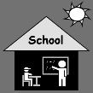
Bet Tefillah | House of Prayer 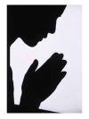
Bet Din | House of Law
Bet Knesset | A meeting place
(b) Describe how the Synagogue is used within a Jewish community. [5]
................................................................................................................................................................................................................................................................................................................................................
................................................................................................................................................................................................................................................................................................................................................
................................................................................................................................................................................................................................................................................................................................................
................................................................................................................................................................................................................................................................................................................................................
................................................................................................................................................................................................................................................................................................................................................
................................................................................................................................................................................................................................................................................................................................................
****************************

The Synagogue is normally built facing Jerusalem. This is where the Temple was, and the Western wall of the Temple still remains!!

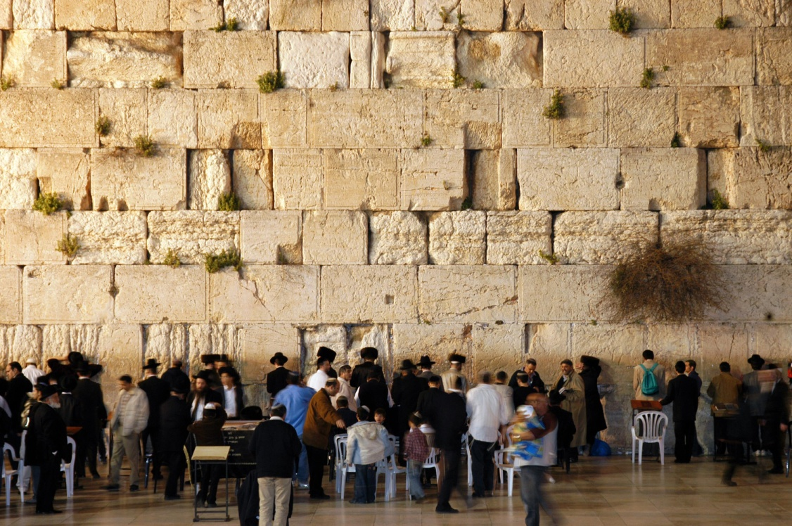

Features inside a Synagogue

Feature |  | Purpose
Ark /  Aron Hakodesh | 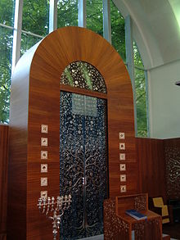 | It’s a cupboard which keep the Torah scrolls safely. Some will close with a decorated curtain and others with doors. During certain prayers the doors and curtain of the ark may be opened or closed e.g. open during Yom Kippur. It is the most important feature within the Synagogue.
Bimah | 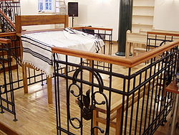 | A raised platform / reading desk  It is in the centre of the Synagogue (Orthodox) so that everyone can see and hear as this is where the Torah is read, by members of the congregation or the Rabbi. The Torah scroll will be brought from the ark to the Bimah during services.
Ner Tamid | 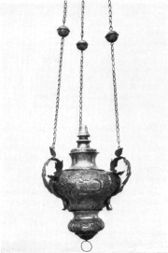 | Everlasting light  In front and slightly above the aron hakodesh, it represents Gods everlasting presence; God is with them at all times. This is kept continually burning/lit. It also reminds the Jews of the Menorah that was used to light the Temple. The Ner Tamid can be electric/battery/gas etc.
Torah | 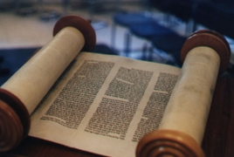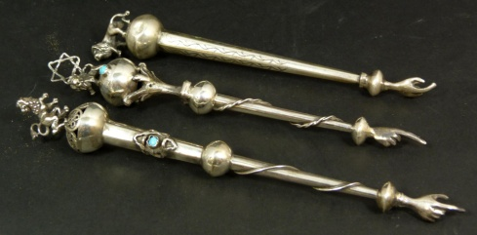 | The Torah scrolls are the most sacred part of any synagogue. They are made from kosher animal skin and are hand written by a scribe. It contains the Five Books of Moses and are read during services. Very often synagogues will have anything up to 7 or 8 scrolls as different ones are used for different services e.g. one for Shabbat service (sidra). It is so holy that one must not touch the scroll, therefore Jews will use a yad (pointer) to read from the Torah.
Ten Commandments | 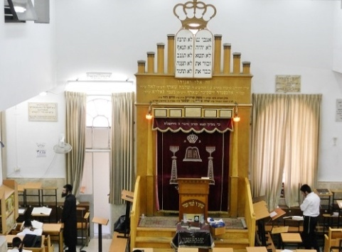 | Jews believe that God revealed to Moses the duties that are expected of all Jews. These are recorded in the Torah. The Ten Commandments are a framework of how a just society should behave. They should be kept by every Jew, regardless of age, wealth, gender. They are central to Jewish beliefs and practice. The 10 Commandments are part of the 613 Mitzvot that should be obeyed.  First 4 = duties concerning humans and God. E.g. “Remember the Sabbath, and keep it holy”  The other 6 = deal with how humans should treat one another e.g. “Do not steal” “Do not kill”.
Seating | 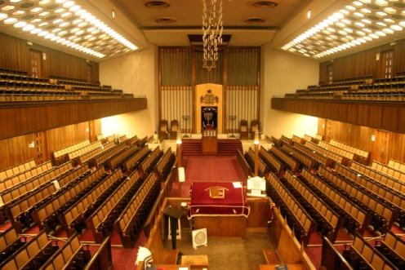 | The women will sit apart from the men in an orthodox synagogue; usually in a women’s gallery on the first floor, or a separate section if only one level. This is to make sure that the men are not distracted during services, worship, and prayer. (women only have to undertake the negative mitzvoth, therefore are not obliged to take part in services of worship). The men will sit on the ground floor to take part in the services. By sitting away from the women and children they can concentrate on the worship / service.  **Reform synagogue however will often have the men and women sat together**

(c) Explain the different features within a synagogue. [8]

................................................................................................................................................................................................................................................................................................................................................
................................................................................................................................................................................................................................................................................................................................................
................................................................................................................................................................................................................................................................................................................................................
................................................................................................................................................................................................................................................................................................................................................
................................................................................................................................................................................................................................................................................................................................................
................................................................................................................................................................................................................................................................................................................................................
................................................................................................................................................................................................................................................................................................................................................
................................................................................................................................................................................................................................................................................................................................................
................................................................................................................................................................................................................................................................................................................................................
................................................................................................................................................................................................................................................................................................................................................
................................................................................................................................................................................................................................................................................................................................................
Reading of the Torah during Synagogue worship

What is the Torah?

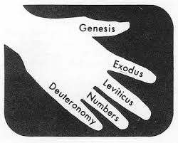
The Torah is the first part of the Jewish bible. It is the central and most important document of Judaism and has been used by Jews through the ages. Torah refers to the five books of Moses which are Genesis; Exodus; Leviticus; Numbers and Deuteronomy.
Jews believe that God dictated the Torah to Moses on Mount Sinai. They believe that the Torah shows how God wants Jews to live. It contains 613 commandments. The Torah is written in Hebrew, the oldest of Jewish languages.
The word Torah has various meanings in English. These include: teaching, instruction and law. For Jews the Torah means all of these.
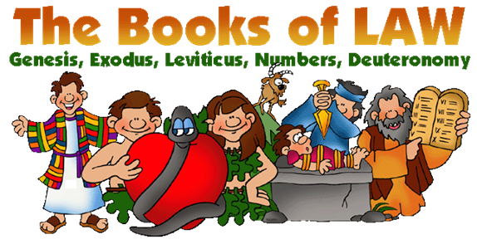

Use of the Torah during services
- The Torah reading service begins when a member of the congregation is given the honor of opening the Ark and taking out the Torah, with much respect and ceremony. The Torah scrolls are taken out from the Ark (Aron hakodesh) and portions read in the synagogue three times each week. On Mondays and Thursdays small sections are read. The main reading is on the morning of Shabbat (Sabbath).

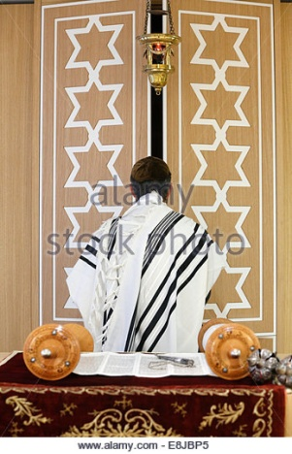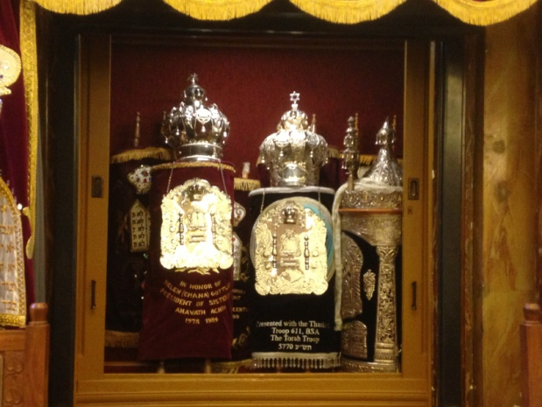
- The Torah is then taken to the Bimah, which is situated in the center of the synagogue. On the occasion when it is necessary to read two or three different portions, two or three scrolls may be taken from the Ark. One or two additional members of the congregation are then honored with carrying the additional Torah Scrolls to the Bimah.

As the Torah Scroll passes by, members of the congregation kiss it or try to touch it with their Tallit as a sign of love and respect. 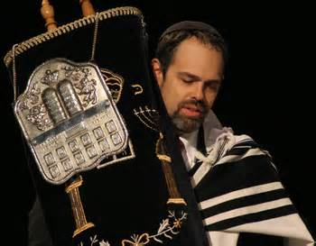 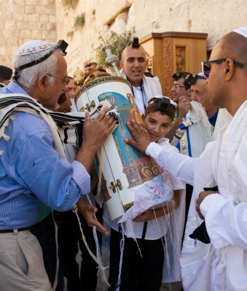 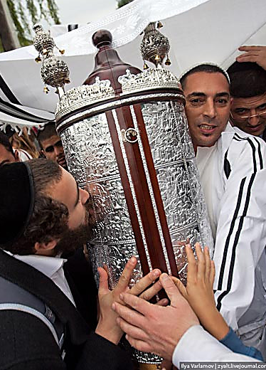
- The scrolls are not directly touched when unfurled on the Bimah. A pointer or Yad (hand) is used instead. This is in the shape of a hand with an outstretched finger. The reading or chanting is performed by a person who has been trained in this task. However it may be carried out by the rabbi. It is a very great honour for a congregant to be asked to attend at a reading during a synagogue service. This is called having an Aliyah which is Hebrew for going up.
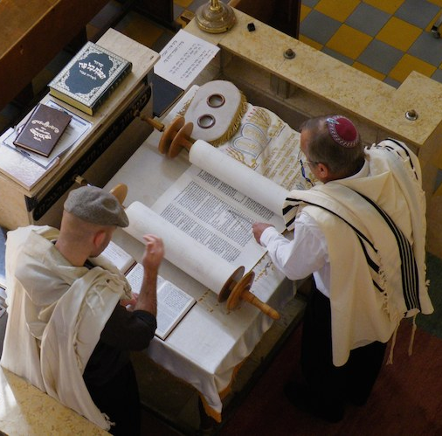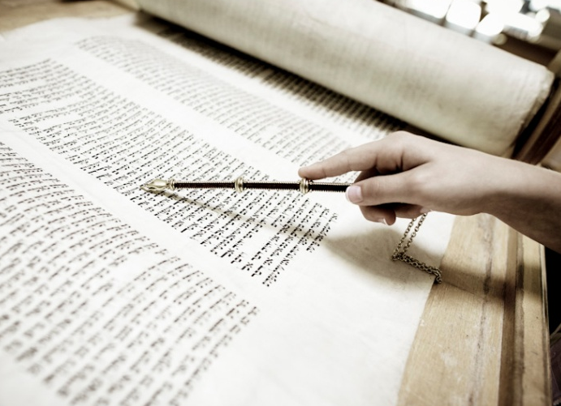
The reader has to be very skilled to read from the scroll because the letters are written without corresponding vowels. They have to know the portion very well to avoid making mistakes. The reading is conducted using an ancient tune and is sung rather than spoken.
The Torah will be read during:-

1 | Daily services | Usually 3 times a day
2 | Festivals | Shabbat; Rosh Hashanah; Yom Kippur; Pesach;  Yom Hashoah (these are the festivals in our  course). The readings will be relevant to the occasion e.g. on Shabbat they will read parts of the Torah remembering God creating the world in 6 days and resting on the 7th day.
3 | Rites of passage | Brit Milah; Bar/Bat Mitzvah (these are the ones listed in our course). E.g. the boy will read a passage from the Torah during his Bar Mitzvah as he is now Son of the Commandment.

Diverse practices within Orthodox and Reform synagogue
Judaism is a diverse religion. Practices and traditions vary from one Jew to another. There are even big differences between the same group –i.e. maybe 2 ‘orthodox’ Jews might do things very differently! Here is a simple table outlining the differences between orthodox and reform worship.
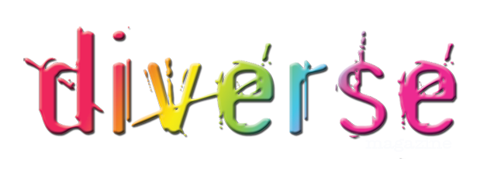
Orthodox | Reform
Seating  Men & women sit apart | Seating  Men & women can sit together
Language  Mostly in Hebrew | Language  Mostly in the local language, and perhaps some in Hebrew.
Dress  Formal; women dress modestly; men wear kippah/tallit/teffilin. | Dress  Casual; optional to wear prayer shawl/teffilin.
Rabbi  Men only! | Rabbi  Men or women!
Music  No music! | Music  Music allowed – used often; sometimes cantor will use instrumental whilst chanting prayers.
Length of services  Tend to quite long e.g. Shabbat service on a Saturday morning can be up to 4 hours long! | Length of services  Shorter services.
Services  Will generally have daily services & services during festivals e.g Shabbat | Services  Many do not hold daily services, just for Shabbat and major festivals e.g Yom Kippur.
Shabbat service  Will hold a service Friday evening – start time vary due on time of sunset. Will also have a lengthy Saturday morning service. | Shabbat service  Will hold a service Friday evening. Generally no Saturday morning service.
(d) ‘Synagogues are very important within Judaism’. Discuss this statement showing that you have considered more than one point of view. (You must refer to religion and belief in your answer.) [15]
................................................................................................................................................................................................................................................................................................................................................
................................................................................................................................................................................................................................................................................................................................................
................................................................................................................................................................................................................................................................................................................................................
................................................................................................................................................................................................................................................................................................................................................
................................................................................................................................................................................................................................................................................................................................................
................................................................................................................................................................................................................................................................................................................................................
...............................................................................................................................................................................................................................................................................................................................................
................................................................................................................................................................................................................................................................................................................................................
................................................................................................................................................................................................................................................................................................................................................
................................................................................................................................................................................................................................................................................................................................................
................................................................................................................................................................................................................................................................................................................................................
................................................................................................................................................................................................................................................................................................................................................
................................................................................................................................................................................................................................................................................................................................................
................................................................................................................................................................................................................................................................................................................................................
................................................................................................................................................................................................................................................................................................................................................
................................................................................................................................................................................................................................................................................................................................................
................................................................................................................................................................................................................................................................................................................................................
................................................................................................................................................................................................................................................................................................................................................

