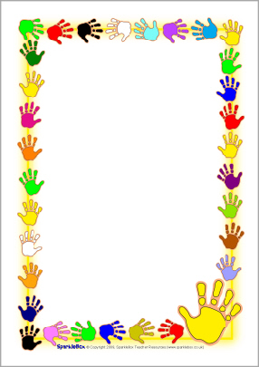

fy tŷ > fy nhŷ

fy cath > fy nghath

fy ci > fy nghi

p

t

c

b

d

g

>

>

>

>

>

>

mh

nh

nhg

m

n

ng

The first letter of the word that comes after ‘fy’ changes.

Here are what they change to:

**Help Llaw / Helping Hand**