Workings and final answer.

What have we learned?

What other mathematical techniques do we need to apply?

What useful information do we know?

**REMEMBER**! Accuracy and spelling of key words * Appropriate paragraphing and sequencing of information presented * Correct phrasing – capitals, punctuation.

What do we want to find out?

Mathematics Unit 11: Internet Relay Chat

Mark (from Sydney, Australia) and Hans (from Berlin, Germany) often communicate with each other using “chat” on the Internet. They have to log on to the Internet at the same time to be able to chat.

To find a suitable time to chat, Mark looked up a chart of world times and found the following:

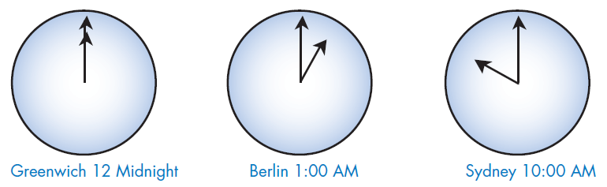

**QUESTION 11.1**  
At 7:00 PM in Sydney, what time is it in Berlin?

**QUESTION 11.2**Mark and Hans are not able to chat between 9:00 AM and 4:30 PM in their local time, as they have to go to school. Also, from 11:00 PM till 7:00 AM their local time they won’t be able to chat because they will be sleeping.  
When would be a good time for Mark and Hans to chat? Write the local times in the table.  
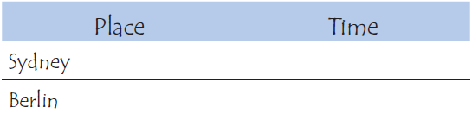

Workings and final answer.

What have we learned?

What other mathematical techniques do we need to apply?

What useful information do we know?

**REMEMBER**! Accuracy and spelling of key words * Appropriate paragraphing and sequencing of information presented * Correct phrasing – capitals, punctuation.

What do we want to find out?

Mathematics Unit 11: Internet Relay Chat