What have we learned?

What other mathematical techniques do we need to apply?

What useful information do we know?

**REMEMBER**! Accuracy and spelling of key words * Appropriate paragraphing and sequencing of information presented * Correct phrasing – capitals, punctuation.

What do we want to find out?

Mathematics Unit 30: Shapes

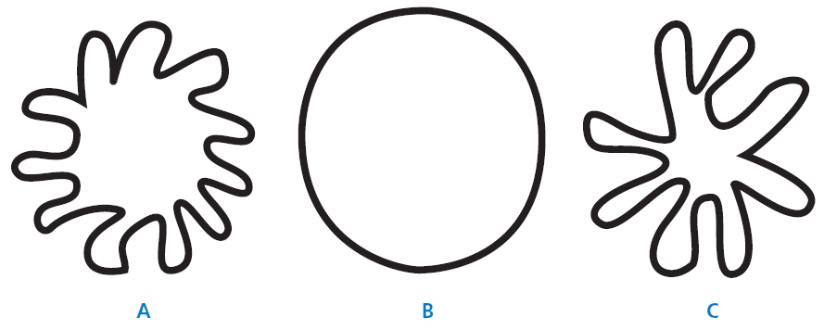

**QUESTION 30.1**

Which of the figures has the largest area? Explain your reasoning.

Workings and final answer.

What have we learned?

What other mathematical techniques do we need to apply?

What useful information do we know?

**REMEMBER**! Accuracy and spelling of key words * Appropriate paragraphing and sequencing of information presented * Correct phrasing – capitals, punctuation.

What do we want to find out?

Mathematics Unit 30: Shapes

Workings and final answer.



**QUESTION 30.2**

Describe a method for estimating the area of figure C.

Workings and final answer.



**QUESTION 30.3**

Describe a method for estimating the perimeter of figure C.

What have we learned?

What other mathematical techniques do we need to apply?

What useful information do we know?

**REMEMBER**! Accuracy and spelling of key words * Appropriate paragraphing and sequencing of information presented * Correct phrasing – capitals, punctuation.

What do we want to find out?

Mathematics Unit 30: Shapes