Workings and final answer.
What have we learned?
What other mathematical techniques do we need to apply?
What useful information do we know?
REMEMBER! Accuracy and spelling of key words * Appropriate paragraphing and sequencing of information presented * Correct phrasing – capitals, punctuation.
What do we want to find out?
Mathematics Unit 31: Braking

The approximate distance to stop a moving vehicle is the sum of:
- the distance covered during the time the driver takes to begin to apply the brakes (reaction-time distance)
- the distance travelled while the brakes are applied (braking distance)
The ‘snail’ diagram on the following slides gives the theoretical stopping distance for a vehicle in good braking conditions (a particularly alert driver, brakes and tyres in perfect condition, a dry road with a good surface) and how much the stopping distance depends on speed.

Workings and final answer.
What have we learned?
What other mathematical techniques do we need to apply?
What useful information do we know?
REMEMBER! Accuracy and spelling of key words * Appropriate paragraphing and sequencing of information presented * Correct phrasing – capitals, punctuation.
What do we want to find out?
Mathematics Unit 31: Braking
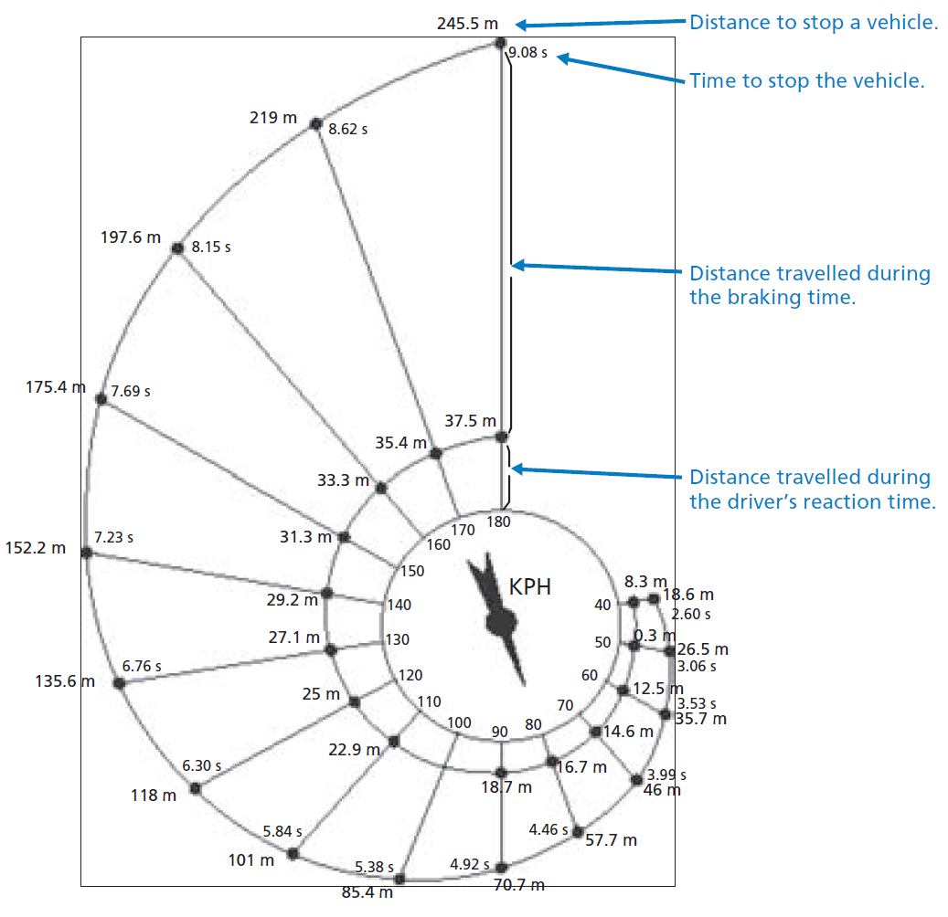
QUESTION 31.1
If a vehicle is travelling at 110kph, what distance does the vehicle travel during the driver’s reaction time?

QUESTION 31.2
If a vehicle is travelling at 110kph, what is the total distance travelled before the vehicle stops?

Workings and final answer.
What have we learned?
What other mathematical techniques do we need to apply?
What useful information do we know?
REMEMBER! Accuracy and spelling of key words * Appropriate paragraphing and sequencing of information presented * Correct phrasing – capitals, punctuation.
What do we want to find out?
Mathematics Unit 7: Speed of Racing Car
Workings and final answer.
What have we learned?
What other mathematical techniques do we need to apply?
What useful information do we know?
REMEMBER! Accuracy and spelling of key words * Appropriate paragraphing and sequencing of information presented * Correct phrasing – capitals, punctuation.
What do we want to find out?
Mathematics Unit 31: Braking

QUESTION 31.3
If a vehicle is travelling at 110kph, how long does it take to stop the vehicle completely?

Workings and final answer.
What have we learned?
What other mathematical techniques do we need to apply?
What useful information do we know?
REMEMBER! Accuracy and spelling of key words * Appropriate paragraphing and sequencing of information presented * Correct phrasing – capitals, punctuation.
What do we want to find out?
Mathematics Unit 31: Braking

QUESTION 31.4
If a vehicle is travelling at 110kph, what is the distance travelled while the brakes are being applied?

Workings and final answer.
What have we learned?
What other mathematical techniques do we need to apply?
What useful information do we know?
REMEMBER! Accuracy and spelling of key words * Appropriate paragraphing and sequencing of information presented * Correct phrasing – capitals, punctuation.
What do we want to find out?
Mathematics Unit 31: Braking

QUESTION 31.5
A second driver, travelling in good conditions, stops her vehicle in a total distance of 70.7metres. At what speed was the vehicle travelling before the brakes were applied?

Workings and final answer.
What have we learned?
What other mathematical techniques do we need to apply?
What useful information do we know?
REMEMBER! Accuracy and spelling of key words * Appropriate paragraphing and sequencing of information presented * Correct phrasing – capitals, punctuation.
What do we want to find out?
Mathematics Unit 31: Braking

