Workings and final answer.

What have we learned?

What other mathematical techniques do we need to apply?

What useful information do we know?

**REMEMBER**! Accuracy and spelling of key words * Appropriate paragraphing and sequencing of information presented * Correct phrasing – capitals, punctuation.

What do we want to find out?

Mathematics Unit 33: Drug Concentrations

**QUESTION 33.1**

A woman in hospital receives an injection of penicillin. Her body gradually breaks the penicillin down so that one hour after the injection only 60% of the penicillin will remain active.

This pattern continues: at the end of each hour only 60% of the penicillin that was present at the end of the previous hour remains active.

Suppose the woman is given a dose of 300 milligrams of penicillin at 8 o’clock in the morning.

Complete this table showing the amount of penicillin that will remain active in the woman’s blood at intervals of one hour from 0800 until 1100 hours.



Workings and final answer.

What have we learned?

What other mathematical techniques do we need to apply?

What useful information do we know?

**REMEMBER**! Accuracy and spelling of key words * Appropriate paragraphing and sequencing of information presented * Correct phrasing – capitals, punctuation.

What do we want to find out?

Mathematics Unit 33: Drug Concentrations

**QUESTION 33.2**  
Peter has to take 80 mg of a drug to control his blood pressure. The following graph shows the initial amount of the drug, and the amount that remains active in Peter’s blood after one, two, three and four days.  
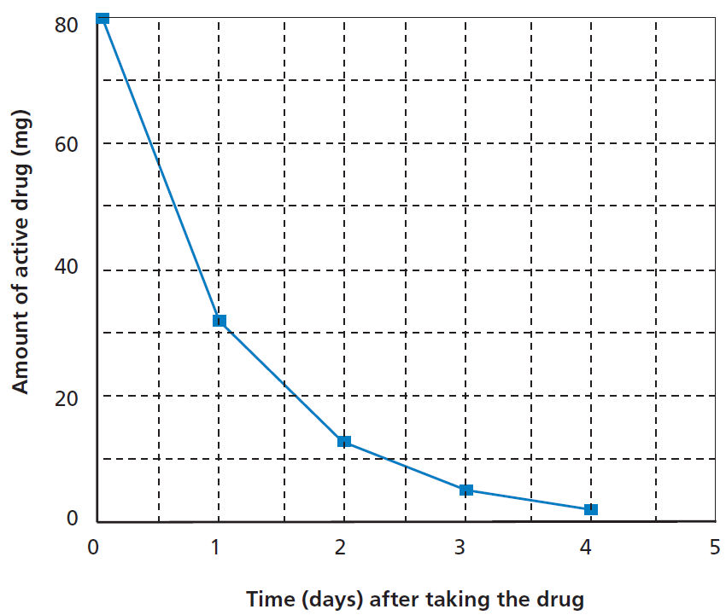  
How much of the drug remains active at the end of the first day?

1. 6 mg.
2. 12 mg.
3. 26 mg.
4. 32 mg.

 **QUESTION 33.3**  
From the graph for the previous question it can be seen that each day, about the same proportion of the previous day’s drug remains active in Peter’s blood.  
At the end of each day which of the following is the approximate percentage of the previous day’s drug that remains active?

1. 20%.
2. 30%.
3. 40%.
4. 80%.

Workings and final answer.

What have we learned?

What other mathematical techniques do we need to apply?

What useful information do we know?

**REMEMBER**! Accuracy and spelling of key words * Appropriate paragraphing and sequencing of information presented * Correct phrasing – capitals, punctuation.

What do we want to find out?

Mathematics Unit 33: Drug Concentrations