Workings and final answer.

What have we learned?

What other mathematical techniques do we need to apply?

What useful information do we know?

**REMEMBER**! Accuracy and spelling of key words * Appropriate paragraphing and sequencing of information presented * Correct phrasing – capitals, punctuation.

What do we want to find out?

Mathematics Unit 37: Spring Fair

**QUESTION 37.1**  
A game in a booth at a spring fair involves using a spinner first. Then, **if** the spinner stops on an even number, the player is allowed to pick a marble from a bag. The spinner and the marbles in the bag are represented in the diagram below.

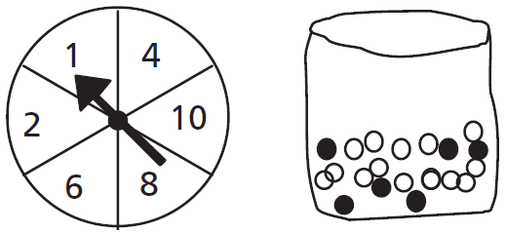

Prizes are given when a black marble is picked. Sue plays the game once. How likely is it that Sue will win a prize?

1. Impossible.
2. Not very likely.
3. About 50% likely.
4. Very likely.
5. Certain.